# BRAT GIS Summary

As requested by Richard, here is the summary of the GIS analysis for the BRAT study. Working directory is B:\ADyk\Richard\BRAT[1]. Please cut and paste from this document to extract what is needed for the paper. This document is a short version, way too much detail can be found in GIS_Steps.docx[2].

Three study areas created by Kangakola are located in northeastern British Columbia (see Figure 5). The GIS analysis will determine the total areas of various Caribou protection and disturbances within each study area that can become inputs in to various treatment and barriers for the BRAT modelling analysis.

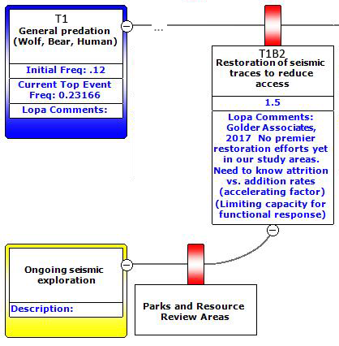

Figure 2. Portion of bowtie analysis requiring seismic activity.

## T1B2 – Restoration of seismic traces

This treatment/barrier requires the total amount of **seismic** disturbances for each of the study areas’ inside herd’s range areas (see Figure 2).

## T1B4 – Management of early seral stage forest

This treatment/barrier requires the total amount of **fire and harvesting** for each of the study areas’ inside herd’s range areas (see Figure 3).

## T3 – Restoration of deforestation and Protected Areas

This treatment/barrier requires the total amount of **deforestation** for each of the study areas’ inside herd’s range areas (see Figure 4). T3B1 Habitat set asides or **protected** areas from **RRA** and **Parks**.

Figure 3. Portion of bowtie analysis requiring fire and harvest activity.

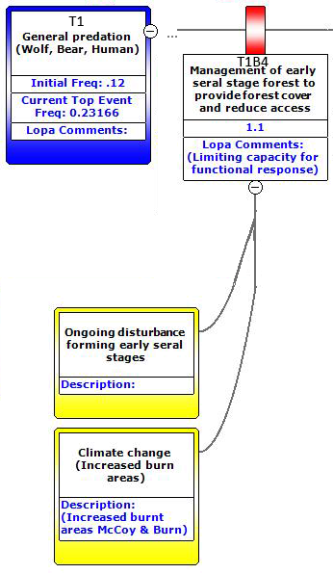

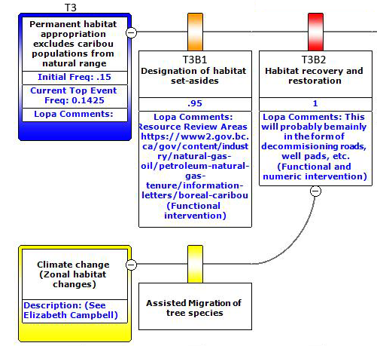

Figure 4. Portion of bowtie analysis requiring deforestation activity.

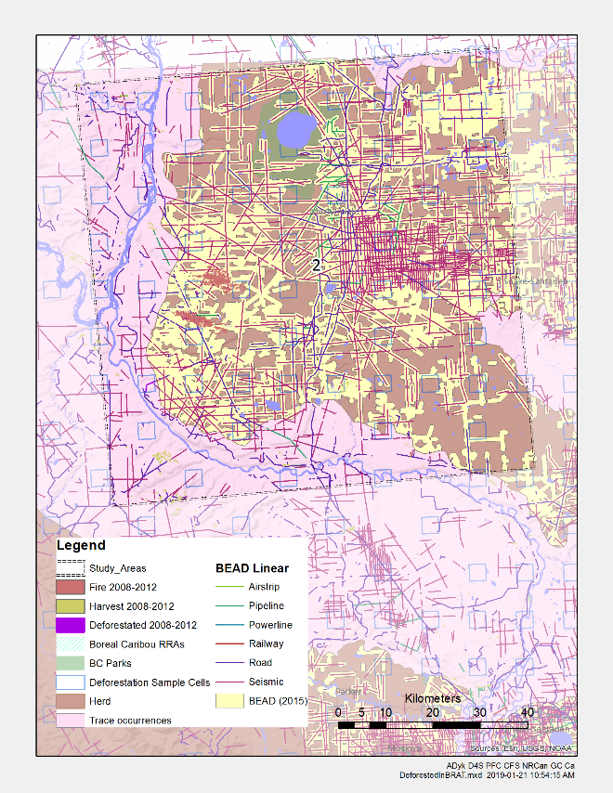 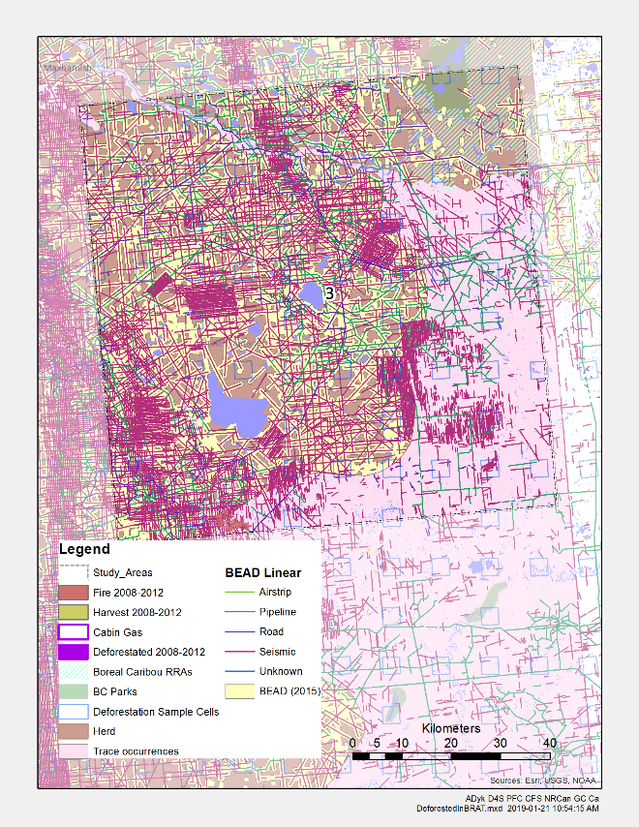

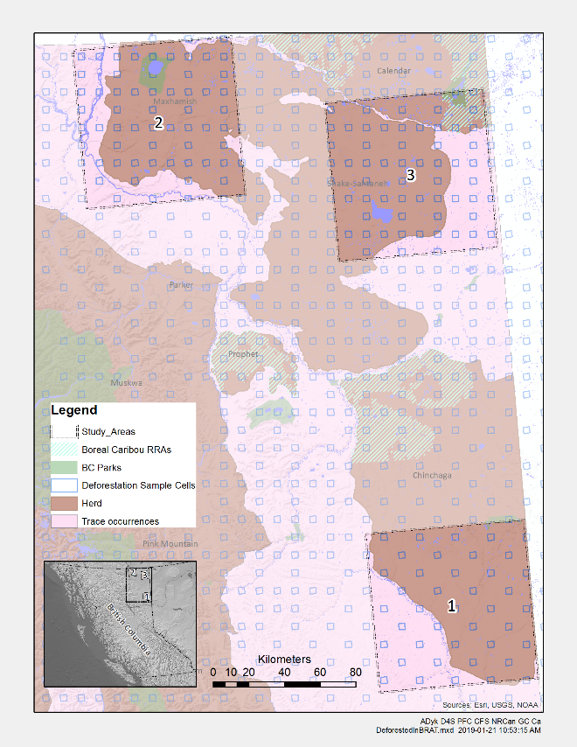 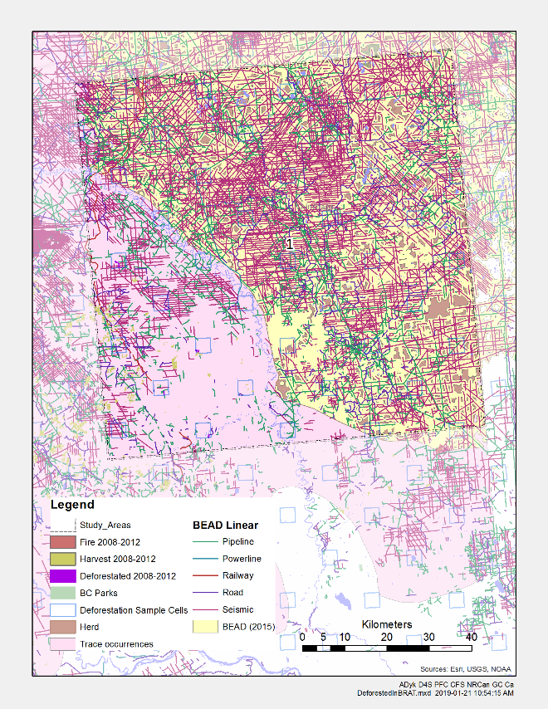

Figure 5. Each study area with disturbances and an overview map of the study areas.

## Sources

Areas of each disturbance results can be found in Table 4.

Table 4. Results of GIS Evaluation[3]

|  | **Study Area 1** | | **Study Area 2** | | **Study Area 3** | | **Total** | |
| --- | --- | --- | --- | --- | --- | --- | --- | --- |
|  | **km²** | **% Study** | **km²** | **% Study** | **km²** | **% Study** | **km²** | **% Studies** |
| Study Area | 8,000 | 100.00% | 8,000 | 100.00% | 8,000 | 100.00% | 24,000 | 100.00% |
| Herd Range | 5,615 | 70.18% | 5,553 | 69.42% | 5,712 | 71.40% | 16,880 | 70.33% |
|  | **km²** | **% Range** | **km²** | **% Range** | **km²** | **% Range** | **km²** | **% Ranges** |
| Protected | 17 | 0.31% | 275 | 4.96% | 458 | 8.02% | 751 | 4.45% |
| Disturbance | 5,380 | 95.82% | 3,745 | 67.43% | 4,366 | 76.42% | 13,490 | 79.92% |
|  | **km** | **km/km²** | **km** | **km/km²** | **km** | **km/km²** | **km** | **km/km²** |
| Linear Disturbance | 12,881 | 2.29 | 4,219 | 0.76 | 11,793 | 2.06 | 28,893 | 1.71 |
|  | **km²/yr** | **% Range** | **km²/yr** | **% Range** | **km²/yr** | **% Range** | **km²/yr** | **% Ranges** |
| Deforested | 0.35 | 0.01% | 0.53 | 0.01% | 1.01 | 0.02% | 1.89 | 0.01% |
| Fire | 0.70 | 0.01% | 7.02 | 0.13% | 1.19 | 0.02% | 8.91 | 0.05% |
| Harvested | 0.12 | 0.01% | 0.05 | 0.01% | 0.00 | 0.01% | 0.17 | 0.01% |

Three **study areas** are 89.44 km × 89.44 km = area 8,000 km² (see Figure 5). Each study site contains around 70% Caribou **herd ranges** and 30% trace occurrence (ECCC 2017?)[4]. [KANAGKOLA]

**Protected** areas are made of the BC Parks (BC Parks Nov. 2001[5]) and Caribou Resource Review Areas (RRA[6], [Cichowski, Culling and McNay 2012](http://www.env.gov.bc.ca/wld/speciesconservation/bc/documents/RRA%20Performance%20Measures%20-%20March%2031,%202012.pdf)[7]). [KANAGKOLA]

**Disturbance** area and **Linear Disturbances** data are derived from the source data used in ECCC’s Boreal ecosystem anthropogenic disturbance ([BEAD](https://open.canada.ca/data/en/dataset/afd0ce47-17c3-445c-b823-2f86409da2e0)[8]) (Boreal ecosystem anthropogenic disturbance vector data for Canada based on 2008 to 2010 Landsat imagery 2012). It represents a single geospatial dataset representing total anthropogenic disturbance footprints across a significant portion of Canada's boreal ecosystem.

**Deforestation** estimates are special calculation using deforestation events that have occurred during the five years 2008-2012 by the National Deforestation Monitoring System (NDMS) ([Dyk et. al. 2015](https://cfs.nrcan.gc.ca/publications?id=36042)[9]). Deforestation estimates are calculated from sample based mapping within 3.5 km × 3.5 km cells, that is then scaled up. The results are shown as annual rates based on the five years of data.

**Fire** and **Harvest** for the years 2008-2012 are derived from the Composite2Change (C2C) dataset ([White et. al 2017](https://cfs.nrcan.gc.ca/publications?id=38885)[10]). The results are shown as annual rates based on the five years of data.

1. \\132.156.150.81\ssos\ADyk\Richard\BRAT
2. \\132.156.150.81\ssos\ADyk\Richard\BRAT\GIS_Steps.docx
3. \\132.156.150.81\ssos\ADyk\Richard\BRAT\scratch\BRAT_GISCalculations.xlsx [Table]
4. <http://donnees.ec.gc.ca/data/species/protectrestore/boreal-caribou-ranges-in-canada/?lang=en>
5. <http://www.empr.gov.bc.ca/Mining/Geoscience/MapPlace/geoData/Pages/default.aspx>
6. <https://www2.gov.bc.ca/gov/content/industry/natural-gas-oil/petroleum-natural-gas-tenure/information-letters/boreal-caribou>
7. <http://www.env.gov.bc.ca/wld/speciesconservation/bc/documents/RRA%20Performance%20Measures%20-%20March%2031,%202012.pdf>
8. <https://open.canada.ca/data/en/dataset/afd0ce47-17c3-445c-b823-2f86409da2e0>
9. <https://cfs.nrcan.gc.ca/publications?id=36042>
10. <https://cfs.nrcan.gc.ca/publications?id=38885>