**CS 457/557 -- Winter Quarter 2018**

**Shaders Final Project: Square Watermelon**

**100 Points**

Stewart Rodger

rodgers@oregonstate.edu

02/27/2018

For this project, I chose to stick with OpenGL/GLman, using a fragment and a vertex shader to attempt to recreate a watermelon, and then make it square as seen in Japanese markets.

The lines and the noise are added in much the same way as the noisy ellipses, however in my case I used the equation for squares like in the checkers handout, having it stop alternating so it would produce lines.

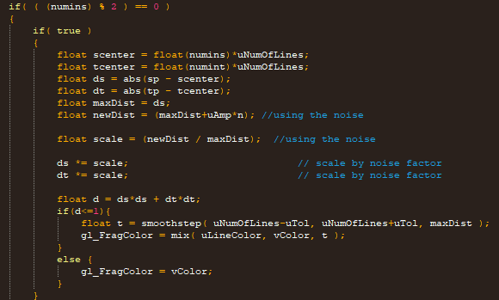

The lighting was directly from the handouts, with one element changed. 

Instead of using a solid color like in the handout, I used gl_FragColor, which was already calculated as the lighting was done last.

Finally, in the vertex file, I used the clamp function to change the circle into the rounded square.

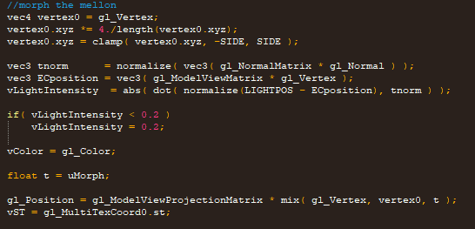

This is the result, before morph (left) and morph (right).

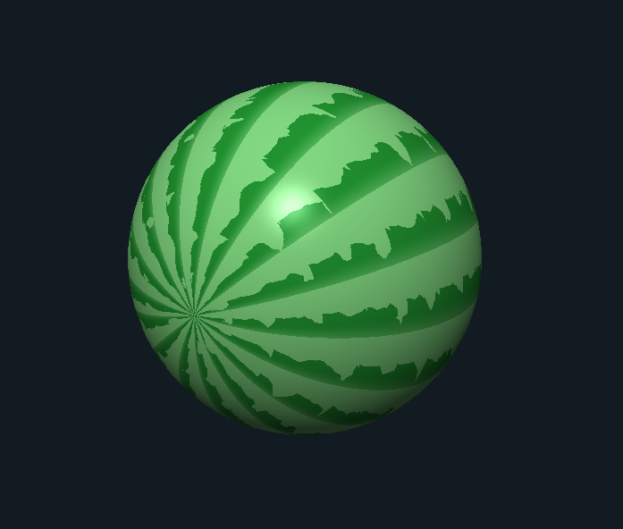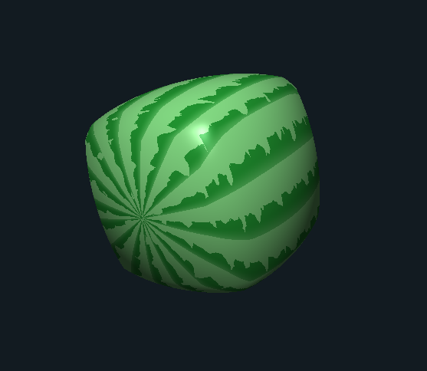

The Kaltura video demonstration can be found here:

<https://media.oregonstate.edu/media/t/0_thcwvrzt>