**Object Oriented Programing Project Report**

Figure 1



**Hospital Management System**

**Prepared by**

**at**

**Seneca Polytechnic**

**March 2024**

**Table of Contents**

Contributions 3

I Presentation YouTube link 3

II Project Description 3

1 Project Overview 3

2 The Purpose of the Project 3

2a The User Business or Background of the Project Effort 3

3 The Scope of the Work 4

III Requirements 4

4 Product Use Cases 4

IV Design 4

5 UML Class Diagram 4

V Testing and Evaluation 4

6 Features to be tested. 4

7 Pass/Fail Criteria 4

VI Project Issues 4

8 Lessons Learnt 4

VII Conclusion 4

VIII References 4

### ****Contributions****

|  |  |  |  |  |
| --- | --- | --- | --- | --- |
| **Student ID** | **Name** | **Components** | **Details** | **Development hours** |
|  |  |  |  |  |
|  |  |  |  |  |
|  |  |  |  |  |
|  |  |  |  |  |

# Presentation YouTube link

# Project Description

## Project Overview

The Hospital Management System aims to facilitate efficient management of patient records, appointment scheduling, and medical staff tracking within a hospital or healthcare facility. It provides a comprehensive solution for organizing patient information, managing appointments, and ensuring seamless communication between medical staff and patients.

## The Purpose of the Project

### The User Business or Background of the Project Effort

Content

The Hospital Management System addresses the need for a centralized platform to manage patient data and appointments effectively. It caters to the requirements of healthcare professionals by streamlining administrative tasks, optimizing resource utilization, and enhancing patient care delivery.

Motivation

The motivation behind the project lies in improving the overall efficiency and effectiveness of hospital operations. By automating various tasks such as appointment scheduling, patient record management, and medical staff tracking, the system aims to reduce administrative burden, minimize errors, and enhance the overall quality of healthcare services.

Considerations

Considerations include the severity of existing challenges in hospital management, the significance of addressing these challenges, and the potential impact of implementing an efficient Hospital Management System on patient care, staff productivity, and resource utilization.

## The Scope of the Work

The scope of the project encompasses the design, development, and implementation of a Hospital Management System that meets the specified requirements outlined in the project guidelines. This includes the creation of patient class hierarchies, implementation of exception handling mechanisms, integration of STL containers for data storage and manipulation, appointment scheduling functionalities, management of medical staff, and user interface development.

# Requirements

## Product Use Cases

* Use Case 1: Add New Patient
* Use Case 2: Search for Patient by ID
* Use Case 3: Schedule Appointment
* Use Case 4: Assign Procedure
* Use Case 5: Manage Medical Staff

# Design

## UML Class Diagram

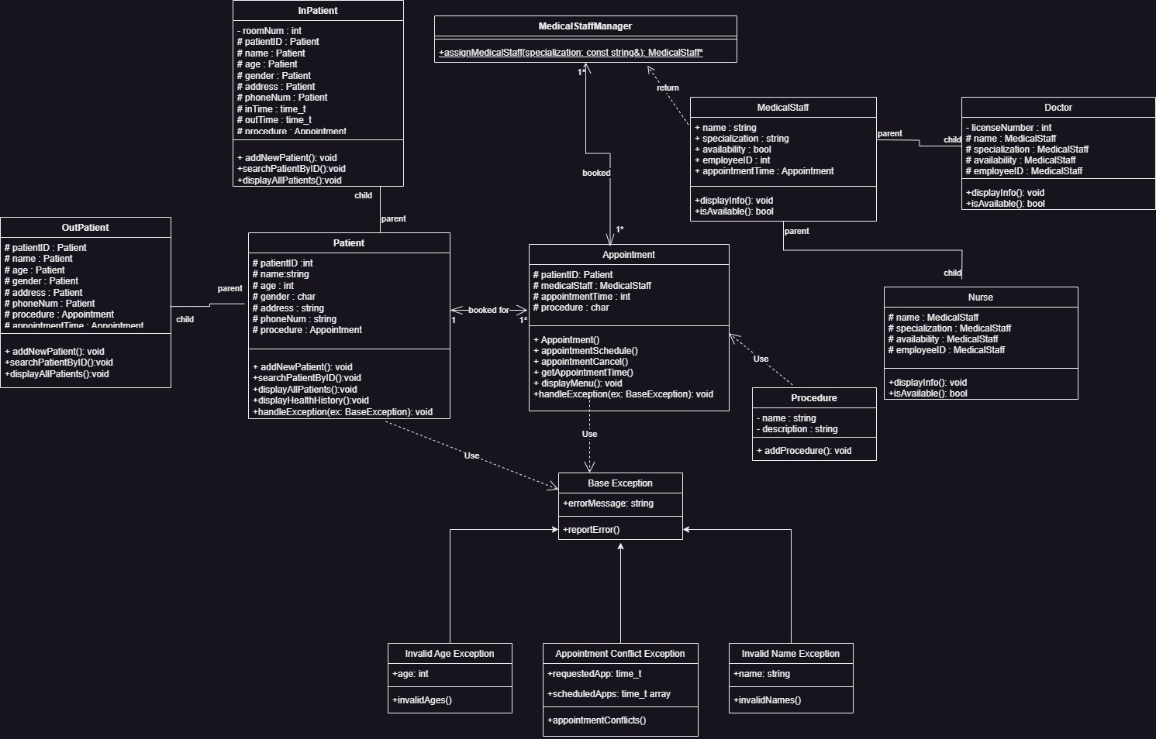

# Testing and Evaluation

## Features to be tested.

* Patient record management
* Appointment scheduling
* Medical staff management
* Procedure assignment

## Pass/Fail Criteria

**Pass:** All implemented functionalities perform as expected without errors.

**Fail:** Any functionality that does not meet the specified requirements or produces unexpected results.

# Project Issues

## Lessons Learned

* Importance of comprehensive planning and requirements analysis.
* Effective utilization of object-oriented principles and design patterns.
* Significance of thorough testing and validation to ensure system reliability.
* Challenges encountered during implementation and strategies for overcoming them.

# Conclusion

Write the conclusion of the project by discussing the issues, solutions and the outcome.

# References

Image link: https://pixabay.com/illustrations/health-care-medicine-healthy-2082630/

SAMPLE REFS:

|  |  |
| --- | --- |
| [1] | Robertson and Robertson, Mastering the Requirements Process. |
| [2] | A. Silberschatz, P. B. Galvin and G. Gagne, Operating System Concepts, Ninth ed., Wiley, 2013. |
| [3] | J. Bell, "Underwater Archaeological Survey Report Template: A Sample Document for Generating Consistent Professional Reports," Underwater Archaeological Society of Chicago, Chicago, 2012. |
| [4] | M. Fowler, UML Distilled, Third Edition, Boston: Pearson Education, 2004. |