Bartlomiej Jedrzejowski
T00261440

- Database Name:
Shoey
- SQL File Name:
shoey.sql
- Explanation of how the system works:
The shoey system is a shopping application which allows users to create an account, log in, browse products, add items to a basket and place orders.
The system uses a session-based basket. If a logged in user adds a product the product ID and quantity are stored in the session array, which is then computed in the basket.
During checkout, the system calculates the total cost of the basket and creates a new ‘order’ in the orders `table`. Each product in the basket is then inserted into the `order_items` table, linking it to the order via a foreign key.

- Where each element is used:
- “Inserts”
  - Creating new account -> CreateAccount()
  - Creating an order -> createOrder()
  - Adding items to order -> createOrder_Items()
- “Selects (with condition)”
  - Searching products by name -> findProductsByName()
  - Retrieving product details => findProductsByID()
- “Deletes”
  - Deleting a customer account ->
- “Updates”
  - Updating order status -> updateOrderStatus()
- “Processing / Calculation”
  - Calculating basket total -> calcTotal()
  - Checkout process -> basketLogic.php

- View of data tables:
- Customers Table:
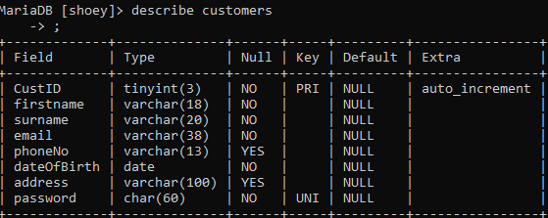
- Products Table:
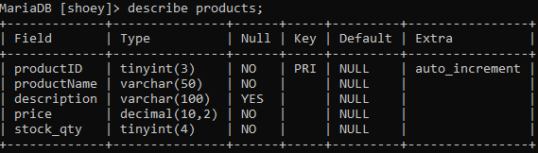
- Orders Table:
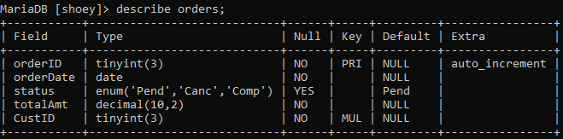
- Order_Items Table:
