# Lab 1: Eclipse IDE Setup (Personal Computer)

Objective:

This lab will help you prepare your personal environment for Java development using Oracle’s Java Development Kit (JDK) and Eclipse Integrated Development Environment (IDE) on your own machine.

# 1 Install Java JDK

In your web browser, search for “Oracle Java JDK.” Choose the search result for [www.oracle.com](http://www.oracle.com). It may look like this.

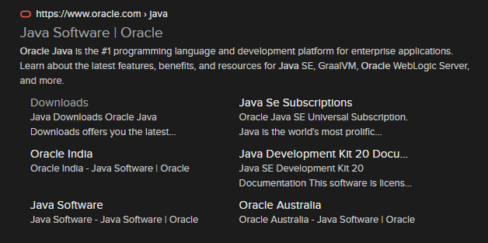

Note the Java edition which is the latest long-term support (LTS) release.

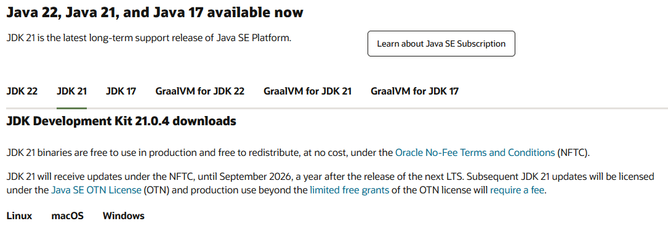

Choose your operating system and download the appropriate installer.

Linux

* x64 Debian package for Ubuntu and Ubuntu-based distros
* x64 RPM package for Fedora

macOS

* x64 DMG Installer for Intel-CPUs
* Arm 64 DMG Installer for ARM-CPUs (M1 machines)

Windows

* x64 Installer

# 2 Install Eclipse IDE

Search for “Eclipse IDE” in your web browser. Choose the search result for [www.eclipse.org](http://www.eclipse.org). It may look like this.

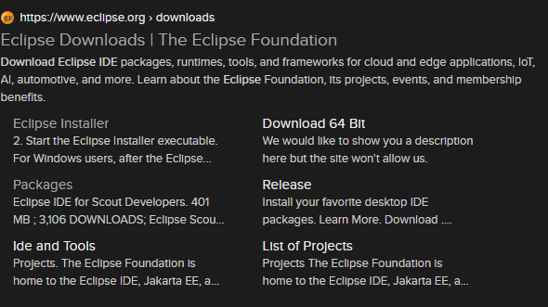

We will be installing the Eclipse IDE for Java Developers.

|  |  |
| --- | --- |
|  |  |
| The download button should download the appropriate installer. | Choosing “Download Packages,” will lead here. Download the installer for your operating system. |

This lab will use the Eclipse Installer. Download and run the installer.

Choose the option Eclipse IDE for Java Developers.

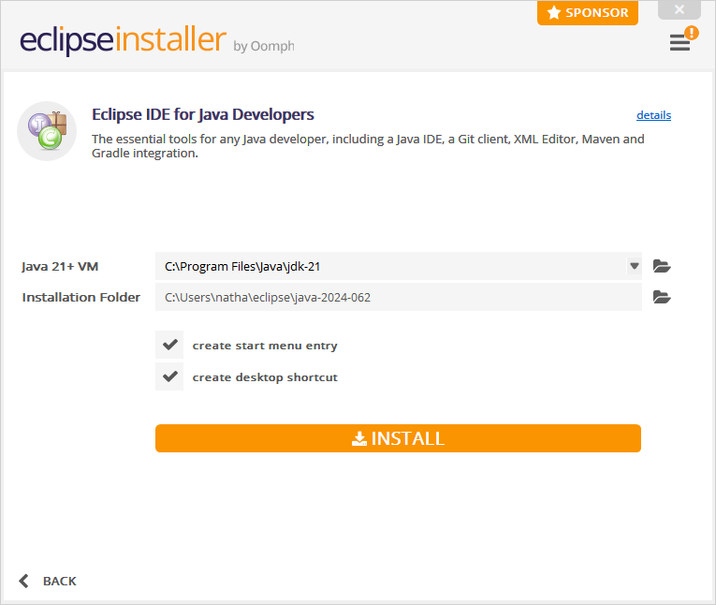

You will be asked to choose the installation folder and the location of the Java VM. The default options should be correct. If the Java VM directory is not the location of a JDK and you installed the Oracle JDK, you will need to choose the folder icon to find it.

Choose Install and accept the Software User Agreement, read it first if you wish.

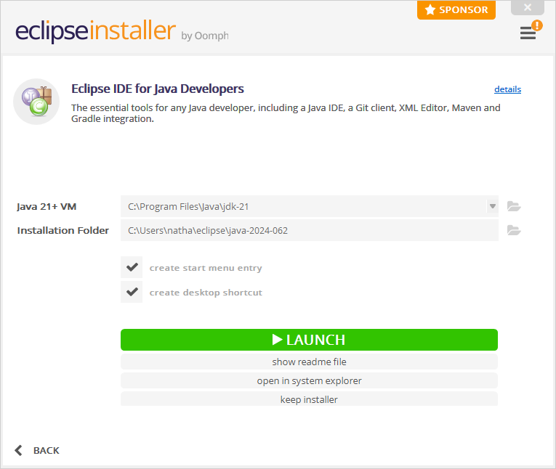

Choose Launch to start Eclipse.

# 3 Working in Eclipse

Upon launching Eclipse, you will be met with a window asking you to choose a directory to use as your Workspace.

This is the directory that Eclipse will store data needed for your projects. You may choose a different directory as you like or accept the default location. Checking the box will tell Eclipse to use this directory for all your projects. Choose Launch once you are finished.

You will be met with a Welcome screen. At the bottom right of the Welcome screen you may check “Always show Welcome at start up.” It will be helpful to easily reach this screen as you learn Eclipse.