**Programming 3**

UCN – Computer Science - C#

_________________________________________________________________________________________

WPF – Wind Chill Factor

# Background

Learn about the Wind Chill Factor: <http://cap2000.dk/chillfactor.htm>

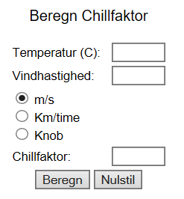

For comparison we will try to do some of the same stuff in a WPF application.

We will use these resources for calculation (test) and to get the formula:

* Online calculation: <https://www.weather.gov/epz/wxcalc_windchill>
* Formula: <https://www.weather.gov/media/epz/wxcalc/windChill.pdf>

According to the first link the calculation is only valid for certain temperatures and wind speeds.

Create a nice GUI, validate the input and get correct output:

|  |  |  |
| --- | --- | --- |
| No input | All ok | Wind speed must be positive |

# Exercise paths

I have made two versions of this exercise: base and challenge version. Furthermore there is the extension: *Add a WCF Service*.

You’re free to follow one of these paths:

1. Base -> 2. Challenge (starting over) -> 3. Add a WCF Service

1. Base -> 2. Add a WCF Service

1. Challenge -> 2. Add a WCF Service

# Base exercise – Wind Chill Factor

**Getting started**

Create an empty solution:



Unpack the WindChillBase.zip file, and add this project into your solution.

You end up with a structure similar to this:

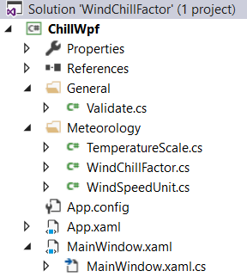

Run the WPF project. It’s obviously that something’s missing:

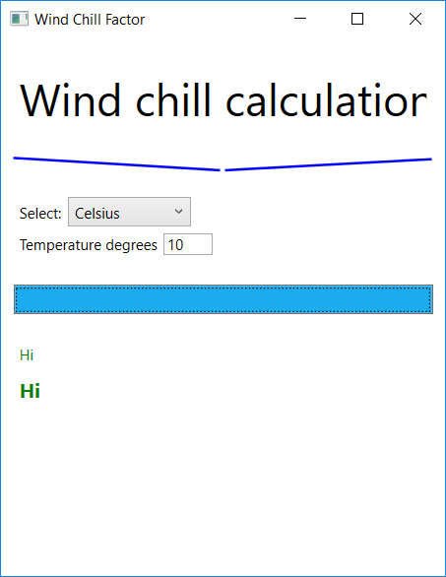

**Modify the project**

Repair / extend the project until it has a similar look and function to the demo program.  
E.g. setup error message, get wind speed and display results.

If time permits: Add a button that clears the input data – and/or experiment with the layout.

# Challenge exercise – Wind Chill Factor

**Getting started**

Get the project up and running as described in ‘Base exercise - Wind Chill Factor’. But in this case Unpack the WindChillChall.zip file, and add this project into your solution.

Run the WPF project. It’s obviously that something’s missing:

Initially – and after button was pressed

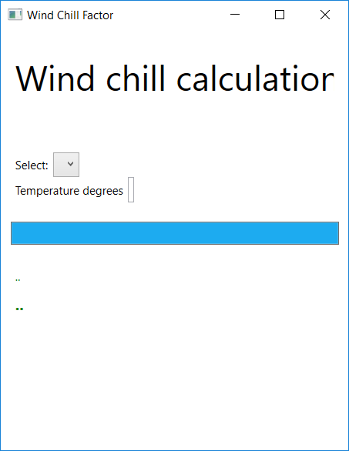 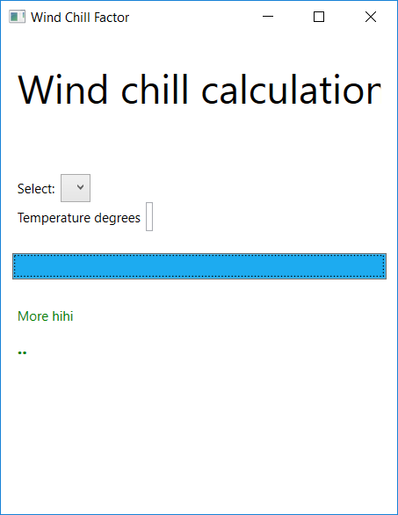

**Modify project**

Repair / extend the project until it has a similar look and function to the demo program.  
A lot of code is missing – you may look for comments about missing code. Also a few errors are introduced – debugging may help you!

Test to ensure robustness and similarity between the results and the online calculation results.

If time permits: Add a button that clears the input data – and/or experiment with the layout.

### Extra

Associate a PreviewTextInput event handler to the Wind Speed input to ensure only digits can be keyed in.

# Add a WCF service

Add a WCF service that handles the calculation.

Incorporate the WCF service in your WPF project. The WCF service must be called to get the result.