**Programming 3**

UCN – Computer Science - C#

_________________________________________________________________________________________

Flexible sorting using Delegates

Content

Getting started 1

Sorting – Console project 2

Sort scores 2

Sort scores – Lambda udtryk 3

Sort scores – Challenge 3

Sorting – GUI 4

# Getting started

**Unpack** the SortDelegate.zip file.

**Create** an empty solution:

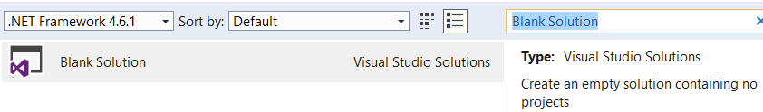

**Add** the unpacked SortDelegate project to your solution.

**Run** the project – result:

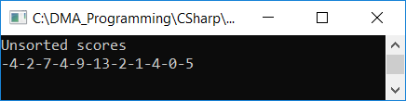

**Modify** to make the listing of numbers a little nicer:

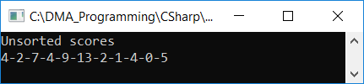

# Sorting – Console project

## Sort scores

It should be possible to sort the scores in different ways.

1.

Use the DelegateBubleSort class and its members to sort scores in ascending order.

Display the ordered scores:

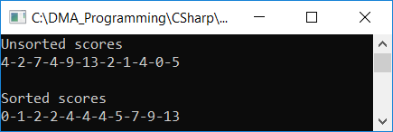

2.

Add a method that allows score to be sorted alphabetically.

Display the ordered scores:

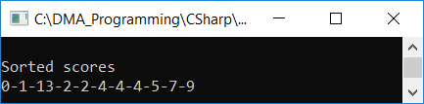

3.

Add a method that sorts even scores before odd scores.

Display the ordered scores:

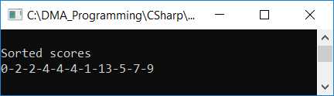

4.

Add a method that sorts even scores in ascending order before odd scores in ascending order.

Display the ordered scores:

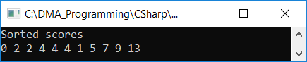

## Sort scores – Lambda udtryk

Add yet another sorting order but this time use a lambda expression instead of a method.

This implies that the sorting order can be determined very flexible in the ManageSortDelegated class.

E.g. sort in descending order:



## Sort scores – Challenge

Use the List<T>.Sort method from the System.Collections.Generic namespace to implement flexible sorting (as above).

You can use a method or a lambda expression.

# Sorting – GUI

Create a GUI where you can sort some objects in different ways, e.g. Team og Gamer objects

You may use the code from SortDelegateGui.zip

On basis on this code first achieve this:

Program just opened After SortByName was pressed

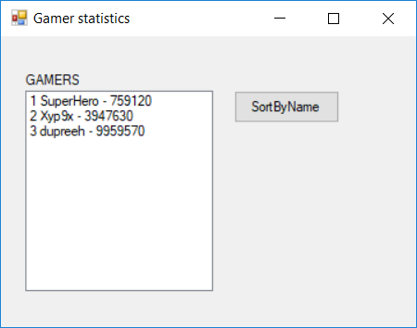 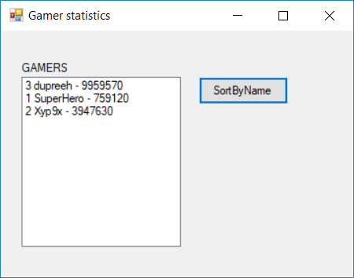

Implement more sorting orders!