**Programming 3**

UCN – Computer Science - C#

_________________________________________________________________________________________

Use async and await 1

# Getting started

**Create** a solution with a console project.

There are pluses and minuses

We want a Main method where you can easily change between three methods than writes pluses and minuses alternately like this:

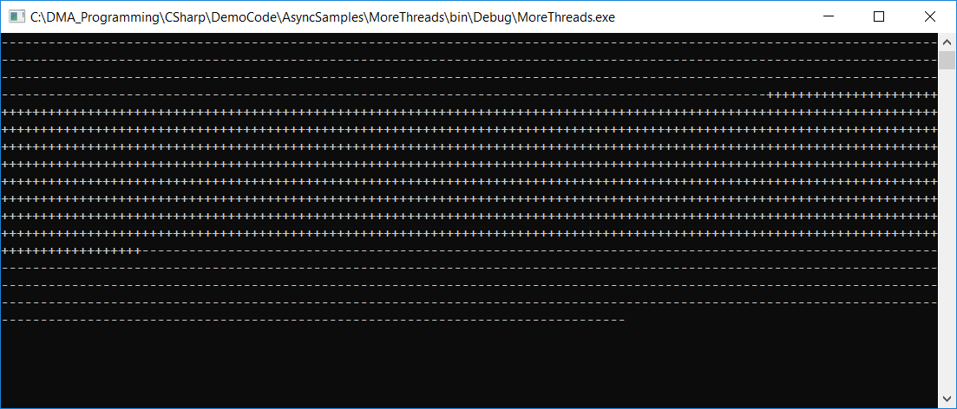



## UseSystemThreading()

Implement these methods:

|  |
| --- |
| private static void UseSystemThreading() {  // Create thread  ThreadStart threadStart = DoWork;  Thread plusThread = new Thread(threadStart);  // Start thread  plusThread.Start();  //  for (int count = 0; count < repetitions; count++) {  Console.Write('-');  }  // Wait for plusThread to terminate  plusThread.Join();  }  private static void DoWork() {  for (int count = 0; count < repetitions; count++) {  Console.Write('+');  }  } |

**Test.**

## UseSystemThreadingTasks()

Implement these methods:

|  |
| --- |
| private static void UseSystemThreadingTasks() {  // Create and run Task  Task plusTask = Task.Run(  () => {  for (int count = 0; count < repetitions; count++) {  Console.Write('+');  }  }  );  Debug.WriteLine("Plus Task status: " + plusTask.Status);  for (int count = 0; count < repetitions; count++) {  Console.Write('-');  }  plusTask.Wait();  Debug.WriteLine("Plus Task status: " + plusTask.Status);  } |

**Test.**

## UseAsync()

Implement methods:

**private static void UseAsync() {**

// Your code here

}

**private static async Task DoWorkAsync() {**

// Your code here

}

**Test.**