Xamarin - Mobile Dev.

**Exercise: Wind Chill Factor**

**Background**

*About windchill factor*

”The windchill factor is the temperature that a person feels because of the wind. For example, if a thermometer reads 35 degrees Fahrenheit outside and the wind is blowing at 25 miles per hour (mph), the windchill factor causes it to feel like it is 8 degrees F. In other words, your 98-degree body loses heat as though it is 8 degrees outside.”

Source: https://science.howstuffworks.com/nature/climate-weather/atmospheric/question70.htm

We will use these resources:

* Online calculation: <https://www.weather.gov/epz/wxcalc_windchill>
* Formula: <https://www.weather.gov/media/epz/wxcalc/windChill.pdf>

The formula is complicated, and you don't really need it for this exercise.

According to the first link the calculation is only valid for certain temperatures and wind speeds!

Try to use the online calculation!

Example:

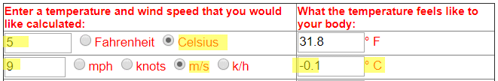

You know the GUI from my demo:

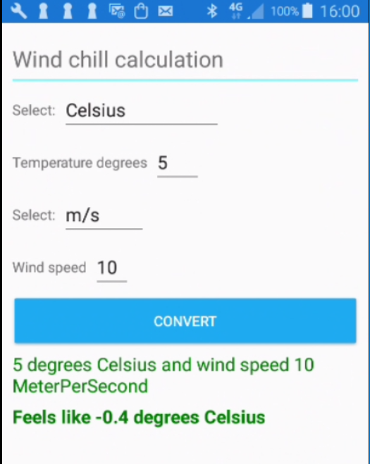

**Exercises**

I have made a base version and a challenge version of this exercise. Please choose one of them!

*In either case the installation and validation of Visual Studio with Xamarin is a prerequisite.*

**Wind Chill Factor – *base exercise***

**Getting started**

First create a project ChillBase with this structure:

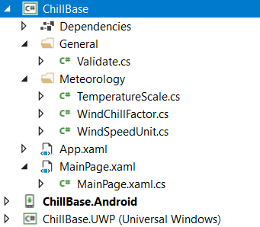

Create the two folders General and Meteorology and the 4 classes contained in them.

Then copy and paste code from ChillBase.zip into your classes and your xaml-file.  
Precaution; Don’t copy all the code – only what’s missing in your xaml-file and classes.

Then compile and run the Android project. It’s obviously that something’s missing:

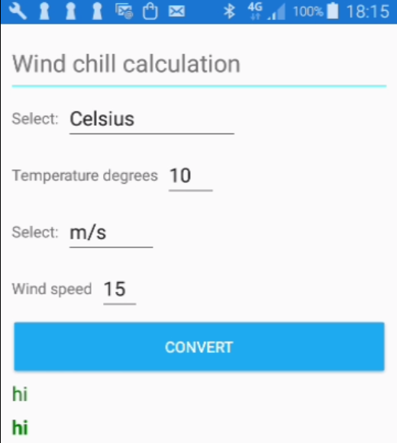

**Extend the project**

Repair / extend the project until it has a similar function to the demo program.  
E.g. get wind speed and setup error message. Print results.

If time permits: Add a button that clears the input data – and/or experiment with the layout.

**Wind Chill Factor – *challenge exercise***

**Getting started**

Get the project up and running as described in ‘Wind Chill Factor – base exercise’, only in this case the project name should be ChillChall - and you should copy code from ChillChall.zip file.

Then compile and run the Android project. Something’s missing:



**Extend the project**

Repair / extend the project until it has a similar function to the demo program.  
A lot of code is missing – you may look for comments about missing code.

Test to ensure robustness and similarity between the results and the online calculation results.

If time permits: Add a button that clears the input data – and/or experiment with the layout.