Xamarin – Mobile Dev.

**Exercise: Layouts**

**1. Layouts – getting started**

Implement one or more pages from LayoutExamples to get acquainted with the different layouts.

You can use MainPage.xaml

Try to experiment with the layouts.  
E.g. rearrange the views, changing the text size, or whatever come into your mind.

**2. StackLayout**

**Create this layout from the presentation:**

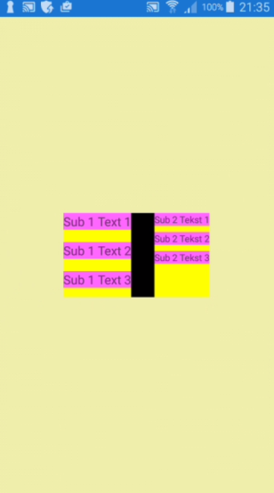

**Create this layout**

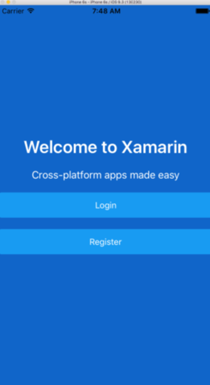

Page background color: #127ac7

‘Login’ and ‘Register’ are buttons.

**Create this layout**

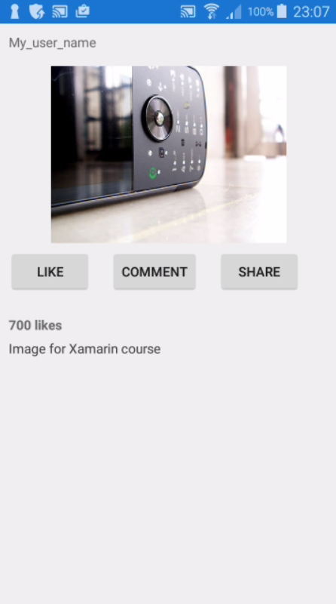

URI for image: https://farm4.staticflickr.com/3510/3212344050_105be2c312.jpg

Optionally create one or more of the layouts in code-behind!

**3. Use styles**

Based on GridLayoutDemo.zip and ExampleStyles.zip experiment with styles!

**4. Embed image**

Try to embed one or more images cf. the recipe from the presentation.

E.g. create a new project or change the above project by downloading and embedding the mobile phone image.