**Layout examples**

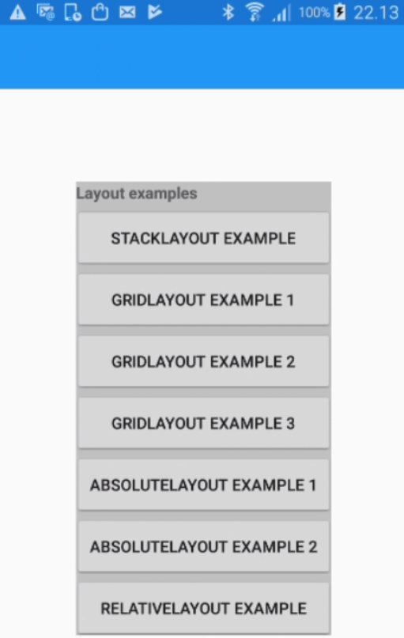

Source: Udemy course by Mosh Hamedani: Xamarin Forms: Build Native Cross-platform Apps with C#

**StackLayout**

|  |  |
| --- | --- |
|  | <?xml version="1.0" encoding="utf-8" ?>  <ContentPage xmlns="http://xamarin.com/schemas/2014/forms"  xmlns:x="http://schemas.microsoft.com/winfx/2009/xaml"  x:Class="LayoutDemo.StackLayout"  Title="StackLayout">  <ContentPage.Padding>  <OnPlatform x:TypeArguments="Thickness" iOS="0, 20, 0, 0">  </OnPlatform>  </ContentPage.Padding>  <StackLayout>  <StackLayout Padding="10">  <Label Text="Xamarin (dmaa0216)" />  </StackLayout>  <Image Source="https://farm4.staticflickr.com/3510/3212344050_105be2c312.jpg" />  <StackLayout Padding="10">  <BoxView HeightRequest="1" Color="#f0f0f0" />  <Label Text="Course objectives:" FontAttributes="Bold" />  <Label TextColor="#444" Text="The purpose of the course is to give the student an overview over the Xamarin Platform, including how to build simple apps." />  <Label TextColor="#444" Text="Note there will be an assignment which you must solve either in groups or alone. The assignment will be introduced by a company in the 1st session and you must present your solution at the 8th session for the customer." />  </StackLayout>  </StackLayout>  </ContentPage> |

**GridLayout**

|  |  |
| --- | --- |
|  | <?xml version="1.0" encoding="utf-8" ?>  <ContentPage Padding="0, 20, 0, 0"  xmlns="http://xamarin.com/schemas/2014/forms"  xmlns:x="http://schemas.microsoft.com/winfx/2009/xaml"  x:Class="LayoutDemo.GridLayout1"  Title="GridLayout 1" >  <Grid BackgroundColor="Yellow" RowSpacing="20" ColumnSpacing="40">  <Label Grid.Row="0" Grid.Column="0" Text="Label 1" BackgroundColor="Silver" />  <Label Grid.Row="0" Grid.Column="1" Text="Label 2" BackgroundColor="Silver" />  <Label Grid.Row="1" Grid.Column="0" Text="Label 3" BackgroundColor="Silver" />  <Label Grid.Row="1" Grid.Column="1" Text="Label 4" BackgroundColor="Silver" />  <Label Grid.Row="2" Grid.ColumnSpan="3" Text="3 colums wide" BackgroundColor="Silver" />  <Label Grid.Column="2" Grid.RowSpan="3" Text="3 rows height" BackgroundColor="Silver" />  </Grid>  </ContentPage> |

|  |  |
| --- | --- |
|  | <?xml version="1.0" encoding="UTF-8"?>  <ContentPage BackgroundColor="#127ac7"  xmlns="http://xamarin.com/schemas/2014/forms"  xmlns:x="http://schemas.microsoft.com/winfx/2009/xaml"  x:Class="LayoutDemo.GridLayout2"  Title="GridLayout 2"  >  <Grid Padding="20">  <Grid.RowDefinitions>  <RowDefinition Height="*" />  <RowDefinition Height="40" />  <RowDefinition Height="40" />  </Grid.RowDefinitions>  <StackLayout Grid.Row="0" VerticalOptions="Center">  <Label Text="Welcome to Xamarin" FontSize="30" TextColor="White" HorizontalOptions="Center" />  <Label Text="Cross-platform apps made easy" FontSize="18" TextColor="White" HorizontalOptions="Center" />  </StackLayout>  <Button Grid.Row="1" Text="Login" BackgroundColor="#1dabf0" TextColor="White" />  <Button Grid.Row="2" Text="Register" BackgroundColor="#1dabf0" TextColor="White" />  </Grid>  </ContentPage> |

|  |  |
| --- | --- |
|  | <?xml version="1.0" encoding="UTF-8"?>  <ContentPage xmlns="http://xamarin.com/schemas/2014/forms"  xmlns:x="http://schemas.microsoft.com/winfx/2009/xaml"  x:Class="LayoutDemo.GridLayout3"  Title="Grid 3">  <Grid Margin="0,30,0,0">  <Grid.RowDefinitions>  <RowDefinition Height="Auto" />  <RowDefinition Height="Auto" />  <RowDefinition Height="Auto" />  <RowDefinition Height="Auto" />  <RowDefinition Height="Auto" />  <RowDefinition Height="Auto" />  <RowDefinition Height="Auto" />  </Grid.RowDefinitions>  <Grid.ColumnDefinitions>  <ColumnDefinition Width="*" />  <ColumnDefinition Width="2*" />  </Grid.ColumnDefinitions>  <Label Text="Full Name"  HorizontalTextAlignment="End"  VerticalTextAlignment="Center" />  <Entry Grid.Column="1"  Margin="0,0,20,0"  WidthRequest="250"  HeightRequest="20"  HorizontalTextAlignment="Start"  VerticalOptions="Center" />  <Label Grid.Row="1"  Text="Your sex"  HorizontalTextAlignment="End"  VerticalOptions="Center"  Margin="5"  />  <StackLayout Orientation="Horizontal"  Grid.Row="1"  Grid.Column="1"  VerticalOptions="Fill"  HorizontalOptions="Fill">  <Picker x:Name="Sex" Title="Sex" Margin="5" >  <Picker.Items>  <x:String>Female</x:String>  <x:String>Male</x:String>  </Picker.Items>  </Picker>  </StackLayout>  <Label Grid.Row="2"  Text="Do you own"  HorizontalTextAlignment="End"  VerticalOptions="Start"  Margin="5" />  <StackLayout Grid.Row="2"  Grid.Column="1"  VerticalOptions="Center"  HorizontalOptions="Start">  <StackLayout Orientation="Horizontal">  <Label Text="Desktop"></Label>  <Switch IsToggled="False" HorizontalOptions="Center" Margin="5" />  </StackLayout>  <StackLayout Orientation="Horizontal">  <Label Text="Laptop"></Label>  <Switch IsToggled="False" HorizontalOptions="Center" Margin="5" />  </StackLayout>  <StackLayout Orientation="Horizontal">  <Label Text="Tablet"></Label>  <Switch IsToggled="False" HorizontalOptions="Center" Margin="5" />  </StackLayout>  </StackLayout>  <Label Grid.Row="3"  Text="Your job"  HorizontalTextAlignment="End"  VerticalOptions="Center"  Margin="5" />  <Picker x:Name="Job" Title="Job" Grid.Row="3" Grid.Column="1"  HorizontalOptions="Start"  VerticalOptions="Center"  Margin="5" >  <Picker.Items>  <x:String>Programmer</x:String>  <x:String>Manager</x:String>  </Picker.Items>  </Picker>  </Grid>  </ContentPage> |

**AbsoluteLayout**

|  |  |
| --- | --- |
|  | <?xml version="1.0" encoding="utf-8" ?>  <ContentPage xmlns="http://xamarin.com/schemas/2014/forms"  xmlns:x="http://schemas.microsoft.com/winfx/2009/xaml"  x:Class="LayoutDemo.AbsoluteLayout1"  Title="AbsoluteLayout 1">  <AbsoluteLayout>  <BoxView Color="Aqua" AbsoluteLayout.LayoutBounds="0,0,1,1" AbsoluteLayout.LayoutFlags="All" />  <BoxView Color="White" AbsoluteLayout.LayoutBounds="0.5,0.1,100,100" AbsoluteLayout.LayoutFlags="PositionProportional" />  <Button Text="Gettng started" BackgroundColor="Silver" TextColor="White"  AbsoluteLayout.LayoutBounds="0,1,1,50" AbsoluteLayout.LayoutFlags="PositionProportional, WidthProportional"/>  </AbsoluteLayout>  </ContentPage> |

|  |  |
| --- | --- |
|  | <?xml version="1.0" encoding="utf-8" ?>  <ContentPage xmlns="http://xamarin.com/schemas/2014/forms"  xmlns:x="http://schemas.microsoft.com/winfx/2009/xaml"  x:Class="LayoutDemo.AbsoluteLayout2"  Title="AbsoluteLayout 2">  <AbsoluteLayout>  <Image Source="http://lorempixel.com/1920/1080/nature/7" Aspect="AspectFill"  AbsoluteLayout.LayoutBounds="0, 0, 1, 1" AbsoluteLayout.LayoutFlags="All" />  <Label Text="Relax" TextColor="White" FontSize="30" HorizontalOptions="Center"  AbsoluteLayout.LayoutBounds="0, 20, 1, 50" AbsoluteLayout.LayoutFlags="WidthProportional" />  <BoxView Color="Black" Opacity="0.5"  AbsoluteLayout.LayoutBounds="0, 1, 1, 100" AbsoluteLayout.LayoutFlags="PositionProportional, WidthProportional" />  <StackLayout Orientation="Horizontal" Padding="30, 0"  AbsoluteLayout.LayoutBounds="0, 1, 1, 100" AbsoluteLayout.LayoutFlags="PositionProportional, WidthProportional">  <Label Text="Profile" HorizontalOptions="Center" VerticalOptions="Center" TextColor="White" FontSize="15" />  <Label Text="Meditate" HorizontalOptions="CenterAndExpand" VerticalOptions="Center" TextColor="White" FontSize="15" />  <Label Text="Themes" HorizontalOptions="Center" VerticalOptions="Center" TextColor="White" FontSize="15" />  </StackLayout>  </AbsoluteLayout>  </ContentPage> |

**RelativeLayout**

|  |  |
| --- | --- |
|  | <?xml version="1.0" encoding="utf-8" ?>  <ContentPage xmlns="http://xamarin.com/schemas/2014/forms"  xmlns:x="http://schemas.microsoft.com/winfx/2009/xaml"  x:Class="LayoutDemo.RelativeLayout"  Title="RelativeLayout">  <RelativeLayout>  <BoxView Color="Aqua" x:Name="banner"  RelativeLayout.WidthConstraint="{ConstraintExpression  Type=RelativeToParent,  Property=Width,  Factor=1}"    RelativeLayout.HeightConstraint="{ConstraintExpression  Type=RelativeToParent,  Property=Height,  Factor=0.3}"  />  <BoxView Color="Silver"  RelativeLayout.YConstraint="{ConstraintExpression  Type=RelativeToView,  ElementName=banner,  Property=Height,  Factor=1,  Constant=20 }"  />  </RelativeLayout>  </ContentPage> |