**PROJECT REPORT TEMPLATE**

# 1 INTRODUCTION

**1.1 Overview**

# Desinigning professtional business cards

The **"Designing Professional Business Cards for Effective Networking"** project focuses on creating visually appealing and impactful business cards that leave a lasting impression and facilitate meaningful connections in the business world. A well-designed business card is an essential tool for networking, showcasing professionalism, and conveying key information succinctly.Our team has created the business card with the help to Canva for that we have used many tools like elements fonts, text, colours, to create excellent business card.we download this project with the help of all these tools in canva.

## 1.2 Purpose

* Small and Convenient
* Affordable Advertisement
* Give A visual aid to Remember your business
* Business cards are a vital networking tool
* Business Cards Create and professinal Image credible

# 2 Problem Definition & Design Thinking

## 2.1 Empathy Map

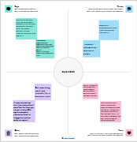

## 2.2 Ideation & Brainstorming Map

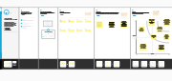

# 3 RESULT

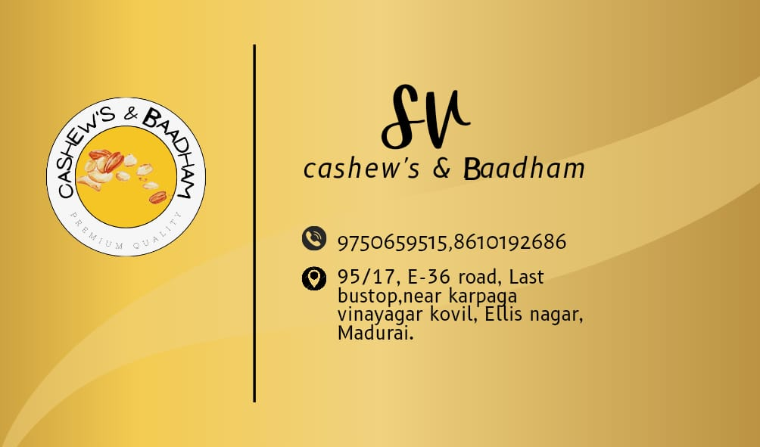

# Business Card

**4 ADVANTAGES & DISADVANTAGES**

## Advantages

* Canva is very simple to use and user friendly
* Canva provides social media templates
* Canva offers a professional look
* Team access
* As well as million of image

## Disadvandage

* The free version is limited
* Unique elements cannot be created
* limited export setting s
* Alignment concerns
* Unable to move one design to another design

## 5 APPLICATIONS

* We create a canva account
* Choose our design type
* And we used business card template
* we uploaded our backround image
* we used uploading photos, and adding text, and used to editing elements ,and change fonts
* Added to the women icon , flower design of corner.
* we created to business card
* Finally we downloaded a design

## 6 CONCLUSION

People in our team worked together to make a business card on the topic " Designing professional business card " through this , a company's advertisement can be brought to the door of the card . canva is an essential tool for most business .It is easy to use offers a wide range of templates, its affordable, customizable and helps business with their branding. Graphic designing can be learned through this project.