

**Tribhuwan University**

**Faculty of Humanities and Social Sciences**

**Job Portal**

**A PROJECT REPORT**

**Submitted to**

**Department of Computer Application**

**Padmashree International College**

**In partial fulfillment of the requirements for the Bachelors in Computer Application**

Submitted by

Amar Shrestha

Under the Supervision of

Ramesh Paudel



**Tribhuvan University**

**Faculty of Humanities and Social Sciences**

**PadmaShree International College**

**Supervisor’s Recommendation**

I hereby recommend that this project prepared under my supervision by Amar Shrestha entitled **“Job Portal”** in partial fulfillment of the requirements for the degree of Bachelor of Computer Application is recommended for the final evaluation.

…..................................................

Ramesh Paudel

SUPERVISOR

Padmashree International College

BCA

Tinkune,Kathmandu



**Tribhuvan University**

**Faculty of Humanities and Social Sciences**

**PadmaShree International College**

**LETTER OF APPROVAL**

This is to certify that this project prepared Amar Shrestha entitled **“Job Portal”** in partial fulfillment of the requirements for the degree of Bachelor in Computer Application has been evaluated. In our opinion it is satisfactory in the scope and quality as a project for the required degree.

|  |  |
| --- | --- |
| …..................................................  Ramesh Paudel (Supervisor)  BCA  PadmaShree International College  Tinkune, Kathmandu | ….................................................. |
| …..................................................  **Internal Examiner** | …..................................................  **External** **Examiner** |

# 

# Abstract

The Job Portal is a web-based platform designed to connect job seekers with potential employers, simplifying the hiring process and enhancing the job search experience. This portal allows users to create and manage profiles, upload resumes, and search for job opportunities based on various filters such as location, job type, and salary range. Employers can post job vacancies, review applications, and manage the recruitment process efficiently.

The platform uses advanced technologies like HTML, CSS, JavaScript for the frontend, and Django with SQLite for the backend, ensuring a responsive, user-friendly interface and a robust data management system. Key features include personalized job recommendations, application tracking, and secure user authentication. The portal aims to streamline the recruitment process, reduce time-to-hire, and provide a seamless experience for both job seekers and employers

# Acknowledgement

The number of people helping me with my projects deserves unexplainable thanks and considerations. Special thanks go to Ramesh Paudel for guiding me to do this project and helping with documentation. Special thanks to my parents as well for helping me in a lot of ways in this project in regard to time, economy, comments and many more. Enough cannot be expressed but thanks to my peers and teachers for helping me with little suggestions.

All the work done in this system is dedicated to my family for being part of me in the whole process, especially our dear friends who stood by me in all situations. Finally, thanks to You tubers, bloggers, stack overflow community, developers and every technical information provider for making this project possible.

# Table of contents

Abstract v

Acknowledgement vi

Table of contents vii

List of abbreviations ix

List of figures x

List of tables xi

Chapter 1: Introduction 12

1.1 Introduction 12

1.2 Problem Statement 12

1.3 Objectives 13

1.4 Scope and Limitation 13

1.5 Development Methodology 13

1.6 Report Organization 14

Chapter 2: Background Study and Literature Review 16

2.1 Background Study 16

2.2 Literature Review 16

Chapter 3: System Analysis and Design 18

3.1 System analysis 18

3.1.1 Requirement Analysis 18

i. Functional requirements 18

ii. Non-functional requirements 18

3.1.2 Feasibility Analysis 19

i. Technical Feasibility 19

ii. Operational 19

iii. Economics 19

3.1.3 Data Modeling: ER Diagram 20

3.1.4 Process Modeling DFD 20

3.2 System Design 22

3.2.1 Sequence Design 22

3.2.2 Interface Design 23

3.3 Algorithm details 25

Chapter 4: Implementation and Testing 26

4.1 Implementation 26

4.1.1 Tools used 26

4.1.2 Implementation details of modules 26

4.2 Testing 27

4.2.1 Test cases for Unit Testing 27

Table 1: Unit Testing 27

4.2.2 Test cases for System Testing 27

Chapter 5: Conclusion and Future Recommendations 30

5.1 Conclusion 30

5.2 Lesson learnt 30

5.3 Future Recommendation 30

References 25

# List of abbreviations

|  |  |
| --- | --- |
| **Abbreviation** | **Meaning** |
| DB  DFD  ER | Database  Data Flow Diagram  Entity Relationship |

# List of figures

**Figure 1: ER Diagram** 20

**Figure 2: Level 0-DFD** 21

**Figure 3:Level 1-DFD** 21

**Figure 4: Sequence Design** 22

# List of tables

**Table 1: Unit Testing** 27

**Table 2: System Testin for login** 28

**Table 3: System Testingfor registration** 29

# Chapter 1: Introduction

## 1.1 Introduction

Job Portal is a versatile web application designed to simplify the job search process, whether you're looking for part-time or full-time positions. Key features include seamless client registration and comprehensive job information storage within the system's database. With a strong focus on user experience, our web-app empowers job seekers to use specific filters, enabling them to quickly find opportunities that match their preferences. The Job Portal Web Application is an innovative platform designed to bridge the gap between job seekers and employers, simplifying the recruitment process and enhancing career opportunities. This application serves as a one-stop solution for individuals seeking jobs, freelancers exploring gigs, and organizations looking to hire the right talent.

With a user-friendly interface and advanced features, the portal enables seamless interaction between recruiters and candidates. It supports powerful search and filtering tools, ensuring an efficient hiring process.

# 1.2 Problem Statement

In today's competitive job market, both job seekers and employers face numerous challenges in finding the right opportunities and candidates. Job seekers struggle to discover suitable openings that match their skills, location, and career aspirations, while employers face difficulties in sourcing qualified and reliable candidates efficiently.

Traditional job-hunting methods, such as walk-ins, newspaper advertisements, or limited online platforms, often fail to address the needs of both parties due to:

* Difficulty in finding specialized IT jobs.
* Jobs and Skills don’t Match.
* Difficult to find Internships.

## 1.3 Objectives

* Simplify the process of finding specialized IT jobs.
* Improve job and skill matching.
* Provide a dedicated section for internship.

## 1.4 Scope and Limitation

**Scope**

The scope of Job portal is users can create and manage profiles, including resumes.

Advanced filters for job roles, locations and job type. Track job applications, receive updates, and communicate with employers through mail.

**Limitation**

The main limitation of job portal is that it is only limited to IT sectors.

## 1.5 Development Methodology

## The development of the web-based job portal will follow the Waterfall model, which provides a structured, sequential approach to project management. This methodology divides the project into clear, distinct phases, making it easier to manage and track progress.

### Requirements Specification: The process begins with gathering and validating requirements to ensure clarity and completeness. This phase establishes a clear understanding of what the system needs to achieve.

### Design: In this phase, the requirements are translated into a detailed design plan. This includes creating flowcharts, architecture diagrams, and a comprehensive system design. The design phase is critical as it lays the groundwork for the subsequent implementation.

### Implementation: During the implementation phase, the actual coding of the system takes place. The frontend will be developed using HTML, CSS, and JavaScript, while the backend will be built with Django, and SQLite3 will be used for database management.

### Testing: Once development is complete, the system will undergo thorough testing to identify and fix any issues. Testing ensures that the application functions as intended and meets the specified requirements.

### Deployment: If testing is successful, the system will be deployed. If any issues are found, necessary adjustments and maintenance will be made before going live.

### This Waterfall approach ensures that each phase is completed before moving on to the next, creating a well-structured and reliable job portal that effectively meets user needs.

## 1.6 Report Organization

This report is organized in 5 different chapters based on the official documentation as per Tribhuwan University.

**Chapter 1: Introduction**

In this chapter the introduction about the project and some related topics are illustrated like why this project, what were the problems in projects and where can it be used, how this project idea came up and how it is built. In this part the primary details of the project, its title and some secondary details are pictured.

**Chapter 2: Background Study and Literature Review**

In this chapter the history of the ideas used in the project along with the previous research and implementation of projects similar to this are illustrated. This chapter contains a study of several other projects with similar ideas, topics and terminologies.

**Chapter 3: System Analysis and Design**

In this chapter the overall system specifications are explained with data in the form of text as well as pictures. This chapter consists of all the requirements, modeling of the architecture and system workflow is defined. This chapter tends to explain if the project is feasible or not along with diagrams like, Block Diagram, DFD, ER Diagram, Interface design.

**Chapter 4: Implementation and Testing**

In this chapter the hardware and software that are in used or used to build this project is summed up along with modular testing and integration testing which tests different test scenarios to deliver the principal of the system performance and functioning.

**Chapter 5: Conclusion and Future Recommendation**

In this chapter different information gained with the projects and to which extent it can be extended or contracted is specified. Different implementations that can but used in future to make this project more sophisticated and evolving are described along with the final outcome of the project in real world scenario.

# Chapter 2: Background Study and Literature Review

## 2.1 Background Study

Job portals have revolutionized the recruitment landscape by serving as digital platforms that connect job seekers with employers. Emerging in the 1990s with pioneers like Monster.com, they have evolved from simple job listing boards to comprehensive solutions incorporating features such as AI-driven job matching, resume builders, and applicant tracking systems. For job seekers, portals provide convenient access to a wide range of opportunities, while employers benefit from streamlined hiring processes and reduced costs. As a cornerstone of modern recruitment, job portals continue to adapt to industry trends, such as mobile optimization and personalized user experiences, making them indispensable in the job market.

Existing job portals like LinkedIn, Indeed, Glassdoor, and Monster leverage technology to streamline the job search process, each with unique features and strengths. LinkedIn combines professional networking with job listings, offering personalized recommendations and company insights, but faces high competition and subscription costs for premium features. Indeed provides extensive job search filters and company reviews, though it can present duplicate listings. Glassdoor emphasizes transparency with company reviews, salary reports, and interview tips, but may have biased reviews and fewer listings. Monster offers job search filters, resume building tools, and career advice, but lacks the extensive job database of larger competitors. Each platform contributes to making job searches more efficient and user-friendly. [1]

## 2.2 Literature Review

The advent of online job portals in Nepal has transformed the traditional job search and recruitment process, making it more efficient and accessible. As internet penetration and digital literacy have increased, several job portals have emerged, providing valuable platforms for job seekers and employers to connect. This literature review explores the state of job portals in Nepal, their key features, and related projects that enhance their effectiveness.

Some related project:

Online job portals in Nepal have gained significant traction over the past decade. These platforms offer a centralized space for job listings across various industries and regions, simplifying the job search process. Prominent job portals in Nepal include:

Mero job

Overview: Established in 2009, Mero job is one of Nepal’s leading job portals, offering a comprehensive range of job listings.

Key Features: Advanced job search filters, company profiles, resume uploads, career advice, and job alerts.

Impact: Mero job has connected thousands of job seekers with potential employers, facilitating a streamlined job search process. [2]

# Chapter 3: System Analysis and Design

## 3.1 System analysis

There are many functional and non-functional, internal and external components that build up this complete system and each of their roles is equally important to carry out different modules, testing and partial deployment of the system so that it can be presented in the real world. Each and every module of a system is analyzed due to which it passes every feasibility exam and produces a user friendly and effective system.

### 3.1.1 Requirement Analysis

There were several requirements in this system and to make this system run well, using a device to do programming, programming language, real world objects to implement and create system, database to store data in this system.

### Functional requirements

User:

Registration: Users must be able to register an account with essential details and receive a confirmation email.

Job Search: Users should be able to search for jobs using filters such as job title, location, and salary, and view search results.

Administrator:

Record Management: Administrators need to create, update, delete, and query job and user records through a backend interface.

Job Information Management: Administrators should update job details and ensure information is current on the portal.

### Non-functional requirements

Performance

• Quick load times (under 3 seconds).

• Able to handle growing numbers of users and job listings.

Reliability

• .Regular vacancy post

• Regular backups for data recovery.

Security

• Encrypted data transmission and storage.

• Strong user authentication and authorization.

### 3.1.2 Feasibility Analysis

This system is a feasible project. For testing feasibility different factors were analyzed and evaluated to determine if this system is technically feasible, feasible with the estimated cost and profitability.

### Technical Feasibility

This system is technically feasible even as this system can be run on all modern technologies and devices without much trouble and our system does not require more specification devices to be carried out. Hence, our system can be implemented in the real world.

### Operational

This system is operationally feasible as the system can be operated by normal users with basic computer skills without any additional training. This system has been developed with the willingness and ability to create, manage and operate a system which is easy for end users to operate it. Since the User Interface is also easy with the reduction of complexities there is no problem in the operation of the system.

### Economics

This system is economically feasible as this is a cost benefit analyzed project. It provides tangible and intangible benefits like reduction in cost, more flexibility, faster activities, proper database management, etc. Since, prime goal of this system is to target local and small-scale business premises, it is economically feasible.

### 3.1.3 Data Modeling: ER Diagram

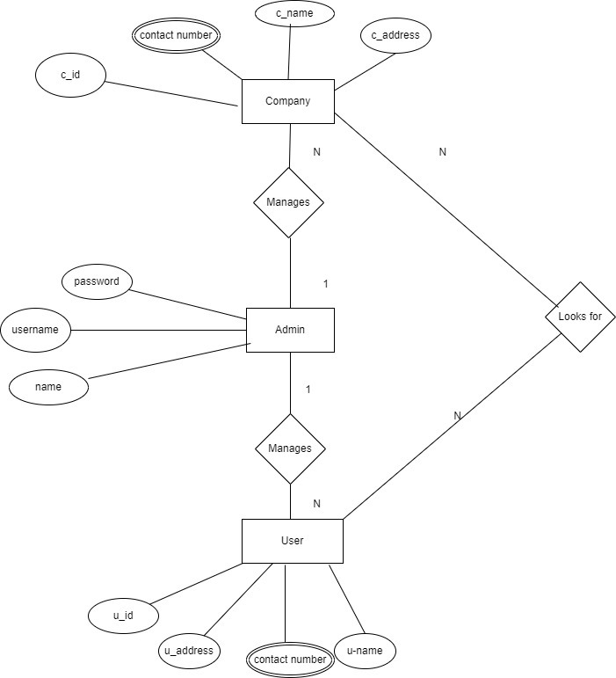

**Figure 1: ER Diagram**

### 3.1.4 Process Modeling DFD

To define the workflow or flow of data between several components I have created level 0, level 1 Data flow diagrams illustrated below:

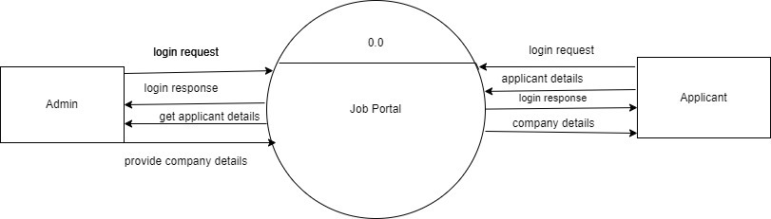

**Figure 2: Level 0-DFD**

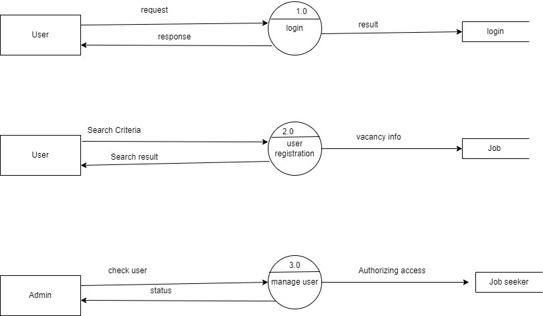

**Figure 3: Level 1-DFD**

## 3.2 System Design

### 3.2.1 Sequence Design

The sequence design for a job portal illustrates the interactions between the system's components (such as users, databases, and services) to complete specific tasks. Here's an example of a sequence diagram a typical job application process in a job portal:

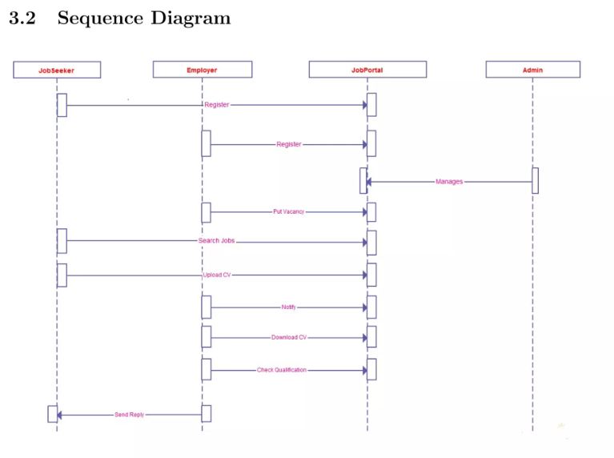

**Figure 4: Sequence Design**

### 3.2.2 Interface Design

In this project, the interface design of the system is provided below:

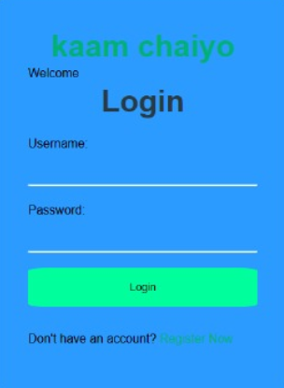

**Interface Design login page**

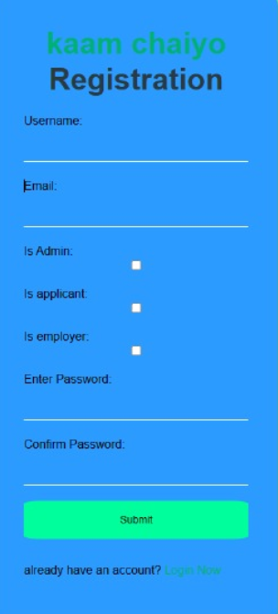

**Interface Design Register Page**

## 3.3 Algorithm details

This system is based on searching and sorting algorithm by which user can search jobs and intern of their wish and search result will be filtered in the user screen while user can also sort job and intern on the basis of their interest as in graphic designer, android developer etc. The insertion sorting algorithm is used in this system, we can sort items on any variants that we like. Similarly, linear searching algorithm is used to search jobs from the list of jobs in this system. To support the analytics of the events required for the better statistical data, admin can set the events and set them according to the date or any margin of time for the better support and decision.

# Chapter 4: Implementation and Testing

## 4.1 Implementation

### 4.1.1 Tools used

The tools used in Job Portal are as follows:

1. HTML: It is used for designing web page.
2. CSS: It is used for styling the web page.
3. JavaScript: For interactive features on the frontend

iv Django: Provides the core framework for backend logic, routing, and server-side.

v SQLite: Lightweight and built into Django for local development

.

### 4.1.2 Implementation details of modules

A module is a software component or part of a program that contains one or more routines.

One or more independently developed modules make up a program. The application name

as Job Portal is divided into different modules:

Registration Module:

The registration module is responsible for creating the new users for this system. In this

module, new users have to enter the username, email, password and other fields in order to

access this system through account creation.

Login Module:

This module is responsible for the admin and user to login in our system for accessing them

respective portal. Here, in this admin login, admin has to enter the email and password and

users have to enter the email and password which was set during the account creation process.

Contact Us Module:

This module is responsible for submitting any queries from the user’s side.

## 4.2 Testing

This system was tested by supervisor feedback is good. So that this system can be implemented in the real time environment. Many important defects, flaws, or errors were caught up in the application code which is resolved now and this system is still in progress to be a better version.

**4.2.1 Test cases for Unit Testing**

In this testing individual pages, button, functionality of a system is tested. Every module was tested to derive the best project for the deployment. Eventually, it helps to identify failures in the algorithms as well as logic to help improve the quality of the code that composes a certain function

|  |  |  |  |  |
| --- | --- | --- | --- | --- |
| **SN** | **Test Description** | **Inputs** | **Expected Result** | **Status** |
| 1 | Open Application | Registration Process | Registered | Pass |
| 2 | Searching for jobs and Intern | Typed keyword 'Intern' | Display all intern lists having word intern in them | Pass |

### Table 1: Unit Testing

### 4.2.2 Test cases for System Testing

In this test I have tested the different modules as a whole by integrating them together to evaluate how the components are working together and showing their result in a group.

|  |  |  |  |  |  |  |  |
| --- | --- | --- | --- | --- | --- | --- | --- |
| **SN** | **Test Description** | | **Test steps** | **Input** | **Expected Result** | **Actual Result** | **Status** |
| 1 | Testing login with correct username and password | 1. Enter email  2. Enter password  3. click login | | Email: amar@gmail.com  Password: amar11 | Login successful | Login successful | Pass |
| 2 | Testing login with incorrect  Username.  username and password | 1. Enter email  2. Enter password  3. click login | | Email: jpt@jpt.com  Password:jpt | Login  unsuccessful | Wrong Credentials | Pass |

**Table 2: System Testing-login**

|  |  |  |  |  |  |  |
| --- | --- | --- | --- | --- | --- | --- |
| **SN** | **Test Description** | **Test steps** | **Input** | **Expected Result** | **Actual Result** | **Status** |
| 1 | Testing with correct email expression and same password | 1. Enter user name  2.Enter regular email  3. Enter same password for password and confirm password  4. click on register | Username: Amar1  Email: amar028@gmail.com  Password: amar11  Confirm password: amar11 | Successfully Registered | Successfully Registered | Pass |
| 2 | Testing with correct email expression and different password | 1. Enter user name  2.Enter regular email  3. Enter a different password for password and confirm password  4. click on register | Username: amar1  Email: amar11@gmail.com  Password: amar11  Confirm password: Amar | Unsuccessful Registration | password not matching! | Pass |
| 3 | Testing with incorrect email expression and same password | 1. Enter user name  2.Enter irregular email  3. Enter the same password for password and confirm password  4. click on register | Username: amar1111  Email: amar11.com+gmail  Password: amar  Confirm password: amar | Unsuccessful Registration | invalid email expression | Pass |

**Table 3: System Testing-registration**

# Chapter 5: Conclusion and Future Recommendations

### 5.1 Conclusion

The Job Portal serves as a bridge connecting job seekers with potential employers, streamlining the recruitment and job application process. By leveraging modern technologies like Django, HTML, CSS, JavaScript, and SQLite, the portal provides a user-friendly, efficient, and secure platform to address the dynamic needs of the employment market.

The key features of job portal are:

Enhanced Accessibility: Both employers and job seekers can easily connect regardless of location, making the hiring process more inclusive and efficient.

Streamlined Process: Features like job search, resume management, and application tracking simplify recruitment workflows.

Scalability: The portal can adapt to various industries and expand its features, such as AI-driven recommendations or multilingual support, for future growth.

Community Impact: By facilitating meaningful connections, the portal contributes to reducing unemployment and fostering economic development.

### 5.2 Lesson learnt

This system teaches me many things and polish my experience towards the web technology which includes CURD Create, Update, Read, delete operation along with different algorithms like searching algorithm, sorting algorithm, k-nn algorithm that are used in this Job Portal system.

### 5.3 Future Recommendation

For the future development of a job portal, integrating advanced technologies such as AI-powered job matching, machine learning algorithms for personalized recommendations, and chatbots for real-time assistance could significantly enhance user experience. Implementing block chain for secure and transparent credential verification would further build trust within the platform. To increase accessibility, developing a mobile application for both Android and iOS would allow users to search for jobs and apply on the go. Additionally, expanding features like skill assessments, video interview integrations, and freelance or gig job options would cater to diverse user needs.