Q.8} Find the equation for the given function by Sampson rule.

X**\*1/1+ $X^{2}$:**

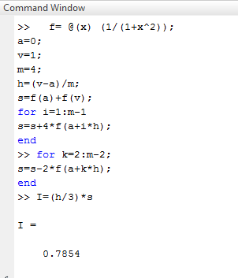

Q.12} Find the equation for the given function by Raphson method.

**2 $x^{2}$*-3*x-1**

