Table of Contents

1 INTRODUCTION 1

2 PROBLEM OF STATEMENT 1

3 OBJECTIVES 2

4 METHODOLOGY 2

4.1 Requirement Identification 2

4.1.1 Study of existing system: 2

4.1.2 Literature Review 2

4.1.3 Requirement Analysis………………………………..……………………………..…3

4.2 Feasibility Study 4

4.2.1 Technical Feasibility 4

4.2.2 Operational Feasibility: 5

4.2.3 Economic Feasibility: 5

4.3 High Level Design Of System 6

4.3.1 System Flowchart 6

4.3.2 Methodology Of the Proposed System: 7

4.3.3 Working mechanism of the proposed system: 8

5 GANTT CHART 9

6 EXPECTED OUTCOME 11

7 REFERENCES 13

# 1. INTRODUCTION

Job Portal is a versatile web application designed to simplify the job search process, whether you're looking for part-time or full-time positions. Key features include seamless client registration and comprehensive job information storage within the system's database. With a strong focus on user experience, our web-app empowers job seekers to use specific filters, enabling them to quickly find opportunities that match their preferences.

**2. PROBLEM OF STATEMENT**

In the past, online job portals were not widely utilized in Nepal. However, with the increasing awareness and acceptance of online platforms, more people are now seeking jobs online. The current online job application process in Nepal is often time-consuming and complex, making it difficult for potential users to connect with suitable opportunities. In an era where technology is transforming every aspect of our lives, it is exciting to see its potential for creating positive social impact. The main problem existing is non- relevant jobs in the current job marketplace

3. **OBJECTIVES**

The main objectives of this application development can be defined as follows:

1. To provide Job filtration based on the user's attributes and geographical location.

# 4 METHODOLOGY

## 4.1 Requirement Identification

### 4.1.1 Study of existing system:

### Existing job portals like LinkedIn, Indeed, Glassdoor, and Monster leverage technology to streamline the job search process, each with unique features and strengths. LinkedIn combines professional networking with job listings, offering personalized recommendations and company insights, but faces high competition and subscription costs for premium features. Indeed provides extensive job search filters and company reviews, though it can present duplicate listings. Glassdoor emphasizes transparency with company reviews, salary reports, and interview tips, but may have biased reviews and fewer listings. Monster offers job search filters, resume building tools, and career advice, but lacks the extensive job database of larger competitors. Each platform contributes to making job searches more efficient and user-friendly.

### **4**.1**.2 Literature Review**

The advent of online job portals in Nepal has transformed the traditional job search and recruitment process, making it more efficient and accessible. As internet penetration and digital literacy have increased, several job portals have emerged, providing valuable platforms for job seekers and employers to connect. This literature review explores the state of job portals in Nepal, their key features, and related projects that enhance their effectiveness.

Some related project:

Online job portals in Nepal have gained significant traction over the past decade. These platforms offer a centralized space for job listings across various industries and regions, simplifying the job search process. Prominent job portals in Nepal include:

Mero job

Overview: Established in 2009, Mero job is one of Nepal’s leading job portals, offering a comprehensive range of job listings.

Key Features: Advanced job search filters, company profiles, resume uploads, career advice, and job alerts.

Impact: Mero job has connected thousands of job seekers with potential employers, facilitating a streamlined job search process. [1]

### 4.13. Requirement Analysis:

**Functional Requirements:**

**Users**

Registration: Users must be able to register an account with essential details and receive a confirmation email.

Job Search: Users should be able to search for jobs using filters such as job title, location, and salary, and view search results.

Administrator:

Record Management: Administrators need to create, update, delete, and query job and user records through a backend interface.

Job Information Management: Administrators should update job details and ensure information is current on the portal.

Non-Functional Requirements:

## Performance

## Quick load times (under 3 seconds).

## Able to handle growing numbers of users and job listings.

## Reliability

## .Regular vacancy post

## Regular backups for data recovery.

## Security

## Encrypted data transmission and storage.

## Strong user authentication and authorization.

## Usability

## Easy-to-use interface.

## Accessible to users with disabilities.

## Maintainability

## Well-documented code.

## Regular updates and support.

## 4.2 Feasibility Study

In this phase of software development, this study is done to assess the viability of the system. The study is done to determine the technical, economic and operational factor.

### 4.2.1 Technical Feasibility:

Job portal is a complete web-based application. The main Technologies and tools that are associated with job search and apply are:

* + HTML
  + CSS
  + JS
  + Django
  + SQLite3

Diagram drawing tools

* + Draw.io

Each of these technologies are freely available and the technical skills required are Manageable. Time limitations of the product development and ease of implementing using these technologies are synchronized. Initially the website will be hosted in a free web hosting space.

From these it’s clear that the project ‘Job portal’ is technically feasible.

### 4.2.2 Operational Feasibility:

### The web-based job portal is operationally feasible due to its design for easy upgrades and maintenance. It is built to integrate with dynamic technologies, allowing for straightforward updates and the addition of new features. Maintenance involves optimizing the database and removing outdated posts or users, ensuring the system remains efficient and relevant. Post-deployment, the system is expected to operate smoothly with minimal issues, facilitating effective daily operations and user satisfaction

### 4.2.3 Economic Feasibility:

### The web-based job portal is economically feasible as it incurs no development costs. Since the project is part of an academic qualification for BCA at Tribhuwan University, it benefits from the use of internal resources, with no external expenses for components or team members. The absence of monetary factors ensures that the project remains financially viable and cost-effective.

## 4.3 High Level Design of System

### 4.3.1 Block Diagram of Job Portal

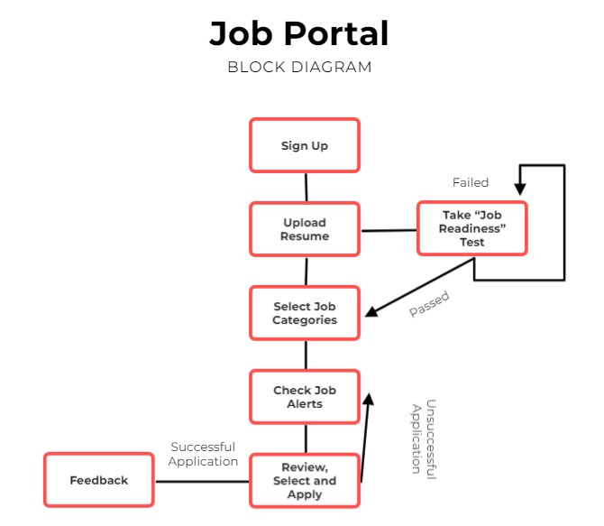

Figure 1: Block Diagram of Job Portal

### 4.3.2 Methodology of the Proposed System:

### The development of the web-based job portal will follow the Waterfall model, which provides a structured, sequential approach to project management. This methodology divides the project into clear, distinct phases, making it easier to manage and track progress.

### Requirements Specification: The process begins with gathering and validating requirements to ensure clarity and completeness. This phase establishes a clear understanding of what the system needs to achieve.

### Design: In this phase, the requirements are translated into a detailed design plan. This includes creating flowcharts, architecture diagrams, and a comprehensive system design. The design phase is critical as it lays the groundwork for the subsequent implementation.

### Implementation: During the implementation phase, the actual coding of the system takes place. The frontend will be developed using HTML, CSS, and JavaScript, while the backend will be built with Django, and SQLite3 will be used for database management.

### Testing: Once development is complete, the system will undergo thorough testing to identify and fix any issues. Testing ensures that the application functions as intended and meets the specified requirements.

### Deployment: If testing is successful, the system will be deployed. If any issues are found, necessary adjustments and maintenance will be made before going live.

### This Waterfall approach ensures that each phase is completed before moving on to the next, creating a well-structured and reliable job portal that effectively meets user needs.

### **4.3.3 Working mechanism of the proposed system:**

1. **User Registration and Login**
   * Users create accounts and log in with their credentials.
2. **Job Search**
   * Users search for jobs using filters (title, location, etc.) and view job listings.
3. **Job Application**
   * Users fill out and submit online application forms for job listings.
4. **Admin Functions**
   * Admins create, update, and delete job postings and manage user accounts.
5. **Database Management**
   * User data, job listings, and applications are stored securely in the database.
6. **System Integration and Maintenance**
   * Frontend and backend are integrated, with regular updates and maintenance performed

# High level Design of system

# a.System Analysis and Design

# i. Data Modeling (ER-Diagram)

The Entity Relationship diagram provides visual representation of different entities involve in a software and shows how they are related to each other. Here, we have three entities that is Admin, User and Company where both user and company are managed by admin. This diagram can serve a useful reference for ongoing development and maintenance.

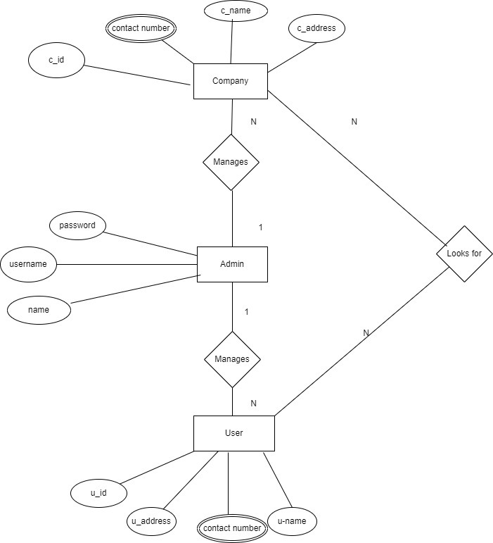

Figure 3: ER Diagram

# Process Modeling (DFD)

Data Flow Diagram (DFD) could be used to represent the different entities involved in the system, such as the admin and applicant, and the flow of data between them. In this level of DFD Level 0 it shows the basic dataflow with a single process node that connect the external entities where, as level 1 DFD shows the process that are further broken down into sub process from context diagram (Level 0 DFD).

Level 0 DFD:

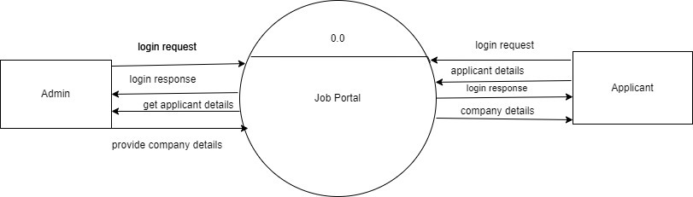

Figure 4: Level 0 DFD

Level 0 DFD could show the high-level overview of the system, including the entities involved, such admin, user the main data flows between them with the help of a process .

Level 1 DFD could show the high-level overview of the system, including the entities involved, such admin, user the main data flows between them with the help of a process.

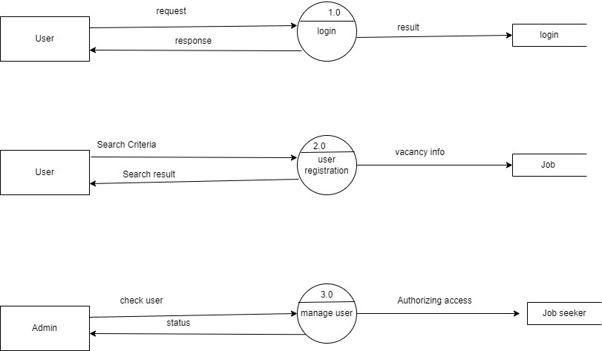

Figure:4 Level 1 DFD

# GANTT CHART

Figure 6: Gantt chart for Job Portal

# 6 EXPECTED OUTCOME

Upon the system's completion, its intended benefits are to develop a system that provides functions to support applicants to view the jobs in their desired geographical area and to develop a system for admin to be able to approve the applicant's applicants to help get jobs.

# 7.References

|  |  |
| --- | --- |
| [1] | "merojob," 17 12 2022. [Online]. Available: https://merojob.com/. [Accessed 10 8 2024]. |

# 7.References

|  |  |
| --- | --- |
| [1] | "merojob," 17 12 2022. [Online]. Available: https://merojob.com/. [Accessed 10 8 2024]. |