**PROJECT NAME: THE EXTENSION OF THE TEMBA AND BABELEGI WASTE WATER TREATMENT WORKS**

**PROJECT LOCATION: CITY OF TSHWANE**

**PROJECT VALUE: R 90M**

**PROJECT SUMMARY:**

The City of Tshwane (CoT) has embarked on the project to upgrade and extend the Temba and Babelegi Waste Water Treatment Works (WWTW) to address the large backlog in the provision of waterborne sanitation to the communities in the greater Temba area. The project is an essential to remove to the development constraint caused by the lack of capacity at the WWTW’s to the development of the area. More than 36 000 existing residential stands will benefit from this project and unlock further economic development in the area.

**CONTINUE TO DETAILED PROJECT SUMMARY**

**Our Standard Quality Construction**

The Temba WWTW is currently operating beyond its design capacity of 12,5 mega litre per day (Ml/day) and any additional flows into the works will have a detrimental effect on the sewerage treatment process and the resulting effluent discharged into the Apies river. This project will expand the capacity of the Temba WWTW by another 20 Ml/day to a total design capacity of 32,5 Ml/day which will accommodate the additional flows generated by the backlog eradication programme and the other housing projects proposed in the Temba area.

LTE consulting was appointed as the lead consultant for the project and was responsible for the conceptual design, the concept development, document preparation, construction supervision, contract administration and Agent’s duties as defined in Occupational Health and Safety act and the associated regulations.

The Temba WWTW had been developed in two distinct sites. The Inlet works are situated 1000m north of the main plant, both on the western bank of the Apies river. The inlet works currently consist of one mechanical and one manual screen, a vortex degritter and a pumpstation. The pumpstation pumps the screened sewage to the main WWTW in a 450 mm dia fibre cement pipeline, before discharging into a division box. The division box divides the incoming flows into three, 2.5 Ml/day to the initial phase and to two 5 Ml/day biological nutrient removal plants. The initial phase consists of primary settling and trickling filters with the sludge drawn off to digester for anaerobic digestion. The stabilized sludge is then dried in drying beds. The remaining process streams constitute conventional biological rector with the three compartments anaerobic, anoxic and aerobic basins with return flows. The effluent of the three streams a then blended and clarified before being disinfected using chlorine and discharged to the Apies river.

**Client :** Tyler Inc.

**Location :** California City FL 23059

**Area :** 1.690 m2

**Finished On :** September 17, 2014

**Value :** $789.000,00

**Remarks :** The project was completed under the budget, with the savings returned to the owner.

**Description**

The extension of the inlet works includes the provision of two additional mechanical screening stations, vortex degritters and two new balancing dams, 7m deep with a combined footprint of 3600m2. The screened sewerage will then be pumped from the balancing dams, in two new 500mm diameter 1100m long continuously welded high density poly ethylene (HDPE) pipeline to a new division chamber which will divide the flows proportionally to the various treatment plants. The extension to the main plant consist of the provision of two biological nutrient removal plants with a combined footprint of 5400m2 , two 32m diameter clarifiers, additional chlorine contact facilities, additional drying beds (1600m2), mechanical sludge drying facilities, a reinforced concrete composting slab (8000m2) and ammonia removal facilities and several minor civil structures. The liquor from the mechanical sludge dewater equipment will be chemically treated to control the pH and settled. The settled liquor will then be pumped to an ammonia stripping tower to remove the high levels of ammonia before discharged into the division chamber.

A key objective of the project was the empowerment of the local community and development of the small and emerging contractors. All the building works, road works, and a substantial amount of the minor structures had been earmarked to be performed by local contractors, and these will enable three of them to register with the CIDB. All the local labour will be receive accredited training on various aspects of the constructions industry, which will assist them with ensuring future employment.

[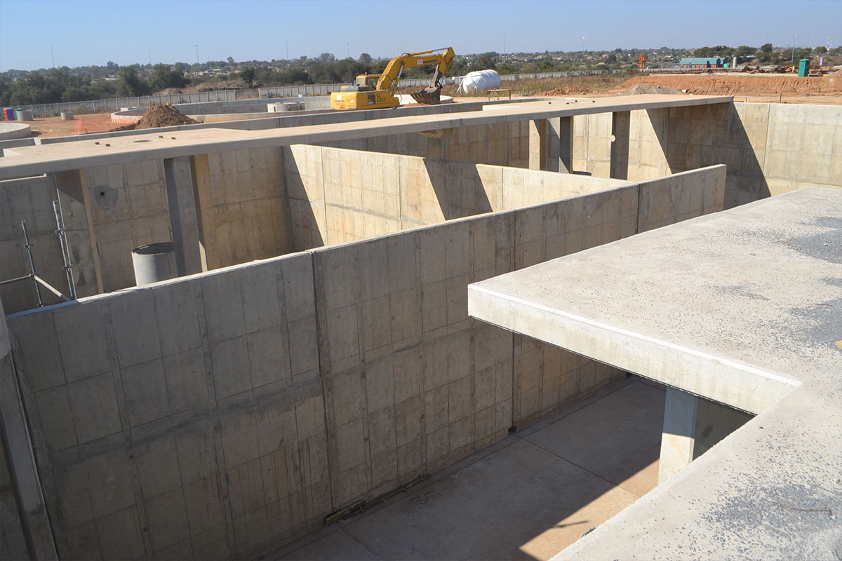](https://webdesignersdurban.co.za/lte/wp-content/uploads/2019/08/Babalegi2.jpg)

[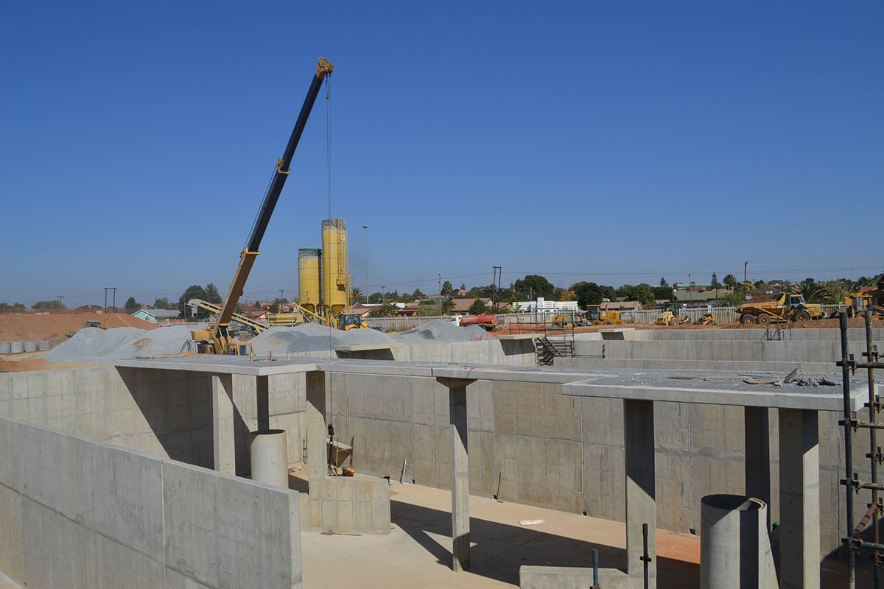](https://webdesignersdurban.co.za/lte/wp-content/uploads/2019/08/Babalegi1.jpg)



