DFSC1316: Digital Forensic and Information Assurance I

Assignment 1

Rules:

1. All you answers will be typed unless otherwise being advised.
2. Submit you assignment in PDF version (Office word can be directly saved as PDF, or you can use virtual PDF printer to ‘print’ it as pdf).

1. **(15 points) In a few sentences, explain what are Digital Forensic and Information Assurance. Do not copy from the slides, use your own words and make your answer concise.**

Digital Forensics is a field of forensics that encompasses any digital evidence. Its purpose is to determine if and how a crime was conducted, using the digital medium. Information Assurance is the practice of ensuring that data remains safe, secure, and does not get lost or corrupted.

1. **(15 points) Find a legal case (online, books, etc.) that was solved (or not) with the help of Digital Forensics. Explain the background, and how DF is involved, for example, what/where/how digital evidence has been found, and what tools have been used. List all references that are necessary.**

A failed, or incorrect, use of Digital Forensics was in a 2008 case against Brad Cooper. Cooper was accused of murdering his wife, and the text messages on his phone could have proven his innocence, or lack thereof. Due to the mistakes of the detective, the phones memory was erased. The detective entered the incorrect unlock codes too many times and resulted in the evidence being lost.

1. **(15 points) Why digital evidence needs special handling? List a few practices of such special handling.**

Digital evidence can very easily be altered without knowledge or intent. Just shutting down a computer can alter data on the drives. Multiple backups of the data can be made, and the backup data will be analyzed to prevent tampering with the original files. The data can be verified using hashing or check-sums, to ensure there was no alteration from when it was originally tested.

1. **(15 points) In your own words, explain the 5 goals of Information Assurance, do not copy from slides.**

Keep the data confidential. Keep it uncompromised and preserve its integrity. Make sure it’s available to be accessed when needed. Make sure it the correct data. Make sure that someone is accountable for the data.

1. (20 points) We have discussed Decimal, Binary and Hexadecimal in class, convert the following number into the other two formats. Do the calculation by hand, and show your steps. You can include a photo copy of your handwriting for this question.
   1. 78 (D)
   2. 100011101 (B)
   3. 7A8D (H)

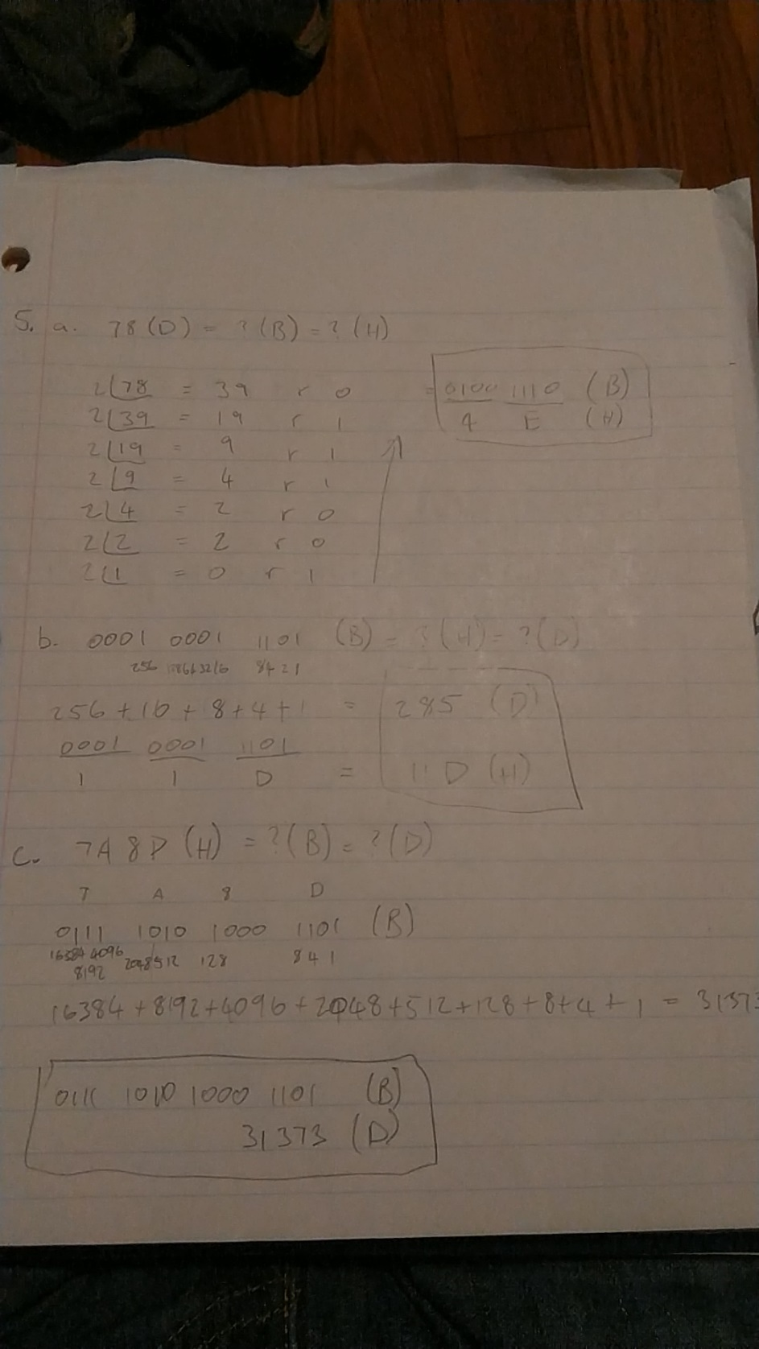

1. (20 points) Show the positional notation for the following numbers. You can include a photo copy of your handwriting for this question.
   1. 11011011110 (B)
   2. 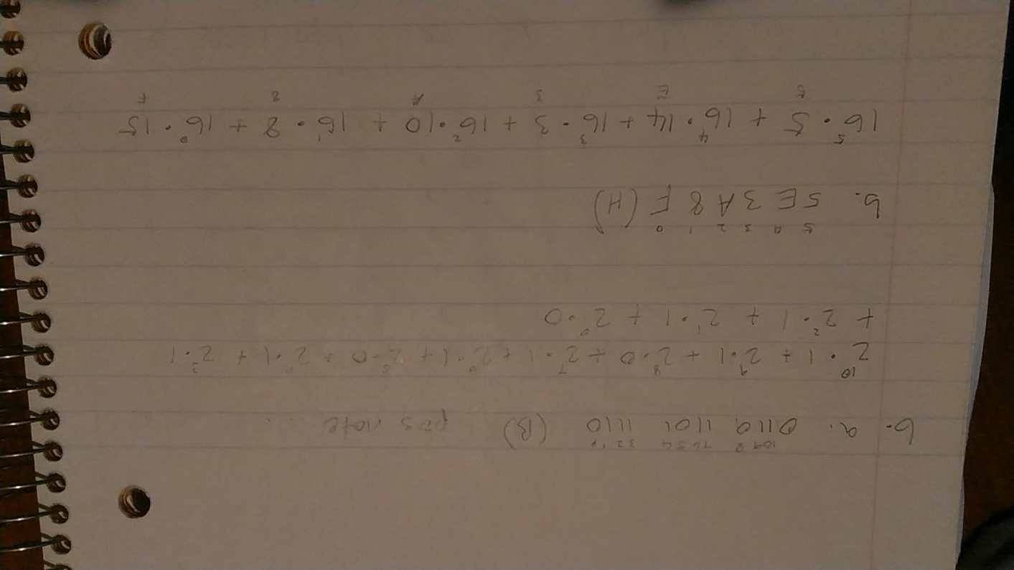5E3A8F (H)