The browser I chose was Internet Explorer 11 for my investigation. I decided to focus on the browser cookies and the cache. In the browser, I decided to log into Blackboard. It generated one cookie file under the path “C:\Users\Stian\AppData\Local\Microsoft\Windows\INetCookies\low” with the name GZMKZZG3.cookie.

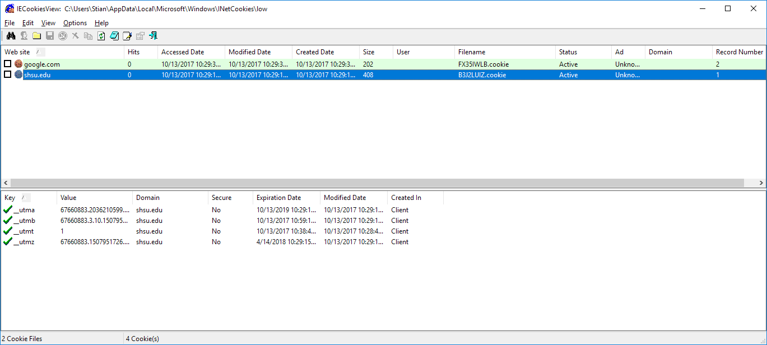

I then did a Google Image search for the term “digital forensics”. I created a cookie file with the name 2DQB3XE5.cookie in the same path as the other cookie.

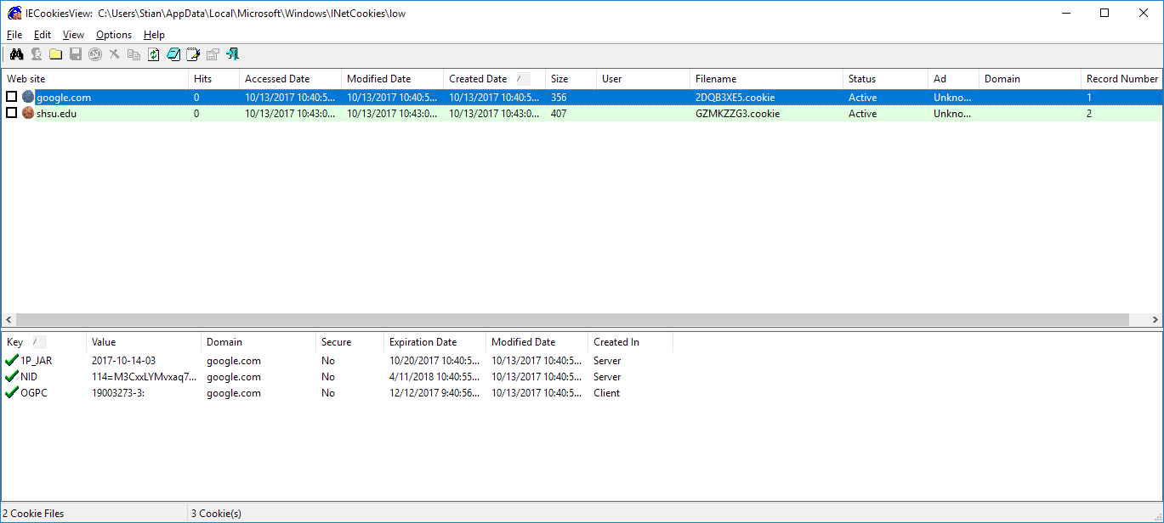

I repeated my actions in Private Browsing mode, and none of the cookies were saved while browsing. After closing the browser and looking for any cookies, none were found. Even after restarting the computer, there were no cookies saved. It seems that private browsing prevents any cookies from being saved.