Christiaan Cronje

Autumn Burks

Lab 5

1. We created the DFSC1316.txt file, we then created another text file, SomeOtherFile.txt, and copied an image DFIA_Photo.jpg. We then deleted the highlighted files.

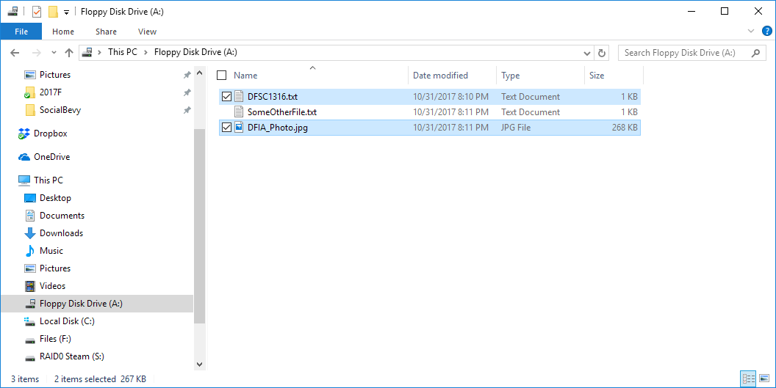

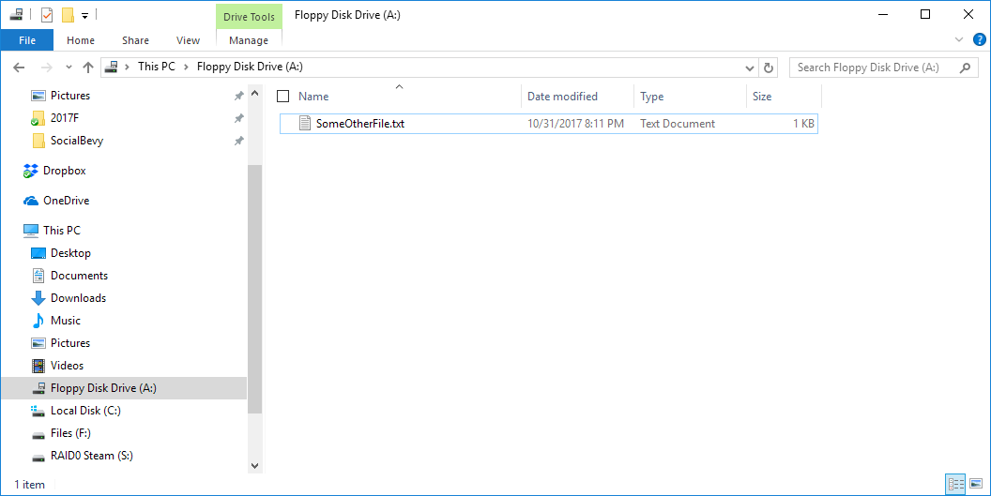

2.

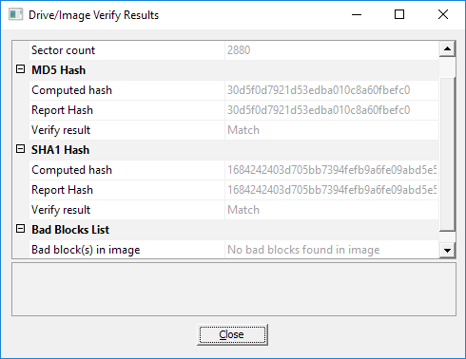

3. The hash value is 30d5f0d7921d53edba010c8a60fbefc0

4. Yes, we were able to recover the DFSC1316.txt file.

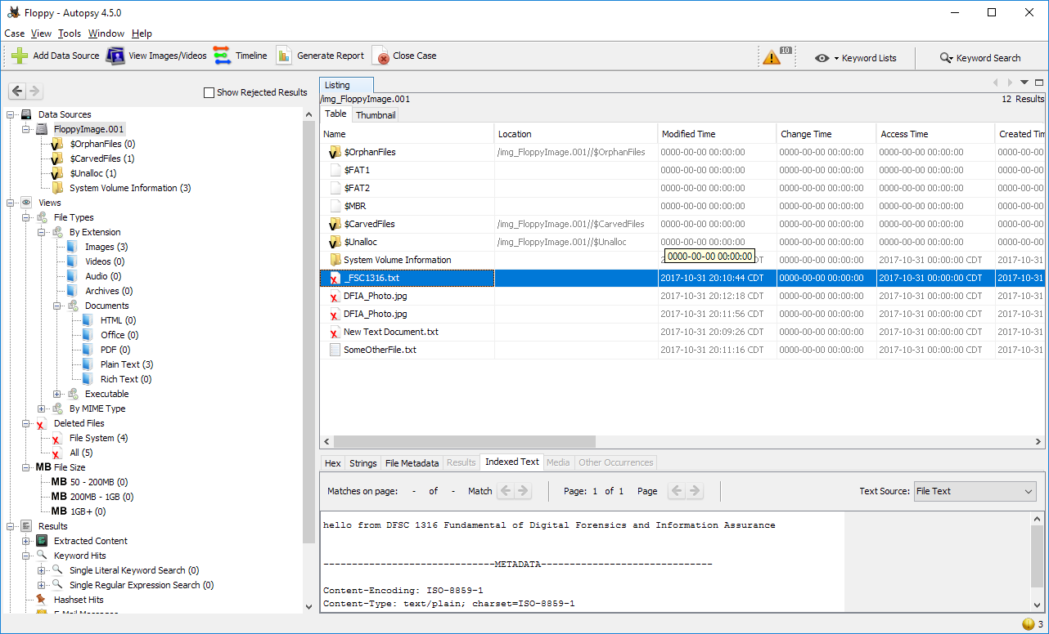

5. It is possible to zero fill the drive when formatting it through the command line. We attempted to do this. The /p flag indicates that we want to write zeros to the drive. We created another Image and ran the test again. No remnants of the files were found on the drive. We erased them successfully.

