Interrupt Progrmming

(interruptProgramming.odt)

By
David S Burris

Ph.D. in Computing Science

Certified Computer Programmer

Certified Systems Professional

Certified Computing Professional

Permission is granted to students in my classes to use any or all of the material in this document for their personnel educational in conjunction with course textbooks. All other rights reserved. Materials may not be transmitted to individuals not registered in my classes.

Update April 2013

Basic Interrupt Processing

An “interrupt” is a combination of hardware and software (frequently referred to as firmware) that forces the system to take note an event has occurred.

Type | address | PC-XT / PC-AT
0 | 0-3 | Divide Overflow
1 | 4-7 | Single Step
 | •••
4 | 10-13 | Overflow
 | •••
7 | 1C | Clock
8 | 2—23 | Time of Day
9 | 24-27 | Keyboard
 | •••
D | 34-37 | Fixed Disk
E | 38-3B | Diskette
F | 3C-3F | Printer
10 | 40-43 | BIOS
 | •••
20 | 80-83 | DOS
 | •••
60 | 180-183 | User Defined
 | •••
FF | 3FC-3FF | Software

The first 1024 bytes of the PC were originally set up as an Interrupt Vector (IV). Each entry in the vector requires 4 bytes to hold the 32 bit address of the associated Interrupt Service Routine (ISR). Hence there are 256 possible interrupts. Most interrupts are reserved by the hardware or operating systems. The remaining interrupts are available for external use. Each entry in the interrupt vector points to an appropriate interrupt service routine in protected memory. The interrupt service routine frequently saves or obtains information required to service the request then starts a lower level/priority process to complete the request.

Each address in the Interrupt Vector contains the location of an Interrupt Service Routine in protected memory. The location in the interrupt vector is associated with specific events at the time the hardware is designed.

For example, the clock interrupt is associated with X’01C’ by the hardware. When the clock interrupt occurs, the hardware branches to the Interrupt Service Routine pointed to by the entry at X’01C’ to service the interrupt. The contents of the interrupt vector and the corresponding service routines in protected memory are normally loaded when the operating system is booted (the power is turned on). The code to boot the system (load the operating system from disk) is frequently contained in a special ROM chip. It accesses a specific hardware track and cylinder on the disk to find the system loader and OS start up routines.

Type | address | PC-XT / PC-AT |  | Memory
0 | 0-3 | Divide Overflow
1 | 4-7 | Single Step |  | Interrupt
 | ••• |  |  | Vector
7 | 1C | Clock
 | •••
FF | 3FC-3FF | Software
 |  | ••• Operating System
 |  | ISR for Divide Overflow |  | ISR’s in
 |  | ISR for Single Step |  | Protected
 |  | ISR for Clock |  | Memory.
 |  | ••• Operating System
 |  | Uers 1 program. |  | Unprotected
 |  | User 2 program. |  | User memory

Historical Problems:
When the PC was originally developed, 512 bytes of memory was considered very large. In fact a 64K limit (displacement of 2^16 = 65,536 bytes) was imposed on individual programs as it was not felt more memory would ever be need or affordable for applications. Most main memories were 8K, 16K, or 32K bytes in length. A size of 128K bytes was beyond financial the limits of all but a few. Upper memory was considered to run from 640K to 1024K bytes and was used for I/O devices, memory mapped I/O and video memory. Memory below 640 K was the main portion of the OS starting at address 0. The memory not occupied by the OS up to 640K was available for user applications.
The main memory was designed to have a one megabyte address space. As cards were inserted for modems, printers, etcetera, their memory was given contiguous address above the portion reserved for users. Actually a portion of the real memory occupied the highest addresses and referred to as high memory. The one megabyte limit, 64K program limit, and splitting of physical memory into high and low portions was a problem for many years after to price of memory dropped and individuals started to purchase multiple megabytes then gigabytes.

On a stack architecture computer, typical interrupt processing implies:

The state of the program in execution at the time of the interrupt is saved (the following must be non-interruptable).

The hardware PSW is pushed into the system stack followed by the programs registers.

The system is changed to supervisor mode (typically from worker mode) by the hardware.

Further interrupts are disabled.

The interrupt is serviced.

An interrupted process is placed back into execution by restoring its state (the following must be non-interruptible).

The programs registers are restored (popped) from the system stack (or PCB _ Process Control Block) back into the corresponding hardware registers. The Interrupt Mask is restored to the mask of the interrupted program and the system is placed in the proper mode (supervisor or worker, normally worker).

The PSW is restored (popped) from the system stack.

Note that that after an interrupt has been serviced the interrupted program is seldom restored directly as indicated by step 3. Normally control is passed to the system process scheduler. The process scheduler may restore the interrupted program or copy it’s state from the system stack back into the program’s PCB. The interrupted program may now be moved to another state such as the ready list to allow the process scheduler to select a higher priority process or switch programs due to an end of time quantum.

A program’s PSW normally contains its interrupt mask, CPU mode indicator, and location counter containing the address of the next program instruction to execute. The instruction to load the PSW may only be executed by a program in supervisor mode.

Assume the process selected for execution is a normal user (worker) mode process with all interrupts enabled in the interrupt mask. When the PSW is loaded, simultaneously the CPU state is switched to worker, the interrupts are enabled, and the next instruction executed is taken from the hardware program counter, i.e., the next instruction from the previously interrupted user programs is loaded and executed. This mechanism allows for multiprogramming. The initial PSW is placed in the PCB by the OS Job Scheduler.

Program Status Word (PSW)
Mode Indicator  (supervisor/worker) | Interrupt mask  (for each interrupt - enabled/disabled) | Compare Bits  <, =, > | Location Counter  next instruction
Operating System State Transition Diagram
 |  |  | Run |  | PCB process 12
 | Ready  (have all resources but CPU) |  |  |  | Wait  (I/O, device, time, etceteras)
 | PCB process 7 |  |  |  | PCB process 6 wait on I/O
 | PCB process 2 |  |  |  | PCB process 12 need printer
 |  |  |  |  | PCB process 7 – sleep 10 minutes

Each process in the system is represented by a “process Control Block (PCB).” The “Ready” state has a list of all processes currently ready to execute in that they have all currently required resources except the CPU. The “Run” state contains the PCB of the process currently executing. If there are multiple CPUs, then there will be multiple PCBs associated with the run state. The “Wait” state contains the PCBs of all processes waiting on an event to occur, or a resource to become available. A Wait State normally has a separate wait list for each type of wait to reduce the time to locate processes waiting on the resource or event to occur.

PCB Format:
PCB
Process Identifier – PID
Save location for PSW
Save locations for all registers
Pointer to swap file in auxiliary storage
Main memory mapping information
List of all resources acquired and currently desired
Accumulated CPU time for current quantum
Total accumulated CPU time
Other information

Pointer to next PCB

Hardware PSW

 | address | PC-XT / PC-AT |  | Memory
 | 0 | Divide Overflow
 | 4 | Single Step |  | Interrupt
 | ••• |  |  | Vector in
 | 1C | Clock |  | Protected
 | ••• |  |  | Memory
 | 3FC | Software
 |  | ••• Operating System
 |  | ISR for Divide Overflow |  | ISR’s in
 |  | ISR for Single Step |  | Protected
 |  | ISR for Clock |  | Memory.

Process Scheduler:

LPSW address

••• Operating System code and data structures including the desired PSW.
PSW

 |  | Uers 1 program. |  | Unprotected
 |  | User 2 program. |  | User memory

Assume the process scheduler has not selected for execution the program previously in the run state for execution at the end of the current interrupt. First the state of the interrupted program is preserved by popping its state (registers and PSW) from the system stack and saving the values in the PCB of the interrupted program. This PCB is then moved to the correct state, e.g., the ready list, or a wait list.

The dispatcher loads the registers of the next process selected by the process scheduler for execution after moving its PCB to the run state. The selected programs CPU mode indicator (system / worker), interrupt mask, and Program Counter are assumed to be part of the program’s PSW. Now assume a protected instruction “LPSW address” which loads the physical hardware PSW register from the indicated memory address. Note that the computer will simultaneously be placed in the CPU mode indicated by the newly loaded PSW, the interrupt mask will be set to the interrupt mask of the new PSW, and the next instruction executed by the CPU will be the instruction specified by the locaton couter of the newly loaded PSW. Hence the program is placed back into execution.

Assume a new user process created by the system Job Scheduler. The PSW placed in the newly created PCB will have the CPU Mode Indicator set to worker (user), the Interrupt Mask will normally have all interrupts enabled, and the Program Counter will be set to point to the first instruction in the program (usually 0). Only the Job Scheduler can create a new PCB and add it to the ready list.

 |  | CPU
 |  | Registers
 |  | Hardware PSW
 |  | Interrupt vector
 |  | Interrupt Service Routines |  | Interrupt
 | ••• | Data Structures |  | Vector in
 | 8567 | PSW for Joe’s program: CPU mode = worker, Interrupt Mask = all enabled, Program counter has address of next instruction (part of Joe’s PCB) |  | Protected
 | ••• |  |  | Memory

Process Scheduler:

•••

LPSW 8567
 |  | ••• Operating System
 | 800000 | (Joe’s program.)  0 mov ax,[20]  1 add ax, 3  2 mov [20], ax  •••  20 124 |  | Unprotected
 | 900000 | Another user’s program. |  | User memory

PCB’s are normally stored in protected memory. If a program a program could access the PSW field of its PCB, every user could give themselves supervisor privileges. Hence the ability to change the contents of the PSW and load it into the hardware PSW register must be zealously guarded.

Assume a PC type architecture where the effective address is normally the address in the instruction plus the contents of a relocation (program or data segment) register when in worker (user) mode. The effective address is simply the address in the instruction when in supervisor mode.

All programs are normally translated relative to zero. In addition, addresses must be positive numbers. For explanatory purposes, we also assume the operating system is loaded (lower addresses) prior to user programs in memory (higher addresses).

Assume the program data is loaded into memory at location 900000. When Joe executes the instruction mov ax,[20], he actually loads the ax register from the effective address = 900000 + 20 = 900020 if the data segment register contain the address 900000 . In worker mode, the contents of the appropriate relocation register (data segment or code segment) is always added to the effective address. This is a hardware feature.

The contents of the relocation registers are part of the state of the process. When the process is interrupted, the contents are saved. When the process scheduler selects it latter for execution, the relocation registers are restored from the PCB save fields prior to restoring the PSW. If the program has to be swapped out and back into memory due to a page or segment fault, the PCB relocation register fields as well as the hardware relocation register fields are set to reflect the current location of all code and data segments. Since addresses may not be negative, and the contents of the relocation register is higher than any address in the operating systems, no user program may access protected memory to modify operating system data structures such as PCB’s.

In supervisor mode, the effective address is the address in the instruction. No relocation register is used. Alternately, in supervisor mode you may think of the contents of the relocation register as being zero. Hence LPSW 8567 loads the hardware PSW register directly from memory location 8567.

The LPSW instruction as well as the instruction to load the segment registers are normally privileged, i.e., the hardware will not execute them unless you are already in supervisor mode. The only way to enter supervisor mode is via an interrupt which forces the hardware to switch to supervisor mode when it branches to the requested interrupt service routine. User program status words are always set to “worker” mode with the interrupts enabled by the Job Scheduler at the time the process is created (and saved in the processes PCB). Hence it is not effectively possible for user processes to be able to access protected memory unless there is an error in the implementation of the operating system kernel code.

CS431 Super Computer

We assume the following hardware Program Status Register:
 |  |  | Interrupt Mask
MI | OI | MP | PF | UC | MV | II | I/O | DMAC | Compare Bits | Location

MI => Mode Indicator, 0 = Supervisor, 1 = Worker

OI => Overflow Indicator, 0 = no, 1 = yes

MP => Memory Parity Failure, 0 = no, 1 = yes

PF => Power Failure, 0 = no, 1 = yes

UC => Undefined Code, 0 = no, 1 = yes

MV => Memory Violation, 0 = no, 1 = yes
II => Internal Interrupt; 0 is enabled, 1 is disabled
I/O => Slow I/O interrupt, e.g., floppy drive, 0 is enabled, 1 is disabled
DMAC => Fast I/O Interrupt, e.g., hard disk, 0 is enabled, 1 is disabled. DMAC means direct memory access control.

Dedicated memory locations:

X0090 Internal Interrupt – MP, PF, UC, MV
X0092 External Interrupt – Clock, Operator Console
X0094 I/O Interrupt – Slow and Fast

Notes:
- Privileged instructions may only be executed when the MI indicates supervisor mode.
- The II, I/O, and DMAC bits represent the interrupt mask, normally all enabled in Worker / User mode. Interrupts are all or partially disabled in Supervisor mode.
- When a user process is created, the MI bit is set to worker (1), and the interrupt mask has all interrupts enabled. For Supervisor Processes the MI = 0.
- There are no instructions to manipulate the contents of the PSW register. Its loading and saving are controlled by the hardware.
- Each processes Process Control Block (PCB) contains space to save the state of the process including the registers contents and PSW. PCB’s are maintained in protected memory accessible only by the operating system.
Typical Routine for Internal Interrupt by Polling:

Address X0090, part of the Interrupt Vector, contains the address of the ISR required by the hardware interrupt mechanism.

 | Interrupt Service Routine (ISR)
 | Set mode to Supervisor (MI = 0),  Disable Interrupts,  Save State. |  |  | Must be non-interruptible.
If MP = 1 Perform MP_Error.
If PF = 1 Perform PF_Error.
If UC = 1 Perform UC_Error.
If MV = 1 Perform MV_Error.
 | Transfer to Process Scheduler.

 | Process Scheduler
 | First: Select the next process from the ready list for execution. |  |  | Must be non-interruptible.
Second: Dispatch the process.
- Restore State of selected process.
- Enable interrupts based on selected processes interrupt mask.
- Set Mode Indicator appropriately.
- Transfer control to process.

Note that loading the PSW register from the PCB into the hardware PSW changes the mode bit, sets the interrupt mask, and reloads the program / location counter. The computer takes its next instruction for the value in the location counter.
Improvements

- Unique trap address for all interrupts. Eliminates the need to poll (associative).

- Associate a small number of interrupts with each trap address and poll rather than all interrupts at the same address. Not as fast but less expensive to build (set associative). Example: DOS interrupt 21h.

- Interrupt routines frequently only disable interrupts long enough to save critical information. When possible, an operating system process such as the I/O Spool program is then awakened to run on the extended machine with higher priority interrupts enabled utilizing the save information. This minimizes the time interrupts are disabled and allows faster reaction to new events.

Priority Interrupt System
  - Each device has an associated priority level. Multiple devices may share the same interrupt level.
  - When an interrupt occurs, the interrupts for all devices at the same and lower priority levels are disabled.
  - If an additional interrupt at these levels occurs during the processing of the current interrupt, the new interrupt is left “pending.” When the current interrupt is completed, the highest priority pending interrupt is processed. After all interrupts are processed, control is returned to normal processes.
  - If a higher priority interrupt occurs while processing a lower priority interrupt, the lower interrupt is (preempted) in favor of the higher priority interrupt. Upon completion of the higher priority interrupt, processing of the lower priority interrupt may be resumed. Note interrupt levels must be assigned in a manner that will preclude race conditions between priority levels.

For example, assume the keyboard has the lowest priority of 0, the floppy disk and CD drive share the next level of 1, and the hard disk drive has the highest priority of 3. If the system were currently processing a floppy disk interrupt, the keyboard and CD interrupt would be kept pending. The hard disk interrupt would preempt the floppy disk interrupt.

Timer Interrupt and Time Slicing

delay 3.0; -- Minimum 3 second delay, not exact under most circumstances.

 | run state |  |  |  |  |  | Job 1 |  | Ω
 | ready list |  |  |  |  |  | Job 10 |  |  |  |  |  |  | Job 5 |  |  |  | Job 3 |  | Ω
 | resource wait |  |  |  |  |  | Job 11 for file “Hope” |  |  |  |  |  |  |  | Ω
 | timer wait |  |  |  |  |  | Job 3 till 2:03 |  |  |  | Ω |  |  |  | Job 7 till 3:10 |  |  |  | Ω
 | Count Down Register |  |  |  |  |  |  |  |  |  | Clock

 | Interrupt Vector
 |  |  |  |  |  | Clock ISR
 |  |  |  |  |  |  |  |  |  | Disk ISR |  |  |  |  |  | Users
 |  |  |  |  |  | Keyboard ISR

Typical Clock Operation:
Assume the clock interrupt occurs every 1/10 second. When a clock interrupt occurs, the ”Count Down Timer” is automatically loaded with a large positive value and simultaneously a branch to the interrupt service routine (ISR) pointed to by the entry in the interrupt vector occurs. The count time timer is connected to a crystal oscillator which decrements the integer value to zero every 1/10 seconds. When the register reaches zero, the timer interrupt occurs. The ISR for the clock adds 1/10 second to the clock. The timer wait state is then examined to see if the current time exceeds the value stored in the wake up field of any task control blocks in the list of waiting task. Such tasks are moved back to the ready list. Control is then typically returned to the process scheduler. They process scheduler typically charges the task in the run state for 1/10 second. The highest priority task is then selected for execution and allowed to execute for the remainder of the timer interrupt or until the next interrupt occurs (timer or otherwise). Note the effect of the clock granularity, the timer interrupt frequency, and overhead in managing the queues.

Assume a time slice (quantum) is 10 ticks or 1 second. When select by the process scheduler for execution, a field in the PCB is set to 1. On each timer interrupt (clock tick) the field is decremented by 1/10 second. When it reaches zero, the time quantum is over.
// Program to intercept the timer interrupt. It utilizes the Borland C++ DOS
// library functions “setvect( )” and “getvect( ). // C:\Software\CPP\CPP\Disk3\beep2.exe

#include <stdio.h> //tc lib ref 477
#include <dos.h>
#include <conio.h>

#define INTR 0X1C // Address of clock tick interrupt

void interrupt (*oldhandler)(...); // Borland definition for pointer to interrupt handler.

int count = 0; // Global for interrupt handler and main program interaction.

void interrupt handler(...) { // Define my interrupt handler.
count++;
oldhandler( ); // Call system ISR to update the clock
}

int main( ) {
oldhandler = getvect(INTR); // set to address of clock ISR

setvect(INTR, handler); // replace with new ISR in interrupt vector

while(count < 20) printf("count is %d\n",count);

setvect(INTR, oldhandler); // restore old clock routine
return 0;
}

Sample output:
count is 0  count is 0  count is 0  count is 1  count is 1  count is 1  count is 1  count is 1  count is 1 | count is 2  count is 2  count is 2  count is 2  count is 2  count is 2  count is 3  count is 3  count is 3 | count is 3  count is 3  count is 3  •••  count is 18  count is 18  count is 18 | count is 18  count is 18  count is 18  count is 18  count is 19  count is 19  count is 19  count is 19  count is 19 | count is 19
; In file PGM1.ASM of language translator directory.
.MODEL small ; Indicates to Borland compiler the code will be
; less than 64k in length, allowing 16 bit
; addresses rather than 32 bit addresses.

.STACK 100h ; Space for program stack.

.DATA
HelloMessage DB 'Hello World',13,10,'$' ;13=cr, 10=lf

.CODE ; Code segment register loadeb by operating system.
start: mov ax,@data
mov ds,ax ;set DS to point to data segment

mov ah,9 ;DOS print string function
mov dx,OFFSET HelloMessage ;point to message
int 21h ;DOS I/O interrupt, parameter 9

mov ah,4ch ;DOS terminate program function

int 21h ;DOS interrupt, parm "4c", program

END start ;termination request.

Sample output:

Hello World

Interrupt 21 is utilized by user programs to communicate with DOS. Parameters are passed through registers. A “9” in the “ah” register is a request to print a string pointed too by the dx register (printing all characters until a “$” is encountered).

User request for service are frequently referred to as “soft” interrupts as opposed to “hard” interrupts. Hard interrupts such as generated by the hard disk have to be serviced rapidly. User request may be postponed.
; file myecho.asm ; file myecho.asm ; used Turbo Assembler”
.MODEL small

.STACK 100h

.DATA
MYCH DB ? ;reserve one char

.CODE
MyEcho: mov ax,@data
mov ds,ax ;set ds to point to data segment.
;DOS loads cs automatically.
EchoLoop:
mov ah,1 ;DOS keyboard input function.
int 21h ;wait for next key stroke.

cmp al,13 ;was it a <cr>?
jz EchoDone

mov dl,al
mov ah,2 ;DOS display output function.
int 21h ;display the char.

mov [MYCH],dl ;echo to printer.
mov cx,1 ;# chars to print.
mov ah,40h ;DOS write to device function #.
mov bx,4 ;DOS printer handle.
mov dx,OFFSET MYCH ;print from ds:dx
int 21h

jmp EchoLoop

EchoDone:
mov ah,4ch ;DOS terminate program function
int 21h
END MyEcho
--package interrupt is
-- type interrupt_range is new integer range 0..16#FF#;
-- type registers is
-- record
-- Ax: integer;
-- Bx: integer;
-- Cx: integer;
-- Dx: integer;
-- Ds: integer;
-- Es: integer;
-- Si: integer;
-- Di: integer;
-- Carry: integer; --0 or 1
-- Flags: integer;
-- end record;
--procedure Vector( On: Interrupt_range; Register_Block: in out Registers);
--end interrupt;

with interrupt; use interrupt;
procedure inter1 is
ch: integer;

procedure outchar(c: character) is
reg_file: registers;
begin
reg_file.Ax := 16#0200#; -- sets AH = 2, DOS function for
-- character output, interrupt 21 argument
reg_file.Dx := character'pos(c);
vector(
on => 16#21#, --DOS interrupt 21
register_block => reg_file
);
end outchar;

begin
for i in 'a' .. 'z' loop outchar(i); end loop;
end;

c:\>inter1
abcdefghijklmnopqrstuvwxyz

Uses the “DOS” package available with the Meridian Ada Compiler.
// Microsoft C++ compiler. Uses DOS interface library. This program attempts to delete
// a file with the name “NOTEXIST.$$$” in the current directory. //C:\Software\CPP\CPP\Disk3\beep3.exe Source: C:\Software\CPP\CPP\Disk1.beep3.cpp

#include <stdio.h>
#include <dos.h>

int delete_file( char near *filename ) {
// deletes file name; returns 0 on success, nonzero on failure
// and set global variable _doserrno to the error code

union REGS inregs, outregs; //_REGS is defined in <dos.h> as a structure to hold
// registers. “Union” is used to indicate the structure inregs will hold the register parameters
// at the time the interrupt is generated. Upon return from the interrupt, the contents of outregs
// will be updated to show final values. Inregs and outregs occupy the same memory locations.

int ret;

inregs.h.ah = 0x2a; // Dos get date function at interrupt 21h.
_intdos( &inregs, &outregs );
printf(“Date” %d/%d/%d/n”, outregs.h.dh, outregs.h.dl, outregs.x.cx);

regs.h.ah = 0x41; //dos interrupt 21 code to delete a file.
regs.x.dx = (unsigned) filename; // Pointer to file name (string).

ret = _intdos(&regs, &regs); // dos interrupt (inregs, outregs) at 21h.

return(regs.x.cflag ? ret : 0); // Check for success.
}

int main(void)
{
int err;
err = delete_file( "NOTEXIST.$$$" );
if (!err)
printf( "able to delete file\n" );
else
printf( "not able to delete file\n" );
return 0;
}

c:\> beep3
Date: 9/3/1994
Able to delete file

C:\> beep3
Date: 9/3/1994
Not able to delete file
/* ctlcHandler in file inter1.c, System dependent integer values typically in signal.h
#define SIGINT 2 //interrupt signal ctl_c
#define SIGFPE 8 //floating point exception
#define SIGABRT 22 //abort signal
*/

#include <signal.h>
#include <time.h>
#include <iostream>
#include <stdlib.h>
using namespace std;

void cntl_c_handler(int sig);

int main( ){ // Microsoft & GNU
long i = 0, j;
double begin, end;
char stop[50];

cout << "Count to J million, enter j: "; cin >> j; j *= 1000000;

signal( SIGINT, cntl_c_handler ); // Install handler

begin = (double) clock( ) / CLOCKS_PER_SEC;
cout << begin << " start time\n";

while(1){
++i;
if(i > j){
end = (double) clock( ) / CLOCKS_PER_SEC;
cout << end << " end loop\n";
cout << "Total time " << end - begin << " seconds\n";
cout << "hit " << j/1000000 << " million " << endl;
cout << "Cause interrupt from main!\n\n ";

raise( SIGINT ); //Simulate ctl c interrupt.

cout << "\nEnter j: "; cin >> j; j *= 1000000;
i = 0;
begin = (double) clock( ) / CLOCKS_PER_SEC;
cout << begin << " start time\n";
}
}
cout << "Stop to view, enter y <cr> to terminate."; cin >> stop;
}

void cntl_c_handler(int sig){
cout << "Ctl C Interrupt has occured!\n";
signal(SIGINT, cntl_c_handler); // Reinstall handler else
} // reverts to default handler in MS-Windows XP.

[csc_dsb@localhost CPP]$ g++ inter1.c
[csc_dsb@localhost CPP]$ ./a.out
Count to J million, enter j: 900
0 start time
1.63 end loop

Total time 1.63 seconds
hit 900 million
Cause interrupt from main!

Ctl C Interrupt has occured!

Enter j: 900
1.63 start time
Ctl C Interrupt has occured!
3.24 end loop
Total time 1.63 seconds
hit 900 million
Cause interrupt from main!

Ctl C Interrupt has occured!

Enter j:

//try – catch in file inter2.c Microsoft & GNU
#include <iostream>
using namespace std;

class DivideByZero {
private:
const char* message;
public:
DivideByZero( ) : message("Divide by zero!"){ }
void printMessage( ) const{ cout << message; }
};

float quotient( int num1, int num2){
if(num2 == 0) throw DivideByZero( );
return ((float) num1) / num2;
}

int main( ){
while(1) {
int n1, n2;
cout << "Enter the dividend (integer): "; cin >> n1;
cout << "Enter the divisor (integer): "; cin >> n2;

try {
float ans = quotient(n1, n2);
cout << "The answer is " << ans << endl;
}
catch (DivideByZero){ // Error handler for division by zero
cout << "Attempt to divide by zero!!!\n";
// return 1; //Signal an error.
}
}
return 0; //Can not get here, but normal return code.
}

[csc_dsb@localhost CPP]$ g++ inter2.c
[csc_dsb@localhost CPP]$ ./a.out
Enter the dividend (integer): 4
Enter the divisor (integer): 5
The answer is 0.8
Enter the dividend (integer): 5
Enter the divisor (integer): 0
Attempt to divide by zero!!!
Enter the dividend (integer): 5
Enter the divisor (integer): 2
The answer is 2.5
Enter the dividend (integer):

// args.c GNU
#include <stdio.h>
#include<stdlib.h>
int main( int argc, char *argv[ ], char *env[ ] ){
int i;
printf("The value of argc is %d\n\n", argc);
printf("These are the %d command line arguments passed to main:\n\n", argc);

for (i = 0; i < argc; i++) printf(" argv[ %d ]: %s\n", i, argv[ I ] );

printf("\nThe enviromental string(s) on this system are: \n\n");
for(i = 0; env[ I ] != NULL; i++) printf(" env[ %d ]: %s\n", i, env[ I ]);
return 0;
}

/*
[csc_dsb@localhost CPP]$ gcc args.c
[csc_dsb@localhost CPP]$ ./a.out arg1 arg2
The value of argc is 1

These are the 3 command line arguments passed to main:

argv[0]: ./a.out
argv[1]: arg1
argv[2] arg2

The enviromental string(s) on this system are:

env[0]: SSH_AGENT_PID=2984
env[1]: HOSTNAME=localhost.localdomain
env[2]: DESKTOP_STARTUP_ID=
env[3]: SHELL=/bin/bash
env[4]: TERM=xterm
env[5]: HISTSIZE=1000
env[6]: GTK_RC_FILES=/etc/gtk/gtkrc:/home/csc_dsb/.gtkrc-1.2-gnome2
env[7]: WINDOWID=39845988
env[8]: USER=csc_dsb
env[9]: LS_COLORS=no=00:fi=00:di=00;34:ln=00;36:pi=40;33:so=00;35:bd=40;33;01:cd=40;33;01:or=01;05;37;41:mi=01;05;37;41:ex=00;32:*.cmd=00;32:*.exe=00;32:*.com=00;32:*.btm=00;32:*.bat=00;32:*.sh=00;32:*.csh=00;32:*.tar=00;31:*.tgz=00;31:*.arj=00;31:*.taz=00;31:*.lzh=00;31:*.zip=00;31:*.z=00;31:*.Z=00;31:*.gz=00;31:*.bz2=00;31:*.bz=00;31:*.tz=00;31:*.rpm=00;31:*.cpio=00;31:*.jpg=00;35:*.gif=00;35:*.bmp=00;35:*.xbm=00;35:*.xpm=00;35:*.png=00;35:*.tif=00;35:
env[10]: GNOME_KEYRING_SOCKET=/tmp/keyring-iRQkcE/socket
env[11]: SSH_AUTH_SOCK=/tmp/ssh-EoDKQP2936/agent.2936
env[12]: SESSION_MANAGER=local/localhost.localdomain:/tmp/.ICE-unix/2936
env[13]: MAIL=/var/spool/mail/csc_dsb
env[14]: DESKTOP_SESSION=default
env[15]: PATH=/usr/kerberos/bin:/usr/local/bin:/usr/bin:/bin:/usr/X11R6/bin:/home/csc_dsb/bin
env[16]: GDM_XSERVER_LOCATION=local
env[17]: INPUTRC=/etc/inputrc
env[18]: PWD=/home/csc_dsb/CS278C/CPP
env[19]: LANG=en_US.UTF-8
env[20]: GDMSESSION=default
env[21]: SSH_ASKPASS=/usr/libexec/openssh/gnome-ssh-askpass
env[22]: HOME=/home/csc_dsb
env[23]: SHLVL=2
env[24]: GNOME_DESKTOP_SESSION_ID=Default
env[25]: LOGNAME=csc_dsb
env[26]: DBUS_SESSION_BUS_ADDRESS=unix:abstract=/tmp/dbus-qOUEdjcGWI,guid=ec2326462eec8cd65794218f6625b400
env[27]: LESSOPEN=|/usr/bin/lesspipe.sh %s
env[28]: DISPLAY=:0.0
env[29]: G_BROKEN_FILENAMES=1
env[30]: COLORTERM=gnome-terminal
env[31]: XAUTHORITY=/home/csc_dsb/.Xauthority
env[32]: OLDPWD=/home/csc_dsb/CS278C
env[33]: _=./a.out
[csc_dsb@localhost CPP]$
*/
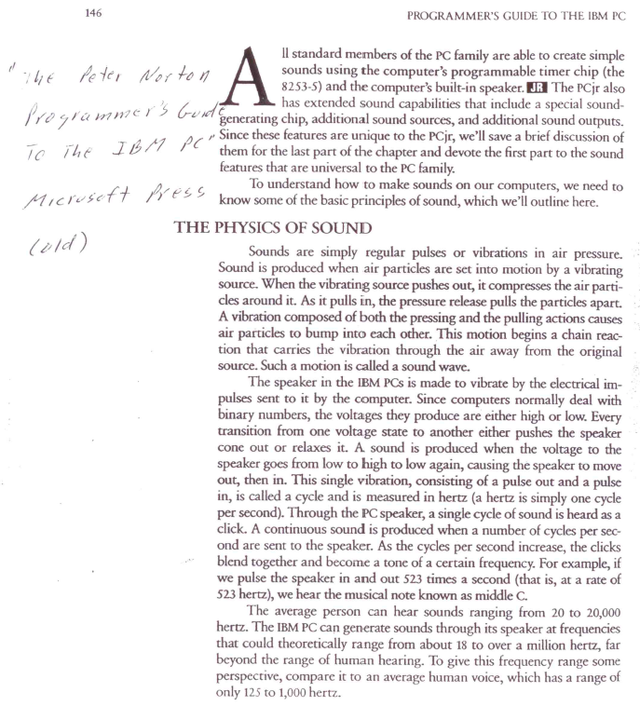
This still works, efforts to keep the archetecture backwards compatible.
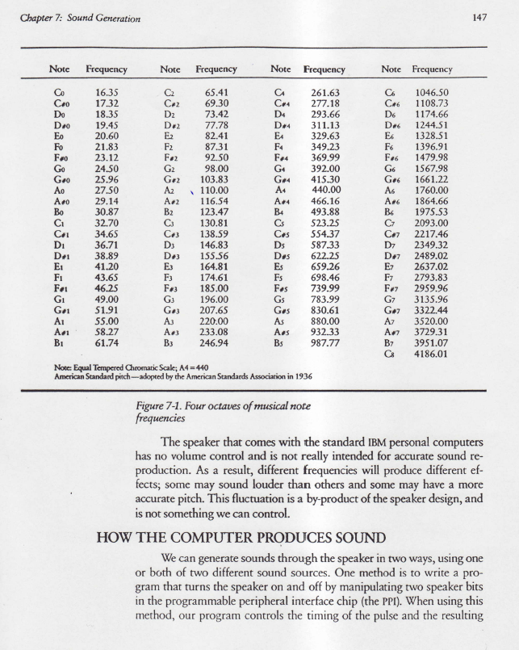
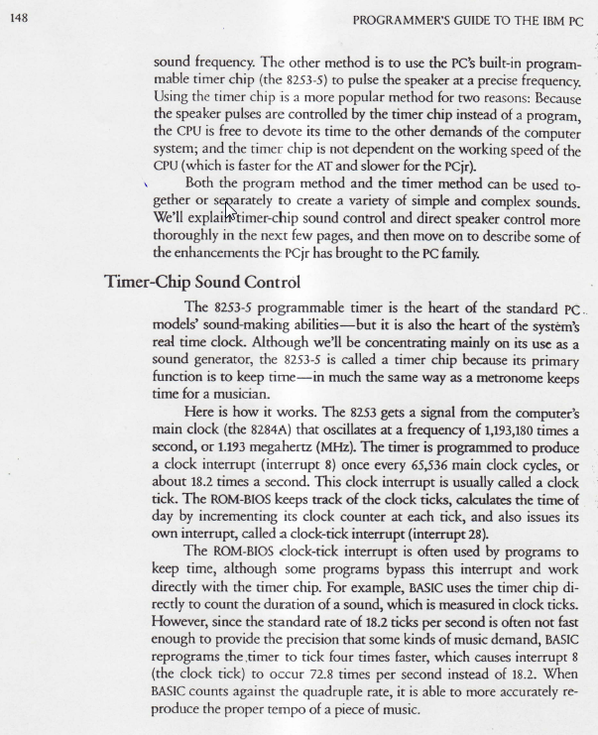
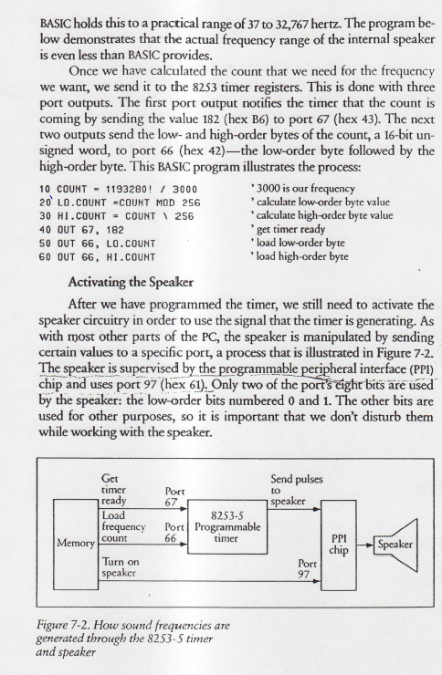
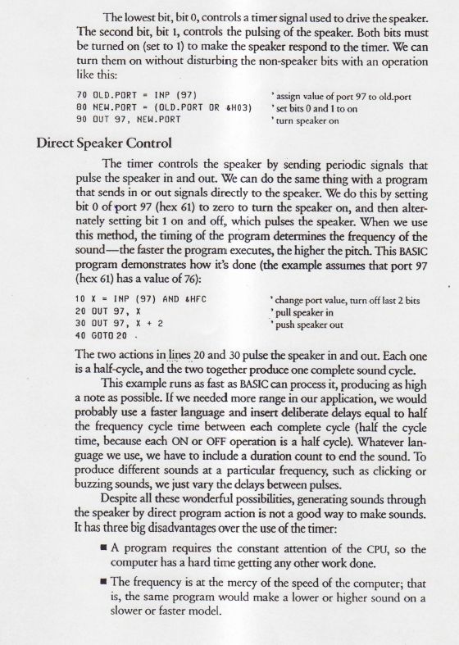
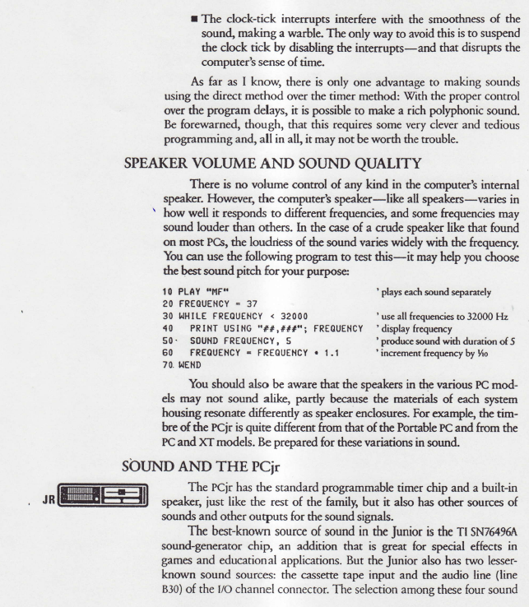
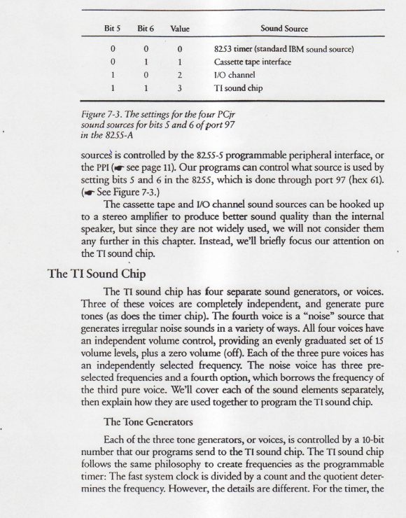
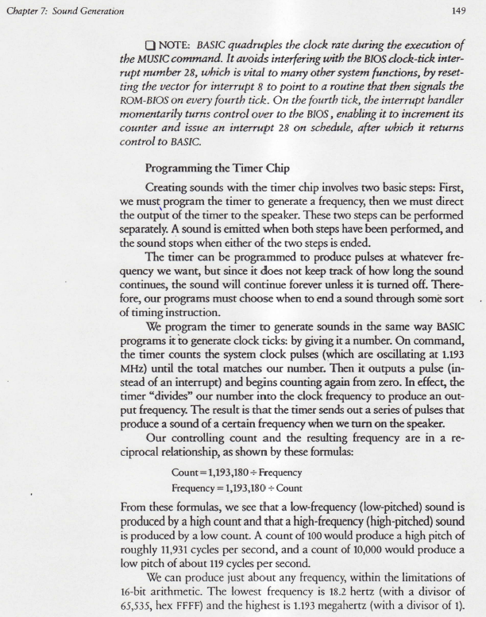
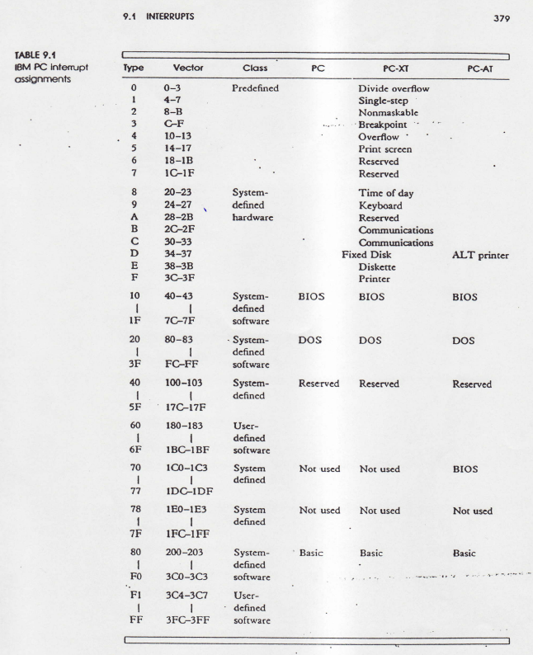
// Based on articule "Making C Sing" by Wayne D. Geiser,
// PC Magazine, April 30, 1991. See explanation by Peter Norton
// on the clock and speaker. In file ballgame.cpp.
#include <conio.h>
#include<dos.h>

#define S 0.0 // silence.
#define C1 261.63 // note frequencies, an S following the note
#define CS1 277.18 // means the note is a sharp (#).
#define D1 293.66
#define DS1 311.13
#define E1 329.63
#define F1 349.23
#define FS1 369.99
#define G1 392.0
#define GS1 415.3
#define A1 440.0
#define AS1 466.16
#define B1 493.88
#define C2 523.25
#define CS2 554.37
#define D2 587.33
#define DS2 622.25
#define E2 659.26
#define F2 698.46
#define FS2 739.99
#define G2 783.99
#define GS2 830.61
#define A2 880.0
#define AS2 932.33
#define B2 987.77
/* The following are note durations. To play the song faster, make the
definition of E smaller. A P in the second position of a name means that
the note is half again as large as the one preceding is
*/
#define E 0.125 //eithth note
#define EP (E*1.5) //dotted eighth note
#define Q (E*2.0) //quarter note
#define QP (E*3.0) //dotted quarter note
#define H (Q*2.0) //half note
#define HP (Q*3.0) //dotted half note
#define W (H*2.0) //whole note
#define WP (H*3.0) //dotted whole note

/* The following define the duration of each note or conversely, the
amount of silence between notes.
*/
#define LEGATO 1.0
#define NORMAL 0.875
#define STACCATO 0.75
// Changing this definition changes the duration of the notes for the
// entire song.
#define NOTE_DUR NORMAL

// The following is used to speed up the programable timer. For faster
// songs this value should be increased.
#define CLOCK_INC 4

#define NUM_NOTES 61
static double notes[NUM_NOTES] = //notes for the music
{
C1,C2,A1,G1,E1,G1,D1,
C1,C2,A1,G1,E1,G1,GS1,
A1,GS1,A1,E1,F1,G1,A1,F1,D1,
A1,A1,A1,B1,C2,D2,B1,A1,G1,F1,D1,
C1,C2,A1,G1,E1,G1,D1,
C1,D1,E1,F1,G1,A1,A1,B1,
C2,C2,C2,B1,A1,G1,FS1,G1,A1,B1,C2
};

static double sizes[NUM_NOTES] = //duration to play the note
{
H,Q,Q,Q,Q,HP,HP,
H,Q,Q,Q,Q,W,Q,
Q,Q,Q,Q,Q,Q,H,Q,HP,
H,Q,Q,Q,Q,Q,Q,Q,Q,Q,Q,
H,Q,Q,Q,Q,HP,HP,
H,Q,Q,Q,Q,W,Q,Q,
HP,HP,Q,Q,Q,Q,Q,Q,HP,HP,W
};

volatile long click = 0;
void interrupt (far *orig_int)(...); //function pointer to origional
//interrupt.
void init_clock(void);
void reset_clock(void);
void sleep(double how_long);
void sound(double freq, double duration);

void main(void)
{
int i;
init_clock(); //change clock and timer interrupt functions

// sound(frequency to play, duration to play the frequency)
// The program sleeps while the sound is played.
for(i=0; i<NUM_NOTES; i++) sound(notes[i], sizes[i]);

reset_clock(); //reset clock and timer functions
}

void interrupt far new_int(...) // New clock interrupt routine
{ //The clock is 4 times faster than normal, every forth timer
//interrupt, the original clock interrupt routine must be called
//to prevent the computer from losing time.
if ((++click % CLOCK_INC) == 0) (*orig_int)();
outp(0x20,0x20);
}

void init_clock(void)
{ //Increase 8253 timmer's channel output by a factor of CLOCK_INC
union { long divisor;
unsigned char c[2];
} count;

orig_int = getvect(0x08); //get origional clock interrupt vector and save.
setvect(0x08, new_int); //insert new clock interrupt vector

count.divisor = (long)65536 / CLOCK_INC; //determine counts for clock
//interrupt (approximately 1/100
//of a second).
outp(0x43, 0x36); //tell 8253 count is comming at port 43h.
outp(0x40,count.c[0]); //send low-order byte of count
outp(0x40,count.c[1]); //send high-order byte of count
}

void reset_clock(void) //reset clock and timer interrupt
{
setvect(0x08, orig_int);

outp(0x43, 0x36);
outp(0x40, (char)0);
outp(0x40, (char)0);
}

void sleep(double how_long)
{
long i, orig, new1;
orig = click;
//normal timmer interrupt is 18.2 times per second
i = (long)(how_long * (18.2 * CLOCK_INC) + orig);
new1 = click;
while (new1 < i) new1 = click;
}

void sound(double freq, double duration)
{ // beep the speaker using the specified frequency
double off, play;
union { long divisor;
unsigned char c[2];
} count;
int p;
play = duration * NOTE_DUR;
off = duration - play;
if (freq != S)
count.divisor = (long)(1193180 / freq); //compute the proper clock
// interrupt count for the frequency.
else
count.divisor = 0;
outp(0x43, 0xb6); // tell 8253 that count is comming
outp(0x42, count.c[0]);
outp(0x42, count.c[1]);
p = inp(0x61); //get existing port bit pattern, 8 bits.
if( freq != S)
outp(0x61, p | 3); //set bits 0 and 1 to on, leave rest alone
else
outp(0x61, p);
sleep(play); //sleep while the speaker is on
outp(0x61,p); //restore origional bit pattern to turn off speaker
sleep(off);
}

