Object Oriented

Programming in

GNU C++

by

David S Burris

Ph.D. in Computing Science

Certified Computer Programmer

Certified Systems Professional

Certified Computing Professional

csc_dsb@shsu.edu

Permission is granted to students in my classes to use any or all of the material in this document for their personnel educational. All other rights reserved. Materials may not be transmitted to individuals not registered in my classes.

Revised Spring 2007, 2009, 2010



As you know the push to colonize the new territories has placed a tremendous strain on our resources. It is imperative that you create software to allow us to track all shuttles and space stations from a central control facility to be created in each sector of colonized space. Each shuttle and space station will be required to identify itself on demand as well as give its location, destination and present course. All shuttles and space stations must accept course adjustments on demand from the central control facility.

- Note that persons, places, and things (nouns) are potential objects.

- Note that verbs represent actions and hence potential object behavior.

Using 1 and 2, attempt to identify the objects and their attributes.

- Establish what objects may be requested to do and what they will require of others.

- Establish the visibility of the respective objects. Implement the objects.
- Iterate!
Objects [Using Object Modeling Technique notation (OMT by James Rumbaugh at GE) or Unified Modeling Language (UML ISO - International Standards Organization standard) ]:
 | class Shuttle |  | class SpaceStation
 | Data Structures:  shuttleName  shuttleDestination  course |  | Data Structures:  stationName  stationDestination  course  location
 | Methods:  Shuttle(--)  Identify(--)  SetCourse(newCourse) |  | Methods:  SpaceStation(--)  Identify( --)  SetCourse(--)
 | Central Control Facility
 | This facility controls all shuttles and space stations in its sector of space.

Visibility
 | Class Shuttle to manufacture shuttles. |  | Class SpaceStation to manufacture space stations
 | Central Control Facility
 | This facility controls all shuttles and space stations in its sector of space.

// in file shuttle1.c GNU g++ -c shuttle1.c
#include <iostream>
using namespace std;
#include <string.h>

class Shuttle{
private:
char shuttle_name[20];
char shuttle_destination[20];
int course;
public: //Exported functionality.
Shuttle( char *name, char *destination, int course_in ); //constructor
void identify( );
void set_course( int new_course );
};

class Space_Station{
private:
char station_name[20];
char station_destination[20];
int course, location;
public:
Space_Station( char *name, char *destination,
int course_in, int location_in );

void identify( );
void set_course( int new_course, int new_location );
};

Shuttle::Shuttle( char *name, char *destination, int course_in )
{
strcpy(shuttle_name, name); strcpy(shuttle_destination, destination);
course = course_in;
}

void Shuttle::identify( )
{
cout << "Shuttle named " << shuttle_name <<
" bound for " << shuttle_destination << " course " <<
course << ".\n\n";}

void Shuttle::set_course( int new_course )
{
course = new_course;
}

Space_Station::Space_Station( char *name,char *destination,
int course_in, int location_in )
{
strcpy(station_name, name); strcpy(station_destination, destination),
course = course_in; location = location_in;
}

void Space_Station::identify( )
{
cout << "Station named " << station_name << " bound for "
<< station_destination << "\n course " << course
<< " location " << location << ".\n\n";
}

void Space_Station::set_course( int new_course, int
new_location )
{
course = new_course; location = new_location;
}

// in file useshut1.c g++ useshut1.c –o useshut1
#include “shuttle1.c”

int main( void )
{ Shuttle Atlantis( "Atlantis", "Freedom", 32 );
Shuttle Endeavor( "Endeavor", "Virgin Islands", 16 );

Space_Station Freedom( "Freedom", "Hubble", 23, 24000);

Atlantis.identify( );
cout << "Atlantis adjust course to 33." << "\n";
Atlantis.set_course( 33 );
Atlantis.identify( );

Endeavor.identify( );

Freedom.identify( );
cout << "Freedom adjust to course 40, location 31808.\n";
Freedom.set_course( 40, 31808 );
Freedom.identify( );
}

$ ./useshut1
Shuttle named Atlantis bound for Freedom course 32.

Atlantis adjust course to 33.
Shuttle named Atlantis bound for Freedom course 33.

Shuttle named Endeavor bound for Virgin Islands course 16.

Station named Freedom bound for Hubble
course 23 location 24000.

Freedom adjust to course 40, location 31808.
Station named Freedom bound for Hubble
course 40 location 31808.
Object Oriented Systems

Object Oriented Designs and Implementations typically consist of a group of independent entities.

Independent in that each object (entity) contains all necessary data structures to represent its state and the functionality to manipulate that state without the existence of other objects in the system.

Objects make request of other objects but do not directly contain part of the state of another object. Nor do they directly manipulate the state of another object.

Data structures representing the state are not directly passed from one object to another. The state of an object is self contained and not global. A request must be made to an object to affect a change in the objects state. The object has the responsibility of examining the request and determining its validity. Improper request may be rejected.

Communications between objects is strictly controlled. The designer / implementer defines the type and nature of communications. The translator and runtime environments enforce the abstractions.

Typically a class definition or template for constructing an object is written first. The translator actually allocates all required data structures and supplies (tailors) the code for each object at the request of the user. This may occur at translation time or run time.
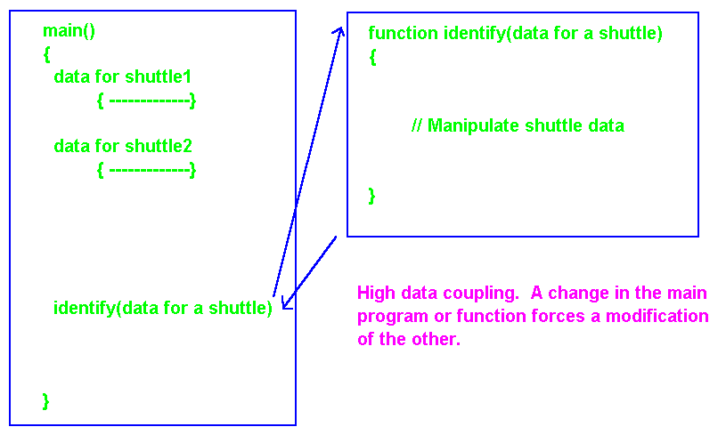
Traditional Model

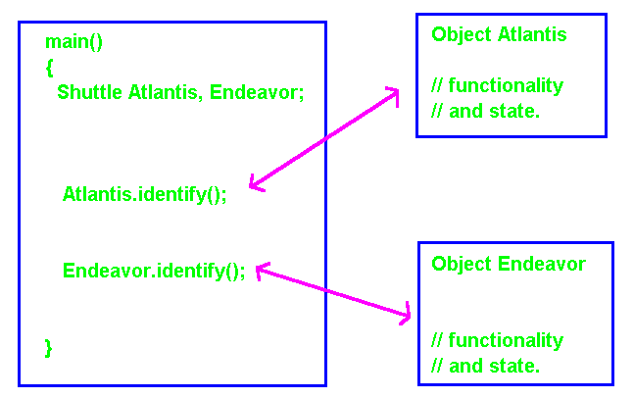
Object Oriented Model

In the OO Model all functionality and state is contained within the object. The internal data structures and methods for reporting the identity of an object can be modified without forcing modification of the main program. This forms a basis for re-use, maintenance, modification, and optimization.
Object Oriented Systems

Object Oriented Technology takes large problems and breaks them into independent objects. It also defines the communication structure between the objects.

Object oriented techniques do not tell you how to implement the detailed code. OOP’s gives no hints on how to implement the internal details of an object.

Switching to object oriented techniques does not mean that you can forget structured programming, top-down iterative refinement, flow charting, Jackson’s Technique, data flow analysis, decision tables, table driven problem solvers, finite state automata, and other problem solving or implementation techniques. It will not show an inexperienced professional how to accomplish detailed tasks.

Object oriented techniques will create an overall structure for the project. They help establish staffing plans and a time line for completion to meet project goals. You will still need all the tricks you have learned in the past however to complete the implementation.

OO Specification, OOD (Design), and OOP (Programming) are meaqnt to improve communications between individuals and teams on large projects!

C++

Philosophy of “C”:

If it feels good try it. It will do something even if its not what you expected. Remember the effect, you can use it some time in the future.

Philosophy of “C++”:

Programmers are human, granted “C” programmers are super human and not bound by the same limitations as normal mortals. Still, they make mistakes. A programming language should protect the programmer as much as possible by preventing and detecting obvious as well as subtle errors.

Developed by:

Bjarne Stroustrup at Bell Labs in the early 80’s to support event drive simulation.

Root Languages:
“C”, Simula67, Algol68

Designed to support Large Software Projects:

ANSI / ISO Standardization:

MAJOR GOALS

- Minimize the expense in time, cost, and other resource requirements during original implementation.

- Maximize re-use of the software components.

- Minimize the cost maintenance, fixing bugs.

- Minimize the cost of modification, responding to changes in the environment.

- Maximize the efficiency of resource utilization.

- Maximize the ability to optimize software with respect to the hardware/software environment while minimizing the cost of the change.

- Allow for extension of the language by a user adding abstract data type (ADT’s).
C++ enhancements to “C”

1) Comment delimiter to the end of the line.

2) The name on an enumeration is a type name.

3) The name of a struct or class is a type name.

4) A declaration within a block is a statement.

5) New scope qualifier operator.

6) Const specifier.

7) Anonymous unions.

8) Explicit type conversion.

9) Function prototypes.

10) Overloading of function names.

11) Overloading of operators.

12) Default values for function parameters.

13) Functions with and unspecified number of parameters.

14) Reference parameters in functions.

15) The inline specifier.

16) The “new” and “delete” operators.
Major Enhancements to “C”

1) The class construct and data encapsulation.

2) Struct as a special case of class.

3) Constructors and destructors.

4) Private, protected, and public.

5) A new meaning for “static” with respect to classes.

6) Objects and message passing.

7) Overloading of operators and function names in classes.

8) Derived classes, inheritance.

9) Virtual functions, polymorphism.

10) The stream library.

11) Templates, generics.

12) Machine independent facilities for multitasking.

13) Machine independent facilities for exception handling.

Complex numbers have the form

C = a + bi, where I = sqrt(-1),

“a” is real, and “I” is the imaginary part.

if c1 = 3.5 + 6.2I

and c2 = 4.6 + 7.5i
--------------------

then c3 = c1 + c2 = 8.1 + 13.7i
Abstract Data Type -- ADT
//file complex1.c
#include <iostream>
using namespace std;
#include<math.h>

class complex {
private:
double real, imag;
public:
complex(double r = 0.0, double i = 0.0); //constructor
void assign(double r, double i);
void print( );

complex operator=( const complex& n); // operator overload
complex operator+( const complex& n);
complex operator-(const complex& n);
};

complex::complex( double r, double I )
{ real = r; imag = i;} //constructor

void complex::assign(double r, double I ){ real = r; imag = i;}

void complex::print( ){ cout << real << " + " << imag << "i\n";}

//complex complex::operator=( const complex& n ) //temp not used
// { complex temp; real = n.real;imag=n.imag; return temp; }
complex complex::operator=( const complex& n)
{ real=n.real; imag=n.imag; } //My preferance for coding

complex complex::operator+( const complex& n )
{ complex temp( real + n.real, imag + n.imag );
return temp; }

complex complex::operator-( const complex& n )
{ complex temp( real - n.real, imag - n.imag ); return temp;}

int main( i
{ float a = 14.3, b = 100.0, c;

complex c1(0,0), c2(0,0), c3(0,0);
complex c4(6.2), c5;

c = a + b; // add operator overloaded.
cout << "a = " << a << " b = " << b << ". c = a+b = " << c << ".\n";

c1.assign( 3.5, 6.2 );
c2.assign( 4.6, 7.5 );

cout << "c1 = "; c1.print( ); cout <<"\n";
cout << "c2 = "; c2.print( ); cout << "\n";
c3 = c1 + c2;
cout << "c3 = "; c3.print( ); cout << "\n";

c3 = c3 - c2;
cout << "c3 = "; c3.print( ); cout << "\n";

c3 = c2;
cout << "c3 = "; c3.print( ); cout << "\n";

cout << "c4 = "; c4.print( ); cout << "\n"; // show defaults
cout << "c5 = "; c5.print( ); cout << "\n";
return 0;
}

a = 14.3 b = 100.0. c = a + b = 114.300003.
c1 = 3.5 + 6.2i

c2 = 4.6 + 7.5i

c3 = 8.1 + 13.7i

c3 = 3.5 + 6.2i

c3 = 4.6 + 7.5i

c4 = 6.2 + 0i

c5 = 0 + 0i

//file comple1b.cpp
#include <iostream>
using namespace std;
#include<math.h>

class complex {
private:
double real, imag;
public:
complex(double r = 0.0, double i = 0.0);
void assign(double r, double i);
void print();

complex operator=( const complex& n);
complex operator+( const complex& n);
complex operator-(const complex& n);
};
complex::complex(double r, double I) { real = r; imag = i;}
void complex::assign(double r, double i){ real = r; imag = i;}
void complex::print(){ cout << real << " + " << imag << "i\n";}

complex complex::operator=( const complex& n) { real=n.real; imag=n.imag; }
// Avoids use of "temp" as a return that is never used!!!!!!

complex complex::operator+( const complex& n)
{ complex temp(real + n.real, imag + n.imag); return temp;} //PREFERRED!
complex complex::operator-(const complex& n)
{ complex temp(real - n.real, imag - n.imag); return temp;}

int main( )
{ float a = 14.3, b = 100.0, c;
complex c1(0,0), c2(0,0), c3(0,0);
complex c4(6.2), c5;

c = a + b;
cout << "a = " << a << " b = " << b << ". c = a+b = " << c << ".\n";
a = 14.3 b = 100. c = a+b = 114.300003.
c1 = 3.5 + 6.2i

c2 = 4.6 + 7.5i

c3 = 8.1 + 13.7i

c3 = 3.5 + 6.2i

c3 = 4.6 + 7.5i

c4 = 6.2 + 0i

c5 = 0 + 0i

c1.assign(3.5,6.2);
c2.assign(4.6,7.5);

cout << "c1 = "; c1.print(); cout <<"\n";
cout << "c2 = "; c2.print(); cout << "\n";
c3 = c1 + c2;
cout << "c3 = "; c3.print(); cout << "\n";
c3 = c3 - c2;
cout << "c3 = "; c3.print(); cout << "\n";
c3 = c2;
cout << "c3 = "; c3.print(); cout << "\n";
cout << "c4 = "; c4.print(); cout << "\n";
cout << "c5 = "; c5.print(); cout << "\n";
}

c1.assign(3.5,6.2);
c2.assign(4.6,7.5);

cout << "c1 = "; c1.print(); cout <<"\n";
cout << "c2 = "; c2.print(); cout << "\n";
c3 = c1 + c2;
cout << "c3 = "; c3.print(); cout << "\n";
c3 = c3 - c2;
cout << "c3 = "; c3.print(); cout << "\n";
c3 = c2;
cout << "c3 = "; c3.print(); cout << "\n";
cout << "c4 = "; c4.print(); cout << "\n";
cout << "c5 = "; c5.print(); cout << "\n";
return 0;
}
Basic Principles

ABSTRACTION:
The essence of abstraction is to extract essential properties while omitting inessential details.

MODULARITY:
Modularity applies to the physical architecture of the system. It is purposeful structuring to help manage complexity.

LOCALIZATION:
Localization is primarily concerned with physical proximity, a collection of related data structures and operations on these data structures are collected into a single highly cohesive unit with minimal coupling to the rest of the system.

UNIFORMITY:
Uniformity simply means that the modules are free from any necessary differences, it usually results from a consistent notation, consistent control structures, and calling sequences.

COMPLETENESS:
Completeness ensures that all important elements (data and functions) are present.

CONFIRMABILITY:
Confirmability implies that we must decompose our system so that it can be readily tested thus helping to make systems more easily modified and maintained.

Maintenance / Modification / Optimization

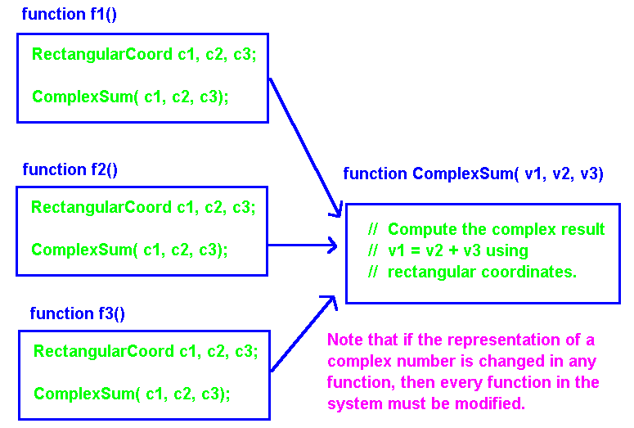
Traditional Design

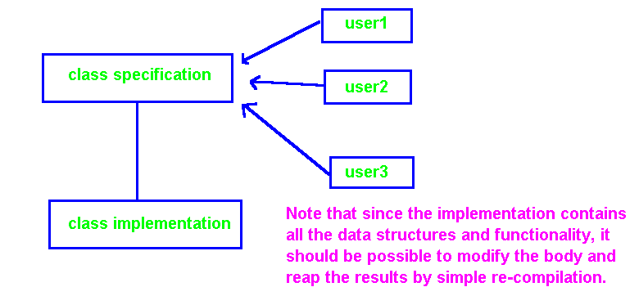
Object Oriented Design
Modifying an Internal Data Structure!
/file comple1a.cpp
#include <iostream>
using namepace std;
#include<math.h>

class complex {
private:
// double real, imag; // This was the old definition.

struct { double rvar; double ivar;} cvar; // The new definition.
public:
complex(double r = 0.0, double i = 0.0);
void assign(double r, double i);
void print( );

complex operator=( const complex& n);
complex operator+( const complex& n);
complex operator-(const complex& n);
};

complex::complex(double r, double i) { cvar.rvar = r; cvar.ivar = i;}

void complex::assign(double r, double i) { cvar.rvar = r; cvar.ivar = i;}

void complex::print( ) { cout << cvar.rvar << " + " << cvar.ivar << "i\n";}

// complex complex::operator=(const complex& n) // Old code.
// {complex temp; real=n.real; imag=n.imag; return temp;}

complex::operator=( const complex& n) // New code.
{complex temp(cvar.rvar = n.cvar.rvar,
cvar.ivar = n.cvar.ivar); return temp;}

complex complex::operator+( const complex& n)
{ complex temp(cvar.rvar + n.cvar.rvar, cvar.ivar + n.cvar.ivar);
return temp;}

complex complex::operator-(const complex& n)
{ complex temp(cvar.rvar - n.cvar.rvar, cvar.ivar - n.cvar.ivar);
return temp;}
int main( )
{ float a = 14.3, b = 100.0, c;
complex c1(0,0), c2(0,0), c3(0,0);
complex c4(6.2), c5;

c = a + b; // add operator overloaded.
cout << "a = " << a << " b = " << b << ". c = a+b = " << c << ".\n";

c1.assign(3.5,6.2);
c2.assign(4.6,7.5);

cout << "c1 = "; c1.print(); cout <<"\n";
cout << "c2 = "; c2.print(); cout << "\n";
c3 = c1 + c2;
cout << "c3 = "; c3.print(); cout << "\n";

c3 = c3 - c2;
cout << "c3 = "; c3.print(); cout << "\n";

c3 = c2;
cout << "c3 = "; c3.print(); cout << "\n";

cout << "c4 = "; c4.print(); cout << "\n"; // show defaults
cout << "c5 = "; c5.print(); cout << "\n";
return 0;
}

a = 14.3 b = 100. c = a+b = 114.300003.
c1 = 3.5 + 6.2i

c2 = 4.6 + 7.5i

c3 = 8.1 + 13.7i

c3 = 3.5 + 6.2i

c3 = 4.6 + 7.5i

c4 = 6.2 + 0i

c5 = 0 + 0i
BASIS for MAINTENANCE, MODIFICATION, and OPTIMIZATION

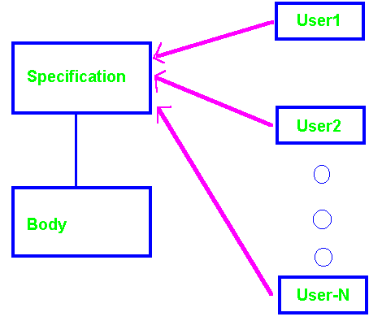

- Modify the Body Only: If you modify only the body then in principle it should be possible to recompile the body and link it to the specification. This would automatically update all users without further effort.

- Modify the Specification: The specification, body, and all user code must be recompiled and linked when data structures or functionality is added to the specification. It will not be necessary to modify any user code however unless the user code wishes to take advantage of new functionality defined in the interface. If functionality is removed from the specification, or the interface for invoking a method is modified, then the user code that exercises these features will also have to be modified.

- Modification of User Code: Modification of user code should not affect the way objects are utilized by the rest of the system.

Pass return address and parameters!
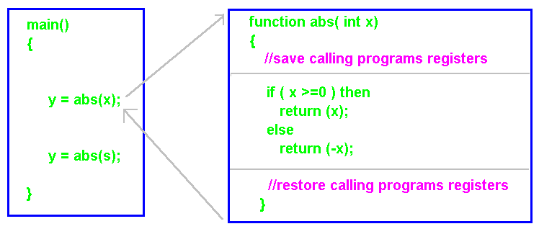
Traditional Linkage

Traditional subprogram linkage requires saving the calling programs registers, passing parameters, a return address, computing the result, restoring the calling programs registers, and transferring control to the return address.

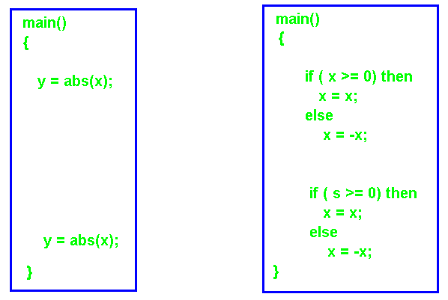
Inline Code Expansion

Inline code expansion saves subprogram linkage at the expense of increased object module size. Saved: passing return address, parameters, saving registers, must still do work, restoring registers, the return!
Generation of Inline Code

//file complex2.c GNU
#include <iostream>
using namespace std;
#include<math.h>

class complex {
private:
double real, imag;
public:

complex(double r = 0.0, double i = 0.0) // Generation of inline code.
{ real = r; imag = i; }

void assign( double r, double I ){ real = r; imag = i; }

void print( ){ cout << real << " + " << imag << "i\n"; }

complex operator=( const complex& n)
{ complex temp; real=n.real;imag=n.imag; return temp; }

complex operator+( const complex& n)
{ complex temp( real + n.real, imag + n.imag );
return temp; }

complex operator-(const complex& n)
{ complex temp( real - n.real, imag - n.imag );
return temp; }

};

int main( )
{
complex c1(0,0), c2(0,0), c3(0,0);
complex c4(6.2), c5;

c1.assign(3.5,6.2);
c2.assign(4.6,7.5);

cout << "c1 = "; c1.print( ); cout <<"\n";
cout << "c2 = "; c2.print( ); cout << "\n";
c3 = c1 + c2;
cout << "c3 = "; c3.print( ); cout << "\n";

c3 = c3 - c2;
cout << "c3 = "; c3.print( ); cout << "\n";

c3 = c2;

cout << "c3 = "; c3.print( ); cout << "\n";
cout << "c4 = "; c4.print( ); cout << "\n";
cout << "c5 = "; c5.print( ); cout << "\n";
return 0;
}

c1 = 3.5 + 6.2i

c2 = 4.6 + 7.5i

c3 = 8.1 + 13.7i

c3 = 3.5 + 6.2i

c3 = 4.6 + 7.5i

c4 = 6.2 + 0i

c5 = 0 + 0i
//file complex3.c GNU
#include <iostream>
using namespace std;
#include<math.h>

class complex {
private:
double real, imag;

public:
complex( double r = 0.0, double i = 0.0 );
void assign( double r, double I ){ real = r; imag = i; } // Inline linkage.

void print( ); // Standard linkage.

complex operator=( const complex& n )
{ complex temp; real = n.real; imag = n.imag; return temp; }

complex operator+( const complex& n );

complex operator-( const complex& n );
};

complex::complex( double r, double I )
{ real = r; imag = i; }

void complex::print( ){ cout << real << " + " << imag << "i\n";}

inline complex complex::operator+( const complex& n ) //inline
{ complex temp( real + n.real, imag + n.imag );
return temp;}

complex complex::operator-( const complex& n ) //standard linkage
{ complex temp( real - n.real, imag - n.imag );
return temp; }

int main( )
{ float a = 14.3, b = 100.0, c;
complex c1(0,0), c2(0,0), c3(0,0);
complex c4(6.2), c5;

c = a + b;
cout << "a = " << a << " b = " << b << ". c = a+b = " << c << ".\n";

c1.assign(3.5,6.2);
c2.assign(4.6,7.5);

cout << "c1 = "; c1.print( ); cout <<"\n";
cout << "c2 = "; c2.print( ); cout << "\n";
c3 = c1 + c2;
cout << "c3 = "; c3.print( ); cout << "\n";
c3 = c3 - c2;
cout << "c3 = "; c3.print( ); cout << "\n";
c3 = c2;
cout << "c3 = "; c3.print( ); cout << "\n";
cout << "c4 = "; c4.print( ); cout << "\n";
cout << "c5 = "; c5.print( ); cout << "\n";
return 0;
}

a = 14.3 b = 100. c = a+b = 114.300003.
c1 = 3.5 + 6.2i

c2 = 4.6 + 7.5i

c3 = 8.1 + 13.7i

c3 = 3.5 + 6.2i

c3 = 4.6 + 7.5i

c4 = 6.2 + 0i

c5 = 0 + 0i

class complex
data:
double real;
double imag;
public:
complex(double r = 0.0, double I = 0.0);
complex operator=(const complex& n);
complex operator+(const complex& n);
complex operator-(const complex& n);
Complex c1(3.4), c2, c3(4.2, 6.7);
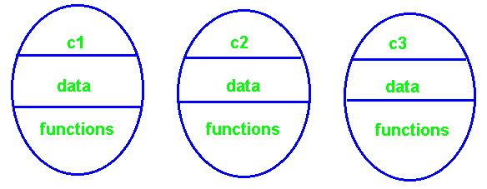

Logical Model

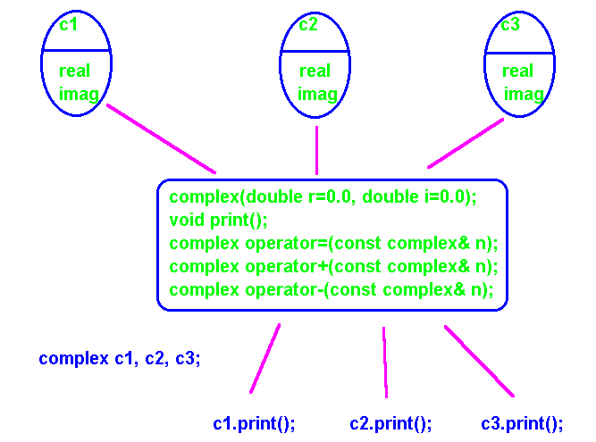
With the use of re-entrant code: a) non self modifying, b) separate data area for each object. Multiple CPU’s may execute the code simultaneously!
Basis for Re-use, Maintenance, Modification,

Enhancement, and Optimization

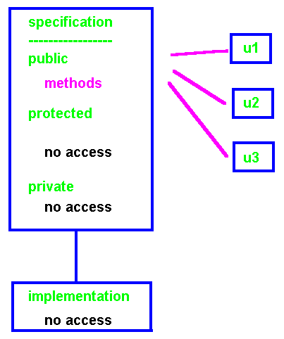

Good designs usually make all data structures private or protected.

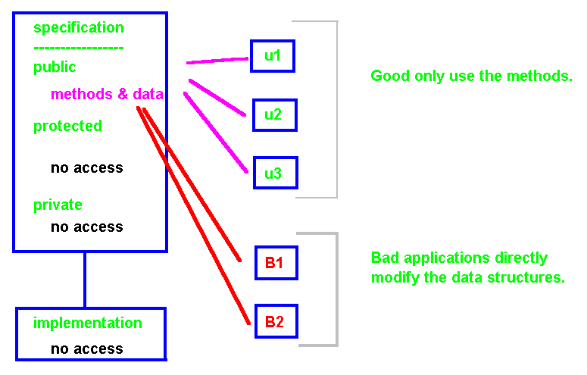
//file complex4.c GNU
#include <iostream>
using namespace std;
#include<math.h>

class complex {
private:

// Nothing declared private.

public:

double real, imag; //These are accessable outside the class.
//Access is not controlled!

complex( double r = 0.0, double i = 0.0 )
{ real = r; imag = i; }

void assign( double r, double I ){ real = r; imag = i; }

void print(){ cout << real << " + " << imag << "i\n"; }

complex operator=( const complex& n )
{ complex temp; real=n.real;imag=n.imag; return temp; }

complex operator+( const complex& n )
{ complex temp(real + n.real, imag + n.imag );
return temp; }

complex operator-( const complex& n )
{ complex temp( real - n.real, imag - n.imag );
return temp; }
};

Example: rectangular vs Polar coordinates when representing complex numbers.
int main( )
{
complex c1(0,0), c2(0,0), c3(0,0);
complex c4(6.2), c5;

c1.assign(3.5,6.2);
c2.assign(4.6,7.5);

cout << "c1 = "; c1.print(); cout <<"\n";
cout << "c2 = "; c2.print(); cout << "\n";

c3 = c1 + c2; // Normal (expected) complex addition.
cout << "c3 = "; c3.print(); cout << "\n\n";

// Uncontrolled complex addition.
c3.real = c1.real + c2.real; c3.imag = c1.imag +c2.imag;

cout << "c3.real = c1.real + c2.real and c3.imag = c1.imag + c2.imag\n";
cout << " is the value c3 = "; c3.print(); cout << "\n";
cout << "Note that this would not be allowed if the data structures\n"
<< " were private.\n";
cout << "This implies potential problems during maintenance and\n"
<< "enhancement.\n\n";
Return 0;
}

c1 = 3.5 + 6.2i

c2 = 4.6 + 7.5i

c3 = 8.1 + 13.7i

c3.real = c1.real + c2.real and c3.imag = c1.imag + c2.imag
is the value c3 = 8.1 + 13.7i

Note that this would not be allowed if the data structures were private.

This implies potential problems during maintenance and enhancement. For example, changing from rectangular to polar coordinates!
Encapsulation of Functionality and Data

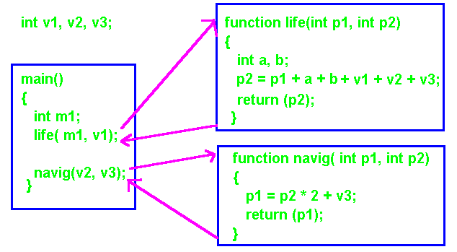
Traditional encapsulation involves the use of functions. Functionally this system has been logically encapsulated with respect to module access. In general data is defined globally or locally and passed to functions as required.

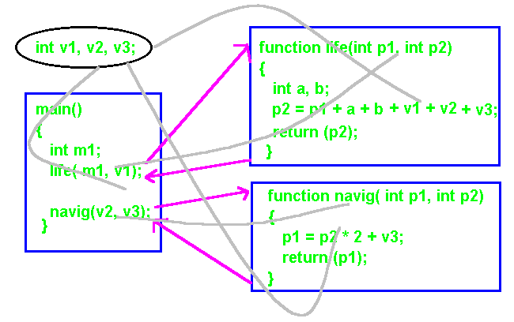
The data structures are not logically encapsulated with controlled access. The result is very high data coupling.
Encapsulation of Functionality and Data

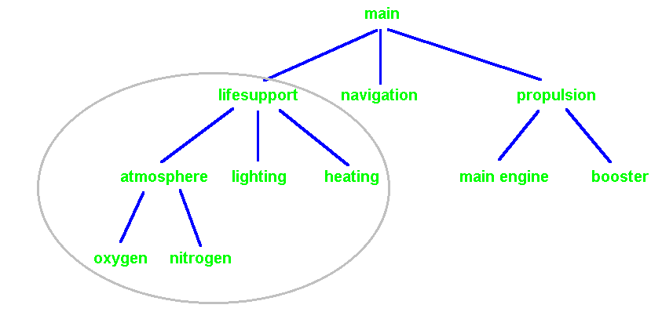

C++ affords the designer and programmer further ability to enforce design abstractions through the use of classes and the extended struct structure.

struct LifeSupport{  // data structures  function atmosphere( );  function lighting( );  function heating( );  function oxygen( );  function nitrogen( );  } | class LifeSupport{  private:  // data structures  function atmosphere( );  function lighting( );  function heating();  function oxygen( );  function nitrogen( );  }

The functions within the “struct” may only be used on the data structures defined in the struct and not on data structures defined external to the struct. This reduces visibility and hence reduces coupling to the rest of the system
Encapsulation of Functionality and Data

.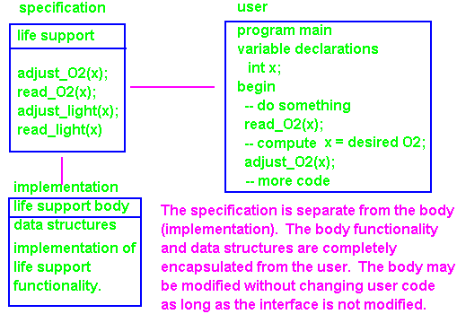

In object oriented analysis and design objects are created in terms of a specification and body. This specification determines the behavior that may be requested of the object. The objects internal data structures and functionality are hidden (encapsulated) from the user.

The data structures representing the state of the object are private to the object and not accessible outside the object. Information transfer between objects is limited to requests for an object to report its current state or assume a new state with appropriate values. This allows for very high level of cohesion within the object and very low data and control coupling between objects. The objects state may not be changed directly by another object in the system. All changes must be properly requested.

A body must be supplied which explains in detail the implementation of the functionality and data structures. The translator however guarantees that users of the object do not have direct access to theses data structures or functions. The abstractions determined during analysis and design are enforced by the translator or runtime system. The only access a user has is through the functionality specified in the user interface, the object specification. The object may determine if a requested action is appropriate and act accordingly.

The body of the object may be modified to correct errors, modified to allow for changing environment (program enhancement), or modified for purposes of optimization for space and/or time. As long as the user interface is not changed, user code need not be recompiled or linked (at least in principle).

If the specification is changed by adding new functionality, then user code must be recompiled and linked. The user code need not in general be modified however unless the user wishes to take advantage of the new functionality. If the definition of existing functions in the user interface is modified, then user code must in general be modified, re-translated, and linked.
FRIENDS

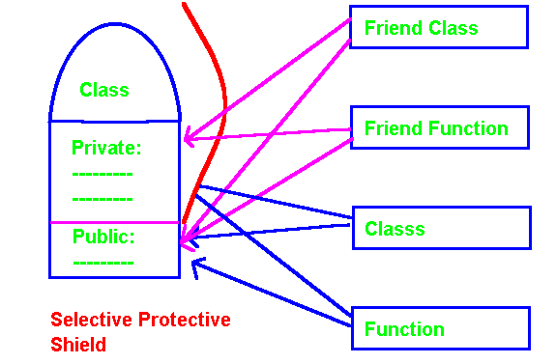

A class definition introduces a bullet proof shield for its private members. It may be desirable on occasion to allow a special class or function to have direct access to the private or protected parts of a class. This can be accomplished through the use of a “friend” class or function. In general you are not encouraged to use this technique unless it is really necessary. By introducing increased data and control coupling in the system the ability to maintain, modify, and optimize the system by changing data structures or code in a base class may be compromised.
A Hole - Friends

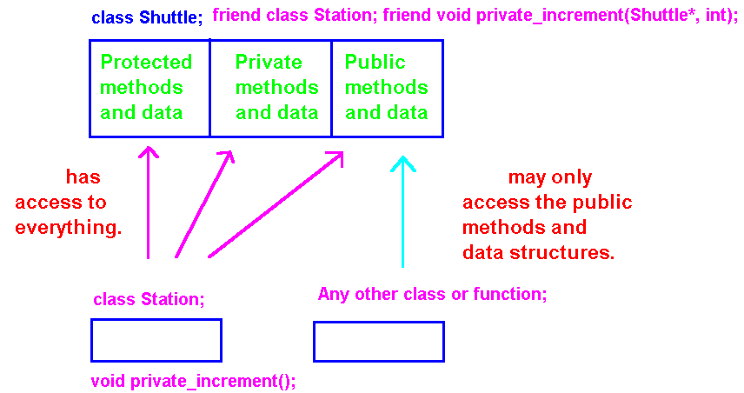
class Shuttle {
private:
friend Station; // All methods in Station are friends.
friend void private_increment(Shuttle*, int); // This function is a friend.
int num_crew;
void put_crew(){cout << "Private to shuttle num_crew = "
<< num_crew << ".\n";}
public:
Shuttle(){num_crew = 0;}
void put_public_crew(){cout << "Public to shuttle num_crew = "
<< num_crew << ".\n";}
void public_increment(int);
};

The class abstraction mechanism places enormous pressure on the designer to ensure the class provides sufficient methods to manipulate all class data structures. Data hiding can also increase computational overhead through linkage mechanisms.

The “friend” mechanism allows a selected number of outside functions and classes to directly access the data structures reducing overhead.

Unfortunately this also reduces the ability to perform effective maintenance and modification. Changes in a base class can snowball throughout the “friend” relationships and hence to abstractions utilizing the friend functions. In the absence of friend classes, the body of a class may be modified without affecting user code.
//friend1.c GNU
#include <iostream>
using namespae std;
class Station;

class Shuttle {
private:
friend class Station; // All methods in Station are friends.
friend void private_increment(Shuttle*, int);
int num_crew;
void put_crew(){cout << "Private to shuttle num_crew = "
<< num_crew << ".\n";}
public:
Shuttle(){num_crew = 0;}
void put_public_crew(){cout << "Public to shuttle num_crew = "
<< num_crew << ".\n";}
void public_increment(int);
};
void private_increment(Shuttle* aShuttle, int addCrew)
{ cout << "Shuttle private increment before "
<< aShuttle -> num_crew;
aShuttle -> num_crew += addCrew;
cout << " after " << aShuttle -> num_crew << ".\n";
}
void Shuttle::public_increment(int addCrew)
{ cout << "Shuttle public increment before " << num_crew;
num_crew += addCrew; cout << " after " << num_crew << ".\n";
}

class Station {
public:
void friend1_Shuttle(Shuttle* aShuttle, int num)
{aShuttle -> public_increment(num);

private_increment(aShuttle, num);}

void friend2_Shuttle(Shuttle* aShuttle)
{ aShuttle -> num_crew++;}
};

int main( )
{
Shuttle Atlantis;

Shuttle* PTshuttle = &Atlantis;

Station Freedom;

Freedom.friend1_Shuttle(PTshuttle, 5); // Uses puplic & private increment

Atlantis.public_increment(4);

Atlantis.put_public_crew();

Freedom.friend2_Shuttle(PTshuttle); // Direct access Shuttle private data.

Atlantis.put_public_crew();
return 0;
}

c:\>friend1
Shuttle public increment before 0 after 5.
Shuttle private increment before 5 after 10.
Shuttle public increment before 10 after 14.
Public to shuttle num_crew = 14.
Public to shuttle num_crew = 15.

//file complex5.c GNU
#include <iostream>
using namespace std;
#include<math.h>

class complex {
private:

double real, imag;

public:

complex(double r = 0.0, double i = 0.0)
{ real = r; imag = i;}

void assign(double r, double i){ real = r; imag = i;}

void print( ){ cout << real << " + " << imag << "i\n";}

complex operator=( const complex& n) //left argument is implied.
{complex temp; real=n.real;imag=n.imag; return temp;}

complex operator+( const complex& n)
{ complex temp(real + n.real, imag + n.imag);
return temp;}

complex operator++( ){ ++(this -> real); return(*this);} //unary prefix
complex operator++(int)( ++(this->real); return(*this);} // unary postfix

friend complex operator-(const complex& c1, const complex& c2);
// For a friend you must allow for both arguments.
};

complex operator-(const complex& c1, const complex& c2)
{
complex temp(c1.real - c2.real, c1.imag - c2.imag);
return (temp);
}

// A "friend F" of a class X is a function or class that, although not
// a member function X, has full access rights to the private and
// protected members of X.

int main( )
{
complex c1(0,0), c2(0,0), c3(0,0);
complex c4(6.2), c5;

c1.assign(3.5,6.2);
c2.assign(4.6,7.5);

cout << "c1 = "; c1.print(); cout <<"\n";
++c1;
cout << "c1 + (1.0 + 0.0i) = ++c1 = "; c1.print(); cout << "\n\n";

c1++;
cout << "c1 + (1.0 + 0.0i) = ++c1 = "; c1.print(); cout << "\n\n";

cout << "c2 = "; c2.print(); cout << "\n";
c3 = c1 + c2;
cout << "c3 = c1 + c2 = "; c3.print( ); cout << "\n\n";

c3 = c3 - c2;
cout << "c3 = c3 - c2 = "; c3.print( ); cout << "\n";
return 0;
}

c1 = 3.5 + 6.2i

c1 + (1.0 + 0.0i) = ++c1 = 4.5 + 6.2i

c1 + (1.0 + 0.0i) = c1++ = 5.5 + 6.2i

c2 = 4.6 + 7.5i

c3 = c1 + c2 = 10.1 + 13.7i

c3 = c3 - c2 = 5.5 + 6.2i
//file comp1.cpp
#include <iostream.h>
#include<math.h>
class complex {
private:
double real, imag;
public:
complex(double r = 0.0, double i = 0.0);
void assign(double r, double i);
void print( );
complex operator=( const complex& n);
complex operator+( const complex& n);
complex operator-(const complex& n);
};
complex complex::complex(double r, double I) { real = r; imag = i;}
void complex::assign(double r, double i){ real = r; imag = i;}
void complex::print( ){ cout << real << " + " << imag << "i\n";}
complex complex::operator=( const complex& n)
{complex temp; real=n.real;imag=n.imag; return temp;}
complex complex::operator+( const complex& n)
{ complex temp(real + n.real, imag + n.imag); return temp;}
complex complex::operator-(const complex& n)
{ complex temp(real - n.real, imag - n.imag); return temp;}
-----------------------------------------------------------------------------------------------
//file ucomp1.cpp
#include <iostream>
using namespace std;
#include "comp1.c"
main( )
{
complex c1(0,0), c2(0,0), c3(0,0);
complex c4(6.2), c5;
c1.assign(3.5,6.2);
c2.assign(4.6,7.5);
cout << "c1 = "; c1.print(); cout <<"\n";
cout << "c2 = "; c2.print(); cout << "\n";
c3 = c1 + c2;
cout << "c3 = "; c3.print(); cout << "\n";
c3 = c3 - c2;
cout << "c3 = "; c3.print(); cout << "\n";
c3 = c2;
cout << "c3 = "; c3.print(); cout << "\n";
cout << "c4 = "; c4.print(); cout << "\n";
cout << "c5 = "; c5.print(); cout << "\n";
}
c1 = 3.5 + 6.2i  c2 = 4.6 + 7.5i  c3 = 8.1 + 13.7i  c3 = 3.5 + 6.2i | c3 = 4.6 + 7.5i  c4 = 6.2 + 0i  c5 = 0 + 0I

C++ Memory Model

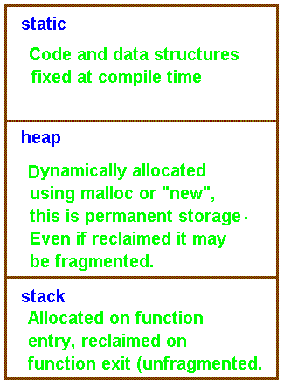

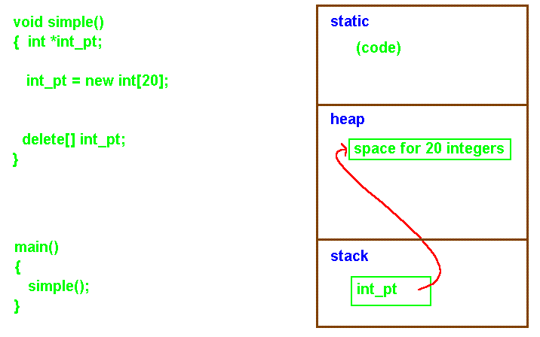

Note that space for int_pt is dynamically allocated in the stack upon entry to the function simple. This space is automatically reclaimed upon function exit as the stack is popped. The space in the heap is lost however and will in general never be available again unless reclaimed via delete. Delete is a garbage collector supplied with the runtime system. A programmer may prefer to do their own garbage collection.

• Space allocated in the stack is temporary!

• Space allocated in the heap is permanent.

// in file delete3.cpp
#include<iostream>
using namespace std;
#include<stdio.h>
void simple( )
{ // Dynamic allocation in stack and reclaimed on exit.
int *int_pt1, *int_pt2;
char *char_pt;

// Programmer defined allocation in heap, not automatically
// reclaimed on function exit.
int_pt1 = new int;
*int_pt1 = 36; cout << "*int_pt1 = " << *int_pt1 << endl;

int_pt2 = new int[20]; // Allocate an array of 20 integers.

char_pt = new char[20];
char_pt = "Sam"; cout << "*char_pt = ";
for(int i=0; i<20 && *(char_pt+i) != '\0';i++)cout<<*(char_pt+i);
cout << "\n";
delete int_pt1; // delete integer pointed to by int_pt1.
delete[ ] int_pt2; //delete array pointed to by int_pt2;
//delete[ ] char_pt; // delete array pointed to by char_pt;
cout << "All storage in heap de-allocated except *char_pt!" << endl;
}

void main( ) {
simple( );
cout << "So long folks!" << endl << endl;
}
// When successful, "new" returns a pointer to the new object. It is
// not necessary to explicitly use "sizeof" as required by "malloc."
// New does this automatically. The pointer is always of the proper
// type and does not have to be cast. If the allocation fails,
// "new" returns a null.

*int_pt1 = 36
*char_pt = Sam
All storage in heap de allocated except *char_pt!
So long folks!
// in file shuttle2.cpp
#include <iostream>
using namespace std;
#include <stdio.h>
#include <string.h>

class Shuttle{
private:
char shuttle_name[20];
char shuttle_destination[20];
int course;
public:
Shuttle(char *name, char *destination, int course_in);

void identify( );
void set_course( int new_course);
};

Shuttle::Shuttle(char *name, char *destination, int course_in){
strcpy(shuttle_name, name); strcpy(shuttle_destination, destination);
course = course_in;}

void Shuttle::identify( ){cout << "Shuttle named " << shuttle_name <<
" bound for " << shuttle_destination << " course " <<
course << ".\n\n";}

void Shuttle::set_course( int new_course) { course = new_course;}
How many shuttles would you like? 3
Shuttle named ShuttleA bound for Freedom course 45.

Shuttle named ShuttleAA bound for Freedom course 45.

Shuttle named ShuttleAAA bound for Freedom course 45.

ShuttleAA change course to 38.
Shuttle named ShuttleAA bound for Freedom course 38.
int main( )
{
char ch[2] = "A";
char name[20] = "Shuttle";
int m;

Shuttle* fleet[26];
cout << "How many shuttles would you like? ";
cin >> m; cout << "\n";

//Dynamic allocation of shuttles.
for(int i = 0; i < m; I++){ strcat(name, ch);
fleet[i] = new Shuttle(name, "Freedom", 45); }

for(int i = 0; i < m; i++) fleet[i] -> identify( );

cout << "\nShuttleAA change course to 38.\n";
fleet[1] -> set_course(38); //Pointer reference notation versus object.method(--).
fleet[1] -> identify( );

return 0;
}

