Object Oriented

Programming in

GNU C++

by

David S Burris

Ph.D. in Computing Science

Certified Computer Programmer

Certified Systems Professional

Certified Computing Professional

csc_dsb@shsu.edu

Permission is granted to students in my classes to use any or all of the material in this document for their personnel educational. All other rights reserved. Materials may not be transmitted to individuals not registered in my classes.

Revised Spring 2007, 2009
Sequentially Allocated Stack

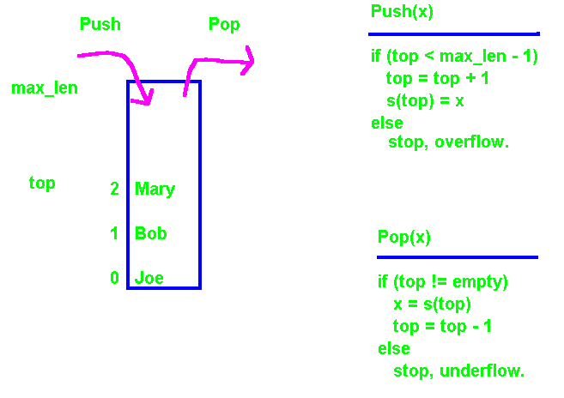
Assume top = -1, implies the stack is empty.

 |  | Goal |  |  |  |  |  | Goal
 |  | I |  |  |  |  |  | I
 |  | H |  | G |  |  |  | H
 |  | C | D | E | F |  |  | G
 |  | B |  |  |  |  |  | F
 |  | A |  |  |  |  |  | E
 |  | Start |  |  |  |  |  | D
 |  |  |  |  |  |  |  | C
 |  |  |  |  |  |  |  | B
 |  |  |  |  |  |  |  | A
 |  |  |  |  |  |  |  | Start

Traverse a maze using a stack. Ask robot to locate and return tool. Robot has located the goal/tool and is ready to return by popping the stack at right.
//stack0.c GNU THIS CLASS CREATES AN INTEGER STACK
#include<iostream>
using namespace std;
#define boolean int

class stack0 {
private:
enum {EMPTY = -1};
int *s;
int max_len;
int top;
public: // two constructors including (first) default constructor
stack0( ) :max_len(20) { s = new int[max_len]; top = EMPTY;}
stack0(int size) { s = new int[size]; top = EMPTY;
max_len = size;}
~stack0( ){ delete [ ] s;} // destructor
void reset( ){ top = EMPTY;}
void push( int x){ if(top < (max_len - 1)) s[++top] = x; }
int pop( ){ if(top != EMPTY) return(s[top--]);else return(0);}
int top_of( );
boolean empty( ){ return boolean( top == EMPTY); }
boolean full( ){ return boolean( top == max_len - 1); }
};

int stack0::top_of( ){ return (s[top]);}

int main(void)
{ int j, num_int;
How many integers do you wish to stack? 3

enter data: 52
enter data: 34
enter data: 21

Pop the stack
value = 21.
value = 34.
value = 52.

stack0 int_stack1(10);

cout << "How many integers do you wish to stack? ";
cin >> num_int;
for( int i = 1; i <= num_int; ++i){
cout << "enter data: "; cin >> j; int_stack1.push(j);
}
cout << "\n\nPop the stack\n";
while( !int_stack1.empty( ) ){
j = int_stack1.pop( ); cout << "value = " << j << ".\n";
}
return 0;
}
//stack1.cpp generic stack
#include<iostream>
using namespace std;
#define boolean int

template <class TYPE>
class stack {
private:

enum {EMPTY = -1};
TYPE* s;
int max_len;
int top;

public: // Overloaded constructor.
stack( ) :max_len(20) { s = new TYPE[20]; top = EMPTY;}

stack(int size) :max_len(size)
{ s = new TYPE[size]; top = EMPTY;}

~stack( ){ delete [ ] s;} // Destructor to reclaim heap space when
// object leaves scope.

void reset( ){ top = EMPTY;}

void push( TYPE x){ if(top < (max_len - 1)) s[++top] = x; }

TYPE pop( ){ if(top != EMPTY) return(s[top--]); else return (0);}

TYPE top_of( );

boolean empty( ){ return boolean( top == EMPTY); }

boolean full( ){ return boolean( top == max_len - 1); }
};

// Syntax to define class member function externally.

template<class TYPE> TYPE stack<TYPE>::top_of( ){ return (s[top]);}

int main(void)
{ int j, num_int;

stack<int> int_stack1(10); // Creation of stack (object) to hold 10 integers.

cout << "How many integers do you wish to stack? ";
cin >> num_int;
for( int i = 1; i <= num_int; ++i){
cout << "enter data: "; cin >> j;
int_stack1.push( j );
}

cout << "\n\nPop the stack\n";
for(int i = 1; i <= num_int; ++i){
j = int_stack1.pop( ); cout << "value = " << j << ".\n";
}
return 0;
}

How many integers do you wish to stack? 3
enter data: 1
enter data: 2
enter data: 3

Pop the stack
value = 3.
value = 2.
value = 1.

%%%%%%%%%%%%%%%%%%%%%%%%%%%%%
stack<int> int_stack2; // default size 20
stack<float> int_stack3; // default size
stack<char> int_stack4(300);

//stack2.c GNU
#include<iostream>
using namespace std;
#define boolean int

template <class TYPE>
class stack {
private:
enum {EMPTY = -1};
TYPE* s;
int max_len;
int top;
public:
stack( ) :max_len(20) { s = new TYPE[20]; top = EMPTY;}

stack(int size) :max_len(size){ s = new TYPE[size]; top = EMPTY;}

~stack( ){ delete [ ] s;}

void reset( ){ top = EMPTY;}
void push( TYPE x){ if(top < (max_len - 1)) s[++top] = x; }
TYPE pop( ){ if(top != EMPTY) return(s[top--]); else return(0);}
TYPE top_of( );
boolean empty( ){ return boolean( top == EMPTY); }
boolean full( ){ return boolean( top == max_len - 1); }
};

template<class TYPE> TYPE stack<TYPE>::top_of( ){ return (s[top]);}
int main(void)
{ int j, num_int;
stack< int > int_stack1(10);
stack< int > int_stack2;
stack< char* > string_stack(5);

char* char_array[3];
char_array[0] = "sam"; char_array[1] = "mary"; char_array[2] = "bob";

cout << "How many integers do you wish to stack in stack1? ";
cin >> num_int;
for( int i = 1; i <= num_int; ++i){
cout << "enter data: "; cin >> j;
int_stack1.push(j);
}
cout << "\n\nPop the stack\n";
for( int i = 1; i <= num_int; ++i){
j = int_stack1.pop(); cout << "value = " << j << ".\n\n";
}

cout << "How many integers do you wish to stack in stack2? ";
cin >> num_int;
for( int i = 1; i <= num_int; ++i){
cout << "enter data: "; cin >> j;
int_stack2.push(j);
}
cout << "\n\nPop the stack\n";
for( int i = 1; i <= num_int; ++i){
j = int_stack2.pop(); cout << "value = " << j << ".\n";
}

cout << "\n\nStack three strings. \n";
num_int = 3;
for( int i = 0; i < num_int; ++i){
cout << "push " << char_array[i] << ".\n";
string_stack.push(char_array[i]);
}
cout << "\n\nPop the stack\n";
for( int i = 1; i <= num_int; ++i){
cout << "value = "; printf("%s\n", string_stack.pop());
}
Return 0;
}
How many integers do you wish to stack in stack1? 3
enter data: 1
enter data: 2
enter data: 3

Pop the stack
value = 3.
value = 2.
value = 1.

How many integers do you wish to stack in stack2? 2
enter data: 4
enter data: 5

Pop the stack
value = 5.
value = 4.

Stack three strings.
push sam.
push mary.
push bob.

Pop the stack
value = bob
value = mary
value = sam
//stack3.c GNU
#include<iostream>
Using namespace std;
#define boolean int
template <class TYPE>
class stack {
private:
enum {EMPTY = -1};
TYPE* s;
int max_len;
int top;
public:
stack( ) :max_len(20)
{ s = new TYPE[20]; top = EMPTY;}
stack(int size) :max_len(size)
{ s = new TYPE[size]; top = EMPTY;}
~stack( ){ delete [ ] s;}
void reset(){ top = EMPTY;}
void push( TYPE x){ if(top < (max_len - 1)) s[++top] = x; }
TYPE pop( ){ if(top != EMPTY) return(s[top--]); else return(0);}
TYPE top_of( );
boolean empty( ){ return boolean( top == EMPTY); }
boolean full( ){ return boolean( top == max_len - 1); }
};
template<class TYPE> TYPE stack<TYPE>::top_of( ){ return (s[top]);}

#include<math.h>
class complex {
private:
double real, imag;
public:

complex(double r = 0.0, double i = 0.0)
{ real = r; imag = i;}
void assign(double r, double i){ real = r; imag = i;}
void print( ){ cout << real << " + " << imag << "i\n";}
complex operator=( const complex& n)
{complex temp; real=n.real;imag=n.imag; return temp;}
complex operator+( const complex& n)
{ complex temp(real + n.real, imag + n.imag); return temp;}
complex operator-(const complex& n)
{ complex temp(real - n.real, imag - n.imag); return temp;}
};
int main(void)
{ int j, num_int;

stack<int> int_stack1(10);

stack<complex> complex_stack;

complex c1(2.0, 4.6), c2(3.5, 6.4), c3(-7.8, 9.2);

cout << "push c1 = 2.0 + 4.6i \n"; complex_stack.push(c1);
cout << "push c2 = 3.5 + 6.4i \n"; complex_stack.push(c2);
cout << "push c3 = -7.8 + 9.2i \n"; complex_stack.push(c3);
cout << "\n\n Pop the complex numbers and print.\n";
complex_stack.pop( ).print( ); cout << "\n";
complex_stack.pop( ).print( ); cout << "\n";
complex_stack.pop( ).print( ); cout << "\n";

cout << "How many integers do you wish to stack? ";
cin >> num_int;
for( int i = 1; i <= num_int; ++i){
cout << "enter data: "; cin >> j;
int_stack1.push(j);
}
cout << "\n\nPop the stack\n";
for( int i = 1; i <= num_int; ++i){
j = int_stack1.pop( ); cout << "value = " << j << ".\n";
}
}
push c1 = 2.0 + 4.6i  push c2 = 3.5 + 6.4i  push c3 = -7.8 + 9.2i  Pop the complex numbers and print.  -7.8 + 9.2i  3.5 + 6.4i  2 + 4.6i | How many integers do you wish to stack? 3  enter data: 1  enter data: 2  enter data: 3  Pop the stack  value = 3.  value = 2.  value = 1.

//stack4.c GNU generic stack
#include<iostream>
using namespace std;
#define boolean int

template <class TYPE>
class stack {
private:

enum {EMPTY = -1};
TYPE* s;
int max_len;
int top;

public:
stack( ) :max_len(20) { s = new TYPE[20]; top = EMPTY;}

stack(int size) :max_len(size) { s = new TYPE[size]; top = EMPTY;}

~stack( ) { delete [ ] s;}

void reset (){ top = EMPTY;}

void push( TYPE x) { if(top < (max_len - 1)) s[++top] = x; }

TYPE pop( ) { if(top != EMPTY) return(s[top--]); else return (0);}

boolean empty( ) { return boolean( top == EMPTY); }

boolean full( ) { return boolean( top == max_len - 1); }
};

template<class TYPE> TYPE stack<TYPE>::top_of( ) { return (s[top]);}

int main(void)
{ int j, num_int;

cout << "How much space should be allocated to the stack? ";
cin >> j;

stack<int> int_stack1(j); // Dynamic allocation of stack space .

cout << "How many integers do you wish to stack? ";
cin >> num_int;
for( int i = 1; i <= num_int; ++i){
cout << "enter data: "; cin >> j;
int_stack1.push(j);
}

cout << "\n\nPop the stack\n";
for( int i = 1; i <= num_int; ++i){
j = int_stack1.pop(); cout << "value = " << j << ".\n";
}
}

How much space should be allocated to the stack? 3
How many integers do you wish to stack? 5
enter data: 1
enter data: 2
enter data: 3
enter data: 4
enter data: 5

Pop the stack
value = 3.
value = 2.
value = 1.
value = 0.
value = 0.

//file tempparm.cpp UPDATE NEW ISO STANDARD - MAX

#include <iostream.h>
// Note this is a "template" function.
template<class T1> void func1(T1 p1, int p2, int p3)
{cout << "p1 = " << p1 << ", p2 = " << p2 << ", p3 = " << p3 << "\n";}

template<class T2> T2 max(T2 p1, T2 p2)
{ return (p1 > p2) ? p1 : p2; }

int max(int, int); //declare function return type and parameter types
double max(double,double);

// Note this is a template class.
template<class T3, int a, int b = 16> class play // Note the default.
{
private:
T3 v1; int v2; int v3;
public:
play(T3 p1) { v1 = p1; v2 = a; v3 = b;}
void print(){cout << v1 << " " << v2 << " " << v3 << "\n"; }
}

void main()
{
int a = 4, b = 6, c = 13; float d = 26.78; char ch = ‘A’;
c:\>tempparm
p1 = 4, p2 = 6, p3 = 13
p1 = 26.780001, p2 = 4, p3 = 6

max 6
max 26
max 65

5 10 20

22.67 80 16
func1(a, b, c);
func1(d, a, b);

cout << "max " << max(a, b) << "\n";
cout << "max " << max(d, b) << "\n";
cout << "max " << max(ch, b) << "\n";

play<int,10,20> obj1(5);
obj1.print();
play<double, 80> obj2(22.67); // default
obj2.print();
}
//file gsort.c based on Wiener & Pinson, p52, ISBN 0-201-15413-7 GNU
#include <iostream>
using namespace std;
#include <string.h>
typedef int(*compare) (void*, void*); //defines a pointer to a function
struct name_type{
char* name;
int id_number;
};
typedef name_type* rec_type;
name_type my_records[] = {"Apples",5,"Orange",7,"Pears",3,"Lemons",1,
"Plums",0, "Limes",2,"Grapes",4};
int main( ){
int cmp1(void* p, void* q); //generic to compare records by name
int cmp2(void* p, void* q); //generic to compare records by id_number
void sort(char* base, unsigned n, int elemsize, compare cmp);
void print(rec_type r, int n);

sort((char*) my_records,7,sizeof(name_type), cmp1); //sort by name
print(my_records,7);

sort((char*) my_records,7,sizeof(name_type),cmp2); //sort id_number
print(my_records,7);
return 0;
}

void sort(char*base, unsigned n, int elemsize, compare cmp){
//bubble sort, pass pointer, number records, number characters in a record,
//and the address of the function to compare records
for (int i = 0; i<n-1; i++)
for (int j = n-1; i<j; j--)
{
char* bj = base + j*elemsize; //locate b[j]
char* bj1 = bj - elemsize; //locate b[j-1]
if((*cmp)(bj,bj1) < 0)
//swap b[j] and b[j-1] a character at a time
for (int k = 0; k <elemsize; k++)
Apples 5
Grapes 4
Lemons 1
Limes 2
Orange 7
Pears 3
Plums 0

Plums 0
Lemons 1
Limes 2
Pears 3
Grapes 4
Apples 5
Orange 7
{
char temp = bj[k]; bj[k] = bj1[k]; bj1[k] = temp;
}
}
}

void print(rec_type r, int n){
cout << "\n\n";
for(int i = 0; i<n; i++)
cout << r[i].name << "\t" << r[i].id_number << "\t" << "\n";
}

int cmp1(void* p, void* q) //compare by name
{ return strcmp(rec_type(p) -> name, rec_type(q) -> name); }

int cmp2(void* p, void* q) // compare by id_number
{ return rec_type(p)->id_number - rec_type(q)->id_number; }
//file gsort2b.c GNU
template <class TSort> // Bubble sort into ascending order
void sort( TSort elements[ ], const int nitems)
{
int exchange, sz = nitems - 1;
do { exchange = 0;
for( int j = 0; j < sz; j++)
{if (elements[j] > elements[j+1])
{
TSort t = elements[j+1]; //Does not bubble hole!
elements[j+1] = elements[j];
elements[j] = t;
exchange++;
}
}
} while (exchange);
}

=============================================
//file gsort2b.cpp.c GNU
#include "gsort2a.c"
#include <iostream>
using namespace std;

//void sort(int iarray[ ], const int nitems); from gsortb.c
//void sort(float farray[ ], const int nitems);
c:\>gsort2b
Sorted integer array!
2
4
10
32

Sorted float array!
-7.8
6.2
13.4

void main()
{ int int_array[ ] = { 10, 2, 32, 4};
sort(int_array, 4);
cout << "Sorted integer array!\n";
for(int i = 0; i < 4; i++){cout << int_array[i] << "\n";}

float farray[ ] = {6.2, -7.8, 13.4};
sort(farray, 3);
cout << "\nSorted float array!\n";
for( int i = 0; i < 3; i++){cout << farray[i] << "\n";}
}

Classification versus Composition

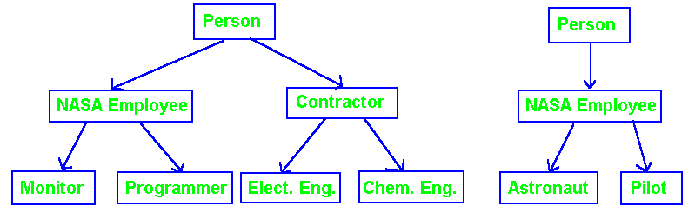
Classification

Object Oriented Design using “classification” implies top-down development and requires inheritance. This depends on superclasses having features common to different subclasses. Most of the details exist in the subclasses. The higher-level objects must exhibit a high degree of related behavior.

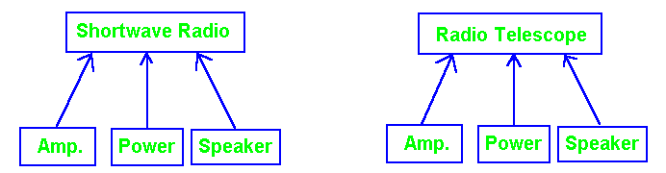
Composition
Object Oriented Design by “composition” implies a bottom-up development recognizing that the same parts can be used to make a variety of higher-level objects. The higher-level objects do not have to exhibit related behavior.

/* file owork.c GNU */
class OriginalWork {
private:
char author[20];
char title[20];
int month, day, year;
float value;
public:
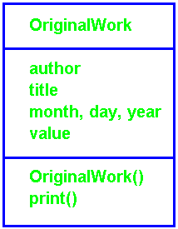
// First, the class constructor. Constructors must have the class name.
OriginalWork(char *Auth, char *name, int m, int d, int y,
float val);

void print( ); // Function to print the contents of an object of the class.
}; // end definition of OriginalWork

#include <iostream>
using namespace std;
#include <string.h>

// code for the constructor
OriginalWork::OriginalWork(char *Auth, char *name, int m, int d,
int y, float val) {
strcpy(author,Auth); strcpy(title,name);
month = m; day = d; year = y; value = val;
} // end constructor OrigionalWork

void OriginalWork::print( ) {
cout << "name: " << title << "\n"; cout << "Author: " << author << "\n";
cout << "Created on: " << month << "/" << day << "/" << year << "\n";
cout << "Value: $" << value << "\n";
}

// file oworkm1.c GNU

#include "owork.c"
int main( )
{
OriginalWork painting("Rembrandt", "Blue Boy", 5, 24, 65, 74.52);

OriginalWork photo("John Zigfield", "Moon", 6, 30, 77, 200.00);

OriginalWork chapter("Bruce Eckel", "Intro to C++", 5, 24, 88, 25.00);

painting.print( );

photo.print( );

chapter.print( );

return 0;
}

name: Blue Boy
Author: Rembrandt
Created on: 5/24/65
Value: $74.519997

name: Moon
Author: John Zigfield
Created on: 6/30/77
Value: $200

name: Intro to C++
Author: Bruce Eckel
Created on: 5/24/88
Value: $25

Single Inheritance

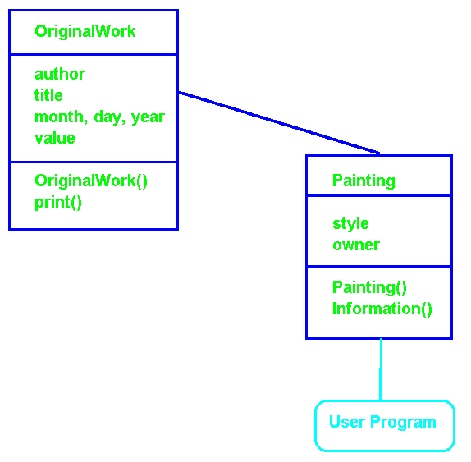

Single Inheritance

//file paint.c

#include "owork.c" // Access to base type.

class Painting : public OriginalWork {
// inherit the base class data structures and functions

char style[30]; //add some new data types for this class
char owner[30];

public:

Painting(char * artist, char * title, char * sty, char * own,
int m, int d, int y, float val);

void information( ); //new function to tell about the painting
};

Painting::Painting( char * artist, char * title, char * sty,
char * own, int m, int d, int y, float val)
: OriginalWork(artist, title, m, d, y, val)
{ strcpy(style,sty); strcpy(owner,own); }

void Painting::information( ) {
cout << "Painting: \n";
print( ); // Call to member function of base class.
cout << "Style: " << style << "\n";
cout << "Owner: " << owner << "\n"; }

//file paintm1.c

#include "paint.c" // Access to class definition.
main( )
{
// create an object
Painting Bull("Ralph Picasso", "Bull & Doves",
"Abstract Expressionism", "Bend Art Museum",
5, 26, 88, 49995.25);

cout << "\nCall to Member function of class paint.\n";
Bull.information( ); //call a member function of class painting

cout << "\n\nCall to member function of base class OriginalWork.\n";
Bull.print( ); //call a function of the base class OriginalWork
}

Call to Member function of class paint.
Painting:
name: Bull & Doves
Author: Ralph Picasso
Created on: 5/26/88
Value: $49995.25
Style: Abstract Expressionism
Owner: Bend Art Museum

Call to member function of base class OriginalWork.
name: Bull & Doves
Author: Ralph Picasso
Created on: 5/26/88
Value: $49995.25

Single Inheritance

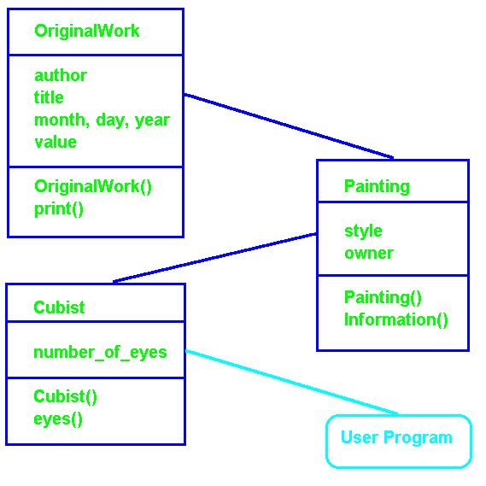

//file cubist.c
// building a new class from an existing class derieved from another class

#include "paint.c" // This indirectly inherits "owork.cpp".
class Cubist : public Painting {
int number_of_eyes; //... on same side of face
public:
Cubist( char * artist, char * title, char * sty,
int eyes, char * own, int m, int d, int y, float val);

int eyes(){return number_of_eyes;}
}; //end class definition

// Note you can call constructors from the immediate base class
// but not directly the class the base class was inherited from.
Cubist::Cubist( char *artist, char *title,
char *sty, int eyes, char *own, int m, int d, int y, float val)
: Painting(artist, title, sty, own, m, d, y, val)
{ number_of_eyes = eyes; }

//file ucubist.c
// building a new class from an existing class derieved from another class.
#include <iostream.h>
#include "cubist.c"
main( )
{
Cubist Only("Bob Dega", "I Only Have Eyes ...",
"early", 3, "Bend Art Museum", 1, 14, 88, 196.45);

Only.information( );
cout << "This was from the " << Only.eyes( )
<< " eye period\n";
}
Painting:
name: I Only Have Eyes ...
Author: Bob Dega
Created on: 1/14/88
Value: $196.449997
Style: early
Owner: Bend Art Museum
This was from the 3 eye period
// file date.c GNU g++ -c date.c
#include <iostream>
using namespace std;
class date {
private:
int month, day, year;

public:
date( ); /*default constructor, initial date value --> use today's date*/

date( int m, int d = 1, int y = 89 );

date( char * datestring );

date( date & );

void print( char * msg = "" );
};

#include <time.h>
#include <stdlib.h>

date::date( ) { struct tm *t; time_t ltim; time(&ltime);
t = localtime(&ltime); month = t -> tm_mon + 1;
day = t -> tm_mday; year = t -> tm_year;
}

date:: date(int m, int d, int y){ month = m; day = d; year = y;}
// note we only give default values in the class declaration

date::date(char* datestring){
char buf[10]; //temporary holder for pieces of the date
char * dt = datestring; month = atoi(dt); //converts until unrecognized char
while(*dt != '/' && *dt != ':') dt++; dt++; //move past '/' or ':'
day = atoi(dt); while(*dt != '/' && *dt != ':') dt++;
dt++; year = atoi(dt);
}

date::date(date & otherdate) { // the copy-initializer
month = otherdate.month; day = otherdate.day; year = otherdate.year;
}

void date::print(char * msg) { cout << msg << " date: " << month <<"/"
<< day << "/" << year << "\n";}
// file datem1.c g++ -o datem1 datem1.c

#include "date.c"
int main( ) {
date today; //calls date();

date also_today(today); //calls data(date &);

date today_too = today; //calls date(date &);

date long_ago(1,15,1947); //calls date(int, int, int)

date far_ahead("7/8/2038"); //calls date(char *);

today.print("today");

also_today.print("also_today");

today_too.print("today_too");

long_ago.print("long_ago");

far_ahead.print("far_ahead");
return 0;
}

today date: 5/02/10
also_today date: 5/02/10
today_too date: 5/02/10
long_ago date: 1/15/1947
far_ahead date: 7/8/2038

Single Inheritance C++

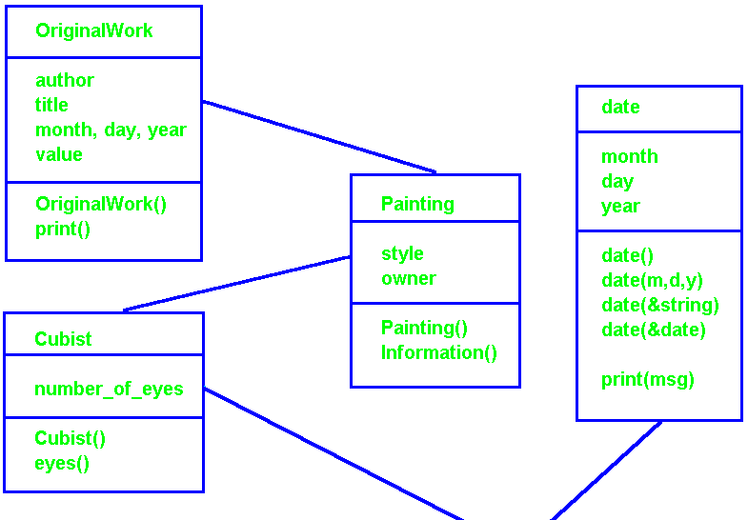
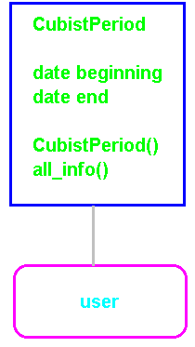

Embed “beginning” and “end” dates in Cubist Period.
//file cubist2.c

#include "cubist.c"
#include "date.c"

class CubistPeriod : Cubist {
date beginning; // getting the structure from another class
date end;
public:
CubistPeriod(char * artist, char * title, char * sty, int eyes,
char * own, int m, int d, int y, float val,
char * start, char * finish)
: Cubist(artist,title,sty,eyes,own,m,d,y,val),
beginning(start), end(finish) { }

void All_info() { information( );
cout << "period starts: "; beginning.print( );
cout << "period ends: "; end.print }
};

// in file cubist2m.c
#include "cubist2.c"
main( )
{
CubistPeriod Dog("Bob Dega", "Five-legged dog",
"middle", 2, "Bend Art Museum", 2, 24, 88, 399.25,
"11/15/87", "2/25/88");

Dog.All_info( );
}

Painting: // From class Painting.
name: Five-legged dog // From class OriginalWork.
Author: Bob Dega
Created on: 2/24/88
Value: $399.25
Style: middle // From class Painting.
Owner: Bend Art Museum
period starts: date: 11/15/87 // From class Date.
period ends: date: 2/25/88
//mixin1bio.cpp GNU
#include <iostream>
using namespace std;
#include <ostream>

class Triangle{
private:
double Base, Height;
public:
Triangle(double B, double H){Base = B; Height = H;}
Triangle( ){Base = 0.0; Height = 0.0;}
double Area( ){return 0.5 * Base * Height;}
void SetTriangleBase(double B){Base = B;}
void SetTriangleHeight(double H){Height = H;}
};

enum ColorType { red, green, blue, gold};
ostream &operator<<(ostream &s, const ColorType &lt) {
switch (lt) {
case red: return (s << "red");
case green: return (s << "green");
case blue: return (s << "blue");
case gold: return (s << "gold");
}
return(s << "unknown color");
}

template <class ClassType>
class ColoredObj: public ClassType{
private:
ColorType MyColor;
public:
ClassType* CpPt;
ColoredObj(ColorType MC){CpPt = new ClassType( ); MyColor = MC;}
ColorType CurrentColor( ){ return MyColor;}
};
T1 area = 176
T3 area = 50

Color = gold
e
int main( ){
char ch;
Triangle T1(16, 22); Triangle T2(17.8, 25.5);

ColoredObj<Triangle> T3(gold);

cout << "T1 area = " << T1.Area( ) << endl;

(*(T3.CpPt)).SetTriangleBase(20.0); (*(T3.CpPt)).SetTriangleHeight(5.0);

cout << "T3 area = " << (*(T3.CpPt)).Area( ) << endl;

if( T3.CurrentColor( )== gold) {cout << "Color = " << T3.CurrentColor() << “\n”; }

cin >> ch; return 0;
}
#include <iostream.h> //mixin1.cpp
#include <ostream.h>

//template <class MyType>
class Triangle{
private:
double Base, Height;
public:
Triangle(double B, double H){Base = B; Height = H;}
Triangle( ){Base = 0.0; Height = 0.0;}
double Area( ){return 0.5 * Base * Height;}
void SetTriangleBase(double B){Base = B;}
void SetTriangleHeight(double H){Height = H;}
};

enum ColorType { red, green, blue, gold};

template <class ClassType>
class ColoredObj: public ClassType{

private:

ColorType MyColor;
public:

ClassType* CpPt;
ColoredObj(ColorType MC){CpPt = new ClassType( ); MyColor = MC;}
ColorType CurrentColor( ){return MyColor;}
};

void main( ){
char ch;
Triangle T1(16, 22);
Triangle T2(17.8, 25.5);
T1 area = 176
T3 area = 50
Color = gold!

ColoredObj<Triangle> T3(gold);

cout << "T1 area = " << T1.Area( ) << endl;
(*(T3.CpPt)).SetTriangleBase(20.0);
(*(T3.CpPt)).SetTriangleHeight(5.0);
cout << "T3 area = " << (*(T3.CpPt)).Area() << endl;
if( T3.CurrentColor( )== gold) cout << "Color = gold!"<< endl;

cin >> ch;

}

#include <iostream> // file templateInheritance.cpp GNU
using namespace std;

template<class T>
class parent{
private:
T a;
public:
parent( ){ a = 0; }
void incrementParent( ){ a++; }
void printParent( ){ cout << "a = " << a << endl; }
};

template<class R>
class child1: public parent<R> {
private:
R b;
public:
child1( ): parent<R>( ) { b = 0; }
void incrementChild1( ){ b++; }
void printChild1( ){ cout << "b = " << b << endl; }
};

Output

p1
a = 0
a = 2
p2
a = 0
a = 1
c1
b = 1
a = 0
int main( ){
parent<int> p1;
cout << "p1\n";
p1.printParent( );
p1.incrementParent( ); p1.incrementParent( );
p1.printParent( );

parent<float> p2;
cout << "p2\n";
p2.printParent( ); p2.incrementParent( );
p2.printParent( );

child1<int> c1;
cout << "c1\n";
c1.incrementChild1( );
c1.printChild1( );
c1.printParent( );
return 0;
}

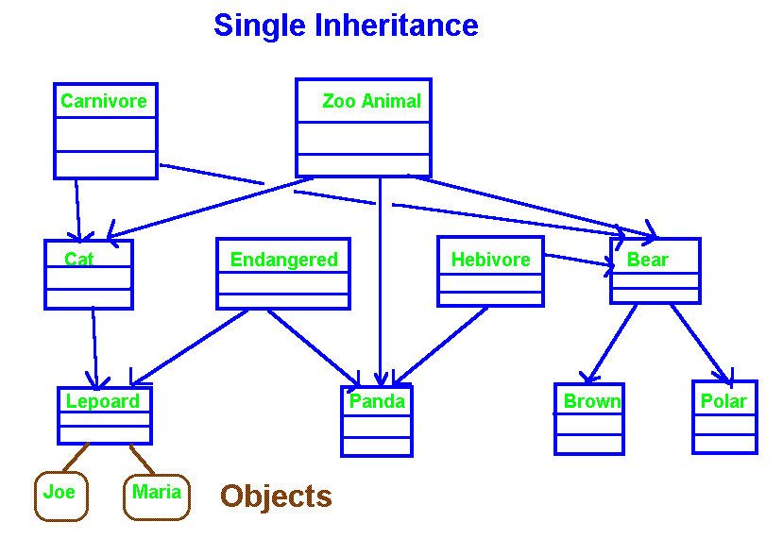

In general data structures and methods are inherited from higher levels. A lower level may choose to redefine any inherited data structure or method. A sub level may decide not to utilize every thing it inherits. This may be an indication of a poor design. Sub levels will in general add new functionality in the form of data structures and / or methods.

Java does not support multiple inheritance. It introduced “interfaces” to provide some of the capabilities. Ada and Java both emphasize the use of design techniques and embedding to eliminate the need for multiple inheritance.

(Single inheritance in C++ despite multiple parents. C++ requires a common ancestor to be multiple inheritance. Multiple inheritance for Java and Ada – more than on parent. )

Inheritance

Replacing and / or Modifying Methods

Each object will have its own copy of all class variables. Class methods are typically shared by all objects (re-entrant code). Note methods that are inherited may be modified, changed, or not utilized.

SpaceShuttle Atlantis, Moonraker;
SpacePlane Enterprise;
Probe Mars1, Mars2, Venus1;

Atlantis.start_motor( );
Moonraker.start_motor( );

Enterprise.start_motor( );

Mars1.start_motor( );

#include <iostream> // Moonrake.cpp GNU
using namespace std;
class SpaceVehicle{
private:
int num_riders, motor, airlock;
public:
SpaceVehicle( ){num_riders = 4; motor = 350; airlock = 1;}
void start_motor( ){ cout << "SpaceVehicle start motor!\n";}
void open_airlock( ){ cout << "SpaceVehicle open airlock!\n";}
void close_airlock( ){ cout << "SpaceVehicle close airlock!\n";}
};

class SpaceShuttle : public SpaceVehicle{
private:
int window;
public:
// Note the use of a "DEFAULT" constructor.
void wave(){ cout << "Shuttle crew wave at crowd.\n";}
};

class SpacePlane : public SpaceVehicle{
public:
void start_motor( ) // Modify inherited start_motor( ). {
cout << "In SpacePlane "; SpaceVehicle::start_motor( );
cout << "Do extras for SpacePlane!\n";
}
};

class Probe : public SpaceVehicle{
public:
void start_motor( ) // Completely change function of start_motor( ).
{cout << "Probe start motor without using inherited start_motor( )!\n";}
};
Atlantis requests SpaceVehicle start motor!

Moonraker requests SpaceVehicle start motor!

Enterprise requests In SpacePlane SpaceVehicle start motor!
Do extras for SpacePlane!

Mars1 requests Probe start motor without using inherited start_motor()!

void main( ) {
SpaceShuttle Atlantis, Moonraker;
SpacePlane Enterprise;
Probe Mars1, Mars2, Venus1;

cout << "\nAtlantis requests "; Atlantis.start_motor( );
cout << "\nMoonraker requests "; Moonraker.start_motor( );

cout << "\nEnterprise requests "; Enterprise.start_motor( );

cout << "\nMars1 requests "; Mars1.start_motor( );
}
Multiple Inheritance

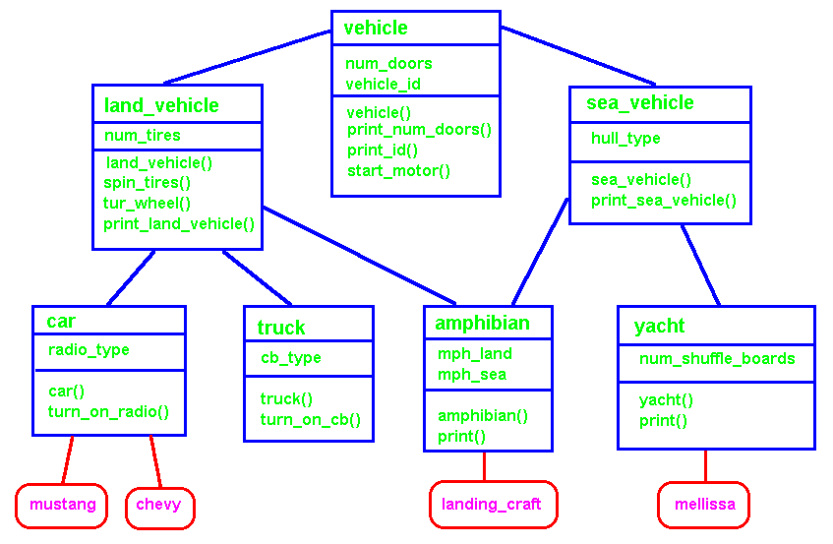

Multiple Inheritance

// file multinh1.c GNU
#include <iostream>
using namespace std;
#include <stdio.h>

class vehicle{
private:
int num_doors;
char *vehicle_id;
public:
vehicle( int ndoors, char* id) { num_doors = ndoors; vehicle_id = id;}
void print_num_doors( ){ cout << "Number of doors is " <<num_doors<< ".\n";}
void print_id( ){ cout << "Vehicle id = " << vehicle_id << ".\n";}
void start_motor( ) { cout << "Vehicle start motor. \n";}
};

class land_vehicle : public vehicle
{ private:
int num_tires;
public:
land_vehicle(int ntires, int ndoors, char* id) : vehicle( ndoors, id)
{ num_tires = ntires;}
void spin_tires( ){ cout<<"Spin " << num_tires << " tires on pavement.\n";}
void turn_wheel( ){ cout << "Turn land vehicle wheel. \n";}
void print_land_vehicle(){ print_id(); print_num_doors( ); }
};

class car : public land_vehicle
{ private:
char* radio_type;
public:
car(char* rtype, int ntires, int ndoors, char* id)
: land_vehicle( ntires, ndoors, id) { radio_type = rtype;}
void turn_on_radio( ){ cout << "Turn on car radio.\n";}
};

class truck : public land_vehicle
{ private:
char* cb_type;
public:
truck( char* cb, int ntires, int ndoors, char* id)
: land_vehicle( ntires, ndoors, id) { cb_type = cb;}
void turn_on_cb( ){ cout << "Turn on CB.\n"; }
};
class sea_vehicle : public vehicle
{ private:
char* hull_type;
public:
sea_vehicle( char* hull, int ndoors, char* id) : vehicle( ndoors, id)
{ hull_type = hull;}
void print_sea_vehicle( ){print_id(); print_num_doors();
cout << "Hull type is " << hull_type << ".\n";}
};

class yacht : public sea_vehicle
{ private:
int num_shuffle_boards;
public:
yacht( int nsboards, char* hull, int ndoors, char* id)
: sea_vehicle(hull, ndoors, id)
{ num_shuffle_boards = nsboards;}
void print( ){ print_sea_vehicle();
cout << "Number of shuffle boards = "
<< num_shuffle_boards << ".\n";}
};

class amphibian : public land_vehicle, public sea_vehicle
{ private:
float mph_land, mph_sea;
public:
amphibian( char* rtype, int ntires, int ndoors,
char* id, int nsboards, char* hull, int mphland, int mphsea)
: land_vehicle( ntires, ndoors, id), sea_vehicle( hull, ndoors, id)
{ mph_land = mphland; mph_sea = mphsea;}
void print( ) { print_land_vehicle(); sea_vehicle::print_sea_vehicle();}
};
int main( )
{
car mustang("AM/FM", 4, 4, "Ford");
mustang.print_id( );
mustang.turn_on_radio( );
mustang.start_motor( );
printf("\n");

car chevy("AM/FM/Tape", 4, 2, "Chevy");
chevy.print_id( );
chevy.turn_on_radio( );
chevy.start_motor();
cout << "Number of doors is ";
chevy.print_num_doors( );
printf("\n");

yacht mellissa( 4, "mono hull", 6, "Mellissa");
mellissa.print( );
printf("\n");

amphibian landing_craft("cb", 8, 0, "landing craft", 0, "mono", 65, 30);
landing_craft.print( );
cout << "\n\n";

landing_craft.land_vehicle::start_motor( );
landing_craft.sea_vehicle::start_motor( );
return 0;
}

Vehicle id = Ford.
Turn on car radio.
Vehicle start motor.

Vehicle id = Chevy.
Turn on car radio.
Vehicle start motor.
Number of doors is Number of doors is 2.

Vehicle id = Mellissa.
Number of doors is 6.
Hull type is mono hull.
Number of shuffle boards = 4.

Vehicle id = landing craft.
Number of doors is 0.
Vehicle id = landing craft.
Number of doors is 0.
Hull type is mono.

Vehicle start motor.
Vehicle start motor.
// Virtual Base Classes
// file multinh3.c GNU
#include <iostream>
using namespace std;

class Adam{ // As a virtual base class, only one
private: // instance of data elements exist
int adam1; // in derived classes with multiple .
public: // inheritance.
Adam( ){ adam1 = 10;}
void put_adam1( ){ cout << "adam1 = " << adam1 << ".\n";}
};

class Betty: virtual public Adam {
private:
int betty1;
public:
Betty( ){ betty1 = 20;}
void put_betty1( ){ cout << "betty1 = " << betty1 << ".\n";}
};

class Cindy: virtual public Adam {
private:
int cindy1;
public:
Cindy( ){ cindy1 = 30;}
void put_cindy1( ){ cout << "cindy1 = " << cindy1 << ".\n";}
};

class David : public Betty, public Cindy { // Multiple inheritance of Adam
private:
int david1;
public:
David( ){ david1 = 40;}
void put_david1( ){ cout << "\nPrint whole family \n"
<< "david1 = " << david1 << ".\n";
put_cindy1( ); put_betty1( ); put_adam1( );}
};

// A default initializer must be specified for virtual base
// classes.

int main( )
{
David family; // Multiple inheritance of virtual base class
// Adam but only one cope of instance variables.

family.put_adam1( );

family.put_betty1( );

family.put_cindy1( );

family.put_david1( );

return 0;
}

c:\>multinh3
adam1 = 10.
betty1 = 20.
cindy1 = 30.

Print whole family
david1 = 40.
cindy1 = 30.
betty1 = 20.
adam1 = 10.

 |  |  |  | Vehicle
Num doors
Vehicle id
 |  |  |  | startEngine
 | Land vehicle |  |  |  |  |  |  | Sea Vechile
 | tires |  |  |  |  |  |  | hull
 |  |  |  |  |  |  |  | startEngine
Car |  |  | Truck |  |  |  | Amphibian |  | Yacht
Radio |  |  | CB |  |  |  | Mph_land  Mph_sea |  | Shuffle board
 |  |  |  |  |  |  | startEngine

Depending on the language, “Amphibian” has one or two copies of the common parent’s data structure, i.e., num_doors and vehicle_id. Many object oriented languages give a single occurrence of common parent data structures as though they are from the first parent in the declaration of the multiple inheritance. C++ allows the programmer to specify either a single or both copies of the common data structures and overloaded methods. This flexibility results in a loss of ability to manipulate the parent without knowledge of its implementation.

To avoid confusion with respect to overloaded function names and data structures, languages like Java and Ada only allow single inheritance. The effects of multiple inheritance must be accomplished via clever design, embedding, or interfaces (Java).

// file multinh2.c GNU
#include <iostream>
using namespace std;

class vehicle{
private:
int num_doors;
char *vehicle_id;
public:
vehicle( ){num_doors = 2; vehicle_id = "EighteenWheller";}
vehicle( int ndoors, char* id) { num_doors = ndoors; vehicle_id = id;}
void print_num_doors( ){ cout << "Number of doors is " <<num_doors<< ".\n";}
void print_id( ){ cout << "Vehicle id = " << vehicle_id << ".\n";}
void start_motor( ) { cout << "Vehicle start motor. \n";}
};

class land_vehicle : virtual public vehicle //Virtual base class
{ private:
int num_tires;
public:
land_vehicle( ): vehicle( 2, "EighteenWheller"){num_tires = 18;}
land_vehicle(int ntires, int ndoors, char* id) : vehicle( ndoors, id)
{ num_tires = ntires;}
void spin_tires( ){ cout<<"Spin " << num_tires << " tires on pavement.\n";}
void turn_wheel( ){ cout << "Turn land vehicle wheel. \n";}
void print_land_vehicle( ){ print_id(); print_num_doors(); }
};

class car : public land_vehicle
{ private:
char* radio_type;
public:
car( ):land_vehicle( ){radio_type = "mono";};
car(char* rtype, int ntires, int ndoors, char* id)
: land_vehicle( ntires, ndoors, id)
{ radio_type = rtype;}
void turn_on_radio( ){ cout << "Turn on car radio.\n";}
};
class truck : public land_vehicle
{ private:
char* cb_type;
public:
truck( char* cb, int ntires, int ndoors, char* id)
: land_vehicle( ntires, ndoors, id)
{ cb_type = cb;}
void turn_on_cb( ){ cout << "Turn on CB.\n"; }
};
class sea_vehicle : virtual public vehicle // Virtual base class
{ private:
char* hull_type;
public:
sea_vehicle( char* hull, int ndoors, char* id) : vehicle( ndoors, id)
{ hull_type = hull;}
void print_sea_vehicle( ){print_id( ); print_num_doors( );
cout << "Hull type is " << hull_type << ".\n";}
};
class yacht : public sea_vehicle
{ private:
int num_shuffle_boards;
public:
yacht( int nsboards, char* hull, int ndoors, char* id)
: sea_vehicle(hull, ndoors, id)
{ num_shuffle_boards = nsboards;}
void print_yacht( ){ print_sea_vehicle();
cout << "Number of shuffle boards = "
<< num_shuffle_boards << ".\n";}
};

class amphibian : public land_vehicle, public sea_vehicle //one copy – virtual base class
{ private:
float mph_land, mph_sea;
public:
amphibian( char* rtype, int ntires, int ndoors,
char* id, int nsboards, char* hull, int mphland, int mphsea)
: land_vehicle( ntires, ndoors, id),
sea_vehicle( hull, ndoors, id)
{ mph_land = mphland; mph_sea = mphsea;}
void print( ) { print_land_vehicle(); print_sea_vehicle( );}
};

main( )
{
car mustang("AM/FM", 4, 4, "Ford");
mustang.turn_on_radio( );
mustang.start_motor( );
yacht mellissa( 4, "mono hull", 6, "Mellissa");
mellissa.print_yacht( );

amphibian landing_craft("cb", 8, 0, "landing craft", 0, "mono", 65, 30);
landing_craft.print( );
cout << "\n\n";
landing_craft.land_vehicle::start_motor( );
landing_craft.sea_vehicle::start_motor( );
}

Turn on car radio.  Vehicle start motor.  Vehicle id = EighteenWheller.  Number of doors is 2.  Hull type is mono hull.  Number of shuffle boards = 4.  Vehicle id = EighteenWheller.  Number of doors is 2. | Vehicle id = EighteenWheller.  Number of doors is 2.  Hull type is mono.  Vehicle start motor.  Vehicle start motor.

Inheritance in Derived Classes

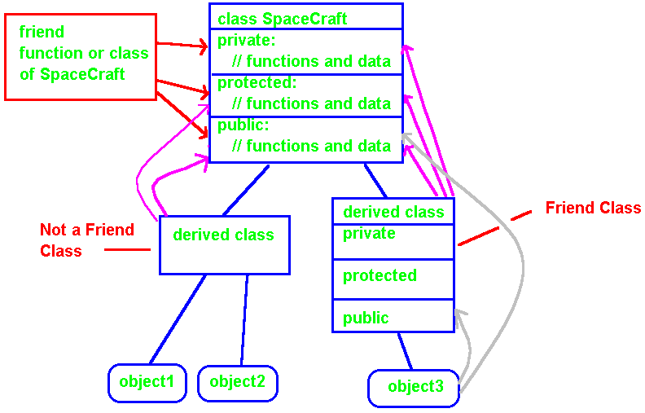

In general, a “friend” class or function has full access to all private and protected data / methods as well as all public data and methods.

A class derived directly from a base class has access to all public data / methods, and protected data / methods in the base class, but has no access to private data / methods in the base class.

Further, the base class public data and methods may be passed to (inherited by) classes or objects constructed (derived) from the first derived class but the protected portions of the base class are not automatically accessable in the second level derived class or object.

PUBLIC: The member may be used by any function.

PRIVATE: The member may be used only by member functions and friends of the class in which it is declared.

PROTECTED: The same as private with the addition the member can be used by member functions and friends of classes derived from the declared class, but only in objects of the derived type.
//file pub1.c
class Congress{
int money; // Congress::money is private by default
char* senator, representative; // also private
public:
int press_rep1; //public access
int pressrep2;
protected:
int skeleton1; // Congress::skeketon1 is protected
};

struct aid{
char* aid_name; // aid::aid_name is public by default
private:
char* aids_nick_name; // private
public:
float salary; // aid::salary is public
};

union voting_record{
int truth; // public by default, there is no other choice
double lies;
};

- PUBLIC: The member can be used by any function.

- PRIVATE: The member can only be used by member functions and friends of the class in which it is declared.

- PROTECTED: Same as private except the member can be used by member functions and friends of classes derived from the declared class, but only in objects of the derived type.

Members of a class are private by default.

Members of a struct are public by default.

Members of a union must be public; this may not be changed.

Base and Derived Class Access
//file pub2.c
class A { };

class B { };

struct C { };

struct D { };

class W: A { }; //Default for class is "private A".

class X: A, public B { };
// Members of A are private, members of B are public.

struct Y: C { }; // Default for struct C is "public"

struct Z: C, private D { };
// C defaults to "public," struct D is private.

The default is private if “A” is a class declaration and public if “A” is a struct declaration.

PUBLIC base class: |  | Public members of a base class are public members of a derived class. Protected members of a base class are protected members of a derived class. Private members of a base class remain private to the base class.
PROTECTED base class |  | Both public and protected members of the base class are protected members of the derived class. Private members of the base class remain private to the base class.
PRIVATE base class |  | Both public and protected members of the base class are private members of the derived class. Private members of the base class remain private to the base class.

Private members of a base class remain private unless “friend” declarations explicitly grant access rights.
Adjusting the Effect of Access Specifiers

// in file pub3.cpp, adjusting the effect of access specifiers. GNU
#include <iostream>
using namespace std;

class Parent {
int a, b; // private by default.
protected:
int pvar;
public:
int c, d;
void pfunc1(void){cout << "Parent pfunc1() \n";}
};

class Child1: private Parent{
// a, b, pvar, c, d, and pfunc1 are private in Child1.
// Note "a" is not directly accessible in Child1.
int e; // Private by default.
public:
Parent::c; // "c" was private to parent but is now public.
int f;
void cfunc1( ){cout << "Child1 cfunc1( ) \n";}
// cfunc1( ) in Child1, which is derived from "private Parent"
// has access to:
// 1) adjusted-to-public Parent::c
// 2) private-to-Child1 members from Parent are pvar, d,
// and pfunc1( ),
// 3) its own private and public members e, f, and cfunc1( )
};

int ExtFunc(Child1& pt){ }; // Can only access c, f, cfunc1( ).
// in file pub4.cpp, adjusting the effect of access specifiers. GNU
#include <iostream>
using namespace std;
class Parent {
private:
int a, b; // private by default;
protected:
int pvar1, pvar2;
public:
int c, d;
Parent(){a=1; b=2; pvar1=10; pvar2=20;}
void pfunc1(void){cout << "Parent pfunc1() \n";}
};
class Child1: public Parent{// a, b, are private to Parent.
// pvar1, and pvar2 from Parent are protected but accessible.
int e; // Private by default.
public:
Child1( ):Parent(){e=30; f=40;}
// Parent::pvar1;//Illegal attempt to grant access to protected variable.
int f;
void cfunc1( ){cout << "Child1 cfunc1() \n";}
void inc_pvar1( ){ Parent::pvar1++; pvar2++;}
// Functions can access pvar1, pvar2, c, d, and pfunc1() from Parent
// as well as all data structures and functions in Child1.
};

int ExtFunc(Child1& pt){ }; // Can access c, d, and pfunc1() from Parent
// as well as all public data structures and functions in Child1.

class GrandChild : public Child1{
private:
int j,k;
void gcfunc1( ){cout << "Hello";}
public:
int l,m;
GrandChild( ):Child1(){j=40; k=50; l=60; m=70;}
void gcfunc2(void){cout << "Hello gcfunc2. \n";}
void gcfunc3( ) { pvar1++; cout << "pvar1 = " << pvar1 << "\n"; }
// Note access to protected variables in Parent.
};
int main( ){
GrandChild gc1;
gc1.gcfunc3( );
// cout << "pvar1 = " << pvar1 << "\n";
//Illegal attempt to access protected variable.
}
Execution Results: pvar1 = 11
//file pets1.c, sample polymorphism and run-time (dynamic) binding - GNU
#include <stdio.h>

struct pet {
// private, protected, and public data & method declarations
// common to all pets

virtual void speak( ) {puts("In pets");} //function definition
};

struct dog : pet{
Bow Wow
Bow Wow
Meow, Purr
Whistle
glub, glub
Change fish to a cat!

Meow, Purr
Bow Wow
void speak( ) {puts("Bow Wow"); }
};

struct cat : pet{
void speak( ) {puts("Meow, Purr"); }
};

struct bird : pet{
void speak( ) {puts("Whistle"); }
};

struct fish : pet{
void speak( ) {puts("glub, glub"); }
};

// aggregate initialization of menagerie

pet* menagerie[ ] = {new dog, new dog, new cat, new bird, new fish};
// objects created on the heap and initialized by the compiler.
// Space for 5 objects reserved in “menagerie” at compile time, created run time!

const int sz = sizeof(menagerie) / sizeof(menagerie[0]);

int main(void) {
dog fido;

for (int i = 0; i < sz; i++) menagerie[i] -> speak( ); //polymorphism

puts("Change the fish to a cat!\n");
menagerie[4] = new cat;
menagerie[4] -> speak( );

fido.speak( ); //simple message to fixed object
return 0;
} //Research indicates many require 12 to 18 months to master polymorphism.
//file pets2.cpp, compile-time (static) binding, GNU
#include <stdio.h>

struct pet {
// private, protected, and public data & method declarations
// common to all pets

void speak( ) {puts("In pets");} //function definition – left off “virtual!”
};

struct dog : pet{
In pets
In pets
In pets
In pets
In pets
Change fish to a cat!

In pets
Bow Wow
void speak( ) {puts("Bow Wow"); }
};

struct cat : pet{
void speak( ) {puts("Meow, Purr"); }
};

struct bird : pet{
void speak( ) {puts("Whistle"); }
};

struct fish : pet{
void speak( ) {puts("glub, glub"); }
};

// aggregate initialization of menagerie

pet* menagerie[ ] = {new dog, new dog, new cat, new bird, new fish};
// objects created on the heap and initialized by the compiler

const int sz = sizeof(menagerie) / sizeof(menagerie[0]);

int main(void) {
dog fido;

for (int i = 0; i < sz; i++) menagerie[i] -> speak( ); //polymorphism

cout << "Change the fish to a cat!\n";
menagerie[4] = new cat;
menagerie[4] -> speak( );

fido.speak( ); //simple message to fixed object
return 0;
}
//file pets3.c, sample polymorphism and run-time (dynamic) binding, GNU
#include <stdio.h>
#include <iostream>
using namespace std;

enum pet_type{dog_type, cat_type, bird_type, fish_type};

struct pet {
// private, protected, and public data & method declarations common to all pets
void speak(pet_type a_pet) {
c:\>pet3
In general print wrong answer!
i=0 Bow Wow
i=1 Meow Purr
i=2 Whistle
I=3 Glub Glub
i=4
Ask fish to speak.

Force fish to err in speech.
Bow Wow

Change the fish to a cat!
Meow Purr

Let fido speak: in dog Bow Wow

Let perch speak: In perch Glub Glub
switch(a_pet)
{
case dog_type: puts("Bow Wow"); break;
case cat_type: puts("Meow Purr"); break;
case bird_type: puts("Whistle"); break;
case fish_type: puts("Glub Glub"); break;
}
}
};

struct dog : pet{
void speak() {cout << "in dog “; pet::speak(dog_type);}
};

struct cat : pet{ void speak( ) {cout << "in cat ";pet::speak(cat_type); } };
struct bird : pet{/* void speak( ){puts("Whistle"); */ }
//*** Note no overload for speak!! };
struct fish : pet{ void speak( ) {cout << "In perch ";pet::speak(fish_type); }};
pet* menagerie[ ] = {new dog, new dog, new cat, new bird, new fish};

const int sz = sizeof(menagerie) / sizeof(menagerie[0]);

int main(void) {
dog fido;
fish perch;

cout << "In general print wrong answer!\n";
for(int i=0;i<sz;i++){cout << "i=" << i <<" "; menagerie[i] -> speak( pet_type(i) );}

cout << "\nAsk fish to speak.\n";
menagerie[4] -> speak( (pet_type) 4 );

cout << "\nForce fish to err in speech.\n";
menagerie[4] -> speak(dog_type);

cout << "\nChange the fish to a cat!\n";
menagerie[4] = new cat;
menagerie[4] -> speak(cat_type);

cout << "\nLet fido speak: "; fido.speak( ); //simple message to fixed object
cout << "\nLet perch speak: "; perch.speak( );

return 0;
}
//file poly1.cpp Use of virtual functions (polymorphism). Based on "An Introduction to //Object-//Oriented Programming and C++" by Richard S. Wiener and Lewis J. Pinson,
//page 148 GNU
#include <stdio.h>
class parent {
protected:
char version;
int main( )
{
parent b;
derived1 d1(3);
derived2 d2(15);
derived3 d3(-565);
print_info(&b);
print_info(&d1);
print_info(&d2);
print_info(&d3);
return 0;
}

c:\>poly1
The parent. Version A
Derived1 info: 3. Version 1
Derived2 info: 15. Version A
Derived3 info: -565. Version 3
public:
parent( ) { version = 'A';}
virtual void print( )
{ printf("\nThe parent. Version %c", version); }
}; //end of parent

class derived1: public parent
{ private:
int info;
public:
derived1(int number) {info = number; version = '1';}

void print( )
{printf("\nDerived1 info: %d. Version %c”, info,version);}
}; //end derived1

class derived2 :public parent
{ private:
int info;
public:
derived2(int number){ info = number;} // Implied parent constructor call.

void print() { printf("\nDerived2 info: %d. Version %c", info, version);}
}; //end derived2

class derived3 : public derived1
{private:
int info;
public:
derived3(int number) : derived1(number) // Explicit parent constructor call.
{ info = number; version = '3'; }

void print( ) { printf("\nDerived3 info: %d. Version %c", info, version);}
}; //end derived3

/*The virtual function print() is able to determine appropriate action from the type of object referenced by the info_holder pointer and not from the type of pointer. If print() were not a virtual function, the action would always be determined by the type of pointer, namely parent pointer. Thus "The Parent" would always be printed out.
*/
void print_info(parent* info_holder) { info_holder -> print( ) }
//file polly4.c GNU
#include <iostream>
using namespace std;
class Parent_Class
{ public:
void fnc1( ){ cout << "Parent fnc1( ) \n";}
void fnc2( ){ cout << "Parent fnc2( ) \n";}
virtual void fnc3( ){ cout << "Parent fnc3( ) \n";}
};

class Derived1 : public Parent_Class
{ public:
void fnc1( ){ cout << "Derived1 fnc1( ) \n";}
void fnc2( ){ cout << "Derived1 fnc2( ) \n";}
void fnc3( ){ cout << "Derived1 fnc3( ) \n";}
};

class Derived2 : public Parent_Class
{ public:
void fnc1( ){ cout << "Derived2 fnc1( ) \n";}
void fnc2( ){ cout << "Derived2 fnc2( ) \n";}
void fnc3( ){ cout << "Derived2 fnc3( ) \n";}
};
c:\>polly4
Parent fnc3( )
Parent fnc1( )
Parent fnc2( )

Derived1 fnc3( )
Parent fnc1( )
Parent fnc2( )

Derived2 fnc3( )
Parent fnc1( )
Parent fnc2( )

obj2 Derived2 fnc1( )

obj2 Derived2 fnc2( )

obj2 Derived2 fnc3( )
void main()
{ Parent_Class *parent_pt = new Parent_Class;
Derived1 *derived1_pt = new Derived1;
Derived2 *derived2_pt = new Derived2;

Derived2 obj2;

parent_pt -> fnc3( ); // function 3 in parent
parent_pt -> fnc1( );
parent_pt -> fnc2( );
cout << "\n";

parent_pt = derived1_pt;
parent_pt -> fnc3( ); // function 3 in derived1
parent_pt -> fnc1( );
parent_pt -> fnc2( );
cout << "\n";

parent_pt = derived2_pt;
parent_pt -> fnc3( ); // function 3 in derived2
parent_pt -> fnc1( );
parent_pt -> fnc2( );
cout << "\n";

cout << "obj2 "; obj2.fnc1( ); cout << "\nobj2 "; obj2.fnc2( );
cout << "\nobj2 "; obj2.fnc3( );

// derived2_pt = parent_pt; //Illegal, cannot convert 'Parent_Class *' to 'Derived2 *'
}
//file struct1.c GNU
//from "The C++ Programming Language" by Bjarne Stroustrup, page 135
#include <iostream.h>

struct date { int month, day, year;};

void set_date(date* date_pt, int mon, int d, int yr)
{
date_pt->month = mon; date_pt->day = d; date_pt->year = yr;
}

void next_date(date* date_pt)
{
date_pt->day = date_pt->day + 1;
}

void print_date(date* date_pt){
cout << date_pt->month << "/" << date_pt->day << "/" << date_pt->year
<< "\n\n";
}
main( )
{
$./struct1
1/15/1947

1/16/1947

1/16/1947
date day1, day2;
date* p1;
p1 = &day1;
set_date(p1,1,15,1947);
print_date(&day1);
next_date(&day1);
print_date(&day1);

// Uncontrolled (unstructured) access to a date variable.
// Note that there is no explicit connection between the functions
// and the data type DATE.
day2.month = day1.month; day2.day = day1.day; day2.year =
day1.year;
print_date(&day2);
}

//file struct2.c GNU
//from "The C++ Programming Language" by Bjarne Stroustrup, page 135
//
//This program establishes an explicit connection between the structure
//DATE and the functions that manipulate it. The functions may only be
//involked for a specific variable of the appropriate type using the
//standard syntax for structure member access. C++ does type checking.`
#include <iostream.h>

struct date { int month, day, year;

void set_date( int mon, int d, int yr)
{
month = mon; day = d; year = yr;
}

void next_date( )
{
day = day + 1;
}

void print_date( )
{
cout << month << "/" << day << "/"
<< year << "\n\n";
}
}; // end structure and associated functions
c:\>struct2
1/15/1947

1/16/1947

1/16/1947

main( )
{
date day1, day2;
day1.set_date(1,15,1947);
day1.print_date( );
day1.next_date( );
day1.print_date( );

// Uncontrolled (unstructured) access to a date variable but,
// the functions are only associated with dates.
day2.month = day1.month; day2.day = day1.day; day2.year = day1.year;
day2.print_date( );
}
//FILE wp_44.c GNU
//Anonymous Unions
#include "iostream"
using namespace std;

main( ){

struct data_rec
{
char *last_name;
char *first_name;
int id_number;
union
{
float annual_salary; // Storage for the largest field(s) is reserved
int hourly_wage; // by the compiler but a record has only one of
// the fields.
};
};

data_rec r1, r2;

r1.last_name = "Jones";
r1.first_name = "Sam";
r1.id_number = 1234;
r1.annual_salary = 123.56;
cout << "My annual salary = " << r1.annual_salary << "\n";

r2.last_name = "Jones";
r2.first_name = "Mary";
r2.id_number = 4256;
r2.hourly_wage = 184;
cout << "My hourly wage is " << r2.hourly_wage << "\n";
}

c:\>w&p_44
My annual salary = 123.559998
My hourly wage is 184

class Share{
private:
int a;
static int b;
public:
Share( ) {a = 0;};
void inca( ) {a++;}
void incb( ) {b++;}
void print( ){cout << "a = " << a << " and b = " << b << ".\n";}
static void initial_b( ) { b = 0;}
};
int Share::b =0; // Proper method for initializing static data members.

Note that the local variable “a” in obj1 is not affected by operations done on variable “a” by obj2, obj3, or obj4. The shared variable “b” however reflects all updates. Variables should be declared static if all objects of a specific type must share the same information. An example might be a counter reflecting the frequency with which a particular function is called by all members of a class. The static counter would be incremented by the local object functions on each call.
//static1.c GNU
#include <iostream>
using namespace std;

class Share{
private:
int a;
static int b;
public:
Share( ) {a = 0;};
void inca( ) {a++;};
void incb( ) {b++;};
void print( ){cout << "a = " << a << " and b = " << b << ".\n";}
static void initial_b( ) { b = 0;}
};
int Share::b =0; // Proper method for initializing static data members.

int main( )
{
Share obj1, obj2;

obj1.inca( ); obj1.incb( );
cout << "In object 1 "; obj1.print( );

obj2.inca( ); obj2.incb( );
cout << "In object 2 "; obj2.print( );

cout << "\nNow object one increments its local and shared variable!\n";
obj1.inca( ); obj1.incb( ); obj1.print( );
obj1.inca( ); obj1.incb( ); obj1.print( );
cout << "\nIn object 2 "; obj2.print( );
Share::initial_b( ); // Example of global maintenance for all class objects.
cout << “\nIn object 2 “; obj2.print( );
}

c:\>static1
In object 1 a = 1 and b = 1.
In object 2 a = 1 and b = 2.

Now object one increments its local and shared variable!
a = 2 and b = 3.
a = 3 and b = 4.

In object 2 a = 1 and b = 4.

In object 2 a = 1 and b = 0.
//file const1.c GNU
//Constants in C++ are variables that have fixed values that may not
//be updated. Constants give the translator an opportunity to generate
//more efficient code.
//In C++ version three you may declare constant functions. A constant
//function is not supposed to modify its parameter list.

#include <iostream>
using namespace std;
int main( )
{
const int a = 32000; // Old ISO default type is int
const long b = 36000L; // Old ISO default long if the value will not fit in an int
const int c = 0123; // Old ISO default octal constant = 83 base 10.
// Octal constants start with a 0.
const int d = 0x1f; // Old ISO default hexadecimal constants contain an x.
const double pi8 = 3.14159265;
//
// A character constant is enclosed in quote marks. Internally it is
// carried as an integer. For example in ASCII the value of '0' is 48
// while in EBCDIC it is 240. The following single character constants
/* have special meanings in C++.
'\b' backspace
'\f' formfeed
'\n' newline
'\r' carriage return
'\t' horizontal tab
'\v' vertical tab
'\\' backslash
'\'' single quote
'\"' double quote
'\0' null, the integer value 0

It is also possible to represent a character as a one-, two-, or
three-digit octal number (or hex). This makes it possible to embed
characters in character strings.
*/
cout << a << " " << b << " " << c << " " << pi8 << "\n\n";
cout << d << "\n\n";
cout << "beep at end of message \007\007";
}

32000 -29536 83 3.141593

31

beep at end of message if your sound is turned on
//file const2.c
Constants may be defined as local to a file in C++ by using the const specifier. This avoids polluting the global name space as might be done using #define with macros:

const int MAX_STACK_SIZE = 100; // These are local to the file where defined.
const char *const pgmname = "Shuttle";

Constants may be share across many files by declaring them as extern. The "extern" declarations are normally placed in a commonly included header file as:
extern const double e;
A single definition of the value must be placed in a convenient program source file ( normally .C or .cpp):

#include <math.h>
extern const double e = exp(1.0);

Note that C++ guarantees that variables are initialized in the order of their appearance within a given source file.*** Note there is no guarantee with respect to ordering of global class objects across multiple source files. ***

Problem: The value of static member values of a class may not be bound at compile time and hence may not be used for array bounds etc.

static const int SIZE1 = 10;
class error1{
static const int SIZE2;
char array1[SIZE1]; // Allowed, legal.
char array2[SIZE2]; // Illegal, SIZE2 is not yet known.
};
const int error1::SIZE2 = 20;

// Work around.
#include <iostream.h>
class works{
private:
int a;
enum { SIZE2 = 20}; // Simulates a constant.
char array1[SIZE2];
public:
char array2[SIZE2];
void fnc1() const { cout << " a = " << a; }
// const member functions are not supposed to modify their objects' data.
};
//file wp47_2.c GNU
//default arguments

#include <iostream>
using namespace std;

void func1( int first,
float second = 36.6,
char third = 'c',
char* forth = "default 4")
{
cout << first << " " << second << " " << third << " "
<< forth << "\n\n";
}

int main( ) // Default arguments may only be trailing arguments.
{
func1(20);

func1(30, 12.2);

func1(40, 15.2, 'k');

func1(50, 17.2, 'm', "hope");
}

$ g++ -o wp47_2 wp47_2.c
$ wp47_2
20 36.599998 c default 4

30 12.2 C default 4

40 15.2 k default 4

50 17.2 m hope

Stream I/O
//wp99.c GNU

#include <iostream>
using namespace std;

int main( )
{
int i;
float r;
char name[80];

cout << "\nEnter an integer: ";
cin >> i;
cout << "\nThe integer is " << i << ".";

cout << "\n\nEnter a real number: ";
cin >> r;
cout << "\nThe real is " << r << ".";

cout << "\n\nEnter your name (80 char max): \n";
cin >> name;
cout << "\nYour name is \"" << name << "\".";
return 0;
}

Enter an integer: 45
The integer is 45.

Enter a real number: 37.87
The real is 37.869999.

Enter your name (80 char max): David Burris

Your name is "David".

//file wp_46.c GNU
//Function Prototypes - C++ data type promotions
//
#include <iostream>
using namespace std;
/* function prototypes */

void function_1(int a,int b);
void function_2(float c, float d);

/* The current ISO Standard no longer allows these defaults!
void function_3(a, b) //Default type is int, no type checking realistic.
{ cout << "a = " << a << " b = " << b << "\n\n"; }

void function_4(c, d) // Style is now obsolete.
float c, d;
{ cout << "c = " << c << " d = " << d << "\n\n"; }
*/

int main( )
a = 4 b = 5

c = 5.8 d = 8.7

a = 5 b = 8

c = 4 d = 5
{
int i = 4,
j = 5;
float k = 5.8,
l = 8.7;

function_1(i,j); function_2(k,l);

function_1(k,l); function_2(i,j);

// function_3(k,l); function_4(i,j); //illegal under new standard
}

void function_1(int a, int b) //c++ type checking is possible
{ cout << "a = " << a << " b = " << b << "\n\n"; }

void function_2(float c, float d) //c++ type checking is possible
{ cout << "c = " << c << " d = " << d << "\n\n"; }

//file wp23.c GNU
//from "An Introduction to Object-Oriented Programming and C++" by
//Richard S. Wiener and Lewis J. Pinson, page 23.
#include <stdio.h>
const int size = 100; //The value of constants may not be changed in
//their scope.
float data[size]; //Array of 100 elements (0-99) all initialized 0.0
char title[ ] = "A First Program";
int main( )
{
float square(float *value, int n = size);
//Note the default value for the second call parameter. If the
//function is only called with one parameter the default is used.
extern void input_values(float *scores, int n);
//ANSI now requires the compiler to do type checking.
//VOID is used for a function that does not return a value
//Extern normally means defined in another file.
int num_values;
printf("%s", title);
printf("\n\nHow many values must be squared: ");
scanf("%d", &num_values);
input_values(data,num_values);
printf("\nThe sum of the square of values = %f", square(data));
}

float square(float value[ ], int n)
{
float sum = 0.0;
for (int i = 0; i < n; i++) sum += value[i] * value[i];
return sum;
}
// Note the declaration and initialization in the above "for" loop.
// C++ allows variables to be declared almost any where. Programmers are //encouraged not to declare variables until needed. Once declared a variable //may be used any where in its scope of reference.

void input_values(float scores[ ], int n)
A First Program

How many values must be squared: 3
Enter score 1: -1
Enter score 2: 2
Enter score 3: 3
The sum of the square of values = 14.000000
{
for (int i = 0; i < n; i++)
{
printf("\nEnter score %d: ", i+1);
scanf("%f", &scores[i]);
}
}

//in file call_by.cpp GNU
#include<iostream>
using namespace std;
/* Declarations no longer allowed in C++
add1(i) /* standard C call by value, style is obsolete!!!! */
int i;
{ i++; cout << "\nIn add1 i = " << i << " C-B-V"; return i;}

add2(i) /* standard C call by reference, style is obsolete!!! */
int *i;
{ (*i)++; cout << "\nIn add2 i = " << *i << " C-B-R"; return *i;}
*/
add3(int i) /* C++ call by value */
{ i++; cout << "\nIn add3 i = " << i << " C-B-V"; return i;}

add4(int &i) /* C++ call by reference */
{ i++; cout << "\nIn add4 i = " << i << " C-B-R"; return i;}

Int main( )
{ extern int add3(int x); // “extern” typically means function
extern int add4(int &x); // is defined in another module.

int j = 3;

cout << "\nIn the main j = " << j;

add3(j); cout << "\nIn the main j = " << j << "\n";

add4(j); cout << "\nIn the main j = " << j;
}

c:\>call_by
In the main j = 3

In add3 i = 4 C-B-V
In the main j = 3

In add4 i = 4 C-B-R
In the main j = 4
//file w&p31_33.cpp, demonstration of call-by-reference (pass-by-reference)
#include <iostream.h> //program in turbo c++
//normal C pass-by-reference

void increment1(value) // Style is obsolute now !!!
int *value;
{
(*value)++; //increment the number at location value: value = value + 1;
}

void increment2(int &value)
{ // the "int &value" instructs the compiler to do type checking
// and to expect the "address" of the call parameter.
// This is a C++ call-by-reference
value++; // value = value + 1;
}

void increment3(int value)
{ //pass-by-value
int j;
j = value++;
cout << "j in increment 3 = " << j << "\n";
cout << "value in increment 3 = " << value++ << "\n";
value = j; //update of temporary "pass-by-value" location
}

main( )
c:\>w&p31_33
a = 2
a = 3

b = 24
b = 25

c = 89
j in increment 3 = 89
value in increment 3 = 90
c = 89
{
int a = 2;
int b = 24;
int c = 89;
cout << "a = " << a << "\n";
increment1( &a);
cout << "a = " << a << "\n\n";

cout << "b = " << b << "\n";
increment2(b);
cout << "b = " << b << "\n\n";

cout << "c = " << c << "\n";
increment3(c);
cout << "c = " << c << "\n";
}
//file w&p33_2.cpp
#include<stdio.h>
main( )
{ //call-by-reference to function swap
void swap(int &a, int &b);
int i = 7,
j = -3;
printf("The value of i = %d j= %d\n\n",i,j);

swap(i,j);
printf("The value of i = %d j= %d\n\n",i,j);
}

void swap(int &a, int &b)
{
int temp = b;
b = a, a = temp;
}

c:\>w&p33_2
The value of i = 7 j= -3

The value of i = -3 j= 7

//file wp26_1.c GNU
//programmer defined data types
//from "An Intorduction to Object-Oriented Programming and C++" by
//Richard S. Wiener and Lewis J. Pinson, page 26.
//
#include <iostream>
using namespace std;

typedef enum {red, green, amber} traffic_light_color;

typedef struct intersection
{
traffic_light_color traffic_light;
int number_cars_queued;
int cumulative_number_cars;
};

intersection network[50];
//
//Note that programmer defined data types are represented internally
//as integers. I/O is the responsibility of the programmer.
//
Int main( )
{
// ... work
network[1].traffic_light = red;
network[2].traffic_light = green;
network[3].traffic_light = amber;

cout << "The light at the first intersection is "
<< network[1].traffic_light << "\n";
cout << "The light at the second intersection is "
<< network[2].traffic_light << "\n";
cout << "The light at the third intersection is "
<< network[3].traffic_light << "\n";
}

The light at the first intersection is 0
The light at the second intersection is 1
The light at the third intersection is 2
//file wp26_2.c GNU
#include "iostream"
using namespace std;

typedef enum {red, green, amber} traffic_light_color;

struct intersection
{
traffic_light_color traffic_light;
int number_cars_queued;
int cumulative_number_cars;

//Redefinition of "<<" operator for Output.
//This also associates the function with the class, i.e., the
//function may only be used on variables of the class.

friend ostream& operator << (ostream &s, intersection &light);
};

ostream& operator << (ostream &s, intersection &light)
{
switch (light.traffic_light)
{
case red: return( s << "red");
case green: return( s << "green");
case amber: return (s << "amber");
}
}

intersection network[50];
//
//Note that programmer defined data types are represented internally
//as integers. I/O is the responsibility of the programmer.
int main( )
{
$ wp26_2
The light at the first intersection is red
The light at the second intersection is green
The light at the third intersection is amber
// ... work
network[1].traffic_light = red;
network[2].traffic_light = green;
network[3].traffic_light = amber;

cout << "The light at the first intersection is "
<< network[1] << "\n";
cout << "The light at the second intersection is "
<< network[2] << "\n";
cout << "The light at the third intersection is "
<< network[3] << "\n";
return 0;
}

