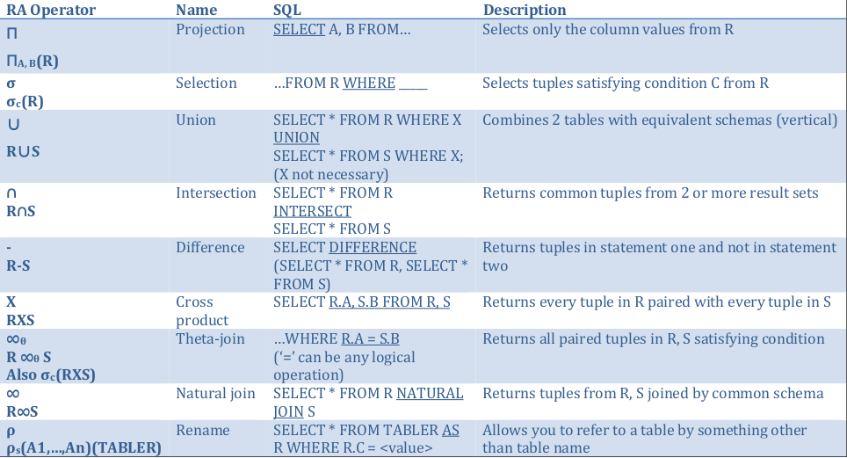
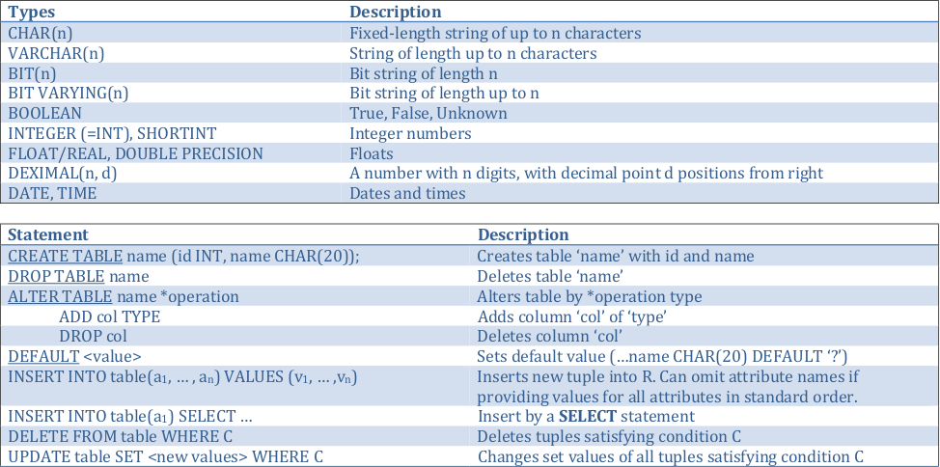
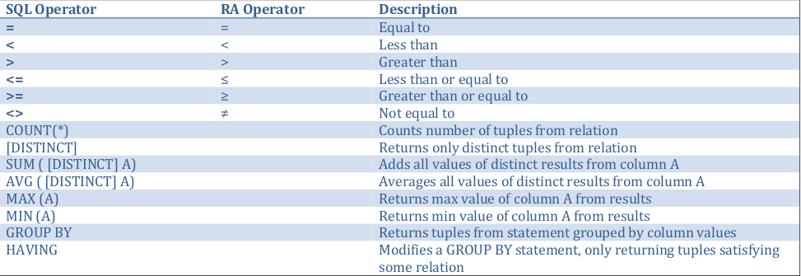
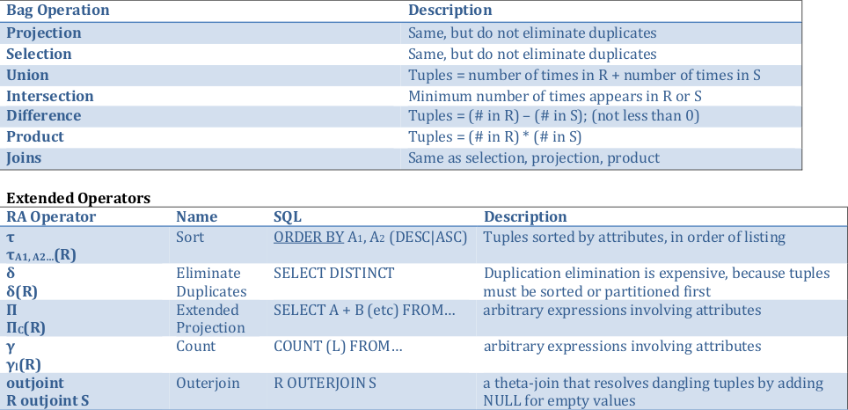
Keys:
• A set of attributes S is a key for a relation R if every pair of tuples in R disagree on at least one attribute in S.
• Select one key (one column or column combination) to be the PRIMARY KEY; declare other keys using UNIQUE
• A table can have at most one PRIMARY KEY, but more than one unique keysPrimary Keys:
• PID INT PRIMARY KEY
• or PRIMARY KEY (A 1 , A 2 )
Unique Keys:
• Any attribute that should not agree with another tuple in the relation can be declared unique
• You may have multiple unique keys
• You may have unique keys with value NULL
Multiple tuples cannot have the same key, and the key cannot be null.
Key constraints are enforced for UPDATE and INSERT operations
Foreign Keys:
• A 1 <type> REFERENCES T 2 (<attribute>) ⇽ for single attributes
• ..., FOREIGN KEY (a 1 , ... , a n ) REFERENCES T 2 (a 1 , ... , a n ) ⇽ for multiple attributes
• any attributes in the referred-to table must be UNIQUE or PRIMARY KEYs
Enforcing Referential Integrity:
1. Default policy is to reject:
a. inserting a tuple with a value not appearing in referenced table
b. updating a tuple with a value not appearing in referenced table
c. deleting a tuple in referenced table that is referenced as a FOREIGN KEY
d. updating a value in referenced table when the old value is one referenced by the referencing table
2. Cascade Policy:
1. if deleting a tuple that is referenced, delete all referencing tuples
2. if updating a tuple that is referenced, update all referencing tuples
3. Set-NULL Policy:1. if deleting a tuple that is referenced, set all referencing values to NULL
2. if updating a tuple that is referenced, set all referencing values to NULL
4. Designer Specified Policy:
1. The policy is set by designer at definition
2. ON DELETE SET NULL or ON UPDATE CASCADE (following key definition)
Constraints:
1. Set on table definition or modified
2. NOT NULL
3. CHECK (condition)
4. Named constraints : CONSTRAINT CName <conditions, etc> can be dropped with ALTER table DROP CONSTRAINT
CName
5. May be added with ALTER and ADD statement with option name and required CHECK statement
Triggers:
• Event = a class of changes in the DB, e.g., INSERT, DELETE
• Condition = a test as in a where clause for whether or not a trigger applies
• Action = one or more SQL statement
• When Event occurs, check Condition; if true, do Action
• CREATE TRIGGER name AFTER (INSERT ON|DELETE|UPDATE OF) table
REFERENCING (NEW ROW|NEW ROW) AS new (or old)
FOR EACH ROW
WHEN (condition)
<action statement>Lecture 6
A bag is a set that allows element repetition.
Duplicate elimination is expensive (sequential search) and some operations are more efficient with bags (projection).
When performing operations on bags, do not eliminate duplicates
Transactions
Why?
• Concurrent database access•
Resilience to system failures
Transaction: A sequence of one or more SQL statements treated as one unit.
May begin implicitly by executing a statement, or implicitly with BEGIN TRANSACTION, finishing with a COMMIT or
ROLLBACK statement.
ACID
A: Atomic → Either the entire transaction is executed or nothing is.
Each transaction is “all-or-nothing,” never half-executed.
C: Consistent → Database constraints preserved.
Each client, for each transaction can assume all constraints hold when transaction begins and must guarantee all
constraints hold when the transaction ends.
I: Isolated → It appears to the user as if only one process executes at a time.
Operations may be interleaved, but execution must be equivalent to some sequential order of transactions.
D: Durable → Effects of a process survive a system crash.
If the system crashes after commits, all effects of transaction remain in database.
Commit → Previous modifications are now permanent in the database.
Rollback → Causes the transaction to end, by aborting the process. Results in no effects on the database.
Failures like division by 0 or constraint violations can cause rollback without programmer intervention.
Interleaving Statements
max before min, delete before insert
Transactions solve the issue of interleaving two separate groups of statements from different users.
Isolation Levels (choices about what interactions are allowed by transactions that execute at about the same time)
1. Serializable → You see the database before or after other operations are completed.
2. Repeatable Read → Read committed, and everything seen the first time is seen the second time (and possible more).
3. Read Committed → You only see transactions that have been committed.
4. Read Uncommitted → Transactions see data even if the modifying transactions were not committed, and never are.

