Use case: As a user, I want to input the date, amount, purpose, and adding or spending money for adding a transaction (or more).

As a user, I want to input the initial date and final date, or initial amount and final amount for searching transaction.

Step1: Open the app.

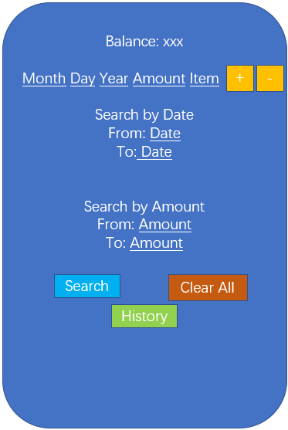

Step2: Input the date, amount, and, purpose.

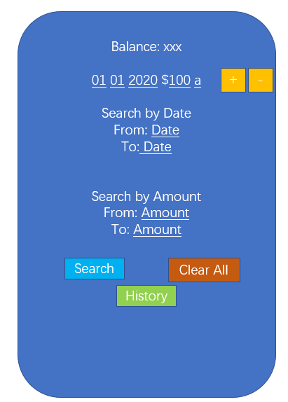

Step3: Press the “+” (or “-” ) button.

Step4: The current balance and history will be displayed.

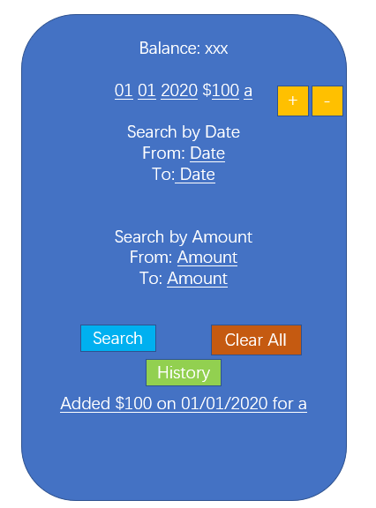

Step5: For searching transaction, we should input the range of date or amount.

