Use case: As a user, I want to input the date, amount, purpose, and adding or spending money for adding a transaction (or more).

Step1: Open the app.

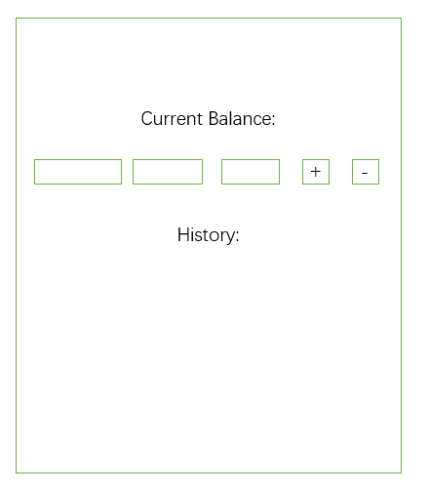

Step2: Input the date, amount, and, purpose.

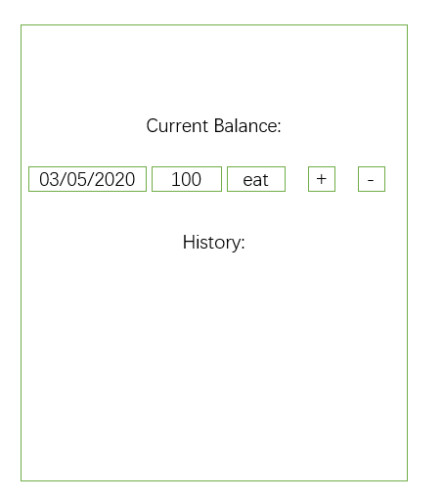

Step3: Press the “+” (or “-” ) button.

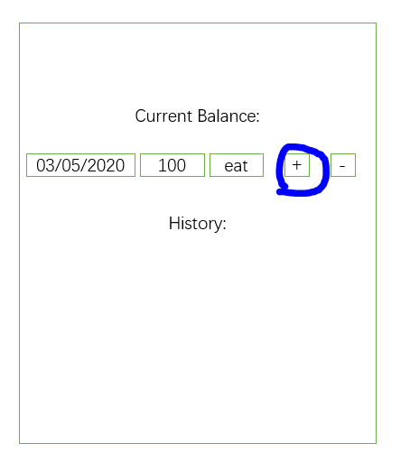

Step4: The current balance and history will be displayed.

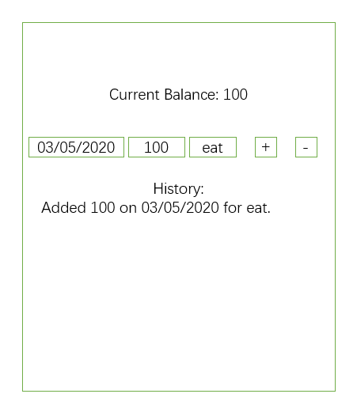

Step5: The current balance and history will be updated and displayed when the user has added another transaction.

