VirtualBox
Working with Virtual Machines

Cody Chand A01049580
Tristan Priestley A01089705

Table of Contents

Table of Contents 2
Introduction 3
1- Installation 3
Before Installing 3
2 - Creating a Virtual Machine 4
3 - Installing an ISO 7
4 - Creating a Network Adapter 10
5 - Using the Virtual Machine 11
6 - Moving data to and from the Virtual Machine 11
6 - Cloning a virtual machine: 14
Glossary 15

Introduction
VirtualBox is a cross-platform application that allows your existing computer to run multiple operating systems (OS) at the same time. Virtual machines have many uses, such as

- testing a new operating system, if you wanted to learn how to use another operating system you have no experience with.
- running old or incompatible software, if you need to run an older version of an Operating System without ruining your host machine.
- deliberately executing malware on your system, you are able to test suspicious files in a virtual machine without harming the host system.
- developing software on another operating system, if you are developing an application for specific Operating System you can use Virtual Machines to test.
- clone a system to another machine, cloning your host machine to have a back-up in case something gets curropted.

This manual will give step by step instructions on how to first download VirtualBox on your computer as well as using VirtualBox to create and run virtual machines (VM).

1- Installation

Before Installing
VirtualBox requires:

- At least 2GB of RAM. You must account for the host OS plus the virtual machine, one virtual machine requires a minimum of 512MB of RAM to run.
- This depends on which OS you plan to use in the virtual machine. For example to run Windows 10 you need at least 50GB. This figure could increase, depending on intended use.
- A supported host OS. Currently supported OS are Windows, Mac OS, and Linux.

Whichever OS you have, the installation process is the same. The download wizard will guide you through the process of installing VirtualBox.

2 - Creating a Virtual Machine
Once VirtualBox is installed, you are now able to create your first virtual machine.

2.1 - Creating a new virtual machine

Click New at the top of the VirtualBox Manager. A window will then appear on screen asking for:
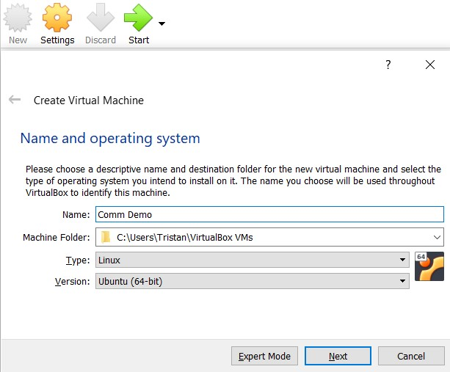
- Type what you want the virtual machine to be called in the Name field
- Click the drop-down menu in Machine Folder and choose where the Virtual Machine is saved.
- Click the drop-down menu in Type and choose which Operating System you want.
- Click the drop-down menu and choose which version of the operating system you want to use.

Once completed click Next to go to the next step.

2.2 - Memory Allocation

Reminder: Each virtual machine requires a minimum of 512MB of RAM.
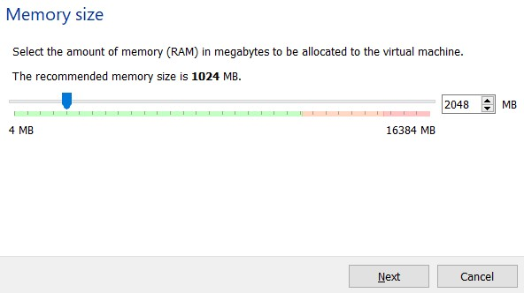
The next screen allows you to choose how much memory (RAM) the virtual machine will have. The RAM that is going to be allocated to the VM will be taken from the host OS. Running multiple VMs at the same time will increase memory usage. The host OS must have at least 256MB of memory to operate. The more memory given to the VM the faster it will be.

Example:
If you have 2GB of RAM and set the virtual machine to have 1GB of RAM that leaves 1GB left for your host OS.

Once completed click Next to go to the next step

2.3 - Hard Disk

2.3.1 - Create a virtual hard disk now

If it’s the first time you are installing a virtual machine.

- New Hard Disk
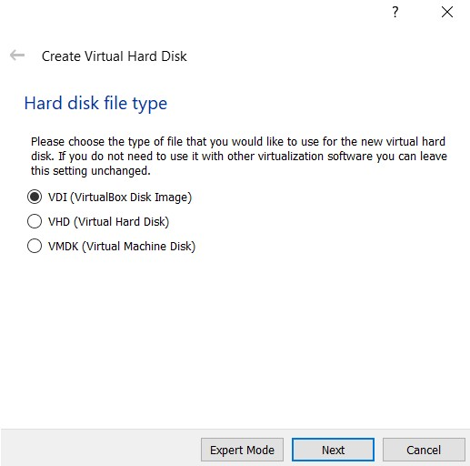
Click Create and a new window will appear. There are three options when choosing how you want to save the hard disk. The default is VDI, this is VirtualBox own hard disk format.

- Dynamic vs. Fixed:

In dynamic the VM will start using the least amount of space possible on the physical hard disk, as it needs more space it grows up to a certain amount (the fixed size). Fixed creates the hard disk space immediately. Fixed takes longer to create but is faster.

Click the option you prefer then click Next.

- File Location and Size
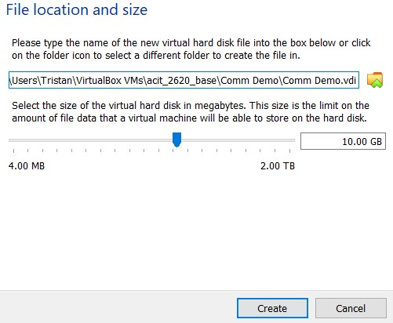
This screen select the path of the virtual disk and choose how large you want the virtual machine to be.

2.3.2 - Use existing virtual hard disk

You can choose an existing hard disk if you have made a virtual machines in the past.

2.3.3 - Do not add virtual disk

For more advanced users, you can skip this step and configure the hard disk once the virtual machine is created.

3 - Installing an ISO

Once the virtual machine has been created, an Operating System needs to be attached in order for the VM to work.

- On the selected VM click Settings, the setting window will appear.
- In the settings window, click the Storage tab.
- 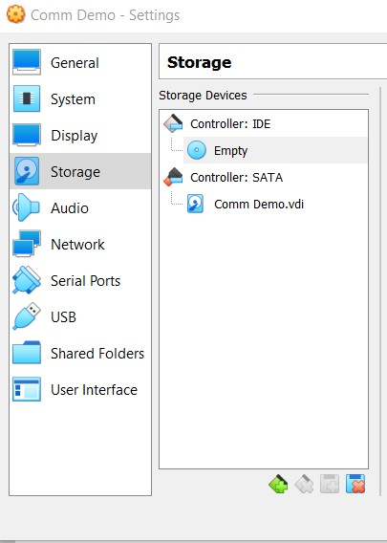Once in the Storage window, under Storage Devices click Empty.
- Under Attributes click on the CD to display a drop down menu. 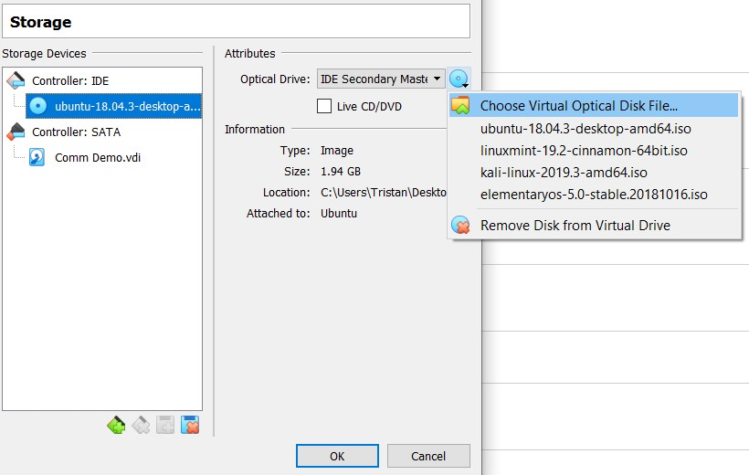
- Click Choose Virtual Optical Disk File, your computers file explorer will appear. Find the ISO file you downloaded and click Open.
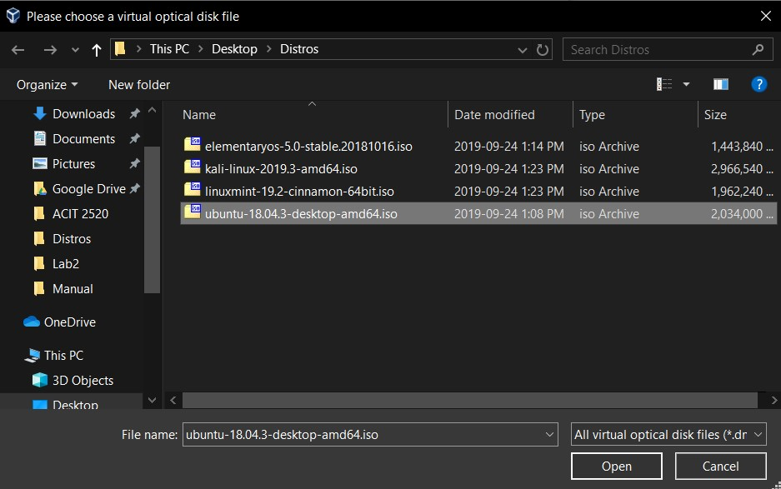
The virtual machine is now created and is ready to start.

4 - Creating a Network Adapter
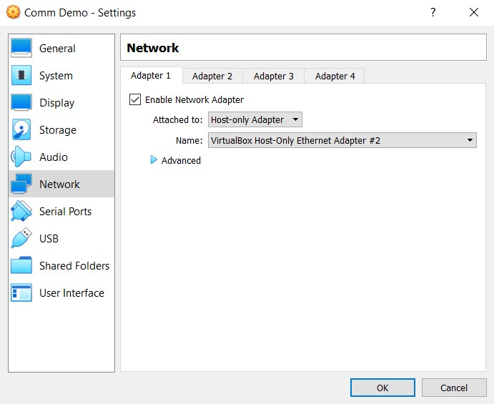
- On the selected VM click Settings, the settings window will appear.
- In the settings window, click the Network tab.
- Click on the Attached to drop down menu and select Host-only adapter.
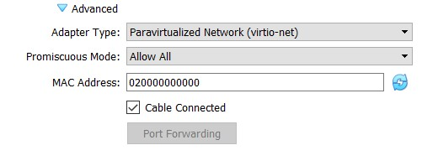
- Click on Advanced.
- Click the Adapter Type drop down menu and select Paravirtualized Network.
- Click the Promiscuous Mode drop down menu and select Allow All.
- Type 020000000000 into the MAC Address field and then click OK.

5 - Using the Virtual Machine

5.1 - starting the virtual machine

Click Start to power the virtual machine on. This launches a new window where the VM
will run. The ISO you chose will boot and you can begin to use the virtual machine.

6 - Moving data to and from the Virtual Machine

6.1 - Clipboard data

To enable shared clipboard, click on the yellow Settings icon. The General settings page will be displayed.
In the General settings page, click on the Advanced tab.
In the Advanced tab, click on the Shared Clipboard dropdown menu and view the available options: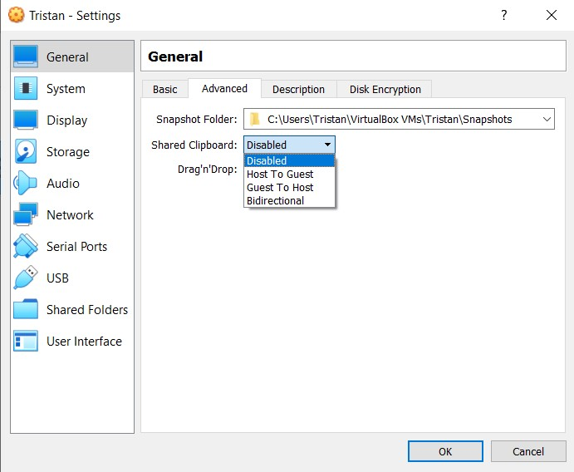

- Disabled: Clipboard data cannot be shared in between physical and virtual machines.
- Host to Guest: The physical machine can copy clipboard data to the virtual machine but not vice versa.
- Guest to Host: The virtual machine can copy clipboard data to the physical machine but not vice versa.
- Bidirectional: Clipboard data is saved between both machines.

Select the option that suits your needs and click OK to save your changes.

6.2 - File data

To enable file sharing between a virtual machine and a physical machine, click on the yellow Settings icon. The General settings page will be displayed.
In the General settings page, click on the Advanced tab.
In the Advanced tab, click on the Drag’n’Drop dropdown menu and view the available options:
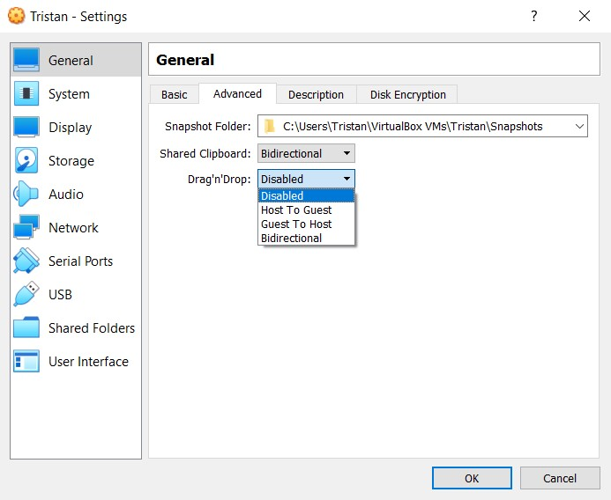

- Disabled: Files cannot be shared in between physical and virtual machines.
- Host to Guest: The physical machine can copy file data to the virtual machine but not vice versa.
- Guest to Host: The virtual machine can copy file data to the physical machine but not vice versa.
- Bidirectional: Files can be moved in between both machines.

Select the option that suits your needs and click OK to save your changes.

7 - Cloning a virtual machine:
Clones can be useful when you want to install an application on multiple machines. Installing the software on one machine then making clones to form exact replicas of the parent virtual machine.

7.1 - Cloning
To clone a virtual machine right click on the virtual machine and click Clone.

This will bring up another window where you can change the:

- In the Name field, type in the name of what you want the clone to be called.
- For the Path, choose the location where the new virtual machine should be saved.
- For MAC Address Policy the clone needs to have it’s own Mac address, to do so:
  - click the drop down menu and select -> Generate new mac address.
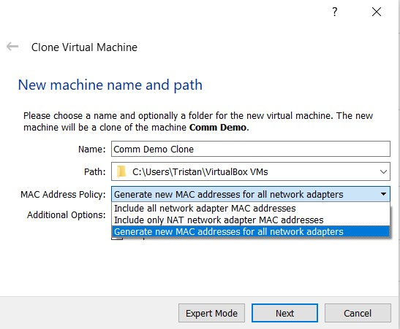
Click Next to continue.

7.2 - Full Clone vs Linked Clone
There are two options when making a clone full clone and linked clone. The full clone will create an exact copy of the original Virtual Machine, this option does not allow the original to make changes to the clones.

Click Linked Clone, this will connect the the original Virtual Machine to the clone.

Click Clone. The new clone can now be run.

7.3 - Shared Folders

To enable the file sharing between the original Virtual Machine and the clone, you must create a folder on your host machine where the files can be stored.

- On the clone Virtual Machine click Settings.
- Click the Shared Folders tab.
- Click the folder icon and a new window will appear. 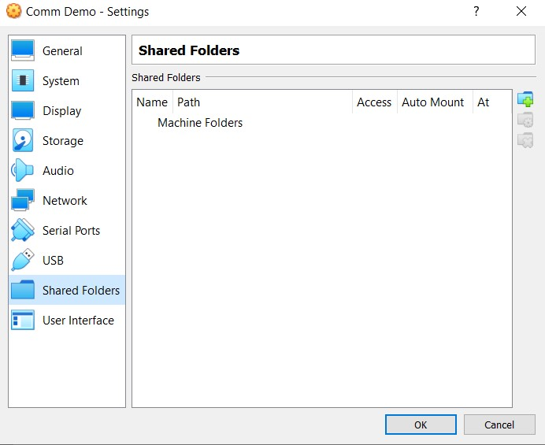
- In the new window
  - Click the drop down menu and choose Other
    - Select a location where the folder should be saved.
  - In the Folder Name field, type what you want the folder to be called.
  - Click the Auto-mount checkbox.
  - Optional, the Mount-Point can be left blank.
- Click OK, you can now share files between the original and clone machine.

  - 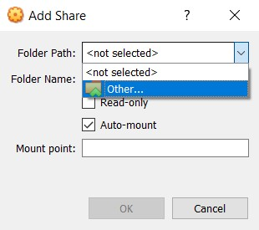

Glossary
Virtual Machine: Isolated instance of an operating system being run inside a host machine.
Host Machine: The main computer that is being used to run the virtual machines.
OS: Stands for Operating System. It is the software that supports the computer’s basic functions.
ISO (image): A disk image format that contains the identical files you would find on a physical installation disk.
RAM: Stands for Random Access Memory.
Clone: A copy of an existing virtual machine.
MAC Address: Stands for Media Access Control. This is a unique identifier assigned to a network interface control card.
Network Interface Control Card: connects a virtual machine to the network.

Troubleshooting

My Virtual Machine is running slowly and/or freezing.
- On the affected VM click Settings, the settings window will appear.
- In the settings window, click the System tab.
- Click on the Motherboard tab and increase Base Memory slider by 50%.
- Click on the Processor tab.
- Increase the Processor Count by 1.

My Virtual Machine interface does not scale when the window size is increased.
- Go to virtualbox.org and click on the Downloads tab.
- Scroll down and download the latest version of VirtualBox Oracle VM VirtualBox Extension Pack.
- After it has been downloaded, run the file.
It will be automatically added to VirtualBox when run.
- Restart the Host Machine.

My Virtual Machine displays a “Failed to boot” error when started.
- On the affected VM click Settings, the settings window will appear.
- In the settings window, click the Storage tab.
- Click any existing disk storage devices and click the Remove icon.
- Click the disk icon and repeat the steps for installing an ISO.

