# Introduction

Media Conversion Tool is used to convert media item’s storing type. With it module you can select some items and converts them to files or stores them to a database.

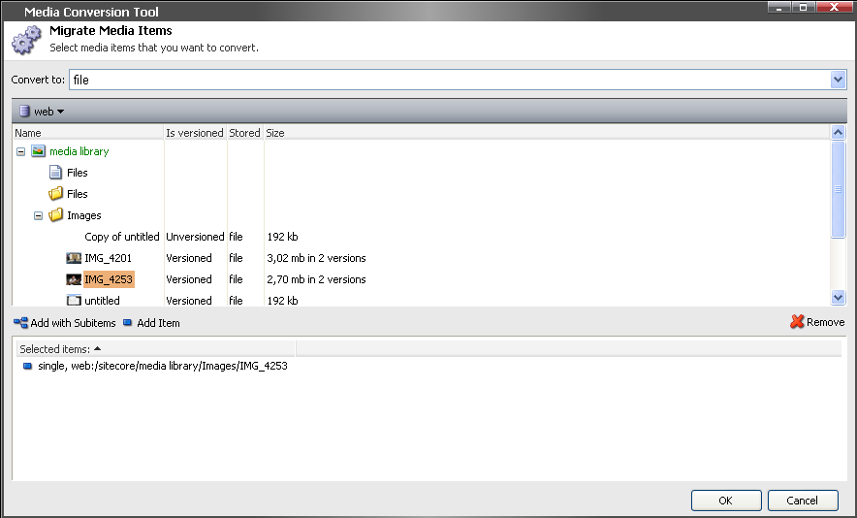

Picture 1. Media Conversion Tool

# Installation

1. Install the package named MediaConversionTool.zip
2. Add the next tag to the <controlSources> section of the web.config file

<controlSources>

………..

***<source mode="on" namespace="Sitecore.Modules.MediaConversionTool.Controls" assembly="MediaConversionTool" prefix="MCT" />***

***<source mode="on" namespace="Sitecore.Modules.MediaConversionTool" folder="/sitecore modules/media conversion tool" deep="true" />***

</controlSources>

# General description

All the items with some media content stores its content in two ways:

1. As a file on a disk
2. As a “blob” field in the database

This ways has their both positive and negative sides. And in different cases one of them are more appropriate than the other.

With a help of the current module it’s possible to convert a part or all the media content to be stored in the necessary way.

# User manual

UI consist only with a “main” and with a “progress” page. At the first, “main” page you can select some items to be processed and define the conversion target with is a file or database.

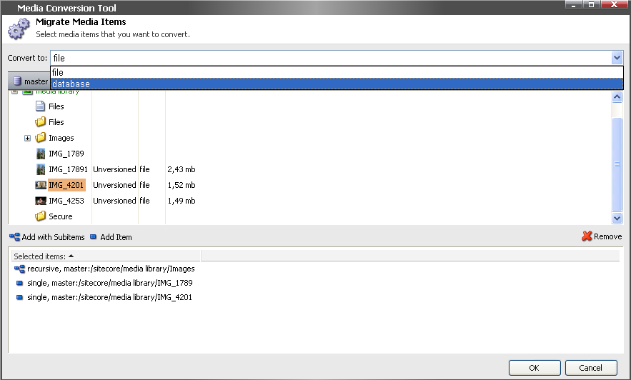

Picture 2. Selecting some items

Press the Ok button and you’ll the “progress” page which will show the progress bar and on which after the converting process you can return to the main page or exit the tool UI.

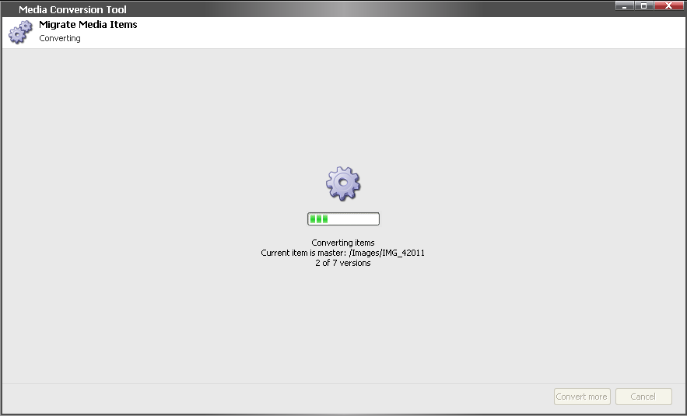

Picture 3. Converting process

# Valid properties/parameters

The files that are result of conversion process will be stored under the media folder which is defined in the web.config file’s <setting > section:

<settings>

…..

<setting name="Media.FileFolder" value="/App_Data/MediaFiles" />

…..

</settings>