Anthony Milton

05/10/2022

Module 11.2 Assignment

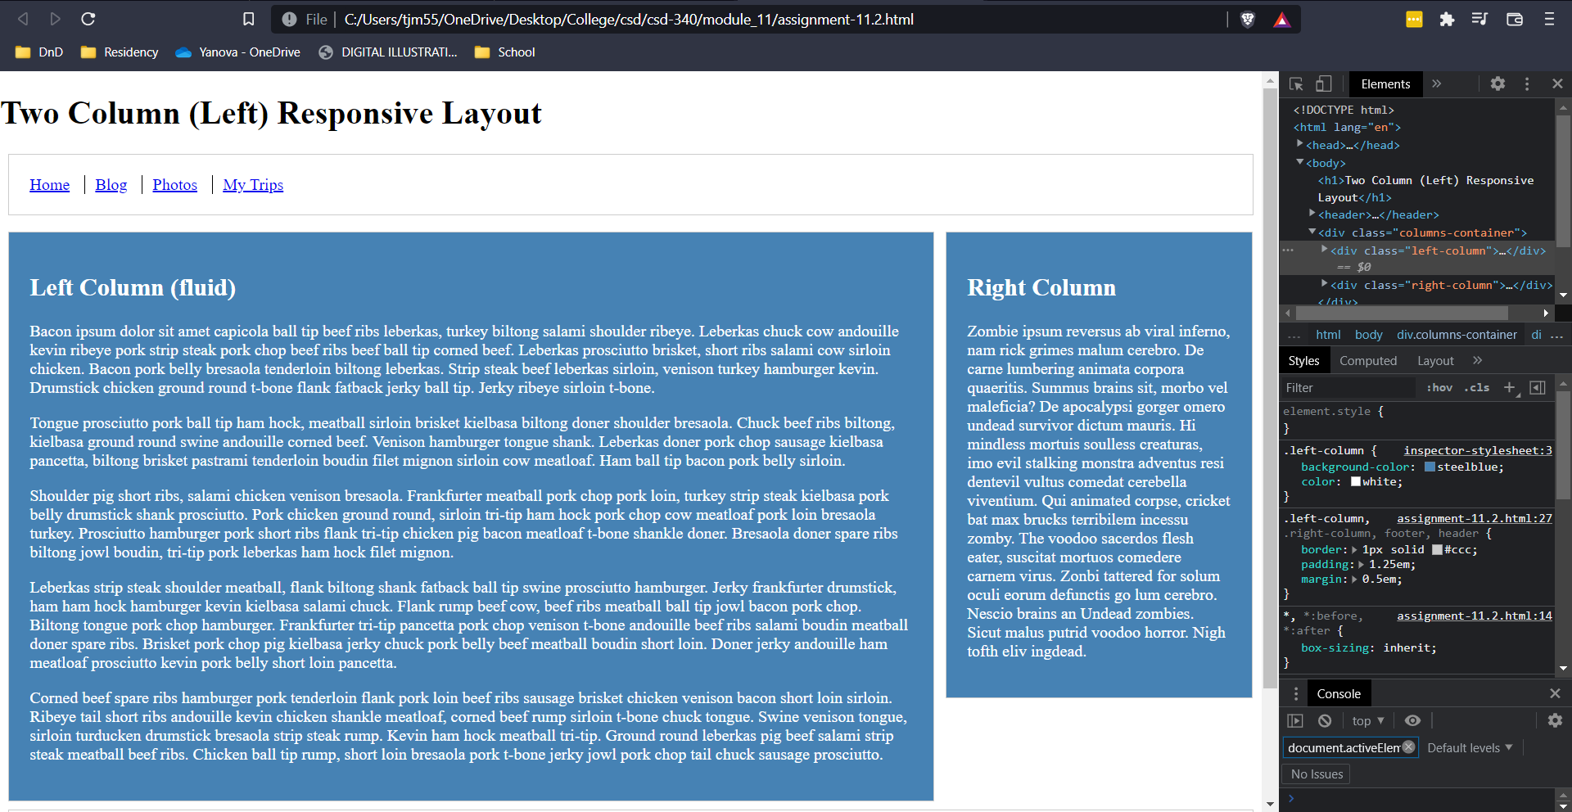

Above: Modified webpage using browser tools. (Technically using Brave instead of Chrome, but since it’s chromium based I figured this was fine)