Matthew Glinski

**Results:**

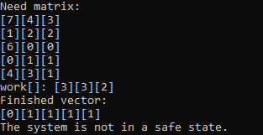

In the above example, the algorithm determines that the system is not in a safe state since the first element of the finished vector is not true and therefore the first of the five processes was not accepted.

**Conclusions:**

Struggles included,

* Correctly implementing the algorithm: initially I was indexing work with i and not j, which led to errors.
* Printing the safe sequence for the case where the system is safe. Initially I was unsure what to print.
* Additionally it almost looked as though there was a serious logical error in the program, as below,

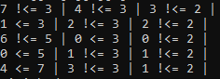

But in reality, the debug message was in error.

