# Assignment 05

## 1. Potential Renewable Energy Spots in China

1.1 [5 points] Download the following data sets and load them in R:

1.2 [10 points] Plot the above data sets over China. You should make three plots, each should contain its own legend.

1.3 [5 points] First, let’s search for regions with relatively high wind speed to build wind farms. Define a reasonable wind speed as the threshold, and describe your favorite spots.

1.4 [5 points] Second, let’s search for regions with relatively high solar radiation and low precipitation as potential locations of photovoltaics (PV) farms. Describe your favorite spots of PV farms.

## 2. More Linux Commands

2.1 [2 points] Make a link called data_demo_link to data_demo folder using ln

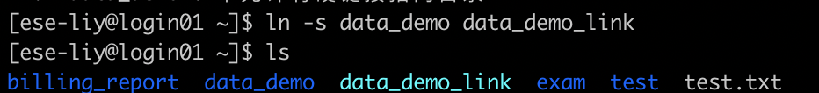

2.2 [2 points] Go to data_demo/data/, make an empty file planets.txt_1st with touch.

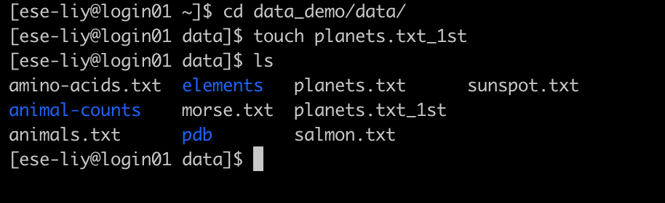

2.3 [2 points] Print your home directory using echo.

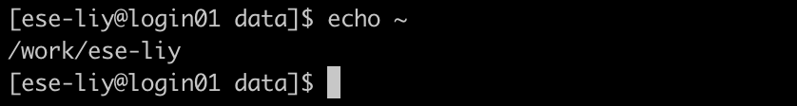

2.4 [3 points] Find how many files in data_demo/data/pdb/ using find.

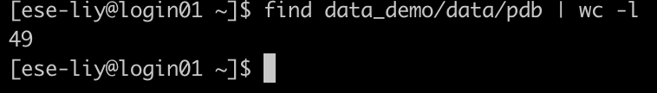

2.5 [3 points] Count how many C character appears in data_demo/data/pdb/tnt.pdb with grep.

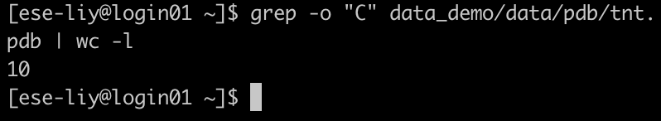

2.6 [2 points] Compare data_demo/data/pdb/ethane.pdb and data_demo/data/pdb/ethanol.pdb with diff

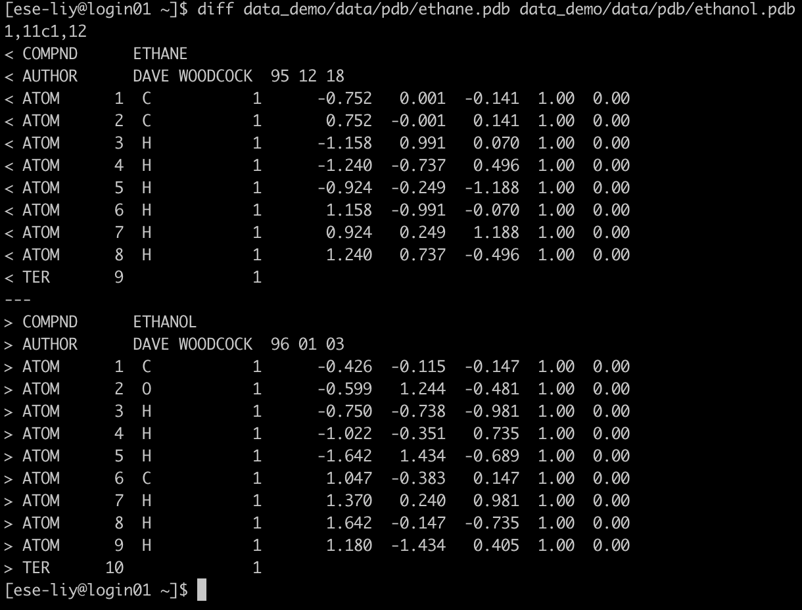

2.7 [2 points] Check the total file size of the data_demo folder using df.

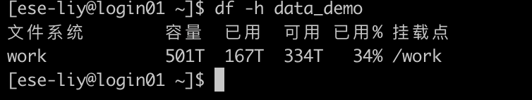

2.8 [3 points] Copy the data_demo folder to data_demo_new, compress it using zip, and decompress the .zip file with unzip.

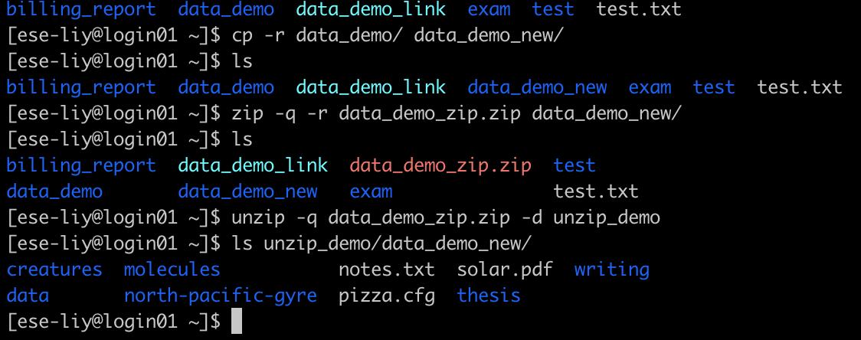

2.9 [3 points] Change the file permissions flags on data_demo_new to drwxr-x--- using chmod.

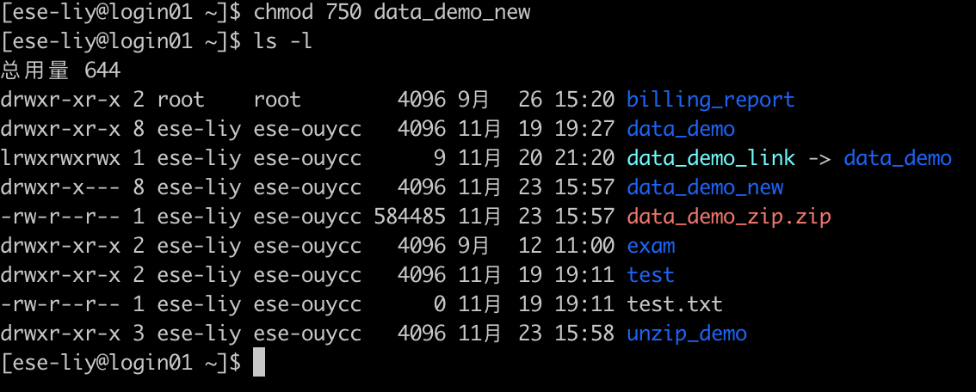

2.10 [3 points] Print the last 10 commands you made using history.

