# Assignment 06

## 1. Matrix multiplication

* 1. ****[5 points]**** Write a subroutine Matrix_multip.f90 to do matrix multiplication.

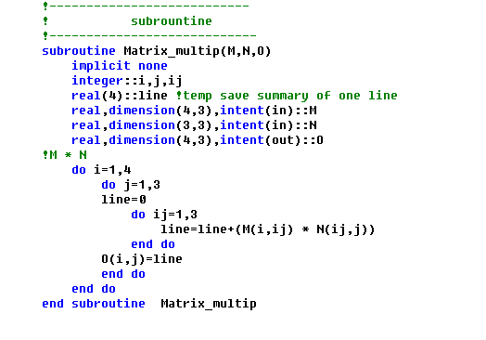

****1.2 [5 points]**** Write a program Main.f90 to read /work/ese-ouycc/fortran_2/M.dat as the matrix M, and /work/ese-ouycc/fortran_2/N.dat as the matrix N.

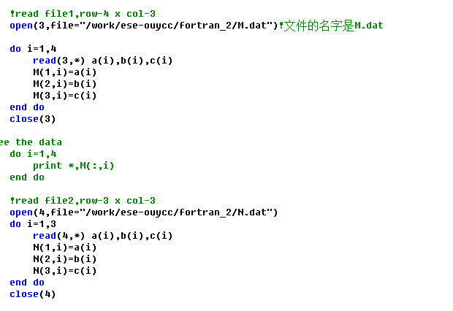

* 1. ****[5 points]**** Call subroutine Matrix_multip() from Main.f90 to compute M*N; write the output to a new file MN.dat, values are in formats of f8.1.

**#Call subroutine:**

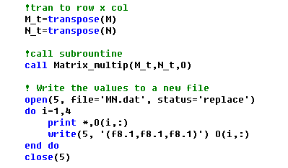

**#execute the program and view the output file**

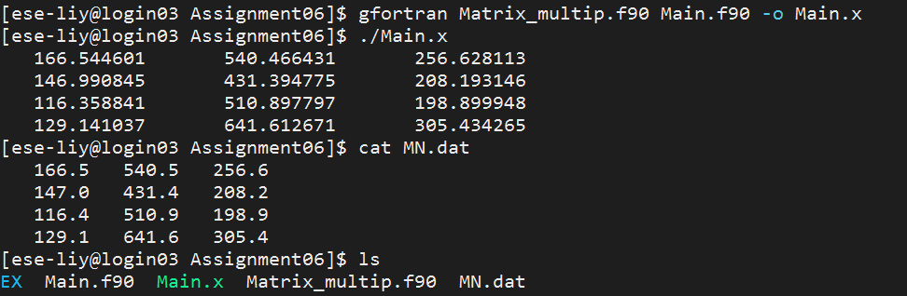

## 2.Calculate the solar zenith angle

****2.1 [5 points]**** Write a module Declination_angle to calculate the declination angle on a certain date.

[****Hint:**** using equation 2]

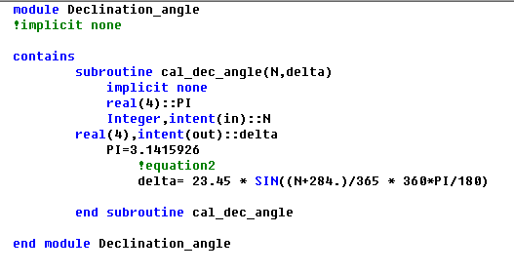

****2.2 [10 points]**** Write a module AST to calculate the apparent solar time (AST; or local solar time) in a certain location for a certain date and time.

[****Hint:**** using equation 3-5]

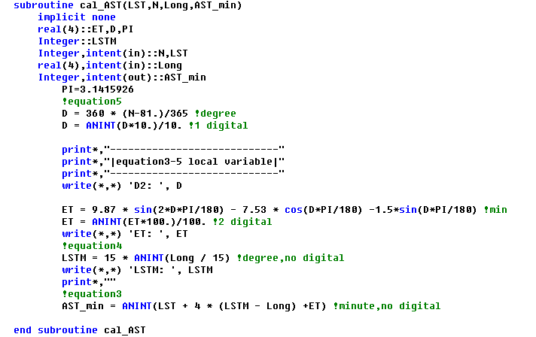

****2.3 [10 points]**** Write a main program (Cal_SZA.f90) that uses module Declination_angle and AST to print the SZA in a certain location for a certain date and time.

[****Hint:**** using equation 6-7]

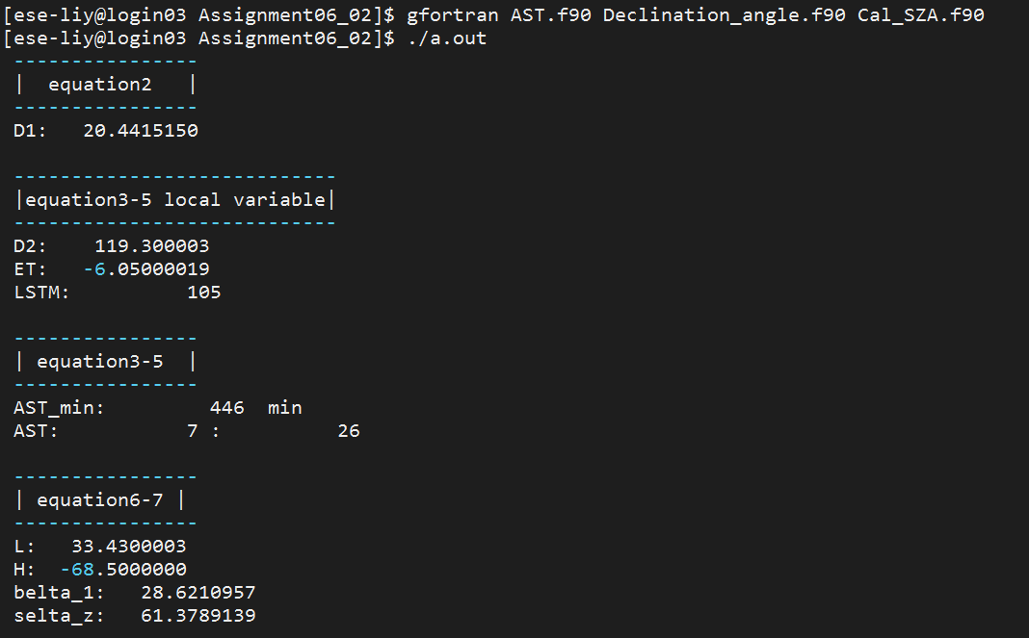

****2.4 [5 points]**** Create a library (libsolar.a) that contains Declination_angle.o and AST.o. Compile Cal_SZA.f90 using libsolar.a.

#execute the program with .o file

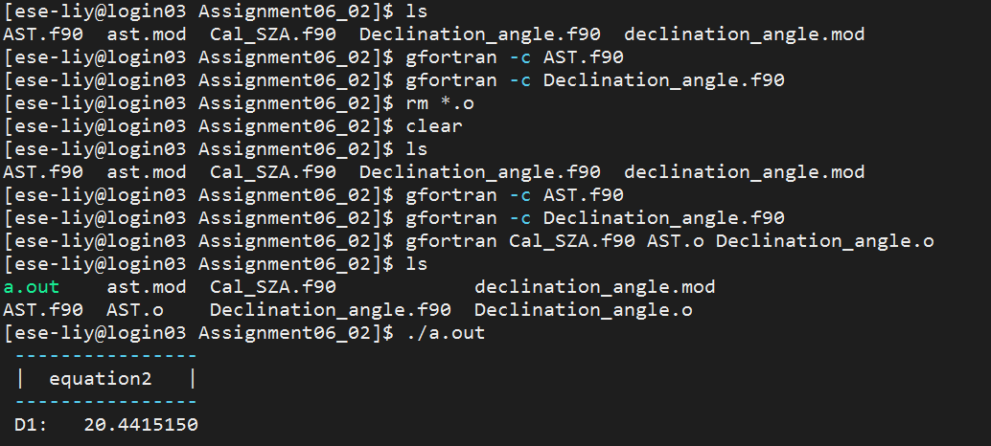

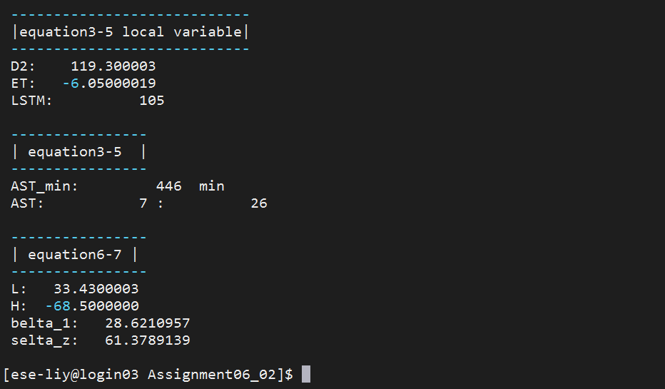

#execute the program with library

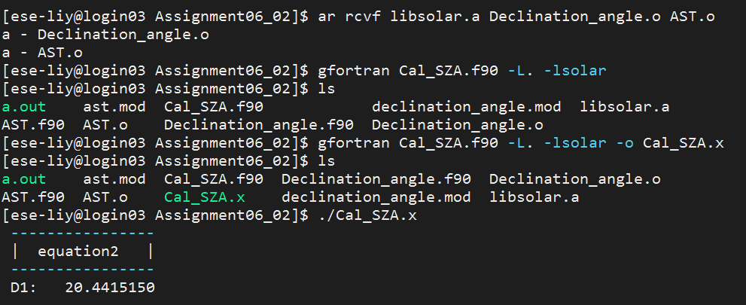

So the library is loaded and ran well.

****2.5 [5 points]**** Print the SZA for Shenzhen (22.542883N, 114.062996E) at 14:35 (Beijing time; UTC+8) on 2020-12-20.

#work flow of the script wrote in Fortran

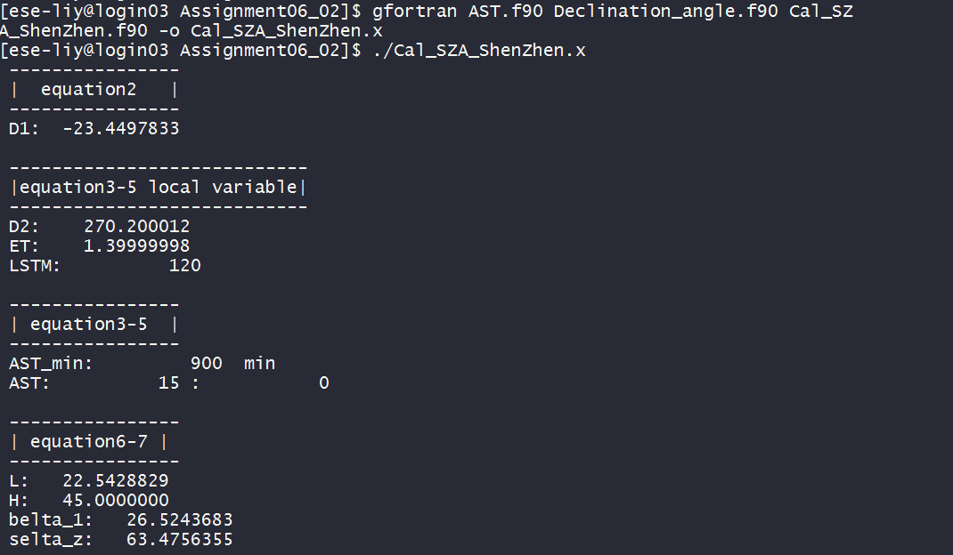

SZA; θZ = 63.48