Trying out R Markdown

Stine Bech Smedegaard

16/6/2021

1. Stine Smedegaard
2. SDCA
3. AU

# intro

**bold**

# Methods

*italics*

## Analysis

2+2

## [1] 4

# Discussion

source(here::here("R/package-loading.R"))

## -- Attaching packages --------------------------------------- tidyverse 1.3.1 --

## v ggplot2 3.3.3 v purrr 0.3.4  
## v tibble 3.1.2 v dplyr 1.0.6  
## v tidyr 1.1.3 v stringr 1.4.0  
## v readr 1.4.0 v forcats 0.5.1

## -- Conflicts ------------------------------------------ tidyverse_conflicts() --  
## x dplyr::filter() masks stats::filter()  
## x dplyr::lag() masks stats::lag()

load(here::here("data/nhanes_small.rda"))

## `summarise()` has grouped output by 'diabetes'. You can override using the `.groups` argument.

table 1. Diabetes status, sex, Mean Age and BMI.

|  |  |  |  |
| --- | --- | --- | --- |
| Diabetes Status | Sex | Mean Age | Mean BMI |
| No | Female | 36.5 | 26.2 |
| No | Male | 34.3 | 26.1 |
| Yes | Female | 59.9 | 33.7 |
| Yes | Male | 58.6 | 31.5 |

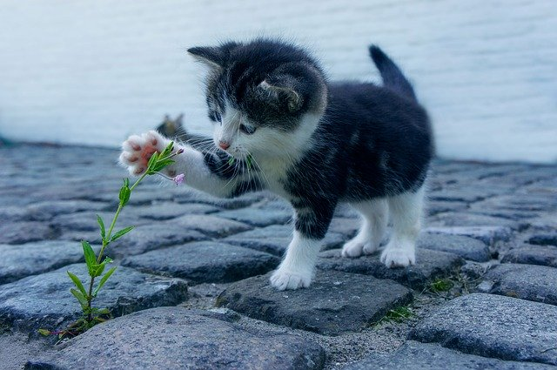

Image by Dimitri Houtteman from Pixabay.

knitr::include_graphics(here::here("doc/Images/kitten.jpg"))



knitr::include_graphics(here::here("doc/Images/kitten.jpg"))



Kitten attacking flowers!