COMMERCIAL PROPOSAL

StingTools + Planscape
BIM automation and cloud coordination platform
Prepared for | Architectural Practice
Attention | The Principal Architect
Prepared by | Sting Davis — Creator, StingTools & Planscape
Date | April 2026

Founding partner rate
$1,200 / year — founding subscriber rate

Executive summary
This proposal presents StingTools and Planscape to a small to mid-size architectural practice. It is sized for an 8-person studio: one BIM author or principal architect operating Revit, plus seven team members covering project architecture, project management, document control, contract administration, site supervision and client liaison.
The headline numbers for an architectural practice of this size are straightforward. Autodesk Forma at full coordination tier costs $38,312 per year for 8 users. Planscape Scenario C — one Revit seat plus seven Coordinators — costs $4,565 per year. The annual saving is $33,747 — 88% of the Autodesk equivalent.

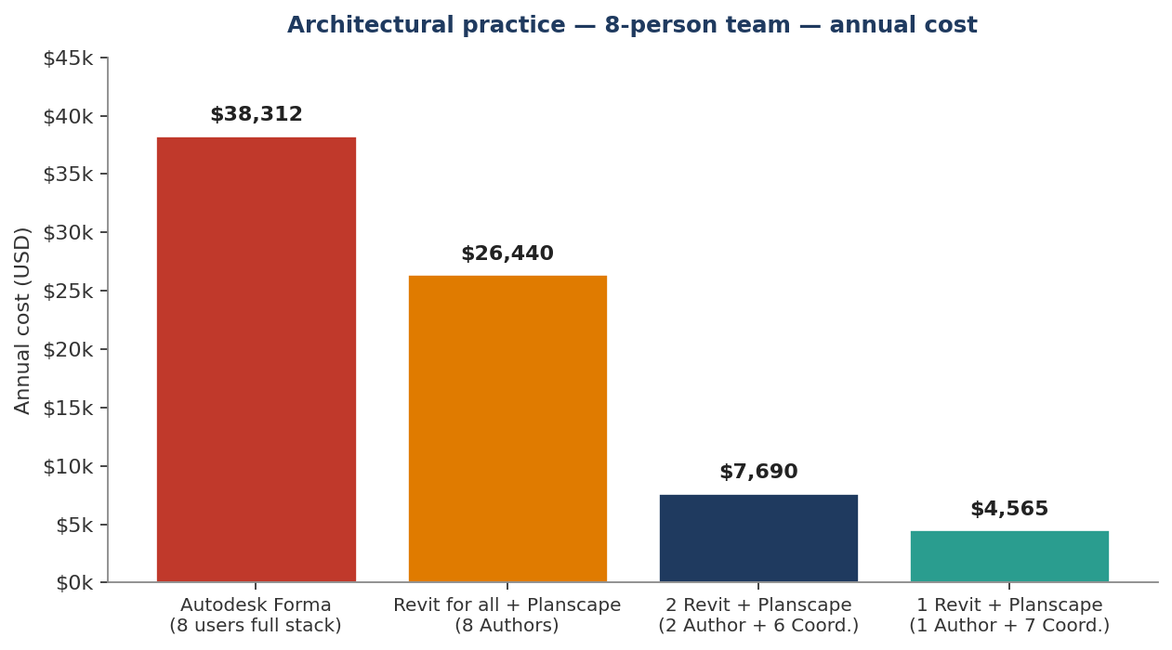

Why this proposal is relevant to an architectural practice
Architectural practices have a different operational profile than M&E or multi-discipline firms. The BIM authoring load is typically lower and concentrated in fewer hands; the document load — sketches, plans, sections, presentations, specifications, transmittals, RFIs — is much higher. The capabilities that matter most to an architectural practice are:
- Drawing sheet automation. The 40 pre-configured drawing profiles cover residential, commercial, mixed-use, hospitality and institutional output. Sheet numbering follows ISO 19650 automatically. Title blocks populate from live project data. A drawing set that takes a junior architect a week is generated in under two hours.
- Document control discipline. The Common Data Environment enforces the four-stage ISO 19650 lifecycle. Drawings cannot reach the client unless they have been formally issued through the CDE. Every revision is retained, every transition is timestamped and attributed. For practices working with international clients, lenders or institutional briefs, this is the document-trail standard required.
- Transmittal and RFI tracking from the field. The mobile app gives site architects, clerks of works and contract administrators full access to drawings, issues, approvals and asset data from a phone. Photo capture, GPS location and offline operation are included.
- COBie handover. Increasingly required by institutional clients even for architecture-led projects. Generated automatically from tagged model elements in hours rather than weeks.
- Schedule automation. Door, window, room finish, fixture and equipment schedules — the schedules an architectural practice ships with every set — generated from live model data with correct grouping and formatting.

What the practice does not need is the full MEP calculation engine, vibro-acoustic analysis or the multi-discipline federation tooling. Those exist in StingTools and remain available, but they sit in the background unless the practice begins multi-discipline modelling. The cost of the platform is the same regardless.

1. The product family — what is being offered
StingTools and Planscape are a single integrated stack with three subscription tiers. The same plugin runs in Revit on every Author seat. The cloud platform connects every team member who does not need to model.

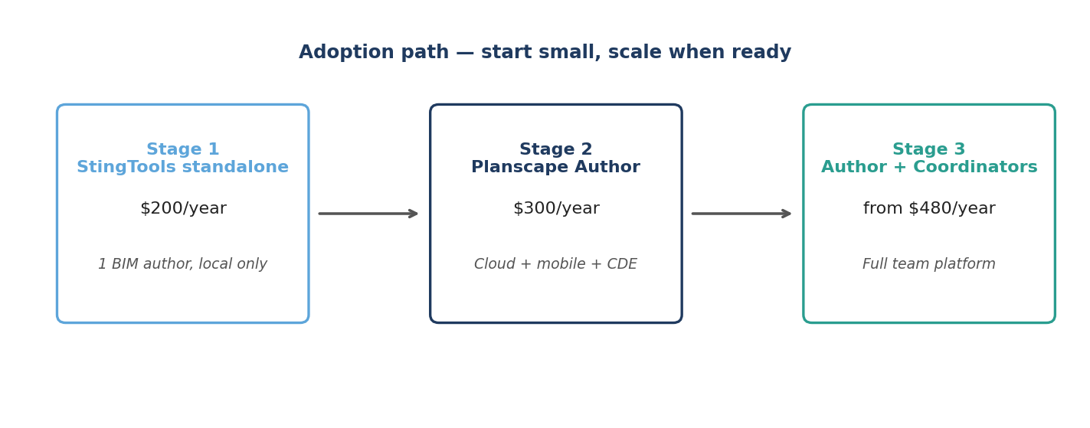

1.1 StingTools — the Revit power engine
StingTools is a plugin that installs directly into Autodesk Revit. It runs on the local machine, requires no internet, and does not depend on the cloud. The full automation suite is available even when offline. Inside Revit, it adds:
- ISO 19650 asset tagging — full 8-segment tag (DISC-LOC-ZONE-LVL-SYS-FUNC-PROD-SEQ) applied across thousands of elements in hours, with collision detection and validation reports.
- Project template setup — 1,527+ shared parameters, 23 view templates, 28 discipline filters, line styles, fill patterns and phases configured in under 90 minutes.
- Drawing sheet automation — 40 pre-configured drawing profiles covering every AEC discipline, with bin-packing viewport placement and ISO 19650 sheet numbering.
- Schedule generation — 168 schedule definitions covering panel boards, room finishes, equipment registers, COBie asset schedules and system takeoffs, all populated from live model data.
- Document automation — 16 document types render from live Revit data into Word and Excel using firm letterheads: transmittals, RFIs, meeting minutes, progress reports, variations, COBie exports.
- MEP engineering calculations — Darcy-Weisbach pipe sizing, 26-fitting duct sizing, Hardy Cross flow balancing, CIBSE TG6 vibro-acoustic analysis, all writing back to model parameters.
- COBie V2.4 export — full 22-worksheet handover package generated in 4–8 hours, not weeks.
- Real-time auto-tagging — elements tag themselves the moment they are placed; no batch run needed.

1.2 Planscape Author — connected command centre
Planscape Author is StingTools plus a live connection to the cloud server and mobile app. Every tag written, every compliance score, every transmittal issued, syncs to the Planscape server in the background. The Author is the one person on the project who models. Everything they produce flows outward to the team through Planscape.
What is added on top of StingTools:
- Common Data Environment with full ISO 19650-2 state machine: Work in Progress → Shared → Published → Archived. Stages cannot be skipped. Every transition is timestamped, attributed and added to an immutable audit chain.
- Transmittal engine that issues from inside Revit, transitions documents in the CDE, sends notifications, and waits for acknowledgement automatically.
- Team and project management dashboard — invite Coordinators, assign roles, set permissions, monitor progress from a browser.
- BIM issue management — raise from inside Revit, with element reference, screenshot and description. Visible immediately to all Coordinators on web and mobile.
- Live ISO 19650 compliance dashboard with quantified scores per discipline and project-level trend.
- Workflow automation — Daily QA, Weekly Data Drop, Document Package and Handover sequences run as single commands.
- Mobile app (iOS and Android) — full project access from any phone, with QR scanning, photo capture, GPS location, and offline operation that auto-syncs on reconnect.

1.3 Planscape Coordinator — the team and field eye
The Coordinator seat gives full access to the Planscape cloud platform and mobile app, without requiring Revit. A Coordinator cannot run StingTools commands or open the Revit model. They can do everything else: review drawings, approve documents, raise and close issues, monitor compliance, receive transmittals, manage meetings, capture site observations.
In a project with 18 people working on it, two or three need Revit. The other 15 to 16 are Coordinators. The cost difference compared to the Autodesk equivalent (Forma Data Management at $500 per user per year) is substantial, and the capability set is purpose-built for BIM coordination rather than general file storage.

2. What Autodesk Forma actually costs
In March 2026, Autodesk rebranded Autodesk Construction Cloud as Autodesk Forma. The names changed; the cost structure did not. The rule that applies to every Forma user without exception is that Forma Data Management is the mandatory foundation of the platform. Every person who needs to access any Forma product must hold a Forma Data Management subscription at $500 per user per year. There is no viewer tier and no coordination-only access without it.

Product | Annual per user | What it provides
Revit | $3,005 | BIM model authoring; no coordination features
Forma Data Management (mandatory) | $500 | CDE foundation, document management, basic markup
Forma Design Collaboration | $1,284 | Cloud Revit coordination, design review, worksharing
Full design coordination stack | $4,789 | Revit + Forma Data Management + Forma Design Collaboration

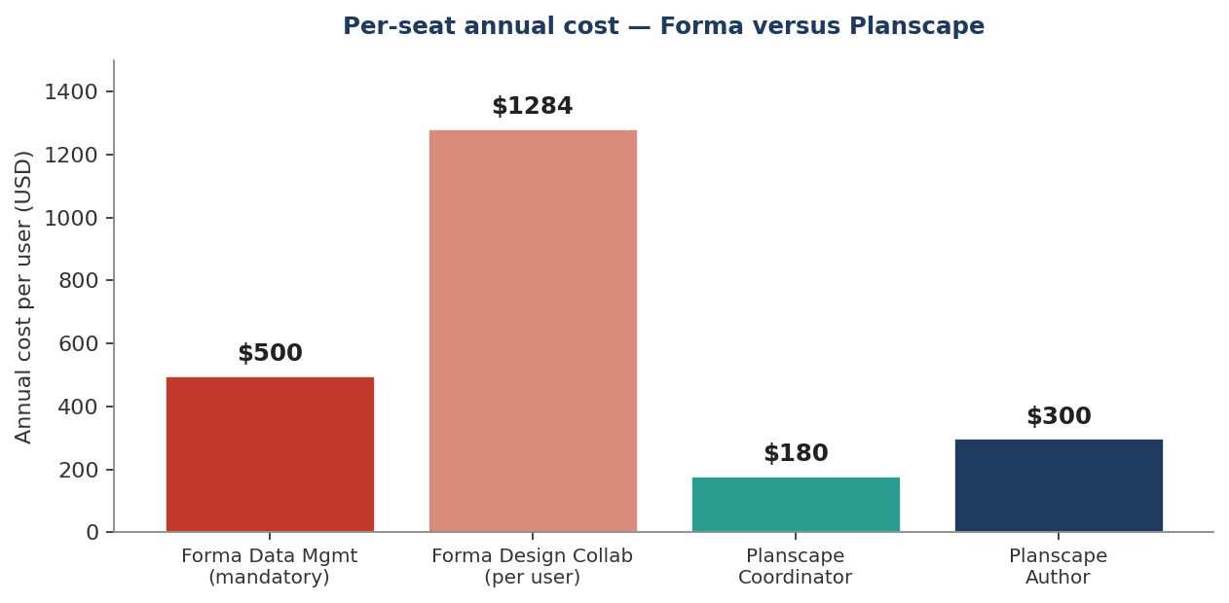

3. Capability matrix — what each seat actually delivers
A direct comparison of what is included with each subscription tier. Partial means the capability exists but in a limited or non-equivalent form. The key categories where Planscape Author is unique are the StingTools automation suite — asset tagging, MEP sizing, drawing production and COBie export — none of which Autodesk Forma offers at any price tier.

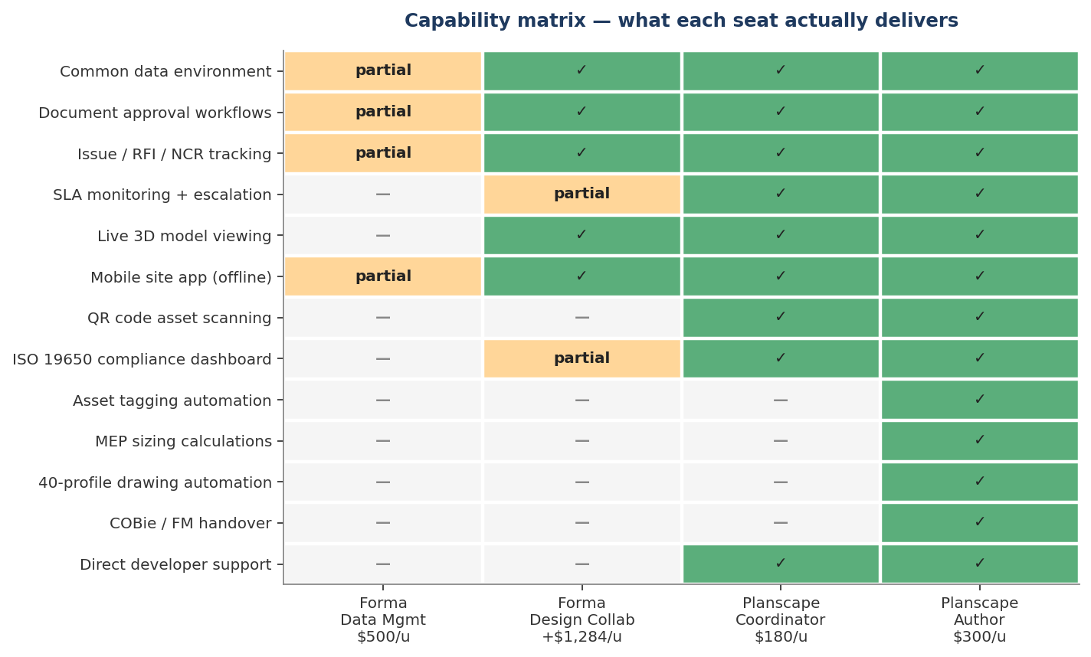

Adoption scenarios for an 8-person practice

Scenario A — full Autodesk Forma stack (8 users)
Item | Per user annual | Quantity | Subtotal
Revit | $3,005 | 8 | $24,040
Forma Data Management | $500 | 8 | $4,000
Forma Design Collaboration | $1,284 | 8 | $10,272
Annual total |  |  | $38,312

Scenario B — Revit for all + Planscape ($25/user/month)
Every architect keeps Revit and adds the full StingTools plugin and Planscape Author seat. Useful for practices where every team member is an active modeller.

Item | Per user annual | Quantity | Subtotal
Revit (Autodesk) | $3,005 | 8 | $24,040
Planscape Author seat | $300 | 8 | $2,400
Annual total |  |  | $26,440
Saving vs Scenario A |  |  | $11,872 / year — 31%

Scenario C — one Revit seat + seven Coordinators (recommended)
The principal architect or BIM author holds the Revit licence. The other seven team members — project architects, contract administrator, document controller, site architect, two project managers, principal — access the full coordination platform from their browser and mobile devices. This is the configuration that fits the typical operating reality of a small to mid-size architectural practice.

Item | Per user annual | Quantity | Subtotal
Revit (Autodesk) | $3,005 | 1 | $3,005
Planscape Author | $300 | 1 | $300
Planscape Coordinator | $180 | 7 | $1,260
Annual total |  |  | $4,565
Saving vs Scenario A |  |  | $33,747 / year — 88%

Scenario D — two Revit seats + six Coordinators
For practices with two active modellers — typically the principal and a senior project architect — the cost remains a fraction of the Forma equivalent.

Item | Per user annual | Quantity | Subtotal
Revit (Autodesk) | $3,005 | 2 | $6,010
Planscape Author | $300 | 2 | $600
Planscape Coordinator | $180 | 6 | $1,080
Annual total |  |  | $7,690
Saving vs Scenario A |  |  | $30,622 / year — 80%

Side-by-side summary — 8-person practice
Scenario | Annual cost | Authors / Coordinators | Saving vs A
A — Full Autodesk Forma | $38,312 | 8 / 0 | —
B — Revit for all + Planscape | $26,440 | 8 / 0 | $11,872 — 31%
D — 2 Revit + 6 Coordinators | $7,690 | 2 / 6 | $30,622 — 80%
C — 1 Revit + 7 Coordinators | $4,565 | 1 / 7 | $33,747 — 88%

The proposal — founding partner terms
The founding subscriber rate of $1,200 for the first year is offered to the practice. This covers cloud infrastructure, deployment, document template integration, ISO 19650 naming convention configuration, team onboarding and direct developer support. After the founding year the subscription continues at the standard managed rate of $1,800 per year.

Founding-year totals — recommended configurations
Configuration | Per-seat subtotal | Founding management fee | Year 1 total
1 Revit + 7 Coordinators (Scenario C) | $1,560 (1 × $300 + 7 × $180) | $1,200 | $2,760
2 Revit + 6 Coordinators (Scenario D) | $1,680 (2 × $300 + 6 × $180) | $1,200 | $2,880
Per-seat figures exclude the Autodesk Revit licence, which is paid separately and is unchanged by this proposal.

What the practice receives for the founding management fee
Item | Included
StingTools plugin installed on every Revit seat | Yes
Planscape Author seat for the BIM author | Yes
Planscape Coordinator seats for the rest of the team | Yes
Cloud infrastructure — fully hosted and managed | Yes
Server deployment for the practice’s tenancy | Yes
Practice document templates built into the platform | Yes
ISO 19650 naming convention configured | Yes
Architectural drawing profile pack — sheet, schedule, title block | Yes
Team onboarding and training | Yes
Direct developer support — priority response | Yes

Infrastructure and hosting
For Planscape to operate as a live cloud service, the following infrastructure is required. It is provisioned, monitored and managed entirely by Sting Davis. The subscriber has no server administration responsibilities.

Component | Monthly (USD) | Annual (USD)
Cloud server — 4 GB RAM, 2 CPU | $24 | $288
Managed PostgreSQL database | $15 | $180
Object storage — documents and models | $20 | $240
Email delivery service | $20 | $240
Domain name and SSL certificate | $3 | $35
Redis cache instance | $15 | $180
Firebase push notifications | Free | $0
Total infrastructure | $97 | ~$1,163

Next steps
To proceed, the following steps are proposed:

Step | Detail | Timing
1. Live demonstration | Full platform walkthrough against current the practice projects | At a convenient date
2. Project identification | Identify the first project to deploy on and confirm the BIM Coordinator | During or after the demonstration
3. Deployment | Server deployment and StingTools installation, handled entirely by Sting Davis | Within one week of confirmation
4. Team training | Onboarding session for all Coordinator-seat users | The week following deployment

Principal Architect, the foundation for this platform was laid in the year of training I delivered with engineers who knew exactly what was missing. I have built it. I am inviting you to be among the first subscribers.
Sting Davis │ Creator, StingTools & Planscape │ April 2026

