COMMERCIAL PROPOSAL

StingTools + Planscape
BIM automation and cloud coordination platform
Prepared for | FBW Group — Multi-discipline practice
Attention | The Directors
Prepared by | Sting Davis — Creator, StingTools & Planscape
Date | April 2026

Founding partner rate
$1,200 / year — founding subscriber rate

Executive summary
This proposal presents StingTools and Planscape — a BIM automation plugin and cloud coordination platform — to FBW Group as a candidate founding subscriber. The proposal is sized for a multi-discipline practice operating across architecture, structural engineering and MEP, where the modelling load is concentrated on a small number of senior BIM authors and the wider team coordinates, reviews and delivers.
Two configurations are presented in detail. The first uses three Revit seats (one per discipline lead) plus Planscape coordination for the rest of the team. The second uses a single Revit seat with Planscape coordination for everyone else — a model that works for projects where one BIM Coordinator is responsible for the federated model. The cost difference between Autodesk Forma and Planscape for an 18-person multi-discipline team is in the range of $74,000 to $80,000 per year.

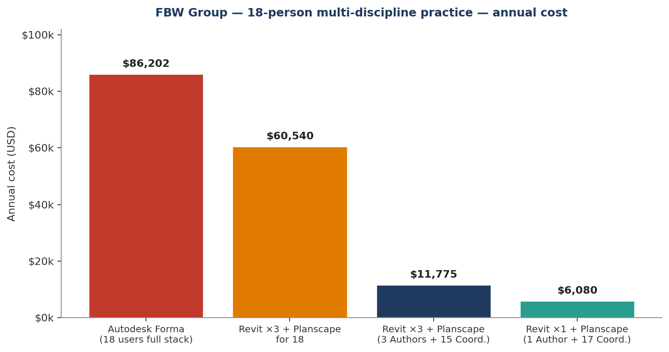

Why this proposal is being addressed to FBW Group
FBW Group is one of the few practices in the region with a genuine multi-discipline capability — architecture, structures and services under one roof, working to international project standards. That capability creates a coordination problem at scale: federated models that need to be readable on site, document trails that need to satisfy international clients and lenders, and asset data that has to survive handover.
Autodesk Forma is the only commercial answer most regional firms have considered. The pricing structure makes it untenable at scale: every team member needs a $500 Forma Data Management licence before they can open a document, and the Design Collaboration tier doubles that to nearly $1,800 per user per year. For an 18-person practice that is a $32,000 annual minimum just to read drawings.
Planscape was built specifically to address this. One person authors the model. Everyone else coordinates through a purpose-built BIM platform at a fraction of the per-seat cost.

1. The product family — what is being offered
StingTools and Planscape are a single integrated stack with three subscription tiers. The same plugin runs in Revit on every Author seat. The cloud platform connects every team member who does not need to model.

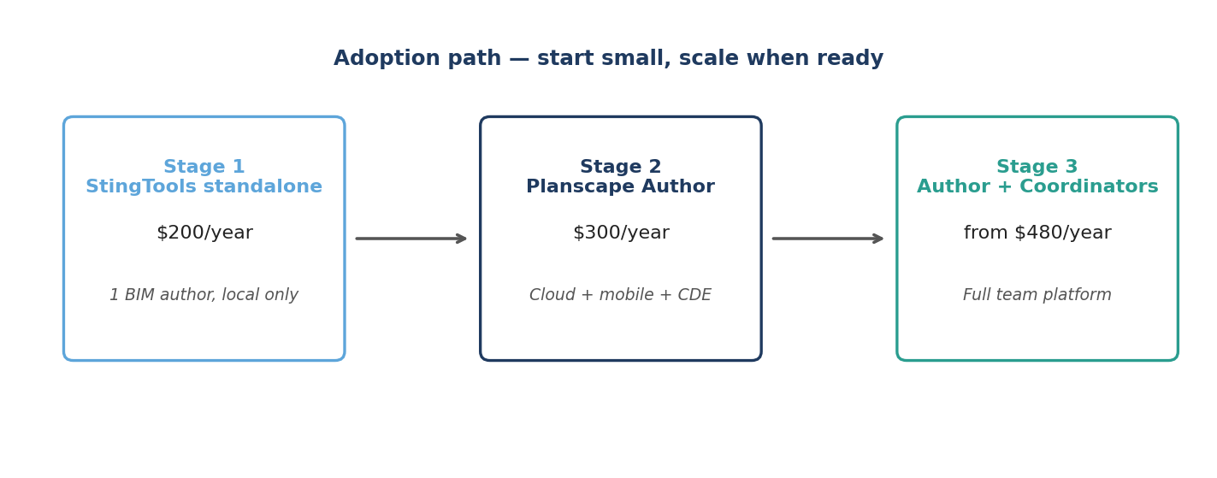

1.1 StingTools — the Revit power engine
StingTools is a plugin that installs directly into Autodesk Revit. It runs on the local machine, requires no internet, and does not depend on the cloud. The full automation suite is available even when offline. Inside Revit, it adds:
- ISO 19650 asset tagging — full 8-segment tag (DISC-LOC-ZONE-LVL-SYS-FUNC-PROD-SEQ) applied across thousands of elements in hours, with collision detection and validation reports.
- Project template setup — 1,527+ shared parameters, 23 view templates, 28 discipline filters, line styles, fill patterns and phases configured in under 90 minutes.
- Drawing sheet automation — 40 pre-configured drawing profiles covering every AEC discipline, with bin-packing viewport placement and ISO 19650 sheet numbering.
- Schedule generation — 168 schedule definitions covering panel boards, room finishes, equipment registers, COBie asset schedules and system takeoffs, all populated from live model data.
- Document automation — 16 document types render from live Revit data into Word and Excel using firm letterheads: transmittals, RFIs, meeting minutes, progress reports, variations, COBie exports.
- MEP engineering calculations — Darcy-Weisbach pipe sizing, 26-fitting duct sizing, Hardy Cross flow balancing, CIBSE TG6 vibro-acoustic analysis, all writing back to model parameters.
- COBie V2.4 export — full 22-worksheet handover package generated in 4–8 hours, not weeks.
- Real-time auto-tagging — elements tag themselves the moment they are placed; no batch run needed.

1.2 Planscape Author — connected command centre
Planscape Author is StingTools plus a live connection to the cloud server and mobile app. Every tag written, every compliance score, every transmittal issued, syncs to the Planscape server in the background. The Author is the one person on the project who models. Everything they produce flows outward to the team through Planscape.
What is added on top of StingTools:
- Common Data Environment with full ISO 19650-2 state machine: Work in Progress → Shared → Published → Archived. Stages cannot be skipped. Every transition is timestamped, attributed and added to an immutable audit chain.
- Transmittal engine that issues from inside Revit, transitions documents in the CDE, sends notifications, and waits for acknowledgement automatically.
- Team and project management dashboard — invite Coordinators, assign roles, set permissions, monitor progress from a browser.
- BIM issue management — raise from inside Revit, with element reference, screenshot and description. Visible immediately to all Coordinators on web and mobile.
- Live ISO 19650 compliance dashboard with quantified scores per discipline and project-level trend.
- Workflow automation — Daily QA, Weekly Data Drop, Document Package and Handover sequences run as single commands.
- Mobile app (iOS and Android) — full project access from any phone, with QR scanning, photo capture, GPS location, and offline operation that auto-syncs on reconnect.

1.3 Planscape Coordinator — the team and field eye
The Coordinator seat gives full access to the Planscape cloud platform and mobile app, without requiring Revit. A Coordinator cannot run StingTools commands or open the Revit model. They can do everything else: review drawings, approve documents, raise and close issues, monitor compliance, receive transmittals, manage meetings, capture site observations.
In a project with 18 people working on it, two or three need Revit. The other 15 to 16 are Coordinators. The cost difference compared to the Autodesk equivalent (Forma Data Management at $500 per user per year) is substantial, and the capability set is purpose-built for BIM coordination rather than general file storage.

2. What Autodesk Forma actually costs
In March 2026, Autodesk rebranded Autodesk Construction Cloud as Autodesk Forma. The names changed; the cost structure did not. The rule that applies to every Forma user without exception is that Forma Data Management is the mandatory foundation of the platform. Every person who needs to access any Forma product must hold a Forma Data Management subscription at $500 per user per year. There is no viewer tier and no coordination-only access without it.

Product | Annual per user | What it provides
Revit | $3,005 | BIM model authoring; no coordination features
Forma Data Management (mandatory) | $500 | CDE foundation, document management, basic markup
Forma Design Collaboration | $1,284 | Cloud Revit coordination, design review, worksharing
Full design coordination stack | $4,789 | Revit + Forma Data Management + Forma Design Collaboration

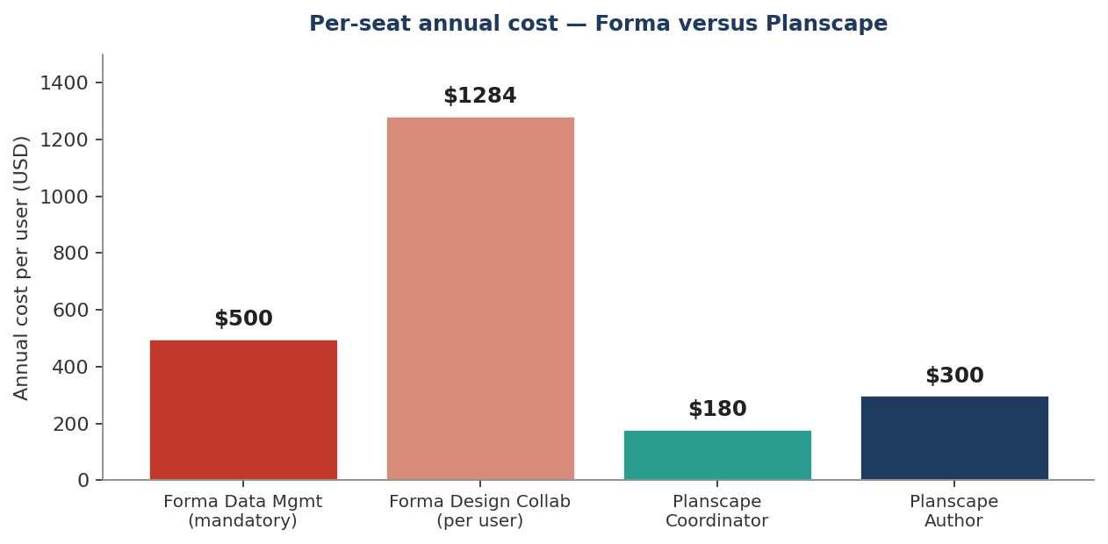

3. Capability matrix — what each seat actually delivers
A direct comparison of what is included with each subscription tier. Partial means the capability exists but in a limited or non-equivalent form. The key categories where Planscape Author is unique are the StingTools automation suite — asset tagging, MEP sizing, drawing production and COBie export — none of which Autodesk Forma offers at any price tier.

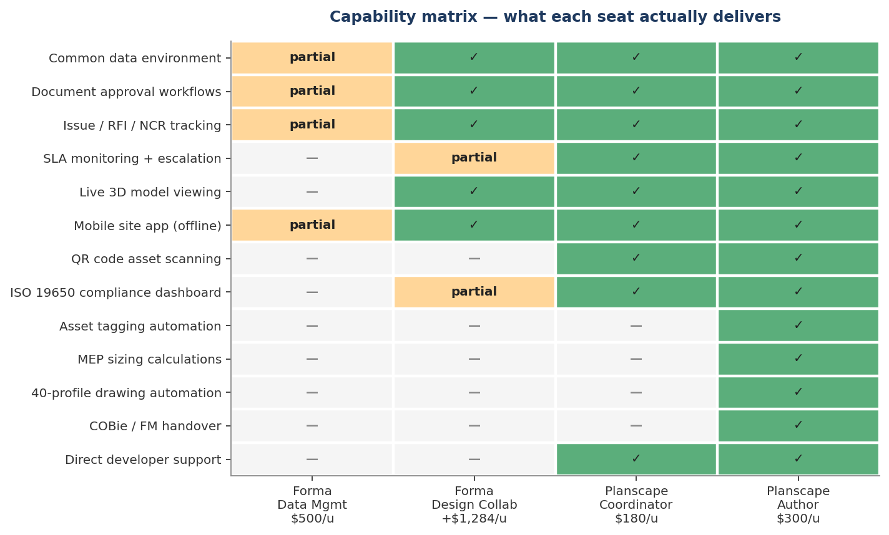

Adoption scenarios for FBW Group
Three configurations are presented below. The first is the Autodesk Forma baseline against which Planscape is compared. The next two are the two recommended Planscape configurations for an 18-person multi-discipline team.

Scenario A — full Autodesk Forma stack (18 users)
Item | Per user annual | Quantity | Subtotal
Revit | $3,005 | 18 | $54,090
Forma Data Management (mandatory) | $500 | 18 | $9,000
Forma Design Collaboration | $1,284 | 18 | $23,112
Annual total |  |  | $86,202

Scenario B — three Revit seats + Planscape coordination
Three discipline leads (architecture, structures, MEP) each hold a Revit seat and a Planscape Author seat. The remaining 15 team members are Coordinators — project managers, contract administrators, site engineers, document controllers, junior engineers, technicians, client liaisons. This is the recommended default configuration for FBW Group at current team size.

Item | Per user annual | Quantity | Subtotal
Revit (Autodesk) | $3,005 | 3 | $9,015
Planscape Author | $300 | 3 | $900
Planscape Coordinator | $180 | 15 | $2,700
Subscription total |  | 18 users | $12,615
Saving vs Scenario A |  |  | $73,587 / year — 85%

Scenario C — one Revit seat + Planscape coordination for the rest
A single BIM Coordinator holds the Revit licence and authors the federated model. All 17 other team members access the full coordination platform through Planscape’s web and mobile interfaces. This configuration suits projects where one senior BIM Coordinator is responsible for the federated model and the disciplines feed in through coordinated workflows rather than parallel authoring.

Item | Per user annual | Quantity | Subtotal
Revit (Autodesk) | $3,005 | 1 | $3,005
Planscape Author | $300 | 1 | $300
Planscape Coordinator | $180 | 17 | $3,060
Subscription total |  | 18 users | $6,365
Saving vs Scenario A |  |  | $79,837 / year — 93%

Side-by-side summary — 18-person team
Scenario | Annual subscription | Authors | Coordinators | Saving vs A
A — Full Autodesk Forma | $86,202 | 18 (Revit) | 0 | —
Revit ×18 + Planscape ($25/u) | $60,540 | 18 | 0 | $25,662
B — 3 Revit + Planscape | $12,615 | 3 | 15 | $73,587
C — 1 Revit + Planscape | $6,365 | 1 | 17 | $79,837

5-year cumulative cost projection
The annual difference compounds. Over a five-year horizon at constant team size, the cumulative software spend differs by hundreds of thousands of dollars.

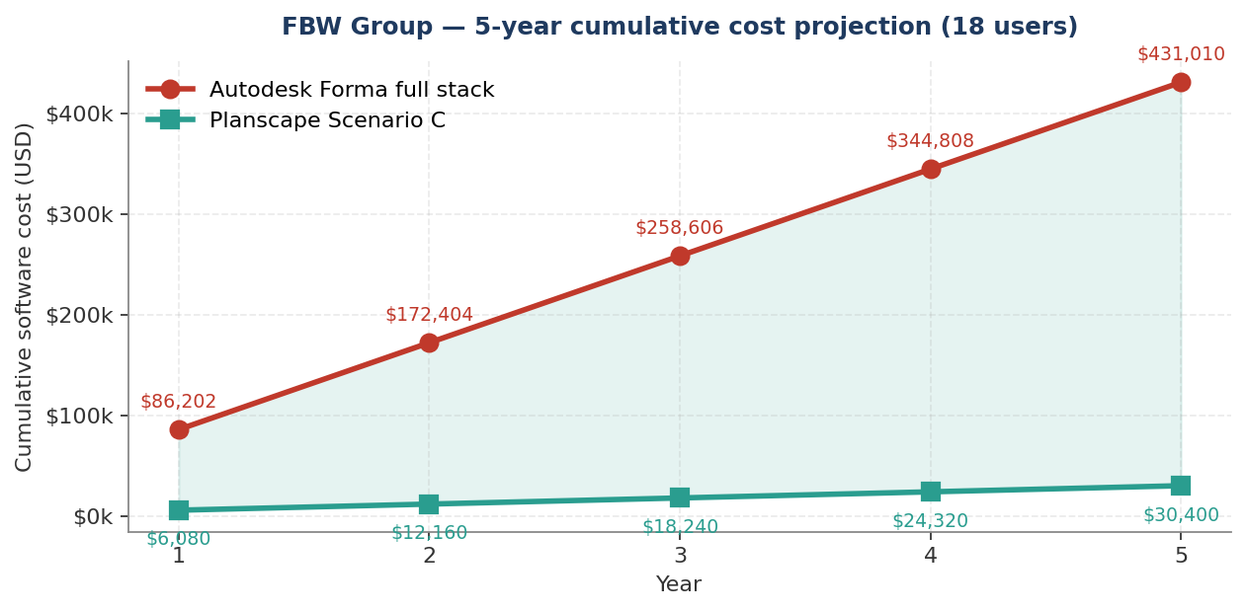

Why a multi-discipline practice benefits from this stack disproportionately
The features that distinguish Planscape from Forma matter most to firms running federated multi-discipline models. The reasons are specific:
- Federation is enforced. Planscape’s ISO 19650 state machine prevents architectural drawings being issued without coordinated structural and MEP. The CDE rejects non-compliant file names and tracks every state transition.
- Issue management is multi-recipient by design. An RFI raised by a site engineer can be assigned to MEP, copied to architecture and the contract administrator, with SLA monitoring on every party. Forma’s issue model is single-assignee.
- COBie handover is automatic. For multi-discipline projects with hundreds of MEP assets, the COBie spreadsheet is normally a six-week manual exercise. StingTools generates it from tagged model elements in 4–8 hours. Forma does not export COBie.
- The mobile app handles offline operation. Site engineers in remote locations can capture issues, scan QR codes, photograph defects and approve documents. The data queues locally and syncs on reconnect. Forma requires connectivity.
- Compliance is quantified. Every published model is scored against ISO 19650 requirements, with discipline-level breakdowns and trend over time. Forma offers no equivalent dashboard.

For a firm pursuing institutional and donor-funded work — World Bank, AfDB, EU programmes, sovereign infrastructure clients — these capabilities are not optional. They are the deliverable specification.

The proposal — founding partner terms for FBW Group
The standard managed Planscape subscription for a practice of this size is $1,800 per year. As a founding subscriber — among the first three firms to deploy the platform commercially — FBW Group is offered the founding rate of $1,200 for the first year. This covers the full management overhead: cloud infrastructure, all platform updates, deployment, document template integration and direct developer support.
The founding offer is decoupled from team size. Whether FBW Group adopts the 1-Revit configuration or the 3-Revit configuration, the management fee for the first year is $1,200. Per-seat costs (Author at $300/year, Coordinator at $180/year) are the same as the published rates and are billed in addition to the management fee.

Founding-year totals — both recommended configurations
Configuration | Per-seat subtotal | Founding management fee | Year 1 total
3 Revit + 15 Coordinators | $3,600 (3 × $300 + 15 × $180) | $1,200 | $4,800
1 Revit + 17 Coordinators | $3,360 (1 × $300 + 17 × $180) | $1,200 | $4,560
Note: the per-seat figures above exclude the Autodesk Revit licence cost, which is paid separately to Autodesk and is unchanged by this proposal.

What FBW Group receives for the founding management fee
Item | Included
StingTools plugin installed on every Revit seat | Yes
Planscape Author seats — for every BIM author | Yes
Planscape Coordinator seats — for every other team member | Yes
Cloud infrastructure — fully hosted and managed | Yes
Server deployment for FBW dedicated tenancy | Yes
FBW Group document templates built into the platform | Yes
ISO 19650 naming convention configured to FBW standards | Yes
Multi-discipline tagging schema (architecture, structures, MEP) | Yes
Team onboarding and training across all disciplines | Yes
Direct developer support — priority response | Yes

Infrastructure and hosting
For Planscape to operate as a live cloud service, the following infrastructure is required. It is provisioned, monitored and managed entirely by Sting Davis. The subscriber has no server administration responsibilities.

Component | Monthly (USD) | Annual (USD)
Cloud server — 4 GB RAM, 2 CPU | $24 | $288
Managed PostgreSQL database | $15 | $180
Object storage — documents and models | $20 | $240
Email delivery service | $20 | $240
Domain name and SSL certificate | $3 | $35
Redis cache instance | $15 | $180
Firebase push notifications | Free | $0
Total infrastructure | $97 | ~$1,163

Next steps
To proceed, the following steps are proposed:

Step | Detail | Timing
1. Live demonstration | Full platform walkthrough against current FBW Group projects | At a convenient date
2. Project identification | Identify the first project to deploy on and confirm the BIM Coordinator | During or after the demonstration
3. Deployment | Server deployment and StingTools installation, handled entirely by Sting Davis | Within one week of confirmation
4. Team training | Onboarding session for all Coordinator-seat users | The week following deployment

FBW Group, the foundation for this platform was laid in the year of training I delivered with engineers who knew exactly what was missing. I have built it. I am inviting you to be among the first subscribers.
Sting Davis │ Creator, StingTools & Planscape │ April 2026

