COMMERCIAL PROPOSAL

StingTools + Planscape
BIM automation and cloud coordination platform
Prepared for | M&E Associates — Kampala, Uganda
Attention | Engineer Sentongo, Director
Prepared by | Sting Davis — Creator, StingTools & Planscape
Date | April 2026

Founding partner rate
$1,200 / year — first founding subscriber

Executive summary
This proposal presents StingTools and Planscape, a BIM automation plugin and cloud coordination platform built for M&E engineering practice. It is addressed to Engineer Sentongo, Director of M&E Associates, Kampala, whose engagement as a training client in 2024–2025 identified the gap this platform is designed to fill.
The proposal covers the full feature set of both products, a direct cost comparison against Autodesk Forma, three adoption scenarios with modelled pricing, and a founding partner offer of $1,200 for the first year of a fully hosted, deployed and supported subscription.

 | Autodesk Forma (full stack, 6 users) | Planscape — Scenario C (1 Author + 5 Coordinators)
Annual cost | $28,734 | $4,205
Model authoring | All 6 users require Revit | 1 Revit seat required
Coordination access | $500/user/year mandatory minimum | Included; no Autodesk cost
Asset tagging automation | Not available at any tier | Included — StingTools
MEP sizing calculations | Not available at any tier | Included — StingTools
COBie / FM handover | Not available at any tier | Included — StingTools
Founding partner saving |  | $24,529 / year — 85% less

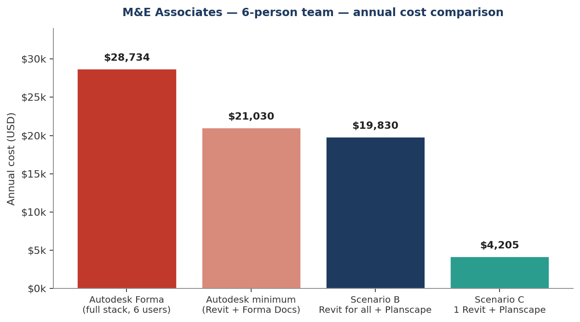

Background
Between June 2024 and June 2025, Sting Davis delivered Revit training to the M&E Associates team. That engagement provided a clear view of the challenge facing a serious M&E engineering practice in Kampala: premium global software priced for firms in London and Houston, with no tooling built around the operational realities of engineering practice in this market.
The result of the year following that training is StingTools, a Revit plugin, and Planscape, a cloud coordination server with a mobile application. This proposal is an invitation for M&E Associates to become the first subscriber.

1. The product family — what is being offered
StingTools and Planscape are a single integrated stack with three subscription tiers. The same plugin runs in Revit on every Author seat. The cloud platform connects every team member who does not need to model.

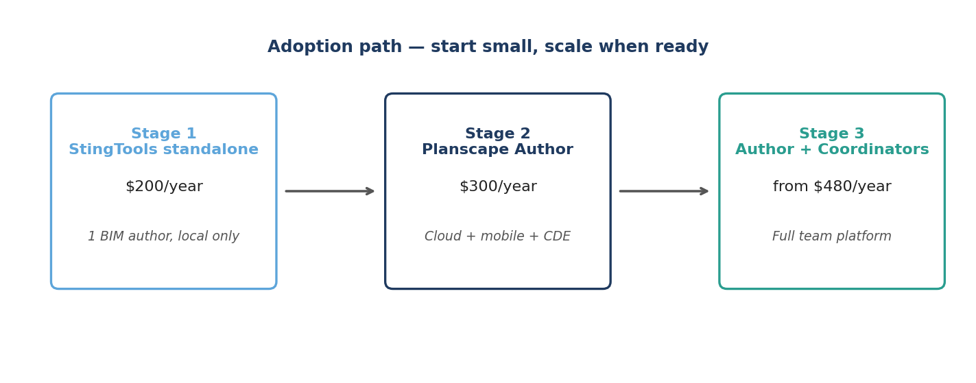

1.1 StingTools — the Revit power engine
StingTools is a plugin that installs directly into Autodesk Revit. It runs on the local machine, requires no internet, and does not depend on the cloud. The full automation suite is available even when offline. Inside Revit, it adds:
- ISO 19650 asset tagging — full 8-segment tag (DISC-LOC-ZONE-LVL-SYS-FUNC-PROD-SEQ) applied across thousands of elements in hours, with collision detection and validation reports.
- Project template setup — 1,527+ shared parameters, 23 view templates, 28 discipline filters, line styles, fill patterns and phases configured in under 90 minutes.
- Drawing sheet automation — 40 pre-configured drawing profiles covering every AEC discipline, with bin-packing viewport placement and ISO 19650 sheet numbering.
- Schedule generation — 168 schedule definitions covering panel boards, room finishes, equipment registers, COBie asset schedules and system takeoffs, all populated from live model data.
- Document automation — 16 document types render from live Revit data into Word and Excel using firm letterheads: transmittals, RFIs, meeting minutes, progress reports, variations, COBie exports.
- MEP engineering calculations — Darcy-Weisbach pipe sizing, 26-fitting duct sizing, Hardy Cross flow balancing, CIBSE TG6 vibro-acoustic analysis, all writing back to model parameters.
- COBie V2.4 export — full 22-worksheet handover package generated in 4–8 hours, not weeks.
- Real-time auto-tagging — elements tag themselves the moment they are placed; no batch run needed.

1.2 Planscape Author — connected command centre
Planscape Author is StingTools plus a live connection to the cloud server and mobile app. Every tag written, every compliance score, every transmittal issued, syncs to the Planscape server in the background. The Author is the one person on the project who models. Everything they produce flows outward to the team through Planscape.
What is added on top of StingTools:
- Common Data Environment with full ISO 19650-2 state machine: Work in Progress → Shared → Published → Archived. Stages cannot be skipped. Every transition is timestamped, attributed and added to an immutable audit chain.
- Transmittal engine that issues from inside Revit, transitions documents in the CDE, sends notifications, and waits for acknowledgement automatically.
- Team and project management dashboard — invite Coordinators, assign roles, set permissions, monitor progress from a browser.
- BIM issue management — raise from inside Revit, with element reference, screenshot and description. Visible immediately to all Coordinators on web and mobile.
- Live ISO 19650 compliance dashboard with quantified scores per discipline and project-level trend.
- Workflow automation — Daily QA, Weekly Data Drop, Document Package and Handover sequences run as single commands.
- Mobile app (iOS and Android) — full project access from any phone, with QR scanning, photo capture, GPS location, and offline operation that auto-syncs on reconnect.

1.3 Planscape Coordinator — the team and field eye
The Coordinator seat gives full access to the Planscape cloud platform and mobile app, without requiring Revit. A Coordinator cannot run StingTools commands or open the Revit model. They can do everything else: review drawings, approve documents, raise and close issues, monitor compliance, receive transmittals, manage meetings, capture site observations.
In a project with 18 people working on it, two or three need Revit. The other 15 to 16 are Coordinators. The cost difference compared to the Autodesk equivalent (Forma Data Management at $500 per user per year) is substantial, and the capability set is purpose-built for BIM coordination rather than general file storage.

2. What Autodesk Forma actually costs
In March 2026, Autodesk rebranded Autodesk Construction Cloud as Autodesk Forma. The names changed; the cost structure did not. The rule that applies to every Forma user without exception is that Forma Data Management is the mandatory foundation of the platform. Every person who needs to access any Forma product must hold a Forma Data Management subscription at $500 per user per year. There is no viewer tier and no coordination-only access without it.

Product | Annual per user | What it provides
Revit | $3,005 | BIM model authoring; no coordination features
Forma Data Management (mandatory) | $500 | CDE foundation, document management, basic markup
Forma Design Collaboration | $1,284 | Cloud Revit coordination, design review, worksharing
Full design coordination stack | $4,789 | Revit + Forma Data Management + Forma Design Collaboration

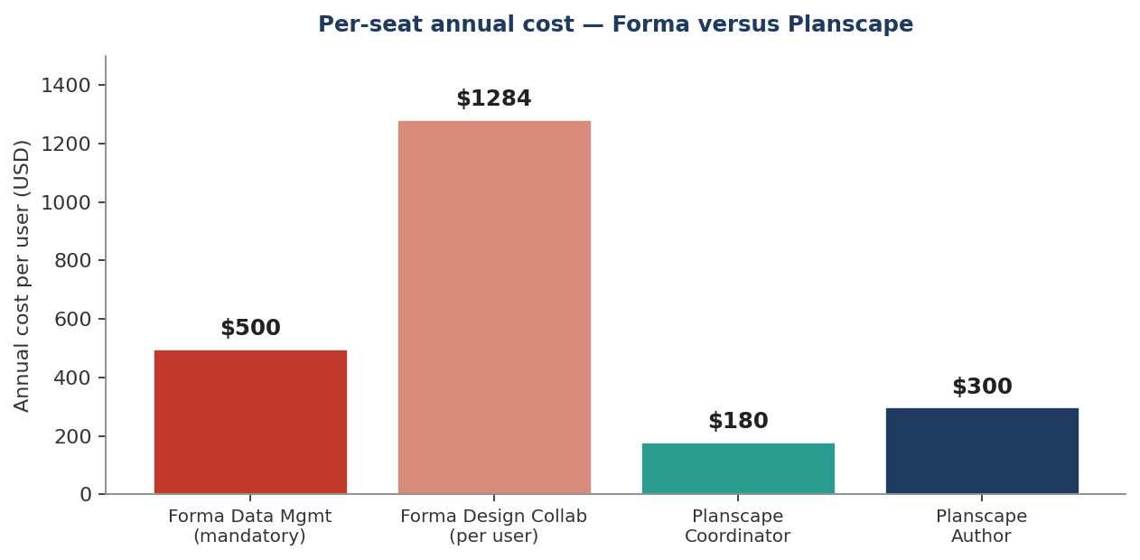

3. Capability matrix — what each seat actually delivers
A direct comparison of what is included with each subscription tier. Partial means the capability exists but in a limited or non-equivalent form. The key categories where Planscape Author is unique are the StingTools automation suite — asset tagging, MEP sizing, drawing production and COBie export — none of which Autodesk Forma offers at any price tier.

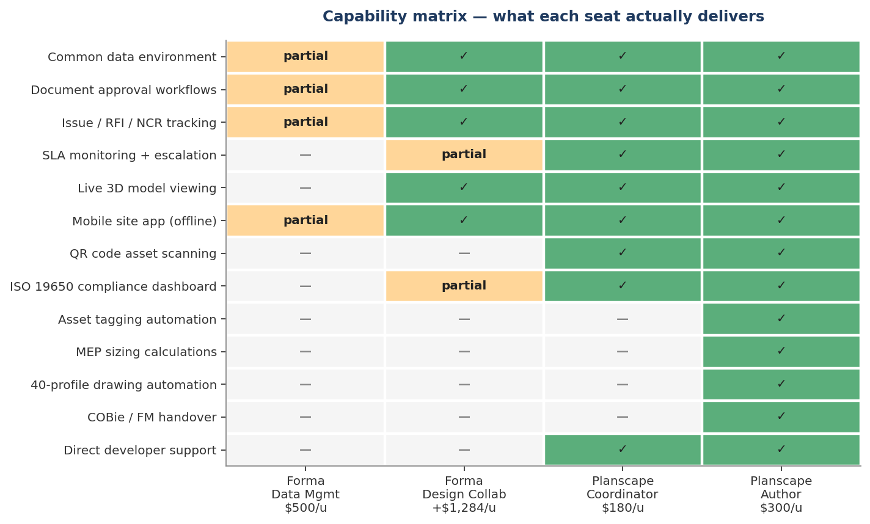

Platform preview
The screens below are taken from the live Planscape coordination console — the same interface that every team member will use through their browser or mobile device.

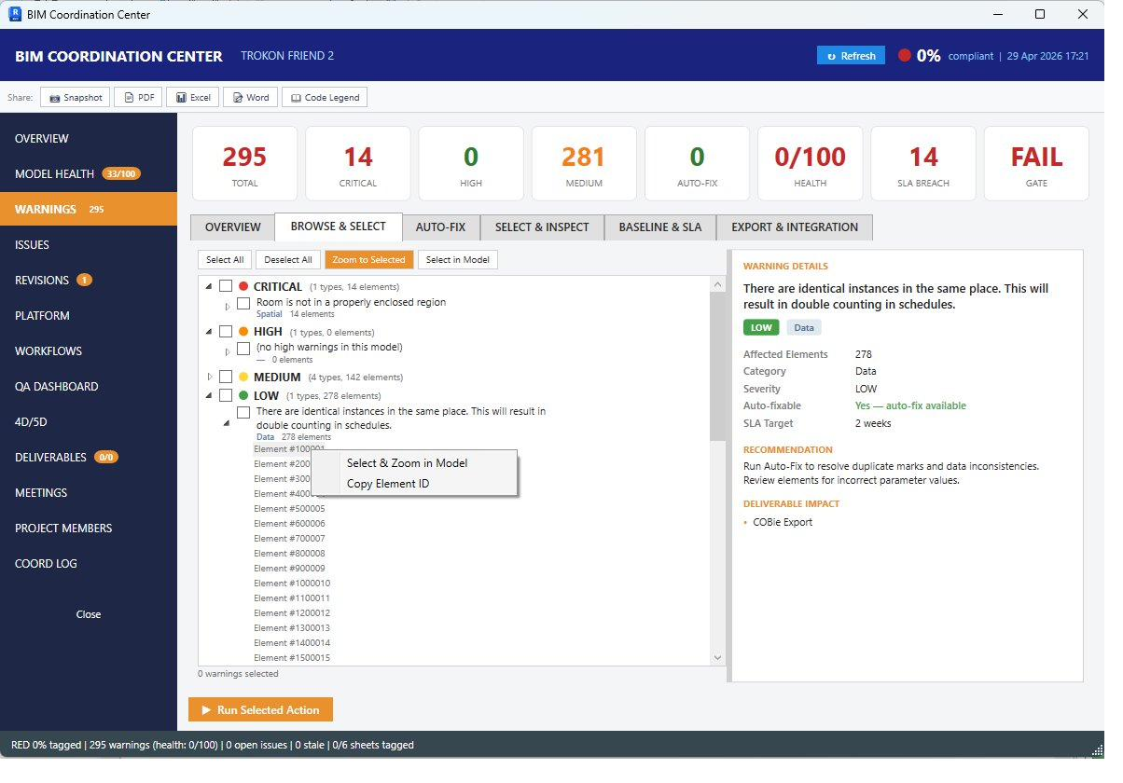
Model health and warnings dashboard. Severity-graded with auto-fix suggestions and SLA tracking on every issue.

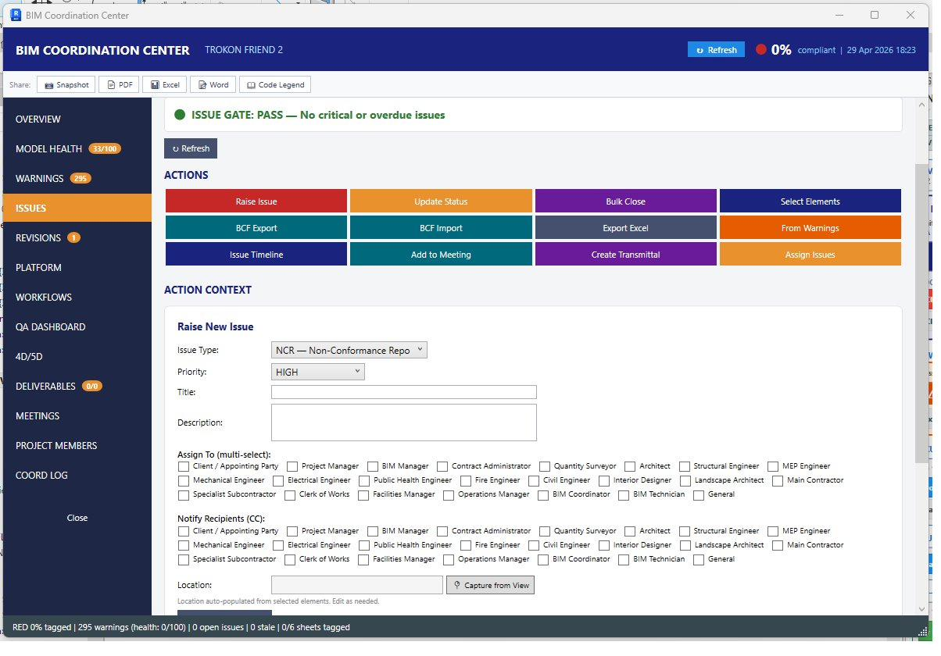
Issue management — RFI, NCR, site instruction. Multi-recipient assignment with notification and audit chain.

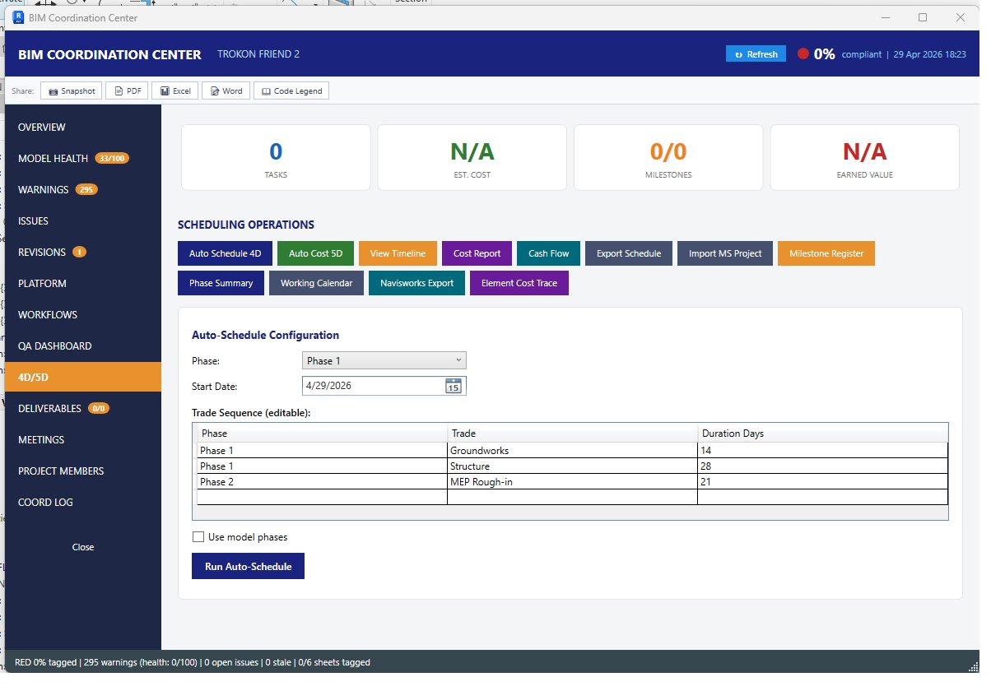
4D/5D scheduling and cost. Auto-schedule from model phases with cash flow and earned-value reporting.

5. Three adoption scenarios — cost comparison

Scenario A — full Autodesk Forma stack
Team size | Revit | Forma Data Mgmt | Forma Design Collab | Annual total
3 users | $9,015 | $1,500 | $3,852 | $14,367
6 users | $18,030 | $3,000 | $7,704 | $28,734
10 users | $30,050 | $5,000 | $12,840 | $47,890
20 users | $60,100 | $10,000 | $25,680 | $95,780

Scenario B — Revit for all + Planscape
Every engineer keeps Revit. Planscape replaces Forma entirely. Every seat gains the full StingTools automation suite — functionality Autodesk Forma does not offer at any price.
Team size | Revit | Planscape ($25/user/month) | Annual total | Saving vs Scenario A
3 users | $9,015 | $900 | $9,915 | $4,452 — 31%
6 users | $18,030 | $1,800 | $19,830 | $8,904 — 31%
10 users | $30,050 | $3,000 | $33,050 | $14,840 — 31%
20 users | $60,100 | $6,000 | $66,100 | $29,680 — 31%

Scenario C — the one-Revit coordination model
One person holds the Revit licence as BIM Coordinator. Every other team member accesses the full coordination platform through Planscape’s web interface and mobile app, without Revit installed, without an Autodesk account, and without a single additional Autodesk payment.
Seat type | Who it is for | Monthly | Annual
Planscape Author | The Revit user — full StingTools + full coordination platform | $25 | $300
Planscape Coordinator | Everyone else — full coordination, no Revit required | $15 | $180

Cost at M&E Associates — Scenario C
Configuration: 1 Author + 5 Coordinators.
Item | Annual (USD)
1 × Revit commercial licence | $3,005
1 × Planscape Author seat | $300
5 × Planscape Coordinator seats | $900
Total subscription | $4,205 / year

Six-person team — direct comparison
Scenario | Annual cost | What the team gets
A — Full Autodesk Forma | $28,734 | Revit + Forma Data Mgmt + Forma Design Collab for all 6
Autodesk minimum | $21,030 | Revit + document storage; no model coordination
B — Revit for all + Planscape | $19,830 | Revit + StingTools + Planscape for all 6
C — One Revit + Planscape | $4,205 | Full authoring for 1, full coordination for all 6
Saving — C vs full Forma | $24,529 / year — 85% cheaper
Saving — C vs Autodesk minimum | $16,825 / year — 80% cheaper

6. The proposal — founding partner terms
The standard annual Planscape managed subscription is $1,800 per year. That covers cloud infrastructure, all platform updates, document templates and naming conventions built in, and direct developer support.
Because M&E Associates is the founding partner whose engagement identified the need for this platform, the first year is offered at $1,200 — a price that covers infrastructure and onboarding with no setup fee and no upsell.

What M&E Associates receives for $1,200 in the founding year
Item | Included
StingTools plugin installed on Revit seat(s) | Yes
Planscape Author seat — BIM Coordinator | Yes
Planscape Coordinator seats — up to 5 additional team members | Yes
Cloud infrastructure — fully hosted and managed | Yes
Server deployment and configuration | Yes
Firm document templates built into the platform | Yes
ISO 19650 naming convention configured | Yes
Team onboarding and training | Yes
Direct developer support — priority response | Yes
Founding year total | $1,200

Year two and beyond
After the founding year, the subscription continues at $1,800 per year — the standard managed rate. This covers quarterly platform updates, infrastructure monitoring and backups, up to four hours per month of direct support and training, and access to every new capability released.

What being the first subscriber means in practice
When something in the platform does not work the way a specific project needs it to, it gets fixed directly with the developer who built it, not through a helpdesk queue managed by a corporation in California. The firm’s coordination workflows, document templates, tag configuration and naming patterns shape how the platform develops. As other firms come on board, the founding rate stays locked. As Planscape grows across the region, M&E Associates’ name is attached to it from the beginning.

Infrastructure and hosting
For Planscape to operate as a live cloud service, the following infrastructure is required. It is provisioned, monitored and managed entirely by Sting Davis. The subscriber has no server administration responsibilities.

Component | Monthly (USD) | Annual (USD)
Cloud server — 4 GB RAM, 2 CPU | $24 | $288
Managed PostgreSQL database | $15 | $180
Object storage — documents and models | $20 | $240
Email delivery service | $20 | $240
Domain name and SSL certificate | $3 | $35
Redis cache instance | $15 | $180
Firebase push notifications | Free | $0
Total infrastructure | $97 | ~$1,163

Next steps
To proceed, the following steps are proposed:

Step | Detail | Timing
1. Live demonstration | Full platform walkthrough against current M&E Associates projects | At a convenient date
2. Project identification | Identify the first project to deploy on and confirm the BIM Coordinator | During or after the demonstration
3. Deployment | Server deployment and StingTools installation, handled entirely by Sting Davis | Within one week of confirmation
4. Team training | Onboarding session for all Coordinator-seat users | The week following deployment

Engineer Sentongo, the foundation for this platform was laid in the year of training I delivered with engineers who knew exactly what was missing. I have built it. I am inviting you to be among the first subscribers.
Sting Davis │ Creator, StingTools & Planscape │ April 2026

