1. Create Database

Ans:



1. Design Schema

Ans:



1. Create tables

Ans:

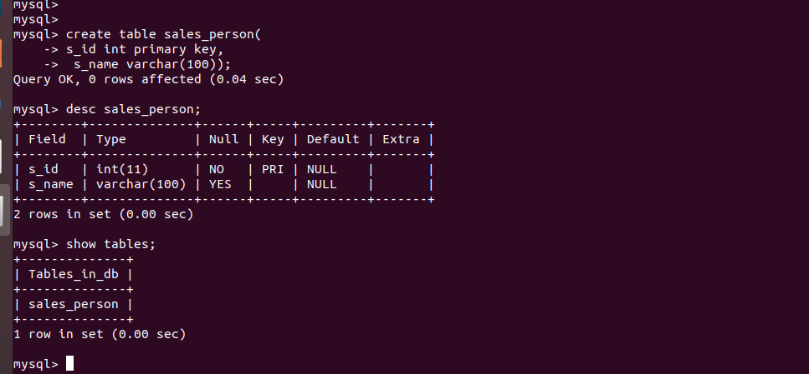

1. Insert sample data

Ans:



1. Find the sales person have multiple orders.

Ans:

Note:- careful about referential integrity

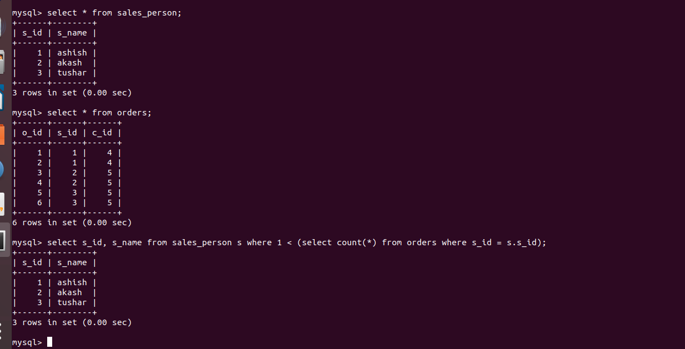

1. Find the all sales person detail along with order detal.

Ans:

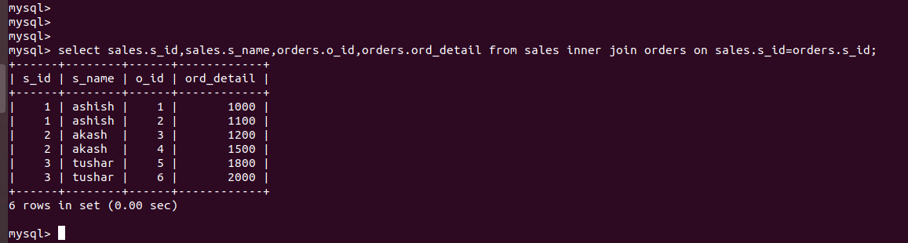

1. Create index

Ans:

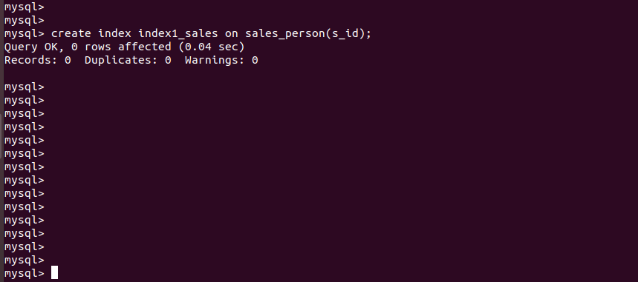

1. How to show index on a table

Ans;

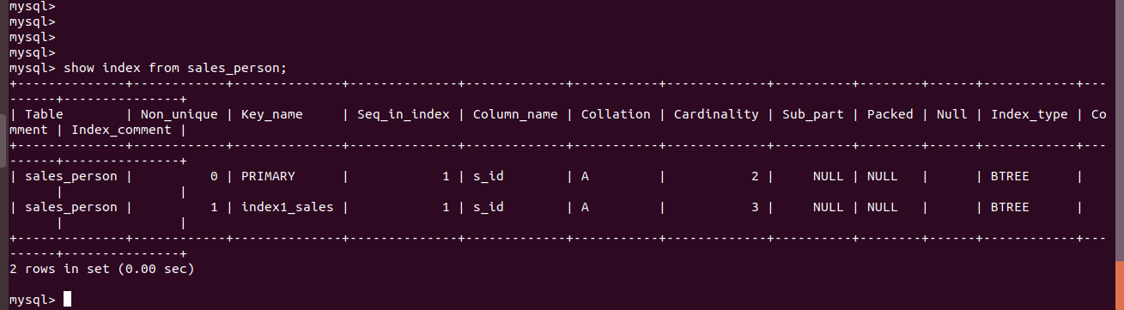

9.Find the order number, sale person name, along with the customer to whom that order belongs to.

Ans

