**HTML EXERCISE USING BOOTSTRAP 4**

5. Write the HTML code to create a table in which there are 4 columns( ID , Employee Name, Designation, Department) and at least 6 rows. Also do some styling to it.

Using **BOOTSTRAP 4**

**ANS:-**

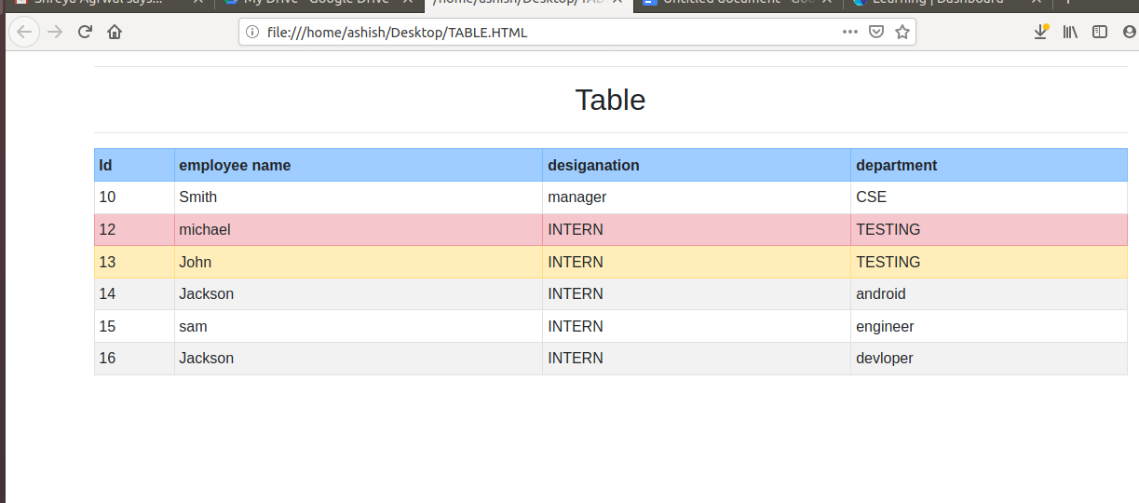

**CODE:-**

<!Doctype html>

<html>

<head><meta charset="utf-8">

<meta name="viewport" content="width=device-width, initial-scale=1, shrink-to-fit=no">

<link rel="stylesheet" href="https://stackpath.bootstrapcdn.com/bootstrap/4.4.1/css/bootstrap.min.css" integrity="sha384-Vkoo8x4CGsO3+Hhxv8T/Q5PaXtkKtu6ug5TOeNV6gBiFeWPGFN9MuhOf23Q9Ifjh" crossorigin="anonymous">

</head>

<body>

<div class="container">

<hr>

<h2 class="text-center"> Table </h2>

<hr>

<table class="table table-striped table-bordered table-hover table-sm">

<tr class="table-primary">

<th>Id</th>

<th>employee name</th>

<th>desiganation</th>

<th>department</th>

</tr>

<tr>

<td>10</td>

<td>Smith</td>

<td>manager</td>

<td>CSE</td>

</tr>

<tr class="table-danger">

<td>12</td>

<td>michael</td>

<td>INTERN</td>

<td>TESTING</td>

</tr>

<tr class="table-warning">

<td>13</td>

<td>John</td>

<td>INTERN</td>

<td>TESTING</td>

</tr>

<tr>

<td>14</td>

<td>Jackson</td>

<td>INTERN</td>

<td>android</td>

</tr>

<tr>

<td>15</td>

<td>sam</td>

<td>INTERN</td>

<td>engineer</td>

</tr>

<tr>

<td>16</td>

<td>Jackson</td>

<td>INTERN</td>

<td>devloper</td>

</tr>

</table>

</body>

</html>

11. Create HTML for web-page.jpg (check resources, highest weightage for answers)

**USING BOOTSTRAP 4**

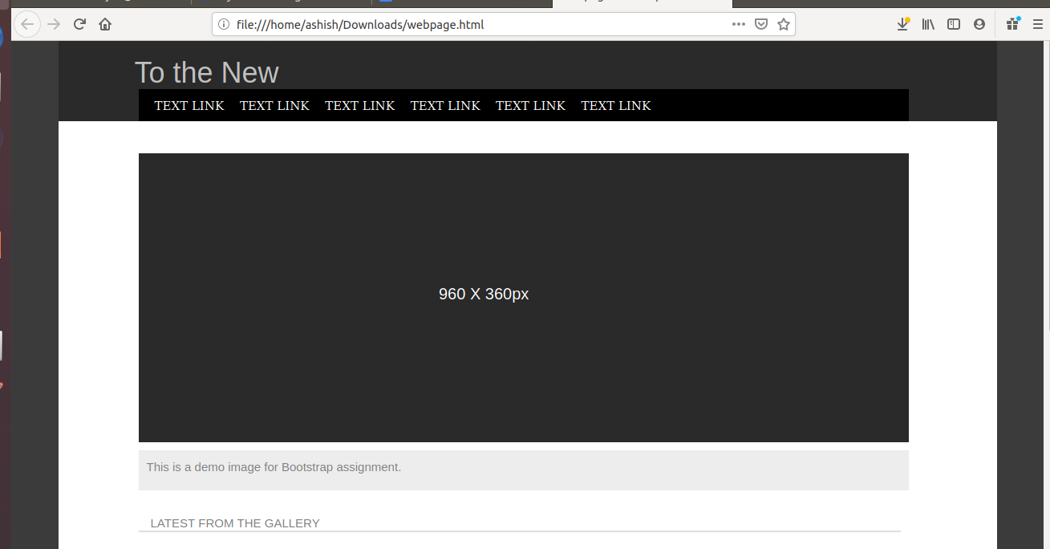

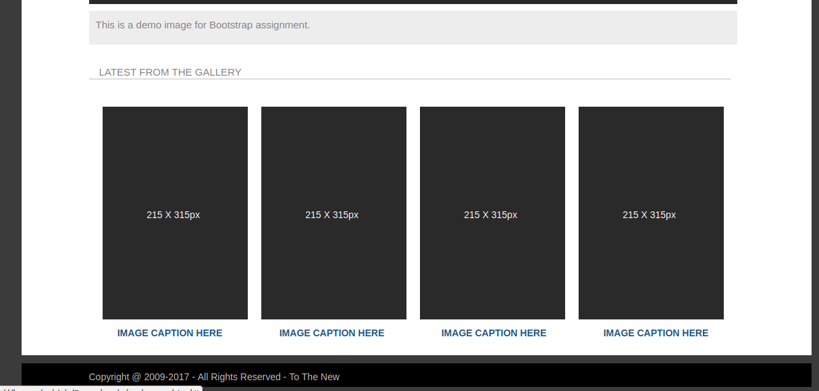

**Code:-**

**<!DOCTYPE html>**

**<html>**

**<head>**

**<title>Webpage Bootsrap</title>**

**<link rel="stylesheet" href="https://maxcdn.bootstrapcdn.com/bootstrap/3.4.1/css/bootstrap.min.css">**

**<style type="text/css">**

**body {**

**background-color: #3B3B3B;**

**}**

**.simg {**

**margin-right:10px; margin-left:10px; width:215px; height:315px; padding-top:16%; padding-left:7%;**

**background-color: #2A2A2A; color: white;**

**}**

**.link {**

**padding: 0px 5px 0px 10px; color: white ;**

**}**

**hr { border:1px solid #DFDDDD; margin-right:120px;**

**}**

**</style>**

**</head>**

**<body>**

**<section class="container" style="background-color:white; height:1020px">**

**<div class="row " style="background-color:#2A2A2A; height: 100px;">**

**<div class="col-md-11">**

**<h1 style="height: 30px; color: silver; padding-left: 80px;">To the New</h1>**

**<div class="row" style="padding-left: 100px">**

**<div class="col-md-11" style="width:960px; height:40px; padding: 10px; list-style-type: none; font-family: Gotham; font-size: 15px; background-color:black;">**

**<a class="nav-link link" href="#"> TEXT LINK**

**<a class="nav-link link" href="#"> TEXT LINK**

**<a class="nav-link link" href="#"> TEXT LINK**

**<a class="nav-link link" href="#"> TEXT LINK**

**<a class="nav-link link" href="#"> TEXT LINK**

**<a class="nav-link link" href="#"> TEXT LINK**

**</div>**

**</div>**

**</div>**

**</div>**

**<div class="row" style="padding-left: 100px">**

**<div class="col-md-11" style="width:960px; height:360px; font-size:20px; color:white; background-color:#2A2A2A; padding-top:15%; padding-left:35%;"> 960 X 360px**

**</div>**

**</div>**

**<div class="row" style="padding: 10px 0px 0px 100px; ">**

**<div class="col-md-11" style="width:960px; height:50px; padding:10px; font-size:15px; color:grey; background-color:#EDEDED;"> This is a demo image for Bootstrap assignment.**

**</div>**

**</div>**

**<div class="row" style="padding: 30px 0px 0px 100px; ">**

**<div class="col-md-11" style="width:960px; height:20px; font-size:15px; color:grey;"> LATEST FROM THE GALLERY**

**</div>**

**<hr>**

**</div>**

**<div class="row" style="padding-left: 100px; padding-top:10px;">**

**<div class="col-md-11" style="width:960px; height:360px;">**

**<div class="row" style="padding:10px;">**

**<div class="col-md-3 col simg" >**

**215 X 315px**

**</div>**

**<div class="col-md-3 col simg" >**

**215 X 315px**

**</div>**

**<div class="col-md-3 col simg">**

**215 X 315px**

**</div>**

**<div class="col-md-3 col simg">**

**215 X 315px**

**</div>**

**</div>**

**<div class="row d-flex justify-content-center" style="margin-bottom: 10px; text-align: center;">**

**<div class="col-md-3">**

**<label>IMAGE CAPTION HERE</label>**

**</div>**

**<div class="col-md-3">**

**<label>IMAGE CAPTION HERE</label>**

**</div>**

**<div class="col-md-3">**

**<label>IMAGE CAPTION HERE</label>**

**</div>**

**<div class="col-md-3">**

**<label>IMAGE CAPTION HERE</label>**

**</div>**

**</div>**

**</div>**

**</div>**

**<div class="row " style="background-color:black; height: 35px; padding:10px; margin-top:30px;">**

**<div class="col-md-11" style="color:silver; padding-left:90px;">**

**Copyright @ 2009-2017 - All Rights Reserved - To The New**

**</div>**

**</div>**

**</section>**

**</body>**

**<!-- jQuery library -->**

**<script src="https://ajax.googleapis.com/ajax/libs/jquery/3.4.1/jquery.min.js"></script>**

**<!-- Latest compiled JavaScript -->**

**<script src="https://maxcdn.bootstrapcdn.com/bootstrap/3.4.1/js/bootstrap.min.js"></script>**

**</html>**

12. Create HTML for form.png (check resources, highest weightage for answers)

**Using bootsstrap 4**

**Ans:-**

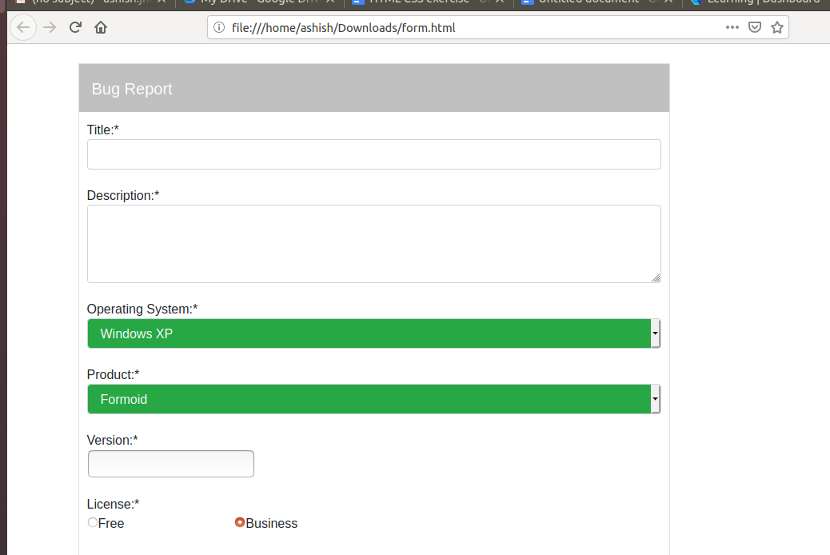

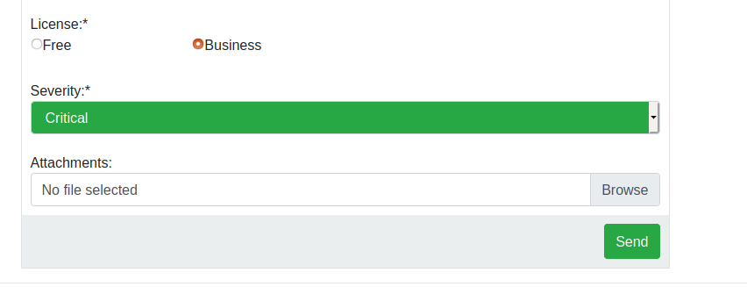

Source code:-

<! DOCTYPE html>

<hmtl>

<head>

<title> Bootstrap Form </title>

<meta charset="utf-8">

<meta name="viewport" content="width=device-width, initial-scale=1, shrink-to-fit=no">

<link rel="stylesheet" href="https://stackpath.bootstrapcdn.com/bootstrap/4.4.1/css/bootstrap.min.css" integrity="sha384-Vkoo8x4CGsO3+Hhxv8T/Q5PaXtkKtu6ug5TOeNV6gBiFeWPGFN9MuhOf23Q9Ifjh" crossorigin="anonymous">

</head>

<body>

<br>

<section>

<div class="container">

<div class="border border-silver col-md-8">

<div class="row justify-content-center h-auto">

<div class="col-md-12 text-white" style="background-color:silver; height:60px; padding:16px; font-size:20px;"> Bug Report </div>

</div>

<div class="row justify-content-center">

<div class="col-md-12" style="padding:10px"> Title:*

<input type="text" class="form-control" id="title"> </div>

</div>

<div class="row justify-content-center">

<div class="col-md-12" style="padding:10px"> Description:*

<textarea class="form-control" rows="3"></textarea>

</div>

</div>

<div class="row justify-content-center">

<div class="col-md-12 " style="padding:10px"> Operating System:* <br>

<select class="form-control bg-success text-white">

<option>Windows XP</option>

<option>IOS</option>

<option>Linux</option>

<option>Windows 10</option>

</select>

</div>

</div>

<div class="row justify-content-center">

<div class="col-md-12" style="padding:10px"> Product:* <br>

<select class="form-control bg-success text-white" id="product">

<option>Formoid</option>

<option>A</option>

<option>B</option>

<option>C</option>

</select>

</div>

</div>

<div class="row justify-content-center">

<div class="col-md-12" style="padding:10px"> Version:* <br>

<input type="text" id="version"> </div>

</div>

<div class="row justify-content-center">

<div class="col-md-12" style="padding:10px"> License:* <br>

<label><input type="radio" name="l" checked>Free &nbsp;&nbsp;&nbsp;&nbsp;&nbsp;&nbsp;&nbsp;&nbsp;&nbsp;&nbsp;&nbsp;

&nbsp;&nbsp;&nbsp;&nbsp;&nbsp;&nbsp;&nbsp;&nbsp;&nbsp;&nbsp;&nbsp;&nbsp;&nbsp;&nbsp;&nbsp;&nbsp;&nbsp;</label>

<label><input type="radio" name="l" checked>Business</label>

</div>

</div>

<div class="row justify-content-center">

<div class="col-md-12" style="padding:10px"> Severity:* <br>

<select class="form-control bg-success text-white">

<option>Critical</option>

<option>Normal</option>

</select>

</div>

</div>

<div class="row justify-content-center">

<div class="col-md-12" style="padding:10px"> Attachments: <br>

<div class="custom-file">

<input type="file" class="custom-file-input">

<label class="custom-file-label">No file selected</label>

</div>

</div>

</div>

<div class="row justify-content-center">

<div class="col-md-12 row justify-content-end" style="background-color:#EBEEEF; height:60px; padding:10px;">

<button type="button" class="btn btn-success" style="height:40px">Send</button>

</div>

</div>

</div>

</div>

</section>

<hr>

</body>

</html>