**1.How are inline and block elements different from each other?**

**Ans:-**

**BLOCK ELEMENT:-**

A block element is an element that has following characterstic:-

* If no width is set, will expand naturally to fill its parent container
* Can have margins and padding
* If no height is set, will expand naturally to fit its child elements
* By default, will be placed below previous elements in the markup
* Ignores the vertical-align property

So, for a block element , it’s not necessary to give it a set width or to give it awidth of 100%. if you want it to fill its parent horizontally. In fact, doing either of those things may cause maintainability issues or other undesirable problems.And, as the fourth item in the above list indicates, it’s also not necessary to “clear” a block element.

Example of block element:- <p>, <div>, <form>, <header>, <nav>, <ul>, <li>, and <h1>.

**INLINE ELEMENT** :-

A block element is an element that has following characterstic:-

* An inline element only takes up as much width as necessary, cannot accept width and height values, and does not force line breaks.
* Inline element doesn’t start on new line.
* Inline element can’t take padding or margin.

Example of inline element:- <a>,<span>,<img> etc.

**2.Explain the difference between visibility:hidden and display:none**

**Ans:**

display:none means that the tag in question will not appear on the page at all. There will be no space allocated for it between the other tags.

visibility:hidden means that unlike display:none, the tag is not visible, but space is allocated for it on the page. The tag is rendered, it just isn't seen on the page.

In both case the tag in question will not appear, but one is space not allocated. And another one is allocated.

**3. Explain the clear and float properties.**

Ans:

Both clear and float are css property which is used for styling.

Float means how an element should folat, but clear property means what elements can float beside the cleared element and on which side.

The float property is used for positioning and formatting content e.g. let an image float left to the text in a container.

The float property have following values:

* left - The element floats to the left of its container
* right - The element floats to the right of its container
* none - The element does not float (will be displayed just where it occurs in the text). This is default
* inherit - The element inherits the float value of its parent

It’s basically usuage for wrapping arround image.

The clear property specifies what elements can float beside the cleared element and on which side.The clear property can have one of the following values:

* none - Allows floating elements on both sides. This is default
* left - No floating elements allowed on the left side
* right- No floating elements allowed on the right side.

**4. explain difference between absolute, relative,fixed and static.**

**Ans:-**

There are 4 different types of CSS positioning, which are as the title of this post states: Static, Relative, Absolute, and Fixed

static:-Static is the default type of positioning. When elements don’t have a position specifically set, they default to static.

fixed:-Fixed elements are completely independent of everything else on the web page. Regardless of any parents, a fixed position element will always be positioned based on the browser window.

relative**:** Making an HTML element relative, gives you the privilege to move the element from its current position. It does not refer to a different element’s position.

absolute:Absolute positioning an HTML element positions the element to its nearest positioned parent. Thus it refers to the nearest parent’s position.

**5. Write the HTML code to create a table in which there are 4 columns( ID , Employee Name, Designation, Department) and at least 6 rows. Also do some styling to it.**

Ans:

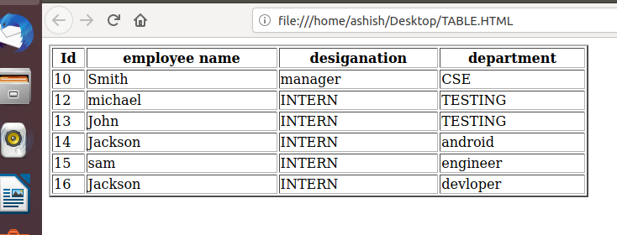

Code:-

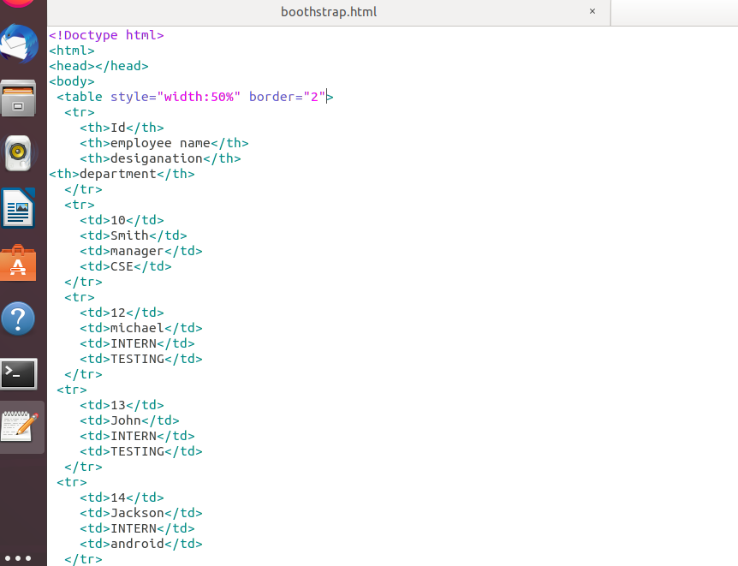

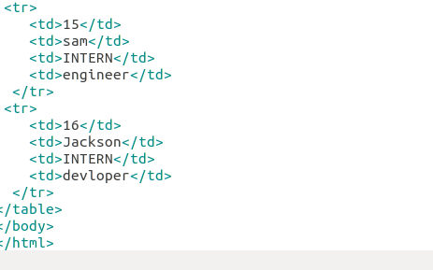

6. Why do we use meta tags?

Ans:-

Meta tags provide information about the webpage in the HTML of the document. This information is called "metadata" and while it is not displayed on the page itself, it can be read by search engines and web crawlers.

Search engines such as Google use metadata from meta tags to understand additional information about the webpage. They can use this information for ranking purposes, to display snippets in search results, and sometimes they can ignore meta tags.

Meta tag actually work on this scenerio

* Meta content type – This tag is necessary to declare your character set for the page and should be present on every page. Leaving this out could impact how your page renders in the browser. A few options are listed below, but your web designer should know what's best for your site.
* Title – While the title tag doesn’t start with "meta," it *is* in the header and contains information that's very important to SEO. You should always have a unique title tag on every page that describes the page.
* Meta description – The infamous meta description tag is used for one major purpose: to describe the page to searchers as they read through the SERPs. This tag doesn't influence ranking, but it's very important regardless. It's the ad copy that will determine if users click on *your* result. Keep it within 160 characters, and write it to catch the user's attention.
* Viewport – In this mobile world, you should be specifying the viewport. If you don’t, you run the risk of having a poor mobile experience

**7. Explain box model.**

**Ans:-**

All HTML elements can be considered as boxes. In CSS, the term "box model" is used when talking about design and layout.

The CSS box model is essentially a box that wraps around every HTML element. It consists of: margins, borders, padding, and the actual content. The image below illustrates the box model:

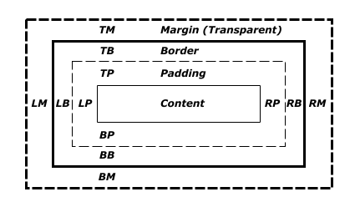

Explanation of the different parts:

* **Content** - The content of the box, where text and images appear
* **Padding** - Clears an area around the content. The padding is transparent
* **Border** - A border that goes around the padding and content
* **Margin** - Clears an area outside the border. The margin is transparent

The box model allows us to add a border around elements, and to define space between elements.

**8. What are the different types of CSS Selectors?**

Ans:-

There are 5 types of css selector:-

1. CSS Element Selector.
2. CSS Id Selector.
3. CSS Class Selector.
4. CSS Attribute Selector.
5. CSS Universal Selector.

#### 

Universal: In an HTML page, the content depends on HTML tags. A pair of tags defines a specific webpage element. The CSS universal selector selects all the elements on a webpage.

* {

color: blue;

font-size: 21px;

}

Element selector: CSS Element Selector is also known as a Type selector. Element Selector in CSS tries tomatch the html element having the same name. Therefore, a selector of <ul> matches all the <ul>.

CSS ID selector helps the developer to match the ID created by the developer to its styling content. ID Selector is used with the help of the hash (#) sign before the ID name declared by the developer. ID selector matches every HTML element having an ID attribute with the value the same as that of the selector, without the hash sign.

Here’s an example:

#box {

width: 90px;

margin: 10px;

}

Css class: The CSS Class selector is one of the most helpful selectors of all the selectors. It is declared by using a dot followed by the name of the class. This class name is defined by the coder, as is the case with the ID selector. The class selector searches for every element having an attribute value with the same name as the class name, without the dot.

.square {

margin: 20px;

width: 20px;

}

CSS Attribute selector styles content according to the attribute and the attribute value mentioned in the square brackets. No spaces can be present ahead of the opening square bracket.

input[type="text"] {

background-color: #fff;

width: 100px;

}

**9. Define Doctype.**

**Ans:-**

Basically, the DOCTYPE describes the HTML that will be used in your page.

Browsers also use the DOCTYPE to determine how to render a page. Not including a DOCTYPE or including an incorrect DOCTYPE can trigger quirks mode. The kicker here is that quirks mode in Internet Explorer is quite different from quirks mode in Firefox (and other browsers), meaning that you'll have a *much* harder job trying to ensure your page works consistently in all browsers if pages are rendered in quirks mode than you will if they are rendered in standards mode.

the DOCTYPE tells the consuming user agent (web browsers, web crawlers, validation tools) what type of document the file is. Using it ensures that the consumer correctly parses the HTML as you intended it.

<!Doctype html>

<html>

</html>

**10. Explain 5 HTML5 semantic tags.**

**Ans:-**

**Html5 is extended version of html3 which is add some more feature,sementic tag**

**Are one of them changes.**

Semantic HTML elements clearly describe it’s meaning in a human and machine readable way. Elements such as <header>, <footer> and <article> are all considered semantic because they accurately describe the purpose of the element and the type of content that is inside them.

#### **<section> and <article>**

“What’s the difference?”, you may ask. Both these elements are used for sectioning a content, and yes, they can definitely be used interchangeably. It’s a matter of in which situation. HTML4 offered only one type of container element, which is <div>. While this is still used in HTML5, HTML5 provided us with <section> and <article> in a way to replace <div>.

#### **<header>**

The <header> element is generally found at the top of a document, a section, or an article and usually contains the main heading and some navigation and search tools.

#### **<footer>**

If there is a <header> there must be a <footer>. A <footer> is generally found at the bottom of a document, a section, or an article. Just like the <header> the content is generally metainformation, such as author details, legal information, and/or links to related information. It is also valid to include <section> elements within a footer.

#### **<aside>**

The <aside> element is intended for content that is not part of the flow of the text in which it appears, however still related in some way. This of <aside> as a sidebar to your main content.

**11. Create HTML for web-page.jpg (check resources, highest weightage for answers)**

**Ans:-**

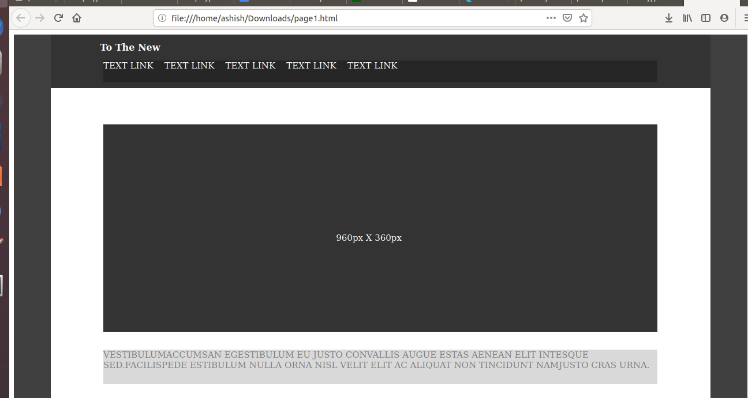

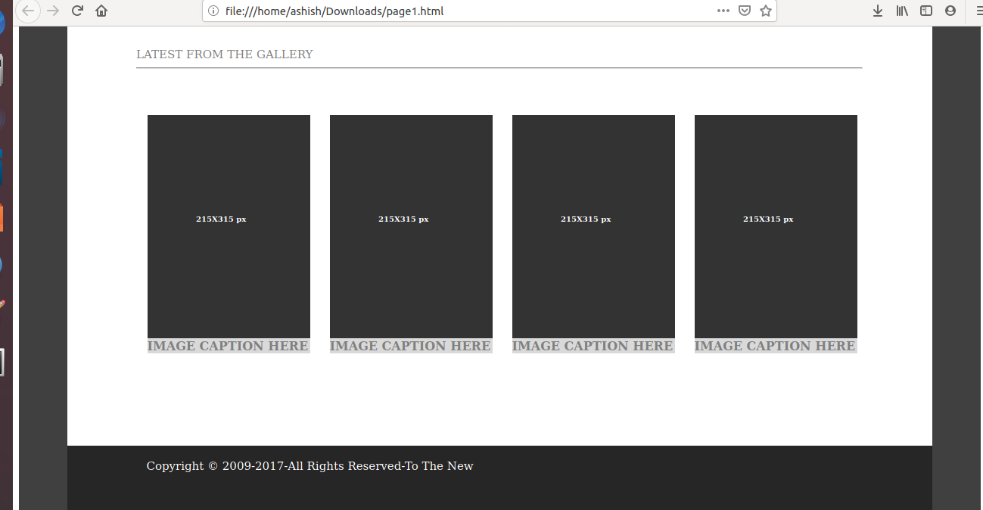

**code:-<html>**

**<head>**

**<title>answer11</title>**

**<style>**

**.menu {**

**float:left;**

**background-color:#404040;**

**width:5%;**

**height:200.5%;**

**}**

**.mainContent {**

**float:left;**

**width:90%;**

**height:100%;**

**font-size:30px;**

**}**

**.content{**

**float :left;**

**width:100%;**

**height:15%;**

**background-color:#333333;**

**}**

**.content1{**

**float:left;**

**position: relative;**

**right: -8%;**

**top:+10%;**

**text-align: left;**

**width:960px;**

**height:40%;**

**background-color:#262626;**

**}**

**.content2{**

**float:left;**

**position: relative;**

**right: -8%;**

**top:+10%;**

**text-align: left;**

**width:960px;**

**height:360px;**

**background-color:#333333;**

**}**

**p{**

**padding-top:18%;**

**padding-right:40%;**

**padding-bottom:40%;**

**padding-left:42%;**

**}**

**h6{**

**padding-top:50%;**

**padding-right:20%;**

**padding-bottom:40%;**

**padding-left:30%;**

**}**

**hr{color:#d9d9d9;}**

**a{color:white;**

**text-decoration: none;**

**font-size:15px;**

**}**

**b{**

**text-align: justify;**

**font-size:16px;**

**}**

**.content3{**

**float:left;**

**position: relative;**

**right: -8%;**

**top:+15%;**

**text-align: left;**

**width:960px;**

**height:60px;**

**color:#808080;**

**background-color:#d9d9d9;**

**}**

**.content4{**

**float:left;**

**position: relative;**

**right: -8%;**

**top:+20%;**

**text-align: left;**

**width:960px;**

**height:60px;**

**}**

**.content5{**

**float:left;**

**position: relative;**

**right: -7%;**

**top:+15%;**

**text-align: left;**

**width:215px;**

**height:315px;**

**border:13px solid white;**

**}**

**.content6{**

**background-color:#333333;**

**float:left;**

**position: relative;**

**right: -6%;**

**top:+15%;**

**text-align: left;**

**width:215px;**

**height:300px;**

**border:13px gray;**

**}**

**.content7{**

**background-color:#d9d9d9;**

**float:left;**

**position: relative;**

**right: 0%;**

**top:+14%;**

**text-align: justify;**

**width:215px;**

**color:#808080;**

**height:20px;**

**border:13px gray;**

**}**

**.content8{**

**float:left;**

**position: relative;**

**top:+40%;**

**text-align: left;**

**width:100%;**

**height:85px;**

**background-color:#262626;**

**}**

**</style>**

**<head/>**

**<body text="white">**

**<div class="menu" ></div>**

**<div class="mainContent" >**

**<div class="content" > &nbsp;&nbsp;&nbsp;&nbsp;&nbsp;&nbsp;&nbsp;&nbsp;**

**<b>To The New </b> </br>**

**<div class ="content1">**

**<a href="">TEXT LINK<a/>&nbsp;&nbsp;&nbsp;**

**<a href="">TEXT LINK<a/>&nbsp;&nbsp;&nbsp;**

**<a href="">TEXT LINK<a/>&nbsp;&nbsp;&nbsp;**

**<a href="">TEXT LINK<a/>&nbsp;&nbsp;&nbsp;**

**<a href="">TEXT LINK<a/>&nbsp;&nbsp;&nbsp;**

**</div>**

**</div>**

**<div class="content2"><p>960px X 360px</p></div></br>**

**<div class="content3" > VESTIBULUMACCUMSAN EGESTIBULUM EU JUSTO CONVALLIS AUGUE ESTAS AENEAN ELIT INTESQUE SED.FACILISPEDE ESTIBULUM NULLA ORNA NISL VELIT ELIT AC ALIQUAT NON TINCIDUNT NAMJUSTO CRAS URNA.</div>**

**<div class="content4"> <font color="gray">LATEST FROM THE GALLERY</font><hr/></div>**

**<div class="content5" ><div class="content6"><h6>215X315 px</h6><div class="content7"><b>IMAGE CAPTION HERE</b></div></div></div>**

**<div class="content5" ><div class="content6"><h6>215X315 px</h6><div class="content7"><b>IMAGE CAPTION HERE</b></div></div></div>**

**<div class="content5" ><div class="content6"><h6>215X315 px</h6><div class="content7"><b>IMAGE CAPTION HERE</b></div></div></div>**

**<div class="content5" ><div class="content6"><h6>215X315 px</h6><div class="content7"><b>IMAGE CAPTION HERE</b></div></div></div>**

**<div class="content8" text-size="5px"> </br> &nbsp;&nbsp;&nbsp;&nbsp;&nbsp;&nbsp;&nbsp;&nbsp;&nbsp;&nbsp;&nbsp;&nbsp;&nbsp;&nbsp;&nbsp;&nbsp;&nbsp;&nbsp;&nbsp;&nbsp;&nbsp;**

**Copyright © 2009-2017-All Rights Reserved-To The New </div>**

**</div>**

**<div class="menu" >**

**</div>**

**</body>**

**</html>**

**12. Create HTML for form.png (check resources, highest weightage for answers)**

**Ans;-**

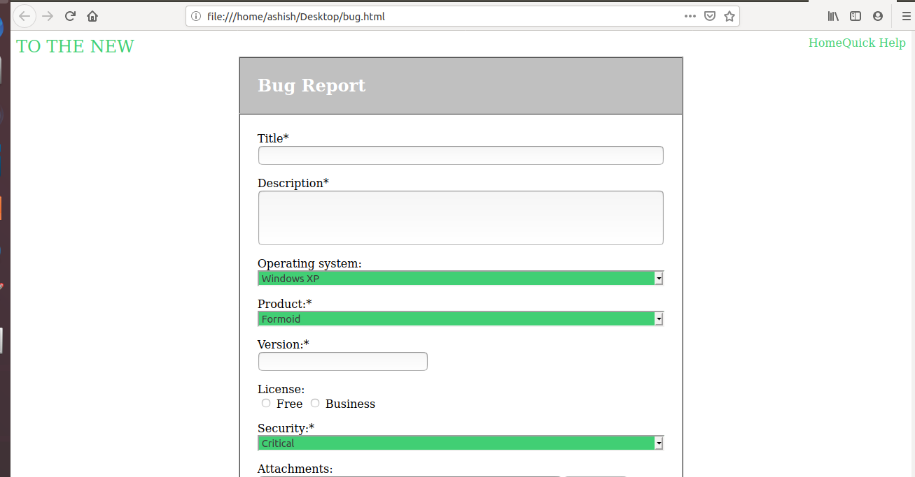

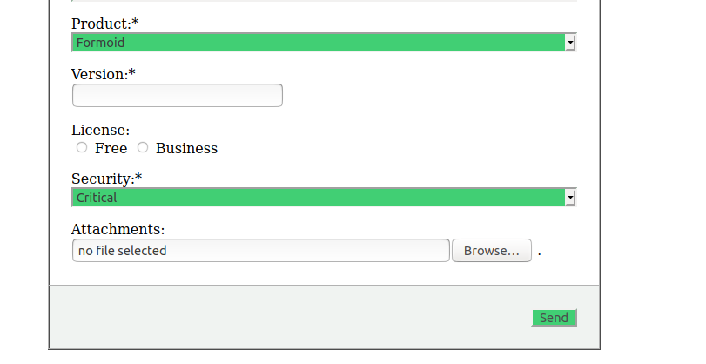

**Code:-**

**<!DOCTYPE HTML PUBLIC "-//W3C//DTD HTML 4.01 Transitional//EN"><html><head><META http-equiv="Content-Type" content="text/html; charset=utf-8"></head><body>**

**<div>**

**<font color="#41CF74" size="5px"> TO THE NEW </font>**

**<a href="http://url" style="text-decoration:none;color:#41cf74;float:right" target="_blank"> Quick Help </a>**

**<a href="http://url" style="text-decoration:none;color:#41cf74;float:right" target="_blank"> Home </a>**

**<form target="_blank" onsubmit="try {return window.confirm(&quot;This form may not function properly due to certain security constraints.\nContinue?&quot;);} catch (e) {return false;}">**

**<table style="width:50%" border="1px" align="center" cellspacing="0" cellpadding="25">**

**<thead>**

**<td bgcolor="#C0C0C0" text="white">**

**<font size="5" color="white"> <b> Bug Report </b> </font>**

**</td>**

**</thead>**

**<tbody>**

**<tr><td>**

**<p> Title\***

**<input style="width:100%"> <br>**

**</p>**

**<p> Description* <br>**

**<input style="width:100%;height:80px">**

**</p>**

**<p> Operating system:**

**<select style="width:100%;background-color:#41cf74" name="Operating System">**

**<option value="Windows XP"> Windows XP </option>**

**<option value="Linux"> Linux </option>**

**<option value="IOS"> IOS </option>**

**<option value="Windows 10"> Windows 10 </option>**

**</select> </p>**

**<p> Product:\***

**<select style="width:100%;background-color:#41cf74" name="Product">**

**<option value="Formoid"> Formoid </option>**

**<option value="B"> B </option>**

**<option value="C"> C </option>**

**<option value="D"> D </option>**

**</select> </p>**

**<p> Version:* <br>**

**<input value=""> <br>**

**</p>**

**<p> License: <br>**

**<input type="radio" name="r1"> Free**

**<input type="radio" name="r1"> Business**

**</p>**

**<p> Security:\***

**<select style="width:100%;background-color:#41cf74" name="Security">**

**<option value="Critical"> Critical </option>**

**<option value="B"> B </option>**

**<option value="C"> C </option>**

**<option value="D"> D </option>**

**</select> </p>**

**<p> Attachments: <br>**

**<input style="width:75%" value="no file selected"><input type="file" style="width:18%">**

**</p>**

**</td></tr>**

**<tr><td bgcolor="#F0F3F1" align="right">**

**<button type="submit" style="background-color:#41cf74" value="Submit"> Send </button>**

**</td></tr>**

**</tbody>**

**</table>**

**</form>**

**</div>**

**</body></html>**