Q1
The query needs four relationships/conditions to connect all five tables.
Supplying three means one pair of tables is joined with no condition, producing a Cartesian product between them. Every row on one side is paired with every row on the other, so the result set multiplies. On this dataset that turns a few hundred rows into hundreds of thousands. On production volumes the query does not finish, and it consumes the server while failing.
Q2
INNER JOIN: Returns only customers who have at least one matching account.
LEFT JOIN: Returns all customers, including those who have no matching account; their account columns will be NULL.
Q3
The condition l.status = 'OVERDUE' sits in WHERE and refers to the optional table. For a branch with no loans, l.status is NULL, so the comparison is NULL rather than TRUE, and WHERE discards the row. The outer join is silently downgraded to an inner join.
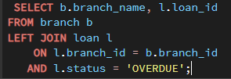
Q4
An anti-join is used to find rows in one table that have no matching row in another table.
Start with the left table → LEFT JOIN the right table → test a non-nullable column from the right table for IS NULL.
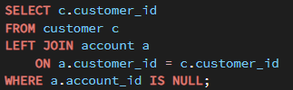
Because NULL is being used to mean "no matching account exists." If account_id itself were allowed to be NULL in a real matching row, the query could confuse an existing account with no matching account, producing incorrect results.
Q5
Because a Branch Manager's manager_id is NULL. An inner join requires a matching row in the manager alias, and NULL matches nothing, so every Branch Manager is dropped. Concretely:
SELECT COUNT(*) with an inner join returns 16, with a left join 24. The eight missing rows are the eight Branch Managers - the most senior people in the organisation, silently absent from the org chart.

Q6
1. COUNT(*) -> Yes — counts every row, regardless of NULLs
36
2. COUNT(interest_rate) -> No — ignores rows where interest_rate is NULL
36 (no NULLs in this column
3. COUNT(DISTINCT account_type) -> No — ignores NULL and counts each distinct value once
3 - SAVINGS, CURRENT, SALARY
4. AVG(balance) –> No — ignores NULL balances
220372.35
Q7
Every column in the SELECT list must either be included in the GROUP BY clause or be inside an aggregate function such as SUM(), COUNT(), AVG(), MIN(), or MAX().
Why the engine cannot pick: the output has one row per group, but the group contains many rows. Branch 1 has four accounts with four different account numbers. There is no principled basis for choosing one of them, and any choice would be arbitrary and unstable between runs. Rather than return a plausible-looking wrong answer, the engine rejects the query. Older MySQL versions did pick, silently, which is why a great deal of legacy reporting SQL is quietly wrong.

Q8
Filters what Individual rows Whole groups
Runs when Before GROUP BY After GROUP BY and aggregation Can reference aggregates No Yes
Which to prefer WHERE, whenever the condition can be expressed on a single row, because fewer rows reach the grouping step and the query does less work
Q9
Our fixed-deposit data contains some NULL nominee names.
Why does it return zero?
NOT IN uses comparisons, and comparison with NULL produces UNKNOWN.
Fix 1
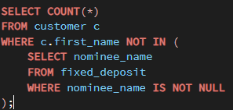
Fix 2
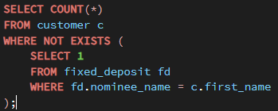
Q10
Fan-out in a SQL join happens when one row from one table matches multiple rows in another table, causing that original row to appear multiple times in the joined result.
One customer with two accounts and twenty-one transactions occupies twenty-one rows after joining all three tables. A wrong but believable report: "total deposits and transaction value per branch". Joining branch, customer, account and account_txn and then writing SUM(a.balance) adds each account's balance once per transaction on that account. A branch with 900,000 in deposits and 60 transactions reports something in the tens of millions. It is believable because the number is large and the query looks correct, and it is caught only when somebody adds the account balances by hand. The fix is either COUNT(DISTINCT ...) for counts, or aggregating each grain separately and joining the summaries.
Q11
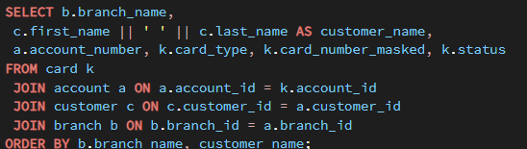
Q12
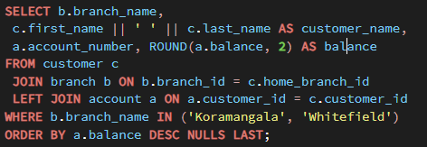
Q13
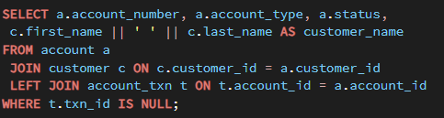
Q14
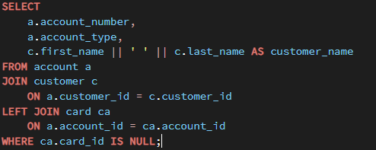
Q15
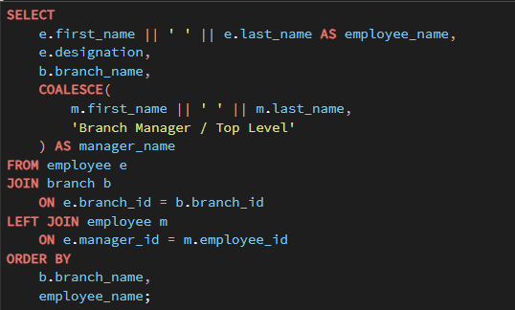
Q16
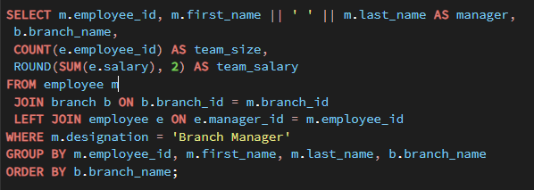
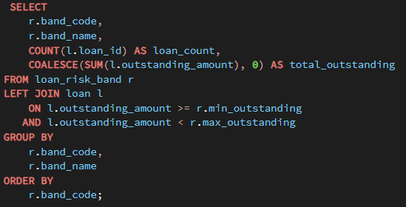
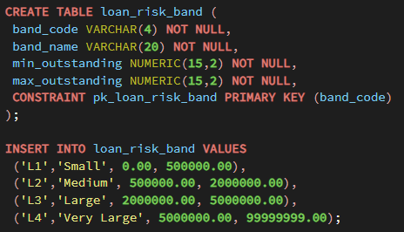
Q17
Q18
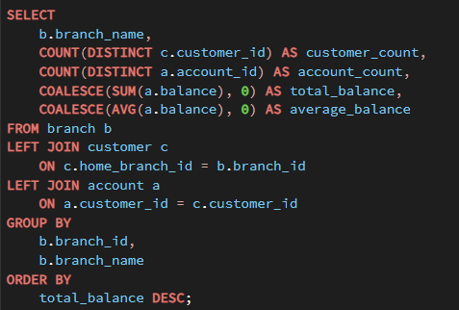
Q19
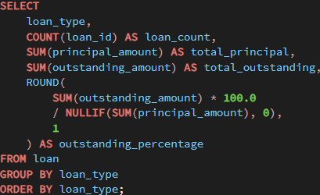
Q20
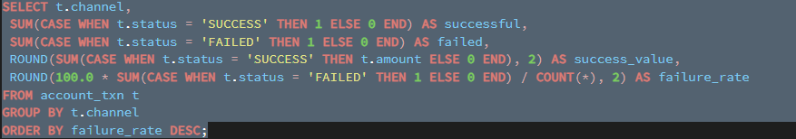
Q21
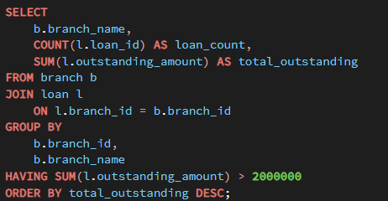

Q22
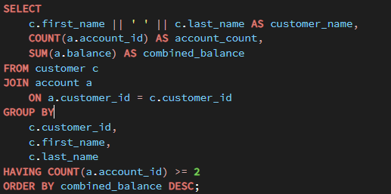
Q23
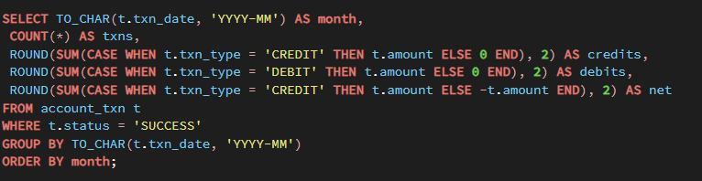
Q24
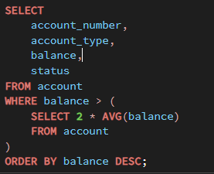
Q25
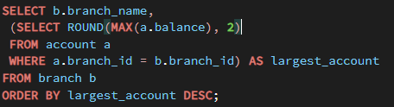

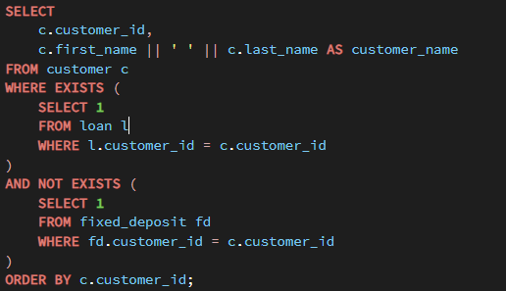
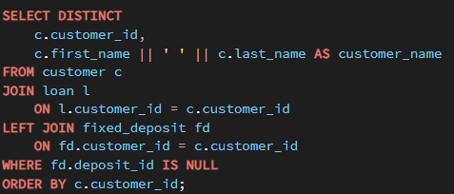
Q26

Q27
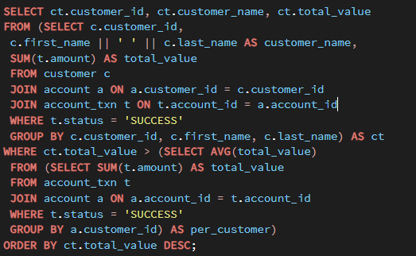
Q28
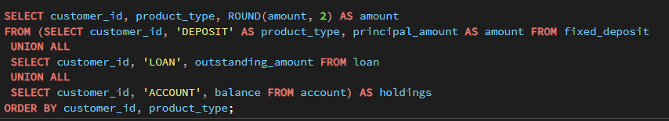
Q29
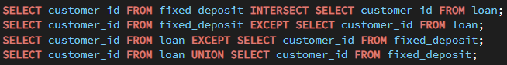

Q30
1. Fan-out on the customer count. COUNT(c.customer_id) counts one row per transaction, not per customer. A customer with 21 transactions is counted 21 times.
2. Fan-out on the balance. SUM(a.balance) adds each account's balance once per transaction on that account. The total is inflated by roughly the average transaction count, which is around fourteen here. This is the number that "looks a bit high".
3. BETWEEN on a timestamp. txn_date is a TIMESTAMP, so the range ends at 2026-03-31 00:00:00 and the whole of 31 March is missing.
4. Inner joins where outer joins are needed. A branch with no transactions in the window disappears from the report entirely, rather than appearing with zeros. Also, t.status is not filtered, so failed transactions are counted as business.
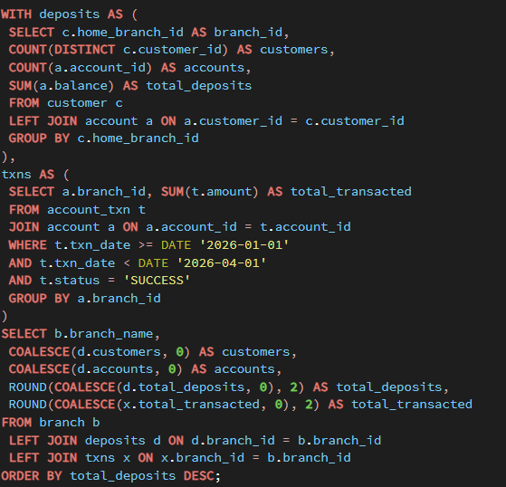

Q31
GROUP BY and HAVING alone cannot solve “top 3 customers within each branch” because they can aggregate customers by branch, but they cannot assign a rank to individual customers within each branch.
You need a window function, such as ROW_NUMBER(), RANK(), or DENSE_RANK().
A window function: ROW_NUMBER() OVER (PARTITION BY branch_id ORDER BY balance DESC), which numbers the rows inside each branch without collapsing them, and then filtering on that number.
Q32
Reports whose correct answer is often zero need explicit validation that the query is actually capable of returning exceptions, rather than treating zero rows as automatically correct. For NOT IN queries in particular, a NULL in the subquery can make the condition evaluate unexpectedly and suppress all rows. A good control is to test the report against known exception cases and compare it with an equivalent NOT EXISTS query. Zero-result reports should also have monitoring or reconciliation checks so that a sudden run of identical zeros is investigated rather than interpreted as evidence of perfect compliance.
Q33
Run the report at a less busy time, such as before branches open, so the 40-second workload does not compete with peak operational activity.
Schedule or automate the report so it is generated before 9 a.m. and the operations head reads the prepared result rather than triggering the expensive query at branch opening time.
Monitor the report's execution time and database resource usage over time, especially CPU, I/O, and concurrent workload, so you can identify whether the 40-second runtime or the 9 a.m. concurrency is becoming a larger operational problem.
Q34
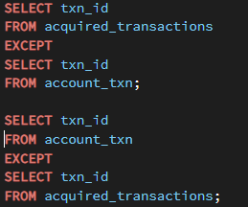
What a non-empty result means. In the first direction, transactions the acquired bank holds that never arrived - a load failure, a rejected row, or a filter applied by mistake. In the second, transactions ICICI now holds that the source never had - duplicates from a re-run, rows from a different date range, or a join in the load that fanned out.
A difference that is not a missing row. A value mismatch. If amount was 1234.50 in the source and loaded as 1234.5 into a column with different scale, or a TIMESTAMP lost its time component moving into a DATE column, the row appears in both directions of the EXCEPT - once as missing and once as extra - even though nothing is lost. This is why a non-empty result must be investigated by key before it is reported as data loss, and why row counts alone are never sufficient evidence that a migration succeeded

Q35
The branch performance pack is now a single query set against the core banking database, so the numbers in it come from one source and will agree with each other. It covers five sections: the branch summary, dormant customers, the ten largest transactions, deposits maturing shortly, and product holdings. Two things stand out this quarter. T Nagar Chennai took in 2,691,432 against Whitefield's 347,122, a gap of nearly eight to one on comparable customer numbers, which is worth understanding before the next target-setting round. Separately, seven of the eight branches paid out more than they took in over the quarter; only Banjara Hills was close to balanced. That may be seasonal, but it is the first thing I would ask the branch heads about. One limitation you should know about. The pack reports what is recorded against each customer's home branch, not where the transaction physically took place. A Fort Mumbai customer withdrawing cash in Pune is counted against Fort Mumbai. For a branch footfall discussion that is the wrong attribution, and we would need to capture the transacting branch on each transaction to answer it properly. I would rather tell you that now than have the numbers used for a decision they cannot support.

