Q1
NoSQL means “Not Only SQL.” It refers to databases designed for large-scale, flexible, and often distributed data storage without requiring the fixed relational table structure of traditional SQL databases.
Key-value (Redis) Balance cache, sessions, rate limiting
Document (MongoDB) KYC documents, where the set of documents varies per customer
Column family (Cassandra) Transaction history at very large scale, written once and read by key
Graph (Neo4j) Fraud rings and beneficial ownership, where the relationships are the query
Q2
CAP theorem: In a distributed system, when a network partition (P) occurs, the system cannot simultaneously guarantee both strong consistency (C) and availability (A).
The phrase “choose two of three” is misleading because partition tolerance isn't really an optional feature in a distributed system: if network partitions can occur, you must decide what the system does during that partition. The practical decision is therefore usually C vs A when P happens, not simply picking any two properties from a menu.
System Gives up Why
Core banking ledger Availability Being wrong about money is worse than being unavailable. Refusing a transaction is recoverable; a wrong balance is not
Balance cache Consistency A balance a few seconds old is acceptable, and the database is always available as a fallback
Session store Consistency Asking a customer to log in again is an inconvenience, not an incident
Q3
Redis should not be the system of record for account balances because banking balances require durable, authoritative, and strongly controlled storage.
- Durability is best effort. Even appendfsync always does not meet a ledger's standard, and everysec accepts up to a second of loss. A confirmed transfer that vanishes on restart is the Module 1 incident.
- Replication is asynchronous. A failover promotes a replica that may be behind the primary, silently reverting the most recent writes. Two customers could see two different balances.
- No transactions across keys with rollback. Redis has MULTI and Lua scripts, which are atomic, but there is no equivalent of a transaction that can be rolled back after a business rule fails partway. Debiting one account and crediting another cannot be made atomic across a failure
Q4
Advantage: atomicity for free. INCR on a shared counter cannot lose an update, because no two commands ever interleave. A thousand application servers incrementing the same API counter need no coordination, and none of Module 6's locking applies.
Danger: one slow command blocks everyone. KEYS * on a cache with ten million keys stalls every client for seconds. During that stall every balance enquiry in the bank waits, and the connection pool fills.
Q5
Last ten transactions, capped List LPUSH then LTRIM key 0 9, read with LRANGE
Is this card blocked Set SADD, SISMEMBER
Top three balances in a branch Sorted set ZADD, ZREVRANGE key 0 2 WITHSCORES
API call count today String counter INCR icici:api:hits:2026-22-11
Session with per-field update Hash HSET, HGET, EXPIRE
Five OTPs per hour, sliding Sorted set scored by timestamp ZREMRANGEBYSCORE, ZCARD, ZADD
Nearest ATM within 2 km Geospatial GEOADD, GEOSEARCH ... BYRADIUS 2 km
Q6
 | Cache-aside | Write-through
When is cache populated? | Only when the application reads data that isn't already cached. It fetches from the database and then puts the result into Redis. | The cache is updated at the same time as the database write.
What does a write cost? | Usually one database write. The cache doesn't need to be updated immediately. | Database write + cache write, so the write path is more expensive.
What does the first read after a write return? | Usually the new value, because the read misses the cache, fetches the latest value from the database, and populates Redis. | The new value is already in Redis, so the first read can return it directly from the cache.
Typical use | Data that is read frequently but doesn't need every write to update Redis immediately. | Data where keeping the cache synchronized with writes is important.
Q7
11:04:22 Application writes the new balance to Redis, returns "successful"
11:04:23 The Redis node fails before the flush to the database
11:04:24 The transfer is in no ledger and no log
The customer was told the transfer succeeded. The money did not move, there is no record that it was ever attempted, and reconciliation cannot detect it because there is nothing to reconcile against. Legitimate use: page view counts, "last seen" timestamps, non-financial analytics counters. Anything where losing a few seconds of updates has no consequence and no audit obligation.
Q8
1. Delete rather than overwrite
Suppose Redis contains:
Redis: ₹50,000
DB: ₹50,000
A withdrawal changes the database to:
DB: ₹45,000
If the application tries to overwrite Redis with ₹45,000, a race can occur:
- Request A reads the old database value: ₹50,000.
- Request B updates the database to ₹45,000.
- Request B writes ₹45,000 to Redis.
- Request A, using its older value, writes ₹50,000 to Redis.
- Redis now contains the stale ₹50,000.
Delete instead of overwrite prevents an older concurrent read from putting stale data back into the cache.
2. Delete after the database commit, not before
Consider:
DB: ₹50,000 Redis: ₹50,000
A transaction wants to change the balance to ₹45,000.
If you delete Redis before the database transaction commits:
- Application deletes Redis.
- Database transaction is still running.
- Another request reads Redis → cache miss.
- It reads the database.
- The database transaction hasn't committed yet, so it sees ₹50,000.
- That request puts ₹50,000 back into Redis.
- Original transaction commits → DB becomes ₹45,000.
- Redis now contains stale ₹50,000.
Delete after commit prevents a concurrent read from repopulating Redis with the old database value while the update is still uncommitted.
Q9
The TTL is the backstop for every invalidation that was never written or that failed to run.
Correct invalidation in transfer() covers transfers made through that function. It does not cover a batch job, an overnight interest posting, a DBA correcting a row by hand, or a new service written next year by someone who does not know the cache exists. It also does not cover the case where the delete itself failed because Redis was briefly unreachable at that moment. Without a TTL, any of those leaves a wrong value cached forever. With one, the damage is bounded to the TTL. That is why a cache key with TTL = -1 is a defect regardless of how good the invalidation logic is.
Q10
A cache stampede happens when a popular cache entry expires or is deleted, causing many requests to miss the cache at nearly the same time and all hit the database simultaneously.
For example, if an ICICI banking service has a cached branch/ATM configuration used by 10,000 requests per second:
Redis key expires
10,000 requests → CACHE MISS
10,000 database queries 💥
Database becomes overloaded
Three ways to prevent it
- Lock / request coalescing
  - When the key is missing, allow only one request to fetch the data from the database.
  - Other requests wait for that request to populate Redis.
  - This is also called single-flight behavior.
- Stale-while-revalidate
  - Continue serving the existing/stale value while one background process refreshes the cache.
  - This prevents a large group of requests from simultaneously hitting the database.
- TTL jitter
  - Add a small random amount to TTLs rather than giving many keys exactly the same expiration time.
Request coalescing / a single-flight lock would be my first choice for a high-value banking workload because it directly prevents the database from receiving hundreds or thousands of identical refill requests at once.

Q11
With maxmemory unset, Redis grows until the operating system's out-of-memory killer terminates the process. The entire cache is lost at once, without warning, at the moment of peak load - because peak load is what filled the memory. Every request then misses, and the database receives the full unfiltered traffic at exactly the wrong time.
With a limit set and allkeys-lru, memory pressure causes gradual eviction of cold keys. Hit rate falls a little, database load rises a little, and there is time to notice and react.
The volatile-lru trap: it evicts only keys that have a TTL. If no key has one - or if the keys under pressure happen to be the ones without - Redis has nothing it is permitted to evict and writes start failing with an out-of-memory error, even though most of the data is discardable. The policy silently depends on a discipline that nothing enforces.
Q12
Possible cause How to tell
TTL too short Check TTL on live keys; compare the expiry interval with the request rate per key
Too many distinct keys DBSIZE against the number of distinct entities; a per-request key such as one including a timestamp gives near-zero reuse
Eviction under mem pressure INFO stats and check evicted_keys; if it is climbing, keys are being discarded before reuse
Over-aggressive invalidation Look for a write path deleting more keys than it changed, for example invalidating a whole branch on one account change

Distinguish them in that order, because the first two are design errors and the second two are operational. DBSIZE compared to the number of accounts is usually the fastest diagnostic: 36 accounts and 400,000 keys means the key design is wrong.
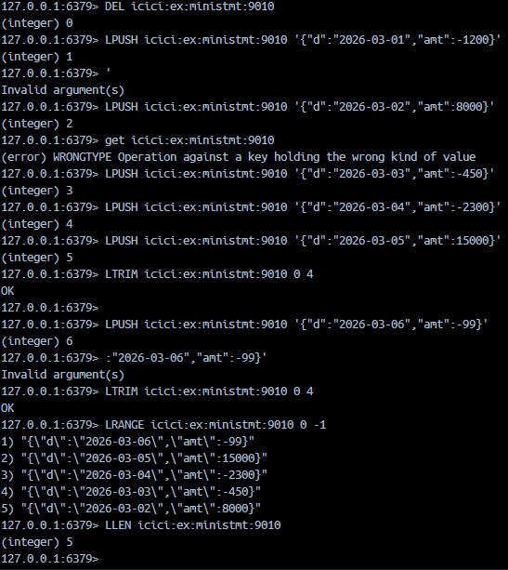
Q13

Q14
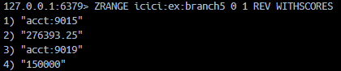
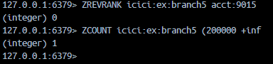
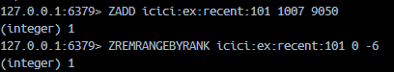
Q15
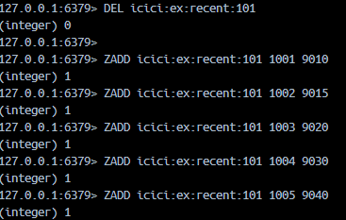

Q16
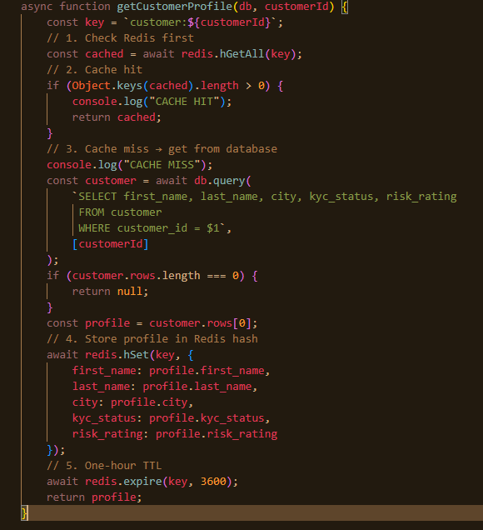

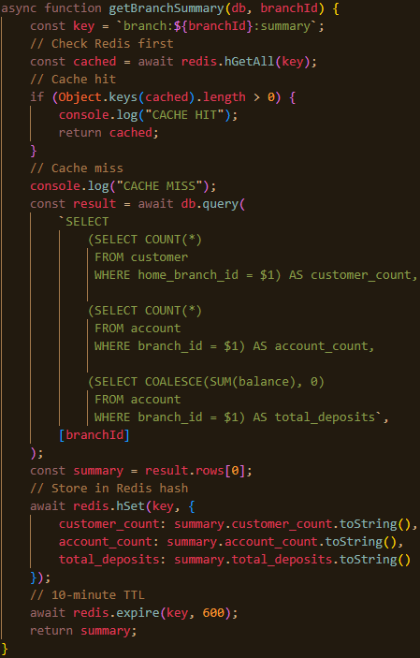
Q17

Q18
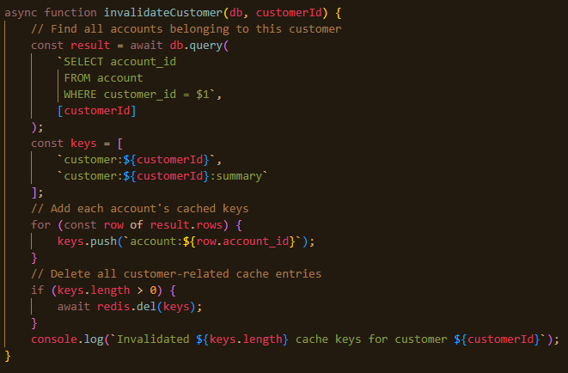

Why KEYS icici:* is unacceptable: it scans the entire keyspace and blocks the single-threaded server for the duration. On a production cache with millions of keys that is a multi-second stall across every client in the bank - an outage caused by an invalidation. If a pattern scan is genuinely needed, SCAN with a cursor is the only safe form, and even then it is a poor design compared with knowing which keys you need to delete.
Q19
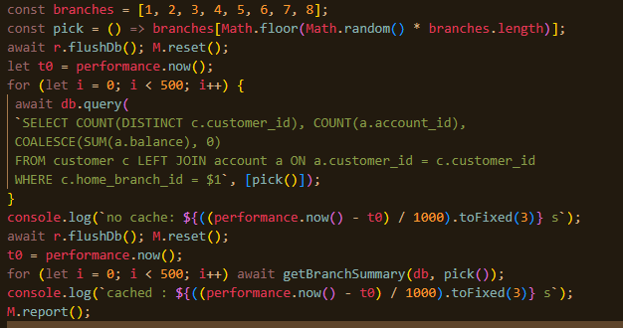
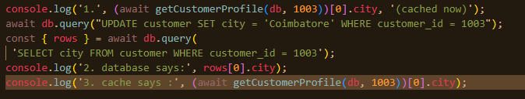
Q20
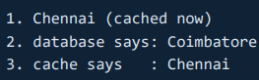

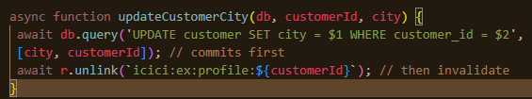
This is followed by:
console.log(await getCustomerProfile(db, 1003));

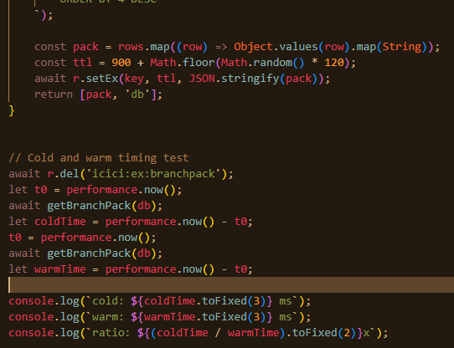
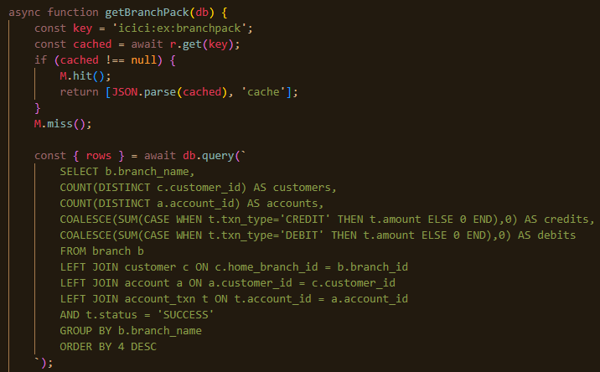
Q21

Q22
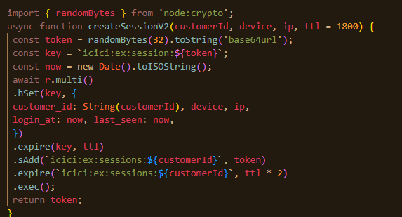
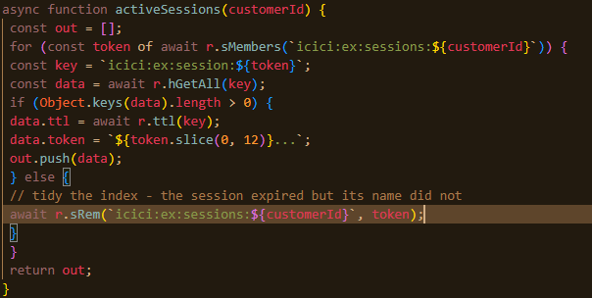
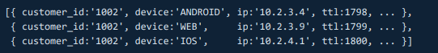
Q23
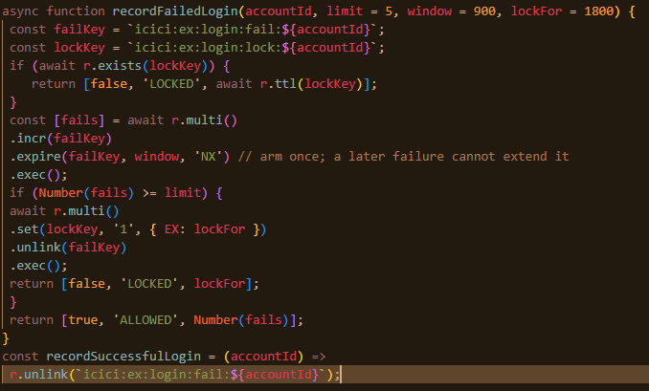
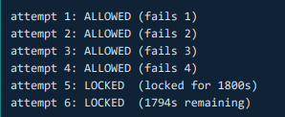
Q24
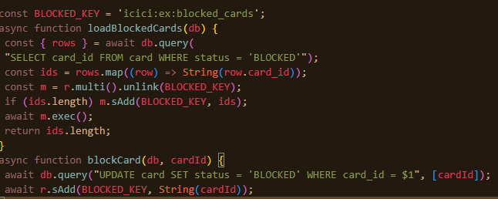
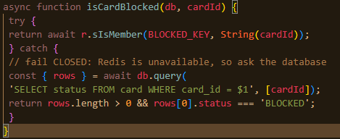
If Redis is unavailable, the code falls back to the database. That is slower, and it is the only acceptable behaviour: this is a security control, so it must fail closed.
Q25
# | Data | Cache? | TTL / Reason
1 | Customer's account balance | Yes, with care | Very short TTL, e.g. 10–30 seconds, and invalidate immediately after a successful balance-changing transaction. Never treat Redis as authoritative.
2 | Result of a fund transfer | No | Do not cache the transfer result as a source of truth. A transfer is a transactional operation and must be obtained from the authoritative transaction system.
3 | Bank's branches and IFSC codes | Yes | 24 hours or longer. This data changes infrequently, and the cache can be invalidated when branch/IFSC data changes.
4 | Today's USD → INR exchange rate | Yes | Short TTL, e.g. 5–15 minutes, depending on how frequently the bank updates its rate.
5 | Customer's full transaction history for the last 7 years | No | Too large and relatively expensive to keep as a cache. The database/data warehouse should remain authoritative. Cache only specific frequently requested summaries or recent transactions if needed.
6 | Whether a card is blocked | Yes, but very carefully | Very short TTL, e.g. 5–10 seconds, with immediate invalidation when card status changes. Security-sensitive data should not remain stale.
7 | One-time password just sent | Yes | 2–5 minutes, matching the OTP's validity period. Redis is well suited because the value naturally expires.
8 | Number of failed login attempts | Yes | 15 minutes, matching the rate-limit window. Redis INCR + EXPIRE is ideal for this.
Q26
I would not approve a 24-hour TTL for account balances just to achieve a high cache hit rate. A high hit rate is not useful if the value being served is financially wrong. Before choosing a TTL, I would ask:
- How quickly can an account balance change?
Transfers, withdrawals, deposits, fees, interest, and other postings can change it many times during a day.
- How stale can the displayed balance safely be?
Is a customer allowed to see yesterday's balance after making a transaction today?
- What is the source of truth?
The core banking database should remain authoritative.
- What happens when a transaction changes the balance?
We need immediate cache invalidation or refresh after a successful transaction.
- Where did the 99.9% hit-rate figure come from?
I would ask for actual traffic and cache measurements rather than accepting it as an assumption.
Use Redis for a short-lived balance cache, More importantly, don't rely on TTL alone.
How I would decide the number
I would measure the application's actual requirements and traffic:
- How frequently balances change
- How frequently balances are read
- Maximum acceptable staleness
- Cache hit/miss rate
- Redis and database latency
- Number of stale-balance incidents
- Database load saved by different TTLs

Q27
Redis is being used for three very different purposes: cache, session state, and security controls. So the correct failure behaviour is different for each.
Component | What happens when Redis goes down at 09:15 | Acceptable? | Change
Balance endpoint | Redis GET fails, so the cached balance cannot be read. | Yes, if it falls back to PostgreSQL | Catch Redis errors and query PostgreSQL directly.
Session store | Session lookup fails because the session exists in Redis. The application cannot verify the session. | No | Use highly available Redis and fail closed if the session cannot be verified.
Rate limiter | INCR/TTL operations fail, so failed-login attempts cannot be counted. | No | Do not allow authentication to bypass the limiter. Use HA Redis and a fail-closed/secondary mechanism.
The general principle: a cache failure should be a performance event; a security control failure must not be a bypass. The same Redis outage must produce different behaviour in different components, and that has to be written deliberately - the default behaviour of an unhandled exception is the same everywhere, and it is wrong in at least one of these cases.
Q28
I would not approve this design. Redis should be a cache for account balances, not the system of record. If the balance exists only in Redis and is written to the database once each night, a Redis failure during the day can permanently lose financial data.
Specifically, we could lose every balance change since the last successful database write. For example, if the nightly job runs at 00:00 and Redis fails at 18:00, all deposits, withdrawals, transfers, fees, interest postings, and other balance changes made between 00:00 and 18:00 could disappear.
We would also lose the reliable transaction history needed to reconstruct how the balance was produced. A final balance alone does not tell us which transactions occurred, when they occurred, or who/what authorised them. This creates reconciliation, audit, dispute, and regulatory problems.
There is also a consistency problem with transfers. If Redis records a debit but the corresponding credit or transaction record is not durably stored, the system could end up with money apparently disappearing or being created. A nightly batch is far too late for this type of state.
The database must therefore remain the authoritative source for balances and transactions. Redis can cache the balance for fast reads, but every financial transaction must be durably committed to the database first. After a successful transaction, we can invalidate or update the Redis cache.
In short: Redis can make the database faster to access, but it cannot replace the database as the financial record. The performance benefit is not worth introducing the possibility of losing a day's financial activity.

Q29
Three other paths that could change an account balance without going through transfer() are:
- Cash deposit/withdrawal at a branch
A teller transaction updates account.balance, but the Redis balance key is not invalidated.
- ATM transaction
An ATM withdrawal changes the balance directly through the banking/ATM transaction system, leaving the cached balance stale.
- Scheduled or batch postings
Things such as interest credits, service charges, standing instructions, loan/EMI deductions, or other end-of-day postings can change the balance without calling the application's transfer() function.
Architecture that catches all of them
I would make PostgreSQL the source of truth and move cache invalidation to a point that observes every successful balance change, rather than putting invalidation logic inside individual application functions
An architecture that catches all of them: change data capture. The database's own write-ahead log is the one thing every path goes through. A CDC connector reads the log, publishes a change event for every committed row change to account, and a small consumer deletes the corresponding cache key.
Any writer -> PostgreSQL -> WAL -> CDC connector -> event -> cache invalidator -> DEL key
Nothing can change a balance without producing a WAL record, so nothing can bypass the invalidation. It also invalidates after the commit by construction, because the log record only exists once the change is committed. The cost: another moving part to run and monitor, replication slots that will fill the disk if the consumer stops, additional latency of tens to hundreds of milliseconds between the commit and the invalidation, and a new failure mode where the consumer silently falls behind. It is worth it in a bank with many writers and a strict staleness requirement. For a smaller system, a shorter TTL is the cheaper answer to the same problem.
Q30
I would not pre-load every account just to eliminate the remaining 4% misses.
A 96% hit rate already means the cache is serving most requests. Pre-loading everything would trade those misses for a significant startup and memory cost.
What pre-loading would cost
At startup, the system would have to:
- Read every account balance from PostgreSQL.
- Write every balance into Redis.
- Keep all those entries in Redis memory.
- Repeat the process whenever accounts are added or balances change, or maintain another mechanism to keep the pre-loaded data current.
- Potentially make startup much slower and create a heavy load on PostgreSQL and Redis.
For example, if there are millions of accounts, loading millions of records at startup creates a large database read and Redis write burst. It also means Redis spends memory on accounts that may never be accessed.
Why the 4% misses may be acceptable
A cache miss is not necessarily a problem. With cache-aside:
Cache miss → PostgreSQL → put result in Redis → return result
The system still gets the correct balance. The miss simply costs one database lookup.
Also, the 4% may represent accounts that are rarely accessed. Pre-loading them would consume resources to optimize requests that might happen only occasionally.
When pre-loading would make sense
Pre-loading can be appropriate when:
- The number of accounts is relatively small.
- Almost every account is expected to be accessed.
- Startup latency is acceptable.
- Redis has enough memory for the entire dataset.
- The data can be refreshed safely when balances change.
- The cost of database misses is high enough to justify the additional infrastructure and startup load.
For a banking balance cache, I would generally use lazy loading/cache-aside plus proper invalidation, rather than pre-loading every account simply to turn 96% into 100%.
Q31
The balance caching change reduced database load by 96% for balance-read requests, because 96% of requests were served directly from Redis rather than querying the database.
Keeping a copy of the balance is safe because PostgreSQL remains the authoritative source. Redis is only a fast copy used for reads. When a balance changes, the Redis copy is removed or refreshed, and it also has a short lifetime. This means an old value can exist only for a limited period rather than becoming the permanent source of truth.
The main risk is that a customer could briefly see an older balance if the database changes before the Redis copy is updated. The damage is limited because the database still contains the correct balance, the cached copy is short-lived, and balance-changing operations refresh or remove the affected copy.
For the internet banking session problem, sessions are now stored in Redis with an expiry time and associated with the customer's active sessions. The system can therefore track multiple devices, identify active sessions, and remove expired session records instead of relying on an unreliable application-side session list.

