Q1.
• Data redundancy – The same customer address is stored in multiple spreadsheets.
• Data inconsistency – When the customer updates the address only at the branch, the credit card department’s copy remains outdated.

Q2
- Data integrity: Ensures rules such as unique account numbers and valid balances. Without it, it would lead to incorrect transactions or records.
- Concurrency: multiple transactions at the same time. Two transactions updating the same account could cause an incorrect account balance.
- Recovery: Recovers data after system crashes or failures. A database failure could lose customer account or transaction records.

Q4
- customer.customer_id: primary key
- account.account_number: candidate key
- account.customer_id: foreign key
- account.balance: none
- employee.manager_id: foreign key
- branch.ifsc_code: candidate

Q5
- A customer checks a balance on the ICICI mobile app.: OLTP
- The risk team calculates non-performing loans by branch for the quarter.: OLAP
- An ATM dispenses 10,000 rupees.: OLTP
- A regulator asks for the total value of transactions above 200,000 in the last financial year.: OLAP
- A teller opens a new savings account.:OLTP
- Marketing finds the top 100 customers by average monthly balance.: OLAP.
Q6
- Performance impact: Running them on the production database can consume CPU, memory, and I/O needed for real-time banking transactions.
- Concurrency and availability risk: Heavy analytical queries running alongside OLTP transactions can increase same time uses, potentially affecting customer operations.
- Workload mismatch: The core database is designed for OLTP—fast, small, frequent transactions—whereas a quarterly regulatory report is OLAP work involving large historical datasets and complex aggregations.
Use a separate reporting/data-warehouse environment populated from the core system
Q7
Atomicity -- d. Money is debited but never credited
Consistency – c. An account exists for a customer who does not
Isoaltion – b. Two ATMs both pay out against the same balance
Durability – a. A committed transfer disappears after a power cut

Q8
The write-ahead log is written to disk before the actual data page so that the database has a record of every change before that change effects the database.

Q9
SELECT * FROM customer makes the application depend on the table's current column structure. If the bank later adds a pan_number column, the query will automatically return that new column, which can break application code that expects the old order of columns, causing incorrect data mapping or display errors.
A safer approach is to explicitly request only the columns the application needs

Q10
- Oracle: Use it for core banking systems where strong transaction management, reliability, security, and enterprise-scale processing are required.
- PostgreSQL: Use it for application databases where an open-source relational database with strong SQL support is suitable.
- MySQL: Use it for web-based banking applications and supporting services where a widely adopted relational database is sufficient.
- Redis: Use it for caching frequently accessed data and fast, low-latency operations such as sessions, temporary data, and frequently requested balances.
Q11
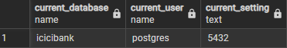
Write a query that returns the database name, the current user and the server port.
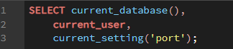
Q12
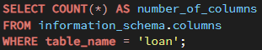
Using information_schema, list every column of the loan table with its data type and whether it accepts NULL. How many columns does loan have? What is the degree of the relation?
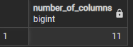
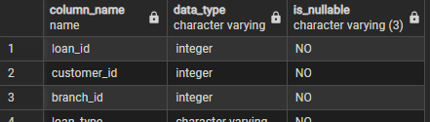
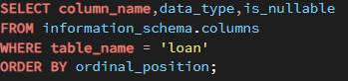

Q13
Report the number of rows in all nine tables in a single result set, sorted by table name.
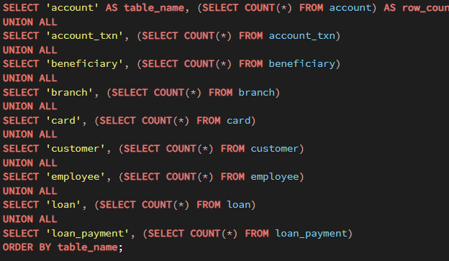

Q14
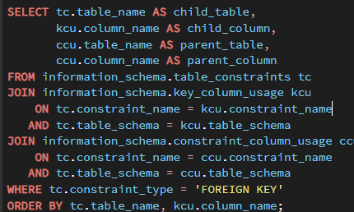

Q15
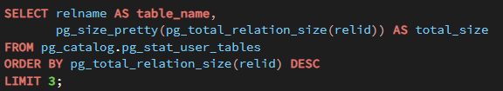

Q16
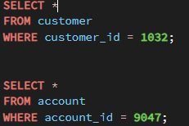
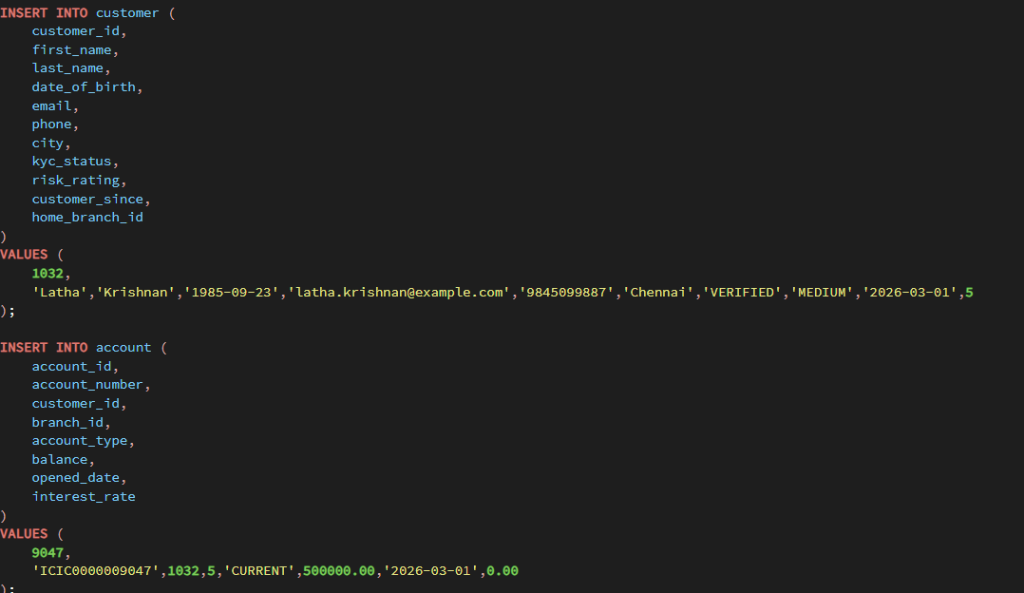
ICICI Bank opens a current account for a new corporate customer. Insert the customer and the account using these details, then read both rows back.

Q17
The customer deposits 75,000 and then withdraws 20,000. Write both updates so that they compute from the current balance rather than assigning an absolute figure, then confirm the final balance is 555,000.
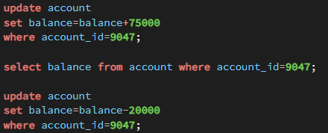
Q18
Try to delete customer 1032 without deleting the account first. Record the exact error. Then delete both rows in the correct order and confirm the table counts are back to 30 and 45.
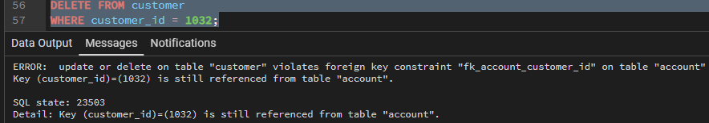
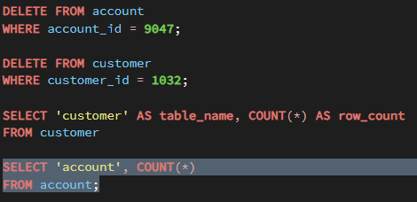
Q19
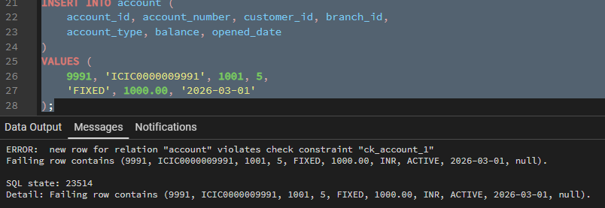
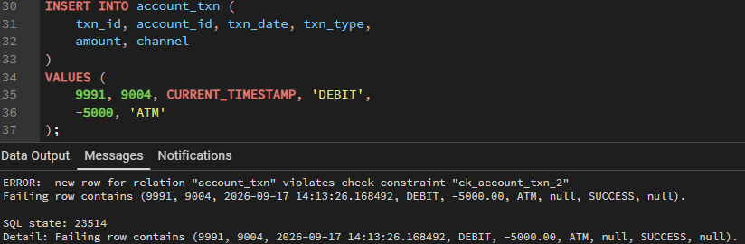
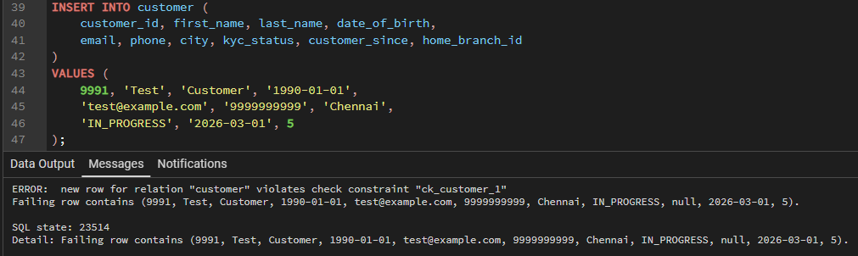
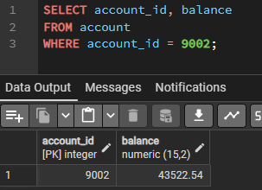
Q20
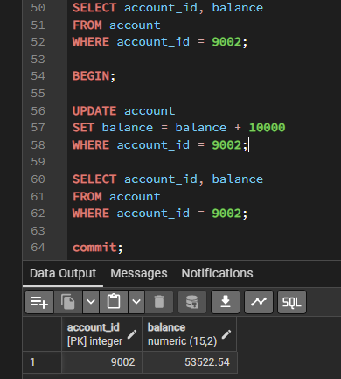

Q21
In a single transaction, transfer 12,000 from account 9004 to account 9010, then roll it back. Prove with a query before and after that neither balance changed.

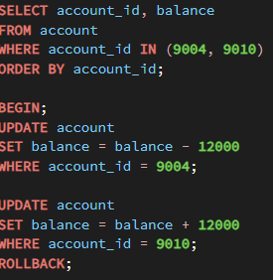
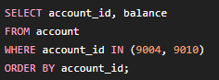

Q22
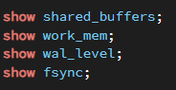
Q23
My recommendation would be not to use MySQL with the MyISAM storage engine for UPI transaction storage. MyISAM does not provide transaction support or row-level locking, creating a risk of inconsistent or lost transaction updates under high concurrent load such as 4,000 transactions per second.
The specific alternative is to use MySQL with the InnoDB storage engine, which provides transactions, ACID compliance, row-level locking, and better support for high-concurrency payment workloads.
Q24
Branch operations: needs fast OLTP-style point queries for one account, such as retrieving all transactions for a particular account_id, ideally supported by an index on (account_id, txn_date).
Risk team: needs OLAP-style analytical queries that scan and aggregate millions of account_txn rows by month and across all accounts; running these directly on the transactional database can consume CPU, memory, and I/O needed for daily banking operations.
Solution
Core/OLTP database — keep account_txn in the transactional system, optimized with indexes for branch screens and real-time transaction processing.
Separate OLAP/reporting database or data warehouse — continuously copy transaction data from the core system and optimize it for large monthly aggregations.
Q25
The statement “The application logged ‘transfer successful’, so the money must have moved” is not evidence because an application log is only a record of what the application tried to do. It could have logged success even if the database transaction was later reverted, failed, or never committed.
- A committed database transaction showing the debit and credit.
- The before-and-after account balances confirming ₹12,000 was deducted from the sender and added to the receiver.
- An outbox table record in account_txn with successful status.
Q26
Do not set fsync = off on the core banking PostgreSQL server. Although it may make batch loads faster, disabling fsync removes PostgreSQL's guarantee that committed data and WAL records are safely written to disk, creating a risk of data loss or database corruption after a crash or power failure.
If it must be used anywhere, restrict it to a temporary, disposable development/test environment or a rebuildable staging database where data loss is acceptable, never on production/core banking data.

Q27
- Protection from every source of data changes:
The database may be accessed by the backend services, admin tools, or other applications. A database constraint ensures that none of them can insert or update an account to a negative balance.
- Centralized data integrity:
The rule is enforced consistently at the data-storage level. Even if an application has a bug or forgets to check the balance, the database rejects the invalid value. Your schema already enforces this with CHECK (balance >= 0).
A rule that depends on complex business logic or external information is often better handled in the application. For example, “allow a withdrawal only if the customer's account has sufficient balance and the customer has not exceeded their daily withdrawal limit” may require checking multiple transactions and business conditions, while the database CHECK constraint is suited to a simple row-level rule like balance >= 0.

Q28
SQL/database features: PostgreSQL and Oracle have different SQL syntax, functions, and database features, so existing queries and application code may need changes.
Transaction and concurrency behaviour: Their implementations of transactions, locking, and isolation can differ, potentially causing different behaviour under concurrent banking transactions.
Configuration and recovery: PostgreSQL settings such as shared_buffers, work_mem, wal_level, and fsync have PostgreSQL-specific meanings and configurations that do not directly map to Oracle.
Storage and performance design: PostgreSQL and Oracle use different storage engines and indexing approaches, so workloads optimized for one system may not perform the same way after migration.

Q29
Moving from spreadsheets to a relational database will give the bank one controlled place for customer and account information instead of maintaining separate copies across teams. This will reduce duplicate information, prevent different departments from holding different versions of the same customer details, and enforce basic rules such as valid account types, valid customer links, and non-negative balances. It will also allow multiple users and systems to work with the same data safely and provide better recovery if the system fails.
However, moving to a database will not automatically make the information correct. Incorrect data entered by staff, outdated customer information, poor business processes, or an incorrectly designed database can still produce wrong results. A database also does not decide whether a business decision is appropriate; those rules and checks still need to be defined by the bank.
As a result, the bank must establish clear ownership of data, define who can create or change each type of information, validate information before it is entered, and ensure that updates are made in the central system rather than in separate spreadsheets. Staff and applications must also follow the agreed procedures, with appropriate access controls, backups, and regular checks of data quality.

