Q1
- A customer's PAN number, always exactly 10 characters.
Char(10) PAN is a fixed-length alphanumeric identifier
- The interest amount credited on a fixed deposit at maturity.
Numeric(15,2) Monetary values need exact decimal precision, typically to 2 decimal places.
- The number of days a deposit runs, maximum 3,650.
Smallint. It’s a number requiring 4 digits
- The exact moment a UPI payment was authorised.
Timestamp. Stores both the date and precise time of the transaction
- The date a loan instalment falls due.
Date. Stores the calendar date on which the instalment is due
- A free-text branch note about a customer complaint.
Varchar2(2000) Allows variable-length text.
- A running counter of every transaction the bank has ever posted.
Bigint. A transaction counter may become very large
- Whether a deposit auto-renews
Boolean. PostgreSQL has a native Boolean type for true/false values
Q2
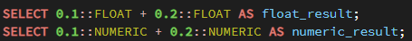
FLOAT → 0.30000000000000004
NUMERIC → 0.3
Using FLOAT for interest amounts can introduce rounding errors, causing incorrect customer interest
Q3
- NOT NULL- A column must always contain a value. customer.first_name VARCHAR(40) NOT NULL
- Unique- No two rows can have the same value in the column. - account.account_number CHAR(14) NOT NULL UNIQUE
- Primary Key. Uniquely identifies each row and cannot be NULL - account.account_id INTEGER NOT NULL with CONSTRAINT pk_account PRIMARY KEY (account_id)
- Foreign Key - Ensures a value corresponds to an existing value in another table - account.customer_id references customer(customer_id),
- Check - Ensures a value satisfies a specified condition - CHECK (balance >= 0) — an account's balance cannot be negative
- Default - Automatically supplies a value when one isn't explicitly provided. - account.status VARCHAR(10) DEFAULT 'ACTIVE'

Q4
A primary key cannot contain NULL values. | A UNIQUE column can allow NULL values in PostgreSQL.
A table can have only one primary key. | A table can have multiple UNIQUE constraints.
deposit_id is used as the primary key because it is the internal, stable identifier for each fixed-deposit record, while receipt_number is treated as a separate business identifier whose uniqueness is enforced by the UNIQUE constraint.

Q5
DELETE: DELETE removes individual rows from a table, and you can use a WHERE clause to specify which rows should be removed. In PostgreSQL, it can be rolled back if executed inside a transaction. DELETE triggers fire when rows are deleted. Since rows are processed individually, it is generally slower on a large table, especially when deleting many rows.
TRUNCATE: TRUNCATE removes all rows from a table but keeps the table structure, columns, constraints, and indexes. It does not allow a WHERE clause. In PostgreSQL, TRUNCATE can be rolled back when used inside a transaction. Normal DELETE triggers do not fire, although PostgreSQL has separate TRUNCATE triggers. It is generally much faster than DELETE when you want to remove all rows from a large table.
DROP: DROP removes the entire table, including its data, structure, indexes, and constraints. It does not allow a WHERE clause. In PostgreSQL, DROP can also be rolled back inside a transaction. DELETE triggers do not fire because the table itself is being removed. It is generally very fast because PostgreSQL removes the table rather than deleting its rows individually.

Q6
The job deletes transactions older than 90 days, but the regulator requires seven years. Within a quarter the bank would be unable to produce its own history, which is a compliance failure, not merely a data-loss bug. It also runs as a single enormous DELETE, which on a 40-million-row table will hold locks, bloat the transaction log and quite possibly time out.
What the bank should do instead: keep all seven years online, and manage size with partitioning by month so that queries touch only the partitions they need. Older partitions can be moved to cheaper storage or archived to a data warehouse, and only data beyond the seven-year retention period is removed, by dropping a whole partition rather than deleting rows.
Q7
SELECT NULL = NULL -> NULL ->Unknown compared to unknown is unknown, not true
SELECT NULL <> NULL ->NULL -> Same reason
SELECT 5000 + NULL -> NULL -> Any arithmetic with NULL is NULL
SELECT COALESCE(NULL, NULL, 'FALLBACK') -> FALLBACK -> Returns the first non-null argument
SELECT 'A' || NULL || ' B ' -> NULL -> Concatenation with NULL yields NULL in PostgreSQL and Oracle
Q8
The two queries give different row counts because AND has higher operator precedence than OR in SQL.
The first query becomes
WHERE branch_id = 1
OR (branch_id = 2 AND principal_amount > 500000);
The second query is translated as
The deposit must be from branch 1 OR branch 2, AND its principal amount must be greater than 500,000.
Q9
txn_date is a TIMESTAMP.
The literal DATE '2026-03-31' is converted to 2026-03-31 00:00:00, so BETWEEN covers only the first instant of 31 March. Every transaction that happened during the working day on 31 March fails the test, and the same is true at the end of every quarter the report has ever run.
WHERE txn_date >= DATE '2026-01-01'
AND txn_date < DATE '2026-04-01'
This half-open range includes the whole of 31 March and excludes 1 April, and it stays correct if the column later gains sub-second precision.
Q10
A column alias is created in the SELECT step. Therefore, when WHERE is evaluated, the alias doesn't exist yet.
WHERE filters before SELECT creates the alias; ORDER BY sorts after SELECT creates the alias.

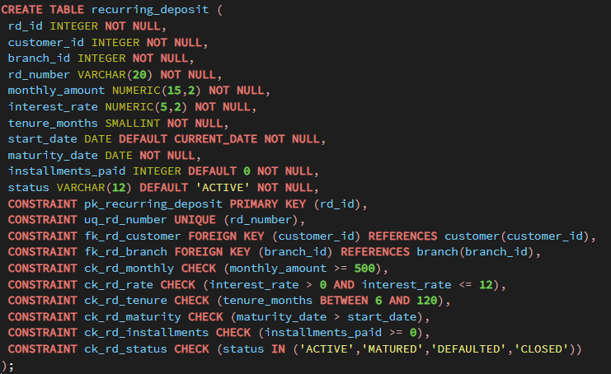
Q11

Q12
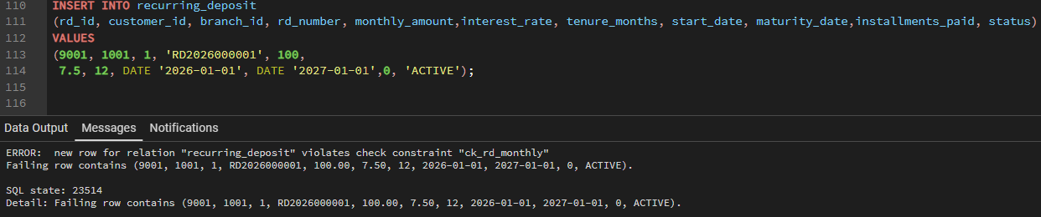
- An RD with monthly_amount of 100
- An RD for customer_id 5555.
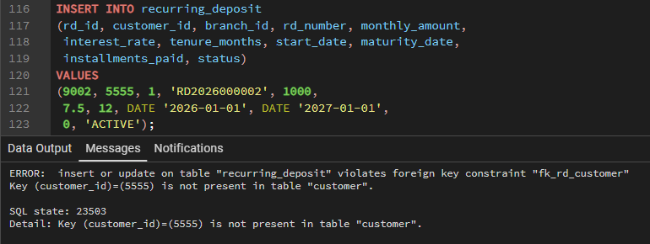
- An RD whose maturity_date is before its start_date
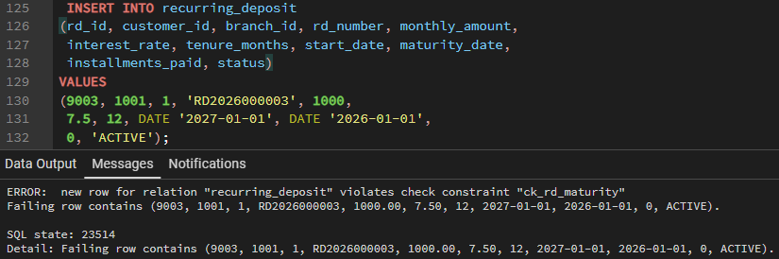
- Two RDs with the same rd_number.
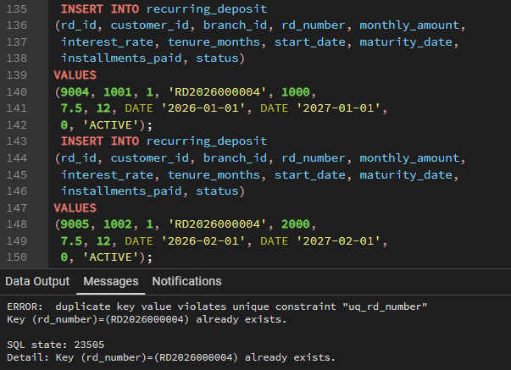
- An RD with status of PAUSED.
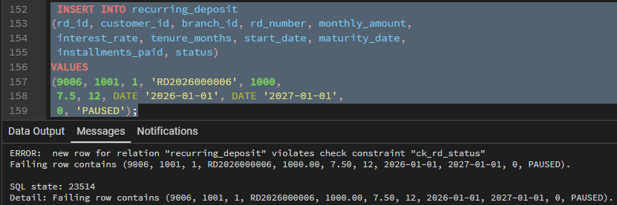
- An RD with installments_paid of -3.
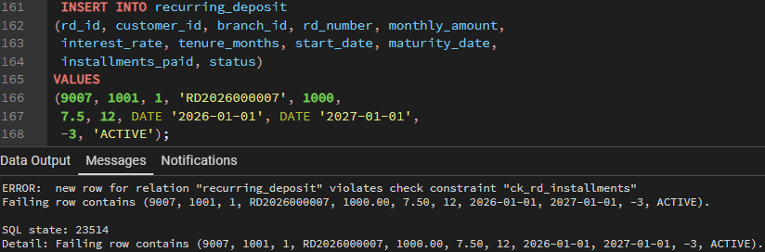
Q13
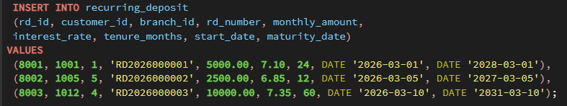
Q14
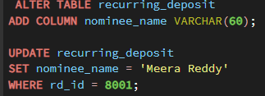
Q15
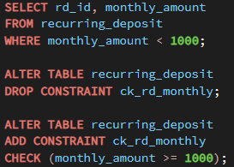
Q16
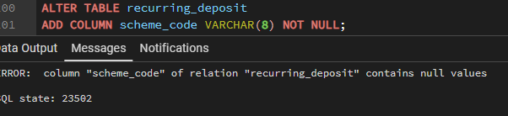
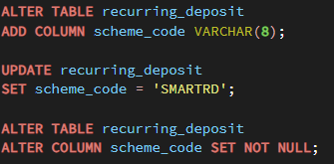
Q17
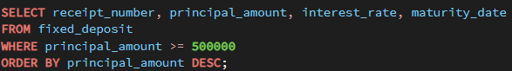
Q18
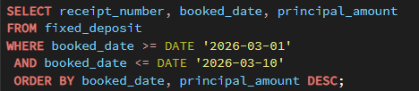
Q19
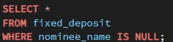
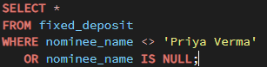
Q20
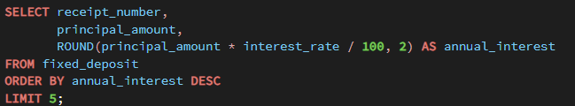

Q21
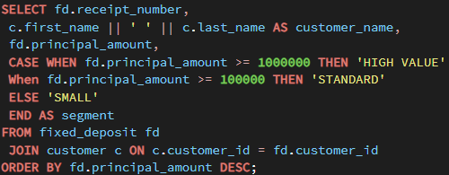
Q22
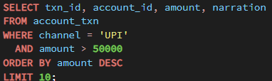
SQL Server
SELECT TOP 10 txn_id, account_id, amount, narration
FROM account_txn
WHERE channel = 'UPI'
AND amount > 50000
ORDER BY amount DESC;
Oracle
SELECT txn_id, account_id, amount, narration
FROM account_txn
WHERE channel = 'UPI'
AND amount > 50000
ORDER BY amount DESC
FETCH FIRST 10 ROWS ONLY;

Q23
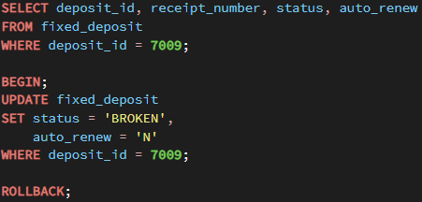
Q24
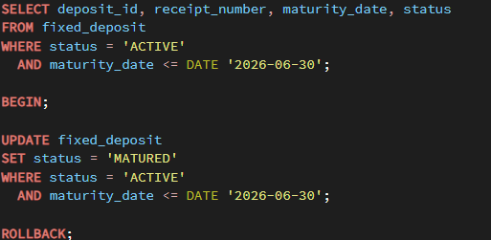
Q25
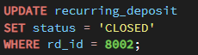
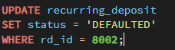

A bank should retain the RD record for audit, regulatory history, and traceability, so changing its status to CLOSED preserves the record instead of destroying it.
Q26
I would not agree to store principal_amount as VARCHAR(30). Principal amount is a financial value, so I would insist that the final database column be a numeric type such as NUMERIC(15,2), which is also consistent with the principal_amount definition in your fixed-deposit schema.
The vendor's three formats should be cleaned and converted before they reach the database:
"250000" → 250000.00
"2,50,000.00" → 250000.00
"250000 INR" → 250000.00
Where the cleaning goes: in a staging layer, not in the target table. The feed lands in a staging table where the column is text exactly as supplied. A transformation step parses, validates and converts, writing clean rows into fixed_deposit and rejected rows into an error table with the reason. That way a malformed value is visible and reportable rather than silently coerced to zero, and the raw feed is retained for the vendor dispute that will follow.
Q27
I would choose RESTRICT because a bank should never automatically delete a customer's financial records when the customer relationship is closed. When a customer leaves the bank, their accounts and deposits are normally closed or settled while the historical records are retained for audit, regulatory, tax, and dispute purposes. ON DELETE CASCADE could unintentionally remove fixed-deposit records and destroy important financial history when a customer record is deleted. With RESTRICT, the database prevents deletion of a customer while dependent deposits still exist, forcing the bank to handle those deposits through an appropriate closure or archival process. Therefore, RESTRICT provides stronger data integrity and is more appropriate for a banking system where historical transaction and deposit records must be preserved.

Q28
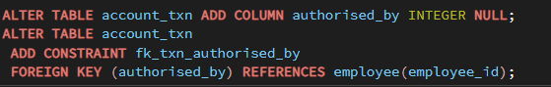
Type -> INTEGER -> Must match employee.employee_id exactly or the foreign key and any index on it are useless
Nullability -> Nullable -> Most transactions are ATM, UPI and POS, with no employee involved. "Where applicable" in the requirement means the fact is genuinely absent, which is what NULL is for
Foreign key -> Yes -> An authorisation attributed to a non-existent employee is worthless in an audit
Existing 40 million rows -> Leave them NULL They were never authorised by an employee; inventing a value would be fabricating audit data
Q29
CHECK constraint approach
Advantages:
- Simple and easy to maintain — the four allowed values are visible directly in the table definition.
- Good performance and fewer objects — there is no additional lookup table or join required just to validate the status.
Lookup table + foreign key approach
Advantages:
- Centralised management — statuses can be stored once in a deposit_status table and reused consistently.
- Easier to extend — adding a new status doesn't require changing the fixed_deposit table's CHECK constraint; you can insert a new status into the lookup table.
Q30
- Immediately stop further changes to the affected application/job if possible, so no additional incorrect updates occur.
- Check whether the UPDATE is truly committed; because autocommit is on, assume the change has already been committed.
- Determine the exact scope of the damage by checking how many accounts now have status = 'DORMANT' and comparing with the expected status distribution.
- Check the database audit logs, application logs, backups, or change history to identify the previous status of each affected account.
- Do not blindly run UPDATE account SET status = 'ACTIVE', because some accounts may legitimately have been dormant already.
- Restore the affected rows using the verified pre-change values, preferably through the team's approved recovery procedure or point-in-time recovery if necessary.
- Verify the restored data against the audit/source records and confirm that no other columns were changed.
- Document the incident, recovery actions, affected rows, and verification results without blaming the person who made the mistake.
- Working-practice change 1: Require production UPDATE/DELETE statements to be tested with a matching SELECT and reviewed before execution, especially when a WHERE clause is required.
- Working-practice change 2: Use transactions for production data changes (BEGIN → verify → COMMIT/ROLLBACK) and restrict direct production write access where practical.

