Q1
Super key (loan_id, customer_id)
Candidate key loan_id
Primary key loan_id
Foreign key customer_id
A candidate key must be minimal—you cannot remove any column and still retain uniqueness.
Therefore, (loan_id, customer_id) is a super key, but not a candidate key, because customer_id is redundant.
Q2
Email can change
A customer may change their email address. Changing a primary key can require updating all related foreign-key records and creates unnecessary dependency.
Email can be NULL
In the existing customer table, email is nullable. A primary key must always be NOT NULL, so email cannot serve as the primary key in the current design.
Email is not a stable business identifier
Email is contact information, not a permanent identity for the customer. Customers may lose access to an email, change providers, or use a different email later.
Keep customer_id as the primary key because it is a stable, system-generated identifier. Then enforce the business rule that emails must be unique using a UNIQUE constraint
Q3
RESTRICT means the parent row cannot be deleted or updated if child rows still reference it. It protects referential integrity.
CASCADE means deleting or updating the parent row automatically deletes or updates the related child rows.

account_txn referencing account — RESTRICT
Transactions are financial records and must not be automatically deleted when an account is deleted.
card_reward_enrolment referencing credit_card — CASCADE
A reward enrolment belongs only to that card, so it can be removed when the card is deleted.
loan referencing customer — RESTRICT
A customer with loan records should not be deleted because loan history must be preserved.
employee.manager_id referencing employee — RESTRICT
Deleting a manager should not automatically delete the employees reporting to them.
loan_payment referencing loan — RESTRICT
Loan payments are financial records and must be retained even if the loan record is being removed.
Q4
Insert anomaly: An insert anomaly occurs when we cannot add a new piece of information to a table without also adding unrelated information.
Update anomaly: An update anomaly occurs when the same piece of information is stored in multiple rows, so changing it requires updating several rows. If some rows are missed, the data becomes inconsistent.
Delete anomaly: A delete anomaly occurs when deleting a row unintentionally removes the only stored information about another entity
For branch_customer_flat:
- Insert anomaly — A new branch cannot be inserted if there is no customer associated with that branch, because the flat table stores branch and customer information together.
- Update anomaly — If a branch's information, such as branch_name or city, appears in multiple customer rows, changing the branch information requires updating every row for that branch. Missing one row creates inconsistent branch data.
- Delete anomaly — If the only customer belonging to a branch is deleted from branch_customer_flat, the branch's information is also lost from the table, even though the branch itself still exists.
Q5
- An employee belongs to exactly one branch, and that branch is mandatory. A branch may have zero, one or many employees. Physically: employee.branch_id is NOT NULL with a foreign key to branch.
- A loan payment belongs to exactly one loan, mandatory. A loan has at least one payment row and may have many - the |{ makes the many side mandatory too. Physically: loan_payment.loan_id is NOT NULL, and the "at least one" rule cannot be expressed as a constraint. It has to be guaranteed by the process that creates a loan, which must create its schedule in the same transaction
Q6
A many-to-many (M:N) relationship cannot be stored using just a foreign key because a foreign key in one table normally points to one row in another table. In an M:N relationship, one row on either side can be related to multiple rows on the other side.
For example, if a customer can have multiple loans and a loan can involve multiple customers, storing only customer_id in loan cannot represent multiple customers for the same loan.
A junction table is therefore created to break the M:N relationship into two 1:N relationships. It contains the foreign keys of both participating tables.
The junction table's primary key should normally be a composite primary key made from both foreign keys

Q7
1NF Atomic values, no repeating groups, every row uniquely identifiable Multiple values cannot be stored, indexed, constrained or counted
2NF In 1NF, and no non-key column depends on part of a composite key Parent facts repeated on every child row
3N F In 2NF, and no non-key column depends on another non-key column Update anomaly; the same fact stored in many rows diverging
Q8
A table with a single-column primary key can never violate 2NF because 2NF only deals with partial dependency on part of a composite key.
- 2NF: A table must be in 1NF, and every non-key attribute must depend on the whole primary key.
- If the primary key has only one column, there is no "part" of the key to depend on.
- Therefore, a partial dependency is impossible.
If a schema uses surrogate keys throughout (such as customer_id, account_id, loan_id), its tables will generally satisfy 2NF automatically with respect to those primary keys.
However, this does not mean the entire schema is normalized. It can still have:
- Transitive dependencies → 3NF violations
- Redundant data
- Update/insert/delete anomalies
Q9
- Normal form violated: 1NF
Reason: Multiple phone columns represent a repeating group of the same attribute.
Fix: Create a separate customer_phone table
- Normal form violated: 2NF
Reason: Assuming (order_id, product_id) is the composite key, product_name and product_price depend only on product_id, not on the whole key.
Fix: Move them to product, keyed on product_id
- Normal form violated: 3NF
Reason: branch_name and branch_city depend on branch_id, not directly on employee_id. This creates a transitive dependency.
Move branch details to branch
- Normal form violated: 3NF
Reason: customer_name depends on customer_id, not directly on account_id, creating a transitive dependency.
Fix: Move it to customer

Q10
Normalization rule broken: 3NF (transitive dependency / redundancy principle) — account.balance is derivable from the transaction records, so storing both creates redundant data.
Business reason for storing it: To provide fast access to the current account balance without calculating SUM() over potentially millions of transactions every time the balance is needed.
One thing that must exist alongside it: A reconciliation/control mechanism ensuring account.balance stays consistent with the authoritative account_txn records.
In short: Stored balance = performance optimization; reconciliation = protection against inconsistency
Q11
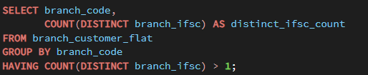
This gives 0 rows
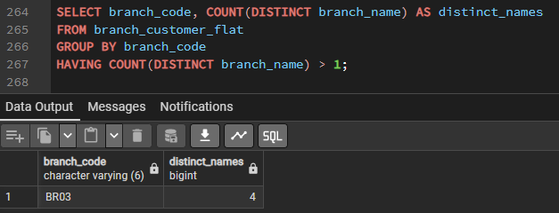
Q12
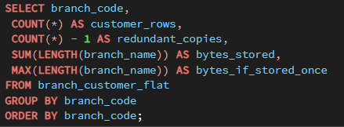
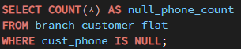
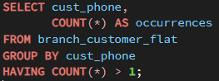
Q13

This shows uniqueness and non nullable
cust_phone is contact information that can change, be reassigned, or be unavailable, so a stable cust_id is more appropriate as the primary key.
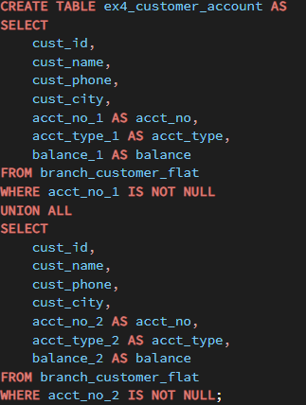
Q14
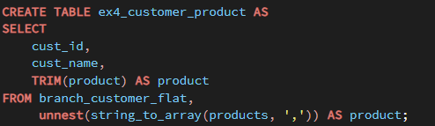

Q15
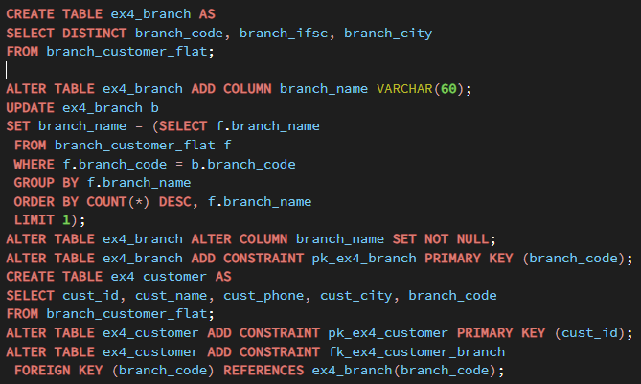
Most frequent spelling, ties broken alphabetically. For BR03 all four spellings occur exactly once, so the tie-break decides and Koramangala survives.
Q16
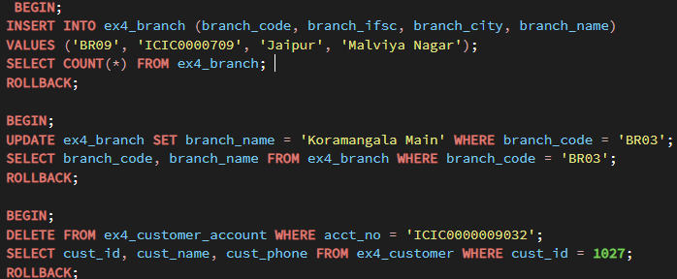
Q17
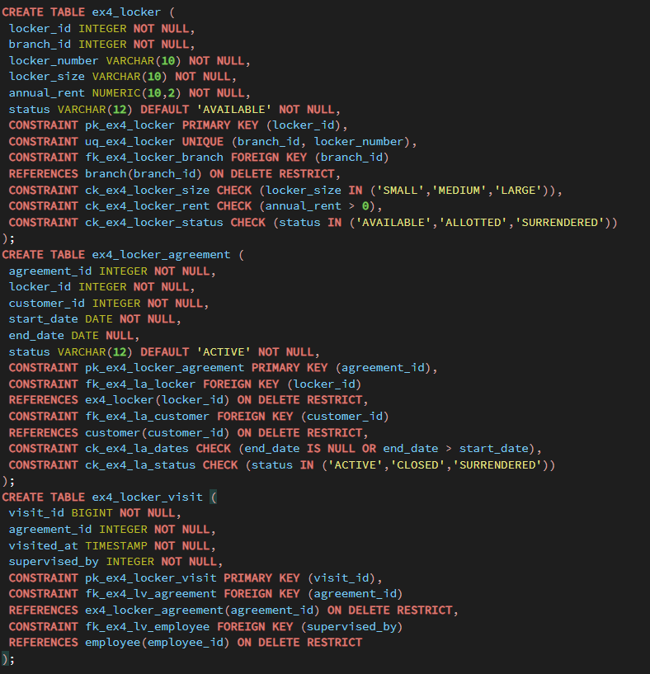
The visit log references the agreement, not the locker. That is deliberate: it records who was entitled to open it at the time, which is what an investigation needs. Referencing the locker alone would leave you unable to say which customer's visit it was after the locker is re-allotted. ON DELETE RESTRICT on supervised_by means an employee who has supervised a visit cannot be deleted from the system. That is correct - the audit trail must survive the employee leaving. The alternative is to soft-close employees rather than delete them, which is what a bank actually does.
Q18
Which entity is weak ex4_locker_visit. A visit has no meaning without the agreement it occurred under, and would be identified as "visit n of agreement x"
Which relationship is many-to-many, and how resolved Customer to locker, over time. Resolved by ex4_locker_agreement, which carries the relationship's own attributes: start date, end date and status
Which foreign key is nullable and why None of the foreign keys. The nullable column is end_date, because an active agreement genuinely has no end date yet, and NULL is the correct representation of a fact that does not exist
Two business rules as CHECK con straints end_date IS NULL OR end_date > start_date, and annual_rent > 0.
Also acceptable: the locker size and status domains
The rule that cannot be a CHECK: "a locker may be allotted to only one customer at a time". That is a constraint across several rows of ex4_locker_agreement, and CHECK sees only one row. It needs either a unique index on the active rows, or a trigger.
Q19
Already declared during table creation :
CONSTRAINT ck_ex4_la_dates CHECK (end_date IS NULL OR end_date > start_date)
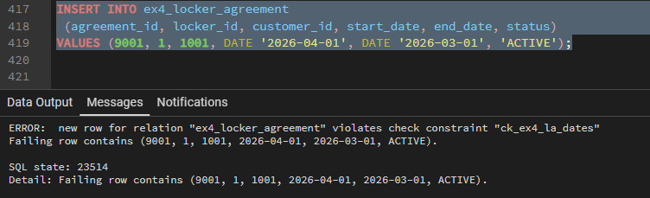
Q20
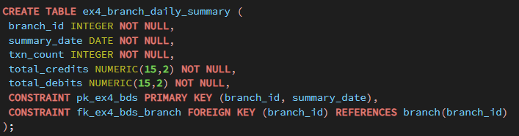

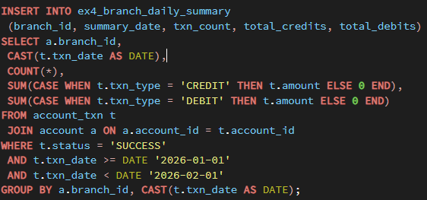

Q21
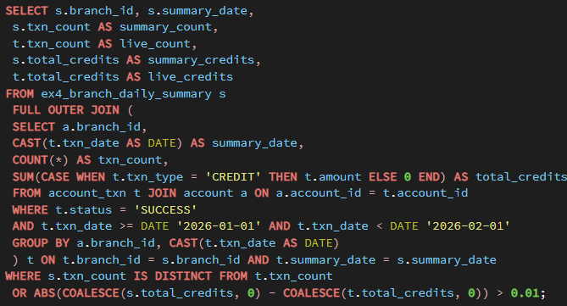
A non-empty result means one of four things, and the shape of the row tells you which: a day present in the summary but not in the source, meaning the summary has rows it should not; a day in the source but not the summary, meaning the load missed it; matching days with different counts, meaning transactions arrived after the summary ran; or matching counts with different totals, meaning a rounding or type difference in the load.
Two details worth teaching. FULL OUTER JOIN rather than an inner join, because an inner join can only find rows that exist on both sides and would silently miss an entirely absent day - the most likely failure. And IS DISTINCT FROM rather than <>, because <> returns NULL when one side is NULL, so a missing day would fail the comparison and be dropped from the exception report.
Q22
We cannot accept ON DELETE CASCADE on every foreign key. In a banking database, cascading deletion from master records into financial and audit records creates a significant data-retention and integrity risk. For example, if a customer is deleted, cascading to account and then to account_txn could delete the customer's account and its entire transaction history. We require financial and audit records to be protected rather than automatically deleted. Please use ON DELETE RESTRICT (or the appropriate non-cascading behavior) for these relationships, with explicit business-controlled archival/deletion procedures where permitted.
Response to the Head of Data Governance:
I recommend rejecting the vendor's blanket ON DELETE CASCADE approach. The specific scenario of concern is deletion of a customer causing their accounts and then all associated account_txn records to be automatically deleted. This could destroy historical financial records and undermine auditability. I require foreign-key actions to be reviewed relationship-by-relationship, with RESTRICT for customer → account and account → account_txn, and any deletion of financial records governed by an explicit retention and archival policy rather than automatic cascading.

Q23
Two arguments against phone_1, phone_2, phone_3:
- It violates 1NF / creates a repeating group. Phone numbers are the same type of attribute repeated across columns. If the business later allows a fourth number, the table structure must be changed. A customer_phone table allows any number of phones without altering the schema.
- It makes operations and constraints harder. Searching, validating, updating, or enforcing rules across all phone numbers requires checking three separate columns. A separate table lets you treat every phone number uniformly and apply constraints/indexes to one column.
One situation where the architect's approach is reasonable:
If the business rule is strictly fixed at three phone numbers, the three positions have distinct meanings (for example, primary, alternate, and emergency), and the application is performance-sensitive enough that avoiding the extra join provides a measurable benefit, storing them as separate columns can be reasonable.
Bottom line: A fixed, semantically meaningful maximum can justify the design; an arbitrary limit of “nobody has more than three” generally does not.
Q24
It is acceptable in a reporting/data-warehouse fact table because the warehouse may deliberately use denormalization to improve reporting performance. Repeating branch_name avoids repeatedly joining a 400-million-row fact table to the branch dimension.
It would not be appropriate in the customer master because branch_name is determined by branch_id/branch_code, so storing it on every customer row creates redundancy and can cause update anomalies or inconsistent branch names.
The control that makes the warehouse approach safe is ETL/ELT data-quality control: the load process must consistently derive and validate the denormalized branch_name from the authoritative branch dimension
Q25
I would not accept the shortcut as the final data-cleaning rule. The most frequent spelling is evidence of what appears most often, but it does not prove that it is the correct official branch name. In this dataset, BR03 has four variants, so automatically choosing the most frequent one could preserve an incorrect value.
I would accept the shortcut temporarily for the cleanup deadline if it is treated as a controlled data-quality decision. I would require the selected value to be recorded in a data-quality/audit log, with the original spellings retained, the selection rule documented, and the surviving name subsequently verified against the bank's authoritative branch/IFSC master.
So: use frequency as a temporary resolution mechanism, not as proof of correctness; require auditability and later validation against the authoritative source.

Q26
The strongest response is that the main cost normalization prevents is not storage cost—it is data inconsistency and the resulting maintenance cost.
In a normalized design, a fact such as a branch's name is stored in one authoritative place. In the flat table, the same branch information is repeated across many customer rows. If the branch name changes, every copy must be updated. If one row is missed, the database can contain conflicting information.
That creates:
- Update anomalies — one real-world fact requires many updates.
- Insert anomalies — some information cannot be stored independently.
- Delete anomalies — deleting one record can accidentally remove the only copy of another fact.
- Data-quality and reconciliation costs — conflicting values must be detected and corrected.
- Operational complexity — applications and reports must decide which duplicate value is correct.
So even if storage is cheap and joins are fast, the cost being prevented is the cost of maintaining consistent, trustworthy data, not primarily the cost of disk space.
Q27
The customer master stored customer, account, product, and branch information together, causing the same branch details to be repeated across many customer records.
It also stored multiple accounts in fixed columns and multiple products in a single field, making the data difficult to maintain consistently.
The audit identified four different spellings of the same BR03 branch name.
We have replaced this structure with separate customer, branch, account, and product records linked by identifiers.
Branch details are now stored once in the branch record rather than being copied into every customer record.
The four BR03 spellings were resolved using the agreed selection rule and one branch record now represents BR03.
A branch code is the primary identifier for each branch, so duplicate branch records for the same code are prevented.
A customer references its branch through a foreign key, so a customer cannot reference a branch that does not exist.
The previous problem of inconsistent branch details across customer rows is therefore prevented by design.
The previous problem of storing multiple products in one customer field is also prevented because each product is stored as a separate record.
Branches must now maintain branch information in the designated branch record rather than entering it repeatedly for each customer.
They must also record each customer account and product as separate records instead of using repeated columns or comma-separated values.

