Optimal Sub-Exposure Calculator

The optimal sub-exposure calculator is an implementation of the process defined and presented by Dr. Robin Glover. The process seeks to compute a minimal sub-exposure time which considers two sources of noise in an image: camera read noise, and noise from sky brightness. (Note that the effects of thermal noise is not considered in this computation).

The concept in this calculation is to provide a sufficiently long exposure so that the effects of camera read-noise are overwhelmed by the signal coming from the target, but not so long an exposure that effects of sky brightness in the image rise to overwhelming levels.

The implementation of this process does not consider the brightness of the target, nor does it consider other factors which may cause an astrophotographer to choose a alternate sub-exposure time. These other factors may include: The storage requirements and extended post-processing time for a large number of short exposures. The impacts of external factors that might occur in very long exposures, such as tracking / guiding performance, changes in sky / weather conditions, intrusions from air traffic or passing satelites.

The tool simply provides additional infomation that can be considered by a photographer in selecting an exposure time given the equipment and observing conditions.

The optimal exposure calculation requires:
- The focal ratio of the optic.
- Information about the quality of sky at the observation location.
- Information about the read-noise of the camera, (at the selected gain).
- A bandpass value for a filter which may be used during imaging.
- An optional input for a noise tolerance, (which by default is set to 5%).

From these inputs the calculator will present graphical of presentation of the optimal sub-exposures over the range of available camera gain (or ISO) value options. The user can make “what if...” adjustments to some of the inputs to the calculator to immediately see how the optimal sub-exposure time will be effected by the changes, and to see the effects of that exposure time on the noise levels that would be present in stacks of images at various stack (integration) times.

Optic Focal Ratio

Low optic focal ratios (commonly referred to as “fast” optics), will acquire light (and noise from light pollution) rapidly. The use of a low focal ration optic will therefore result in shorter calculated exposure times. Conversely, the use of a high optic focal ratio (a “slow” optic), will result in longer exposure times.

[We plan to rely upon the focal ratio as read from from Indi, so this would not be a user configurable value in the exposure calculator].

Changes to optic focal ratio would only be achieved through the use of reducers or Barlow lens, or the use of a different optical train.

[A deficiency in the calculator is that no consideration is given to the efficiency of the optic. For example two optics of the same focal ratio, a refractor (with no obstruction) and a reflector (with a secondary mirror obstruction) are being treated as equivalent optics in the computations.]

Camera read noise and gain / ISO selection

Read-noise is incurred at the instant that the exposure has completed, as the voltages within the pixels of the imaging sensor are being read and converted to numeric values through an electronic circuit known as an analog to digital converter (ADC).

For a given gain or ISO setting on a camera, there will be a pre-determined read-noise value. Details of this gain to read-noise relationship may be published in the technical documentation of some cameras, but the calculator tool must rely upon a data file that is transcribed from the camera technical documentation in order to produce the correct calculation for an exposure.

[Developers: My research into CCD cameras has lead me to beleive that the read-noise on these cameras is not affected by gain. Can anyone confirm this? My code includes an enum GAIN_SELECTION_TYPE_FIXED that is intended as a placeholder for further development if this is true.]

The read-noise in an image can be thought of as a “fixed cost” of taking an image. A longer exposre does not incurr a greater amount of read noise.

When the camera is producing a high read-noise, the calculation for exposure time will be increased. This is because more exposure time will be needed to overwhelm the read-noise with the desired data from the target.

But a read-noise level will normally vary with a change in the selected gain or ISO value on the camera. The selection of low gain / ISO values will typically result in high read-noise values, and therefore higher exposure times. Conversely a high gain / ISO value will typically result in low read-noise values, and therefore lower exposure times. However, the selection of a high gain/ISO will reduce the dynamic range in the image, and the selection of a low gain/ISO will result in higher dynamic levels in the image. So the photographer must weigh the benefits and costs in choosing a gain / ISO setting.

Some cameras may show a smooth progression curve in the read-noise over the range of gain values, other cameras may have very pronounced steps (and other anomalies) in their read-noise. A few cameras have an option to select among different operational modes, and these modes can have unique read-noise “curves”.

Hint: When a selected camera which has a pronounced step in its read-noise, a photographer may wish to select a gain which is at the bottom of that step. This may provide a reduced read noise, and shorter exposure without a significant loss in dynamic range when compared to an image shot at a gain selection that is at the top of that step.

[Developers: In this proof of concept application the ui setup code will read a folder for camera xml files, and add them to a combo box. So new cameras files can be created for testing. You could simply copy an existing camera file and edit it. But I would instead recommend editing the buildSensorDataFile method in fileutilitysensordata.cpp to add a new camera file. There is call to this method (currently commented out) in main.

For read-noise data on ZWO and QHY cameras I have been copying an image of the cameras read-noise graph into a cad application, measuring the axis to get scaling factors, and then measuring the locations of markers on the graph to find a read-noise for a given gain.

If you wish to add a DSLR, there is a great site for information. https://www.photonstophotos.net/Charts/RN_e.htm

After a camera is selected the graph will appear, but clicking the box with the camera name will show a table that can be harvested for the gain to read-noise data.

(Just be aware that for a DSLR you need to set the gain selection type enum to GAIN_SELECTION_TYPE_ISO_DISCRETE and the gainSelection vector needs to list the actual selectable ISO values that the camera supports).

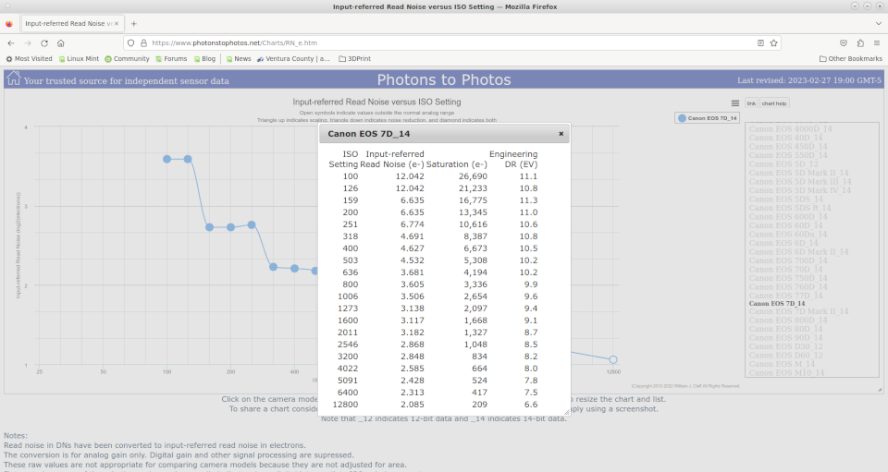

]

The Sky Quality Meter (SQM) value, Noise from Sky Brightness, (Light Pollution)
A Sky Quality Meter provides a value of the brightness of the sky in the units of magnitude per square arc-second. The scale will range from around 16 (for a very heavily light polluted sky), to around 22 (for a sky with no light pollution). The noise from sky brightness, represents a “variable cost” of taking an image. A short exposure will be less effected by this noise. A very long exposure may result in an image which is overwhelmed by this noise.

A Sky Quality Meter can provide a reading at the time of the imaging session, but a basic value from sky quality surveys may also be found on the web at sites, (such as https://www.lightpollutionmap.info). But be aware that sky brightness is also effected by moonlight scattering in the atmosphere (natural light pollution). The light pollution maps on the web do not seem to consider the effect of moonlight on the SQM value.

Filter compensation

[
Developers: This is where the calculator has some deficiencies. So we may need some discussion as to whether it is worthwhile to address them. These deficiencies may not have a significant impact on the calculation, so we may choose to just mention these deficiencies in documentation. But I wanted to raise them for discussion.

The presentation by Dr Glover that I watched in 2020 did not provide much detail on how the effects of filters should be considered in the exposure time and noise calculation process.

In researching how other astrophotographers (posting on astonomy forums), have implemented adjustments in their calculations to account for the effects of filters, they seem to making simple assumptions that I believe are prone to errors.

Issue #1: All cameras seem to be treated as though they are only sensitive to visible light. The math being employed in the forum posts seems to use a 300 nm bandwidth as the standard for an unfiltered camera, and filter compensation is based on a fraction of this value. But we know that an unfiltered camera sensor is sensitive to some UV and IR light. In reality it may be sensitive to bandwidth of 600 nm or more.

One problem this may create is that the application of a luminance filter; truncating UV and IR bands will not show any effect on the noise levels, and will not cause a change in the calulated exposure time. From my research, I beleive that mercury lamps emit a considerable amount of UV light and I would think that an unfitlered camera would see this as noise.

Issue #2: The compensation for the use of some filters seems to assume an even distribution of light pollution across the spectrum.

On the forum posts the compensation for an R, G, or B filter seem to be treated as a 100 nm bandwidth. So noise from light pollution with an R, G, or B filter is adjusting the sky brightness input to 1/3 of an unfiltered value. This seems erroneous to me, mainly because pollution from artificial light is not distributed evenly across the spectrum. There are very specific emission lines from the common sources of atrifical light pollution, sodium and mercury light sources. For example I would think that a blue filter would be passing much more artificial light pollution from a mercury lamp than would a green or red filter.

I suspect that the only realistic accurate filter compensation would be when a very narrow band filter (3 to 5 nm) compensation is applied in the calculation.
]

Allowable Noise Increase

Dr Glover’s process allows the photographer to specify a noise tolerance value in the computation of the exposure time. He indicated that a 5% noise increase is a “reasonable” value. But this default value is not the most extreme low noise result that the calculator will produce. But it is a reasonable value in terms of the diminishing returns on an increase in exposure time on the reduced noise in a stack.

The calculator allows for adjusment of this value; the change will alter the balance of read-noise to light pollution noise. Increasing this allowable value will shift the balance to more read-noise and less noise from sky brightness; and shorter exposure time will be computed. Decreasing allowable noise will shift the balance to less read-noise and more noise from sky brightness; and a longer exposure time will be computed. The value cannot be set to 0, as this would cause an infinite exposure time. But a lower value can slightly improve the noise ratio in a stack.

An scenario where reducing the allowable noise would make good sense is when the Sky Quality is poor, and the therefore the calculated optimal exposure time, is very short.

For example: At SQM 18.5, Focal Ratio f/5, a camera setting with a low read noise (2 electrons), and an R, G, or B filter: the calculation with allowable noise increase at 5% produced an exposure time of just 7.5 seconds. But changing the allowable noise increase to 0.5% raised the exposure time to 77 seconds. A one hour stack will have a slightly better noise ratio.

A scenario where increasing the allowable noise would make good sense is when the Sky Quality is moderate, and a narrow band filter is used.

For example: At SQM 20, Focal Ratio f/5, with a ZWO ASI-6200mm at gain 100, and a 3 nm filter. With 5% allowable the calculation will produce a exposure time of 646 seconds. This may be longer than the photographer would prefer given concerns for guiding, etc. By raising the allowable noise to 12.5% the exposure time drops to 249 seconds. But the stacks will show a much worse noise ratio.

Reference:

Mercury Lamp Spectra:
