Undervalued Player Finder
Project Documentation
Market-value prediction for top-5 European league footballers, built to surface players the market may be under- or over-pricing relative to their performance stats.

1. Overview
This project builds a model that predicts a football player's market value from their performance statistics, age, position, contract situation, and club strength. The intended use is to spot players whose stats suggest they are worth more (or less) than the market currently values them at.
The project went through several phases: fixing methodological problems in an earlier version of the model (data leakage, bad age data), adding missing features by scraping Transfermarkt, removing an artificial floor on the target variable by scraping ~1,450 additional players, and finally scoping the model to the value range it can actually predict reliably.
Final dataset: 1,813 players (up from an original 378), covering market values from €75k to €220m.
Final model scope: trained on all 1,813 players, but evaluated and used only for the middle 80% by value (€1.8m–€40m) — see Section 6.

2. Data Sources
File | Rows | Role
podaci/top5_stats_combined.csv | 1,828 | Raw per-90 performance stats for top-5-league players (no market value). Source of truth for stats; contains no assists/xA/key-pass data.
podaci/combined_top5_marketvalue.csv | 378 | Original target list: stats joined with market value, but only for players who appeared on Transfermarkt's top-500-by-value list.
podaci/players_scraped.csv | 378 | Transfermarkt-scraped Age, Position, Contract expiry and current club for the original 378 players.
podaci/players_scraped_extra.csv | 1,436 | Same scrape, extended to the ~1,450 players below the original €20m floor.
podaci/clubs_scraped.csv | 250 | Squad total market value per club (the CLUB_STRENGTH feature).
podaci/league_clubs.csv | — | Cache of which clubs play in each top-5 league per season; used to disambiguate player-name matches.
podaci/combined_top5_marketvalue_enriched.csv | 1,813 | Final merged dataset used by main.py.

3. Problems Found and Fixed

3.1 Evaluation leakage (pre-existing)
The original model tuned hyperparameters and used early stopping against data it later reported results on, and used a stale test-set-informed iteration count during cross-validation. This made the reported accuracy look better than it really was.
Fix: switched to scikit-learn's cross_val_predict with a 5-fold KFold split, so every player's prediction comes from a model trained only on the other folds. All metrics in this document are out-of-fold.

3.2 Bad age data (pre-existing)
The original Age column had scraping errors (e.g. Alexander Isak listed as 18, Ousmane Dembélé as 17).
Fix: Age is now sourced from a fresh Transfermarkt scrape instead of the original data.

3.3 Name-matching bug: wrong player selected (Kenan Yıldız)
Python's unicodedata.normalize("NFKD", ...) does not decompose several letters, including the Turkish dotless ı. The accent-stripping helper silently dropped it, which let a retired, unrelated player with a coincidentally ASCII-spelled name outscore the real Kenan Yıldız on name similarity — even though the real player's market value matched our data exactly and the wrong one had none at all.
Fix: added explicit character mappings (ı→i, ø→o, đ→d, etc.) before NFKD normalization, and rewrote the matching logic to require agreement on market value first, with name similarity as a secondary check. A full revalidation pass across all 378 players confirmed this was the only affected row.

3.4 Market value parsing bugs
- "bn" (billion) suffix was not recognized, so a club's €1.33bn squad value parsed as €1.33m (a 1000x error). Found while scraping club strength for Arsenal, Real Madrid, Bayern Munich, etc.
- "k"/"Th." (thousand) suffix was not recognized in one code path, so player values like €800k parsed as €800m. Found in the first batch of the below-€20m player scrape (bench players are often valued in the low hundreds of thousands).
Fix: parse_market_value() now handles bn / m / k / Th. suffixes explicitly. Affected batches were re-scraped after the fix.

3.5 Transfermarkt search failing on special characters
Search queries containing "&", "/", or parenthetical disambiguators (e.g. "Brighton & Hove Albion", "FK Bodø/Glimt", "Al-Nasr SC (UAE)") returned no results.
Fix: added a fallback that strips parentheses, replaces "&"/"/" with words or spaces, and retries — and, for a few cases, also retries without a short all-caps club prefix like "FK".

3.6 Overly strict confidence check for non-top-5-league clubs
The club-matching confidence rule only trusted a match if the club played in one of the five target leagues. This wrongly flagged ~150 clubs as needing manual review even when the matched name was an exact string match — because many players had since transferred to Saudi, Turkish, Portuguese, Dutch, Belgian, or MLS clubs, or their club had been relegated to the Championship.
Fix: a near-exact name match (≥97% similarity) is now trusted on its own; league membership is only used to break ties among lower-similarity candidates.

4. Feature Engineering
Feature | Source | Notes
Position (GK/CB/FB/DM/CM/AM/W/ST) | Transfermarkt scrape | Stats mean different things per position; previously missing entirely.
Contract years left | Transfermarkt scrape | Computed as contract-expiry year minus season year. 103 of 1,813 players have no listed expiry date and get the column median.
Club strength | Transfermarkt scrape (250 clubs) | Total squad market value of the player's current club, log-transformed. "Without club" (23 free agents) is set to 0, not imputed.
League (one-hot) | Original data | Multi-league transfer strings collapsed into a single "Multi-league" category.
Age (spline) | Transfermarkt scrape | Given a natural cubic spline instead of a linear term, since value rises into the mid-20s and falls after.

4.1 Feature tried and rejected
A RECENTLY_TRANSFERRED flag (current club in a different top-5 league than the stats' league) was added to capture a real data quirk affecting ~40 of the original 378 players. It did not move cross-validated R², so it was removed again — confirmed by re-running the pipeline and matching the pre-flag baseline numbers exactly.

5. Removing the €20m Floor
The original 378-player dataset only contained players from Transfermarkt's top-500-by-value list, so every player was worth €20m or more. A model trained only on that population cannot say anything useful about cheaper players — which matters for an undervalued-player finder, since cheaper players are exactly where market inefficiencies are more likely to be found.

5.1 Scraping the remaining players
- ~1,450 players from top5_stats_combined.csv had stats but no market value. These were scraped in 5 batches of ~290 players each.
- Matching logic: a candidate is accepted if its club plays in the player's stats-league (checked against a cached per-league, per-season club list), or if it is the only near-exact name match with a listed market value.
- 1,381 of 1,450 matched confidently; the rest were flagged NEEDS_REVIEW with the best-guess candidate shown, rather than guessed.

5.2 Manual review pass
The ~57 NEEDS_REVIEW players were reviewed manually. For each one either a corrected Transfermarkt profile link was supplied, or the player was dropped (retired, no market value, or unidentifiable).
- These links were fetched directly and cross-checked: the script re-derives the canonical club name and re-confirms the page actually matches the target player's name, flagging anything below a 50% name-similarity threshold instead of trusting the link blindly.
- This caught one incorrect link (a corrected "Aarón Martín" link that actually pointed to a different player, Abdel Abqar) which was fixed after being flagged.
- One case ("Oso" → Rômulo) was a real nickname that failed the automatic similarity check and was confirmed manually.
- One player (Facundo Garcés) has no market value listed on Transfermarkt at all and was excluded — there is nothing to predict for a player with no target value, so this was not treated as an imputable gap.

5.3 Result
1,435 additional players were merged in, bringing the dataset to 1,813 players spanning €75k–€220m (median €9.0m). Club strength coverage was extended from 71 to 250 clubs to cover the clubs these new players introduced.

6. Modeling Approach

6.1 Models
- Ridge regression with a cubic spline on Age, one-hot-encoded League/Position, and standardized features. RidgeCV picks the regularization strength via its own internal cross-validation, so no tuning leaks into the reported evaluation.
- XGBoost with fixed, deliberately un-tuned hyperparameters, kept purely as a benchmark.
- The target (market value) is log-transformed (log1p) before fitting, since it is heavily right-skewed — this makes the model's errors approximate percentage errors rather than raw euro errors.

6.2 Evaluation
All results use 5-fold cross_val_predict: every player's prediction comes from a model that never saw that player during training. Metrics reported: mean absolute error (euros), R² (log scale), median percent error, and the share of players within ±25% / ±50% of their actual value.

6.3 Scoping to the middle 80% by value
Errors concentrate at both ends of the value range, for different reasons: the cheapest fringe players have noisy, idiosyncratic values (squad-depth role, loan status) that per-90 stats can't explain, while the priciest superstars carry a reputation/hype premium over statistically similar peers that isn't in this feature set at all (see Section 7.4).
main.py now drops the bottom and top 10% by value before evaluating (keeping roughly €1.8m–€40m, 1,393 of 1,813 players). This is a scoping decision documented in code, not a data-quality fix — the full 1,813-player dataset stays in the CSV so this choice can be revisited.
Measured effect: mean percent error dropped from ~50–54% to ~39–42%, median percent error from ~31–34% to ~30%, and the within-±50% share rose from ~68–73% to ~72–75%. R² drops (less remaining variance to explain) but this is expected and not a sign of a worse fit.

7. Results

7.1 Final performance (middle 80% by value, n=1,393)
Metric | Ridge + age spline | XGBoost
MAE (euros) | €3.98m | €3.86m
R² (log scale) | 0.675 | 0.712
Median % error | 30.5% | 29.6%
Mean % error | 42.2% | 39.3%
Within ±25% | 41.3% | 41.9%
Within ±50% | 71.9% | 75.2%

7.2 Performance by value tier (full 1,813-player set)
For reference, before scoping to the middle 80% — shows how error scales with player value.
Tier | n | Ridge median % | XGBoost median %
< €20m | 1,274 | 36.9% | 35.1%
≥ €20m | 537 | 28.6% | 27.1%

7.3 Performance by position (full 1,813-player set, XGBoost)
Position | n | Median value | MAE (euros) | Median % error | Within ±25%
FB (Full-back) | 323 | €6.0m | €3.44m | 28.1% | 46.1%
AM (Attacking mid) | 110 | €15.0m | €8.17m | 28.5% | 42.7%
CM (Central mid) | 276 | €8.3m | €5.48m | 29.1% | 44.2%
CB (Centre-back) | 394 | €9.0m | €4.83m | 31.6% | 43.7%
DM (Defensive mid) | 160 | €8.0m | €5.30m | 32.1% | 38.1%
W (Winger) | 298 | €10.0m | €6.54m | 33.2% | 39.6%
ST (Striker) | 252 | €8.5m | €6.89m | 35.7% | 37.7%
No goalkeepers appear anywhere: the underlying stats file only contains outfield-player columns (tackles, carries, shots), so this dataset cannot say anything about keepers.
Defenders and central midfielders are predicted noticeably better than wingers and strikers. This tracks with what's missing from the data — there is no assists / expected-assists / key-passes data anywhere in the source files, which is exactly the signal that separates a good winger or striker's value from a merely-average one with similar shot volume.

7.4 The superstar under-prediction problem
Looking at the 20 highest-value players in the full dataset (all above the model's €40m scope), every single one is under-predicted, most by 25–60%:
Player | Actual (€m) | XGBoost pred. (€m) | Error
Lamine Yamal | 220.0 | 134.3 | -39.0%
Erling Haaland | 220.0 | 95.2 | -56.7%
Kylian Mbappé | 200.0 | 110.7 | -44.6%
Jude Bellingham | 160.0 | 73.0 | -54.4%
Alexander Isak | 100.0 | 38.7 | -61.3%
(Full top-20 table available in project chat history.) This is a ceiling effect, not a training-population problem: excluding these players from training entirely (tested for both a €90m and a €50m cutoff) changed the resulting error metrics by less than noise — removing 1.5–6% of the rows doesn't meaningfully change what the model learns from the rest. The real cause is that pure stat lines don't explain why one exceptional player commands a premium over another statistically similar one; reputation, hype, and potential aren't in this feature set, and there's no mechanism forcing predictions to exceed what the model has already seen in training.

7.5 Most undervalued players (model — market, middle-80% scope)
Ranked by how far XGBoost's prediction exceeds the actual value:
Player | Pos | Age | Actual (€m) | XGB pred. (€m) | Upside
André Silva | ST | 30 | 3.0 | 16.0 | +432%
Filippo Terracciano | CB | 23 | 4.5 | 23.0 | +411%
Ivan Smolcic | FB | 26 | 3.5 | 15.1 | +331%
Mateo Joseph | ST | 22 | 3.5 | 14.8 | +323%
Giovanni Reyna | AM | 23 | 4.0 | 15.4 | +286%
Riccardo Sottil | W | 27 | 3.0 | 11.2 | +273%
Adama Boiro | FB | 24 | 2.5 | 8.5 | +241%
Sékou Mara | ST | 24 | 4.0 | 13.3 | +232%
Sadibou Sané | CB | 22 | 7.0 | 22.7 | +225%
Gianluca Gaetano | DM | 26 | 6.5 | 20.0 | +208%

7.6 Most overvalued players (model — market, middle-80% scope)
Ranked by how far XGBoost's prediction falls below the actual value:
Player | Pos | Age | Actual (€m) | XGB pred. (€m) | Downside
Andrei Rațiu | FB | 28 | 18.0 | 4.6 | -75%
Tylel Tati | CB | 18 | 25.0 | 6.4 | -74%
Arthur Vermeeren | DM | 21 | 22.0 | 5.9 | -73%
Marquinhos | CB | 32 | 28.0 | 8.0 | -71%
Loïs Openda | ST | 26 | 32.0 | 9.3 | -71%
Yáser Asprilla | W | 22 | 14.0 | 4.1 | -71%
Jadon Sancho | W | 26 | 18.0 | 5.4 | -70%
Lucas Paquetá | AM | 29 | 32.0 | 9.8 | -70%
Chrislain Matsima | CB | 24 | 22.0 | 6.8 | -69%
Youssouf Fofana | DM | 27 | 25.0 | 8.0 | -68%
Caveat for both lists: these are exactly the cases where the model and the market disagree the most, which is the point of the exercise — but they're also the predictions with the least real-world validation. Several of the "overvalued" names have well-known reasons for their price that stats alone don't capture (age-curve reputation, high-ceiling youth prospects priced on potential, club captaincy/leadership), so this list is a starting point for further digging, not a verdict.

8. Explaining Predictions (SHAP)
To check whether the XGBoost model's predictions - and in particular the undervalued/overvalued rankings above - rest on believable reasoning rather than a fluke of one feature, each prediction was broken down into a per-feature contribution using SHAP (SHapley Additive exPlanations).

8.1 Method
- TreeSHAP (exact, not approximated) run on XGBoost only - Ridge's contributions would just be coefficient × (feature - average), which adds no information beyond the coefficients themselves.
- Computed out-of-fold: for each of the same 5 folds used for evaluation, a model trained on the other 4 folds explains that fold's held-out players. This matches how the undervalued/overvalued rankings are produced - no player is ever explained by a model that saw them during training.
- Values are on the log scale the model is trained on (same scale as Section 6.3), one column per feature - including each one-hot League/Position dummy separately, with no grouping or conversion to euro multipliers.
- Additivity was verified for every player: base value + sum of that player's SHAP values reproduces the model's raw output to within 1e-4.
Outputs: outputs/shap/shap_values_all_players.csv (every player, every feature), global_importance_bar.png / global_beeswarm.png (below), and a waterfall chart + CSV for each of the top-10 undervalued and top-10 overvalued players from Sections 7.5-7.6.

8.2 Global feature importance
Ranked by mean absolute SHAP value across all 1,393 players - i.e. how much each feature moves a typical prediction, in either direction:
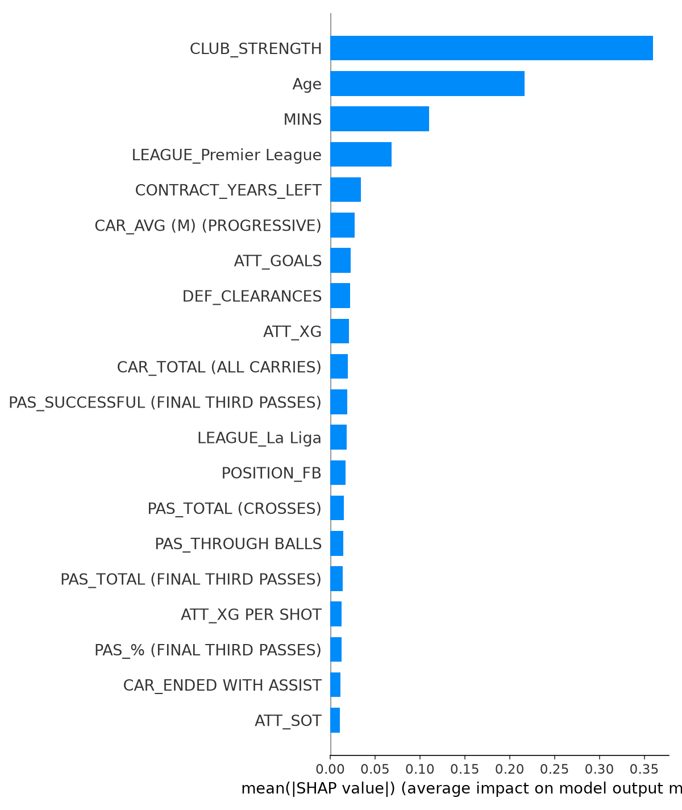
Club strength dominates, followed by age and total minutes played. This lines up with Section 7: features that are broad proxies for reputation and playing time outweigh any individual performance stat.
The beeswarm view below adds direction: each dot is one player, colored by that player's own value for the feature, positioned by the SHAP value (the push on the prediction).
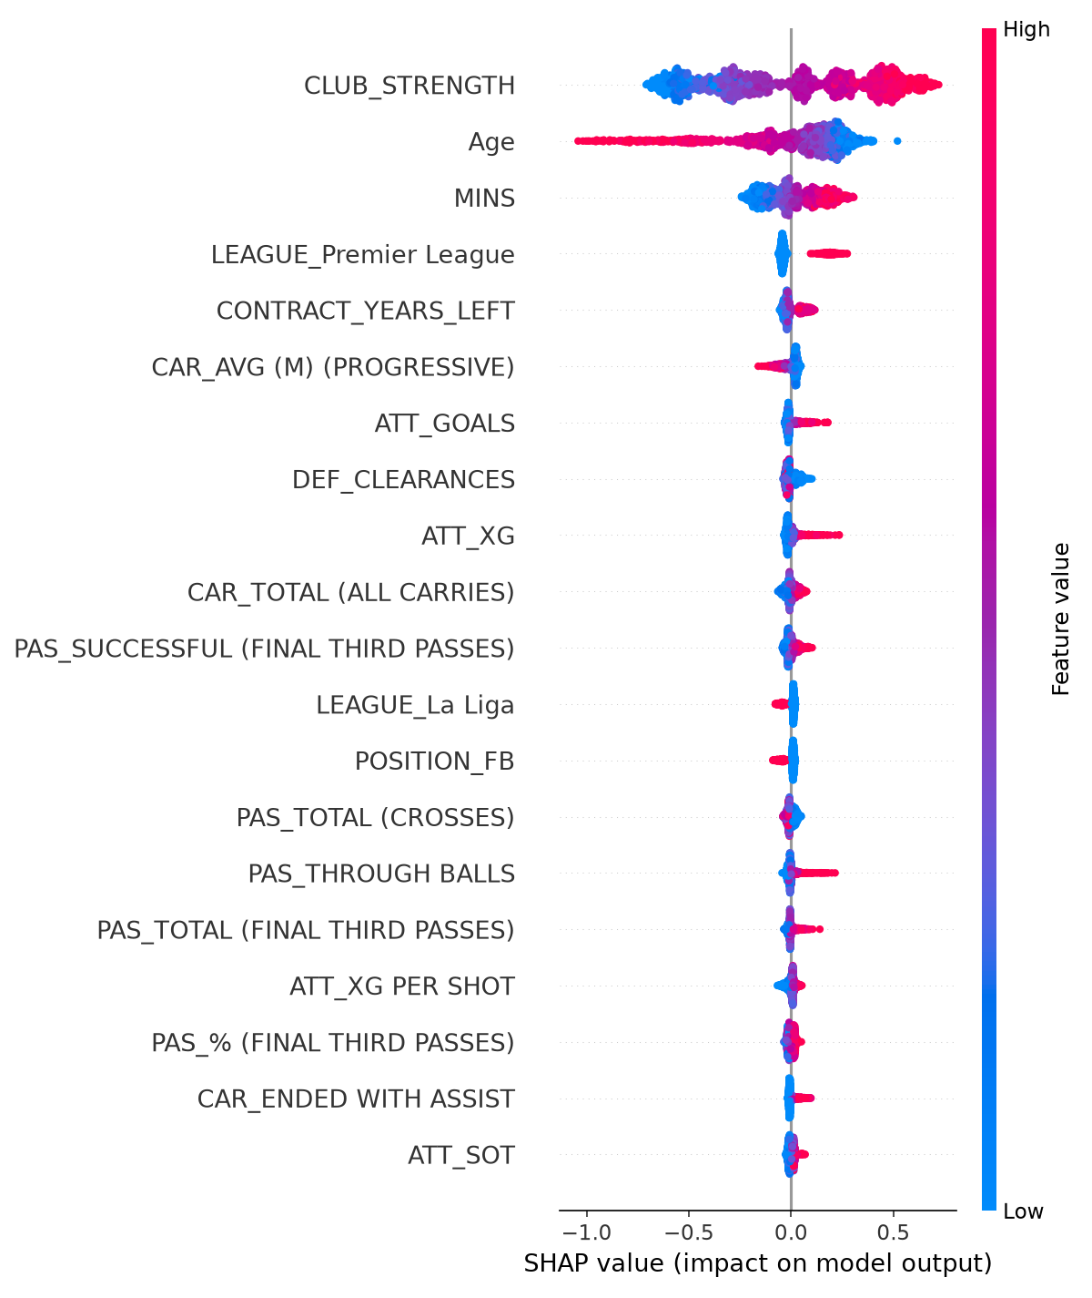
- Higher club strength (red) pushes value up; playing for a weaker club (blue) pushes it down - the single strongest effect in the model.
- Age behaves as expected from the spline: younger players (blue) are pushed up, older players (red) are pushed down.
- More minutes played push value up, confirming durability/manager trust is a real signal distinct from per-90 stat quality.

8.3 Reading the undervalued/overvalued lists through SHAP
Breaking down the top-10 lists from Sections 7.5 and 7.6 by their top two SHAP contributors shows a consistent, and important, pattern:
- All 10 "most undervalued" players are pushed up almost entirely by CLUB_STRENGTH and Age - i.e. they are young players at strong clubs. Not one of them is flagged primarily because of an attacking or defensive stat.
- 9 of the 10 "most overvalued" players are pushed down primarily by CLUB_STRENGTH (playing for a comparatively weaker club than their price would suggest), sometimes combined with Age.
Practical reading: these two rankings are best understood as "players at strong clubs whose individual market value hasn't caught up to their club's level" (undervalued) and "players commanding prices above what their current club's level would suggest" (overvalued) - not as a broad, stats-driven verdict on performance. A player near the top of either list is worth a second look specifically at the club-strength/age angle, not automatically at their full stat line.

9. Known Limitations
- No assists, expected assists (xA), or key-pass data exists in any of the three source files — confirmed by listing all 42 columns of the raw stats file. This is the single biggest gap for attacking positions.
- No goalkeepers: the stats file has no goalkeeping-specific columns, so keepers are entirely absent from the dataset.
- Superstar premium not modeled: the model has no way to represent reputation, hype, or sell-on potential, so it systematically under-predicts the very top of the market (see 7.4). The model's scope is explicitly limited to €1.8m–€40m for this reason.
- Snapshot mismatch: scraped age/club/contract/value reflect “today”, while performance stats reflect the season they were recorded. Around 40 of the original 378 players had since transferred to a different league; this was measured (a RECENTLY_TRANSFERRED flag) but not found to affect accuracy, so no correction was applied.
- 103 of 1,813 players (11 original + 92 new) have no contract-expiry date on Transfermarkt and get the column median imputed.
- 1 player (Facundo Garcés) has no market value on Transfermarkt at all and is excluded from the dataset entirely.
- “Without club” free agents (23 players) get CLUB_STRENGTH = 0 rather than an imputed value, since that is a real fact about them.
- SHAP explains why the model predicted a given value, not why the market disagrees with it - the actual-vs-predicted gap is exactly the part the model can't see. Correlated stats (the various passing/carrying columns) can split credit between themselves somewhat arbitrarily, and a contribution reflects a learned association, not a causal effect.

10. Repository Structure & Reproduction
To rebuild podaci/combined_top5_marketvalue_enriched.csv from scratch, run the following scripts in order:
Step | Script | Produces
1 | scrape_transfermarkt.py | podaci/players_scraped.csv (Age/Position/Contract for the original 378)
2 | merge_scraped_data.py | podaci/combined_top5_marketvalue_enriched.csv (378 rows, pre-club-strength)
3 | scrape_clubs.py | podaci/clubs_scraped.csv (squad market value per club)
4 | merge_club_strength.py | Adds CLUB_STRENGTH to the enriched CSV (still 378 rows)
5 | scrape_remaining_players.py --batch 1..5 | podaci/players_scraped_extra.csv (the ~1,450 below-floor players)
6 | scrape_needs_review.py | Resolves manually-reviewed NEEDS_REVIEW rows using provided profile links
7 | extend_dataset.py | Final podaci/combined_top5_marketvalue_enriched.csv (1,813 rows)
8 | main.py | Trains and evaluates Ridge + XGBoost; prints all metrics in Section 7.1
9 | shap_analysis.py | Out-of-fold SHAP explanations; writes outputs/shap/ (Section 8)
scrape_transfermarkt.py contains the shared helpers (parse_market_value, strip_accents, POSITION_BUCKET, search_player) reused by the other scraping scripts. Steps 1–2 and 3–4 are only needed once; steps 5–7 can be re-run if the source stats file is refreshed.

