Creating simulated data sets in R

Brad Duthie

8 July 2020

# Contents

**The ability to simulate data is a useful tool for better understanding statistical analyses and planning experimental designs. These notes illustrate how to simulate data using a variety of different functions in the R programming language, then discuss how data simulation can be used in research. These notes borrow heavily from a Stirling Coding Club session on** [**randomisation**](https://stirlingcodingclub.github.io/randomisation/randomisation_notes.html)**, and to a lesser extent from a session on** [**linear models**](https://stirlingcodingclub.github.io/linear_modelling/)**. After working through these notes, the reader should be able to simulate their own data sets and use them to explore data visualisations and statistical analysis. These notes are also available as** [**PDF**](https://stirlingcodingclub.github.io/linear_modelling/index.pdf) **and** [**DOCX**](https://stirlingcodingclub.github.io/linear_modelling/index.docx) **documents.**

* Introduction: Simulating data
* Univariate random numbers
  + Random normal: rnorm
  + Random uniform: runif
  + Random binomial: rbinom
  + Random poisson: rpois
* Random sampling using sample
* Simulating data with known correlations
* Simulating a full data set
* Conclusions

# Introduction: Simulating data

The ability generate simulated data is very useful in a lot of research contexts. Simulated data can be used to [better understand statistical methods](https://stirlingcodingclub.github.io/linear_modelling/#makeup), or in some cases to actually [run statistical analyses](https://stirlingcodingclub.github.io/randomisation/randomisation_notes.html#rand_m) (e.g., simulating a null distribution against which to compare a sample). Here I want to demonstrate how to simulate data in R. This can be accomplished with base R functions including rnorm, runif, rbinom, rpois, or rgamma; all of these functions sample univariate data (i.e., one variable) from a specified distribution. The function sample can be used to sample elements from an R object with or without replacement. Using the [MASS](https://cran.r-project.org/web/packages/MASS/MASS.pdf) library, the mvtnorm function will sample multiple variables with a known correlation structure (i.e., we can tell R how variables should be correlated with one another) and normally distributed errors.

# Univariate random numbers

There are several functions in R that generate random numbers from particular distributions, or sample elements from vectors or lists. Below, I introduce some of these functions and show how to use them.

**Sampling from a normal distribution**

The rnorm function returns some number (n) of (pseudo)randomly generated numbers given a set mean (; mean) and standard deviation (; sd), such that . The default is to draw from a standard [normal (a.k.a., “Gaussian”) distribution](https://en.wikipedia.org/wiki/Normal_distribution) (i.e., and ).

rand_norms_10 <- rnorm(n = 10, mean = 0, sd = 1);

The above code stores a vector of ten numbers, shown below.

## [1] -0.75967965 -1.03246647 0.40022340 1.15770710 -0.81383672 1.12936672  
## [7] -0.05265399 0.19615509 -1.22709616 -0.48876879

We can verify that a standard normal distribution is generated by plotting a histogram of a very large number of values created using rnorm.

rand_norms_10000 <- rnorm(n = 10000, mean = 0, sd = 1);  
hist(rand_norms_10000, xlab = "Random value (X)", col = "grey",  
 main = "", cex.lab = 1.5, cex.axis = 1.5);

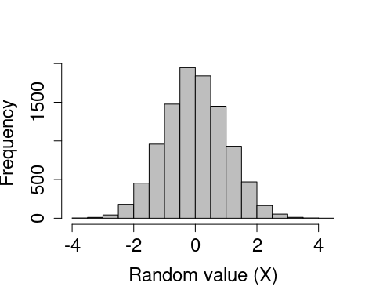

**Sampling from a uniform distribution**

Like the rnorm function, the runif function returns some number (n) of random numbers, but from a [uniform distribution](https://en.wikipedia.org/wiki/Uniform_distribution_(continuous)) with a range from (min) to (max) such that , where . The default is to draw from a standard uniform distribution (i.e., and ).

rand_unifs_10 <- runif(n = 10, min = 0, max = 1);

The above code stores a vector of ten numbers, shown below.

## [1] 0.7101657 0.8140436 0.8575069 0.0966789 0.6921411 0.9077216 0.1693771  
## [8] 0.7197693 0.1450784 0.5646749

As with the randomly generated normally distributed numbers, we can verify that a standard uniform distribution is generated by plotting a histogram of a very large number of values created using runif.

rand_unifs_10000 <- runif(n = 10000, min = 0, max = 1);  
hist(rand_unifs_10000, xlab = "Random value (X)", col = "grey",  
 main = "", cex.lab = 1.5, cex.axis = 1.5);

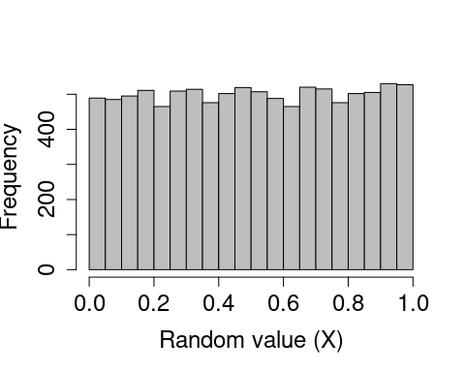

**Sampling from a binomial distribution**

Like previous functions, the rbinom function returns some number (n) of random numbers, but the arguments and output can be slightly confusing at first. Recall that a [binomial distribution](https://en.wikipedia.org/wiki/Binomial_distribution) describes the number of ‘successes’ for some number of independent trials (). The rbinom function returns the number of successes after size trials, in which the probability of success in each trial is prob. For a concrete example, suppose we want to simulate the flipping of a fair coin 1000 times, and we want to know how many times that coin comes up heads (‘success’). We can do this with the following code.

coin_flips <- rbinom(n = 1, size = 1000, prob = 0.5);  
print(coin_flips);

## [1] 484

The above result shows that the coin came up heads 484 times. Note, however, the (required) argument n above. This allows the user to set the number of sequences to run. In other words, if we set n = 2, then this could simulate the flipping of a fair coin 1000 times once to see how many times heads comes up, then repeating the whole process to see how many times heads comes up again (or, if it is more intuitive, the flipping of two separate fair coins 1000 times).

coin_flips_2 <- rbinom(n = 2, size = 1000, prob = 0.5);  
print(coin_flips_2);

## [1] 504 511

In the above, a fair coin was flipped 1000 times and returned 504 heads, and then another fair coin was flipped 1000 times and returned 511 heads. As with the rnorm and runif functions, we can check to see what the distribution of the binomial function looks like if we repeat this process. Suppose, in other words, that we want to see the distribution of times heads comes up after 1000 flips. We can, for example, simulate the process of flipping 1000 times in a row with 10000 different coins using the code below.

coin_flips_10000 <- rbinom(n = 10000, size = 1000, prob = 0.5);

I have not printed the above coin_flips_10000 for obvious reasons, but we can use a histogram to look at the results.

hist(coin_flips_10000, xlab = "Random value (X)", col = "grey",  
 main = "", cex.lab = 1.5, cex.axis = 1.5);

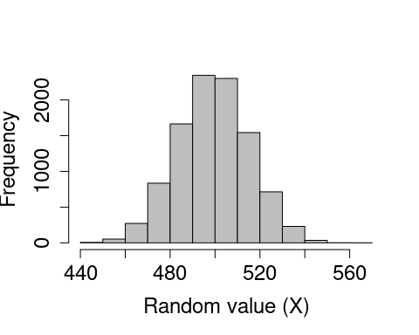

As would be expected, most of the time ‘heads’ occurs around 500 times out of 1000, but usually the actual number will be a bit lower or higher due to chance. Note that if we want to simulate the results of individual flips in a single trial, we can do so as follows.

flips_10 <- rbinom(n = 10, size = 1, prob = 0.5);

## [1] 0 1 1 1 1 1 0 0 1 1

In the above, there are n = 10 trials, but each trial consists of only a single coin flip (size = 1). But we can equally well interpret the results as a series of n coin flips that come up either heads (1) or tails (0). This latter interpretation can be especially useful to write code that randomly decides whether some event will happen (1) or not (0) with some probability prob.

**Sampling from a poisson distribution**

Many processes in biology can be described by a [Poisson distribution](https://en.wikipedia.org/wiki/Poisson_distribution). A Poisson process describes events happening with some given probability over an area of time or space such that , where the rate parameter is both the mean and variance of the Poisson distribution (note that by definition, ). Sampling from a Poisson distribution can be done in R with rpois, which takes only two arguments specifying the number of values to be returned (n) and the rate parameter (lambda).

rand_poissons <- rpois(n = 10, lambda = 1);  
print(rand_poissons);

## [1] 0 1 2 1 1 0 1 2 1 2

There are no default values for rpois. We can plot a histogram of a large number of values to see the distribution when below.

rand_poissons_10000 <- rpois(n = 10000, lambda = 4);  
hist(rand_poissons_10000, xlab = "Random value (X)", col = "grey",  
 main = "", cex.lab = 1.5, cex.axis = 1.5);

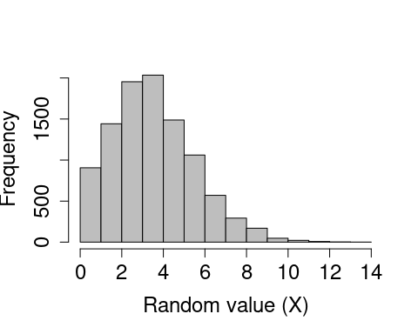

# Random sampling using sample

Sometimes it is useful to sample a set of values from a vector or list. The R function sample is very flexible for sampling a subset of numbers or elements from some structure (x) in R according to some set probabilities (prob). Elements can be sampled from x some number of times (size) with or without replacement (replace), though an error will be returned if the size of the sample is larger than x but replace = FALSE (default). To start out simple, suppose we want to ask R to pick a random number from one to ten with equal probability.

rand_number_1 <- sample(x = 1:10, size = 1);

The above code will set rand_number_1 to a randomly selected value, in this case 9. Because we have not specified a probability vector prob, the function assumes that every element in 1:10 is sampled with equal probability. We can increase the size of the sample to 10 below.

rand_number_10 <- sample(x = 1:10, size = 10);  
print(rand_number_10);

## [1] 1 6 10 9 7 8 5 4 3 2

Note that all numbers from 1 to 10 have been sampled, but in a random order. This is becaues the default is to sample with replacement, meaning that once a number has been sampled for the first element in rand_number_10, it is no longer available to be sampled again. To change this and allow for sampling with replacement, we can change the default.

rand_number_10_r <- sample(x = 1:10, size = 10, replace = TRUE);  
print(rand_number_10_r);

## [1] 3 9 7 9 2 5 3 1 5 8

Note that the numbers {3, 5, 9} are now repeated in the set of randomly sampled values above. We can also specify the probability of sampling each element, with the condition that these probabilities need to sum to 1. Below shows an example in which the numbers 1-5 are sampled with a probability of 0.05, while the numbers 6-10 are sampled with a probability of 0.15, thereby biasing sampling toward larger numbers.

prob_vec <- c( rep(x = 0.05, times = 5), rep(x = 0.15, times = 5) );  
rand_num_bias <- sample(x = 1:10, size = 10, replace = TRUE, prob = prob_vec);  
print(rand_num_bias);

## [1] 2 4 9 2 1 2 7 4 6 7

Note that rand_num_bias above contains more numbers from 6-10 than from 1-5.

# Simulating data with known correlations

# Simulating a full data set

# Conclusions