Adela Krylova [a.krylova@innopolis.university](mailto:a.krylova@innopolis.university)

Task2:

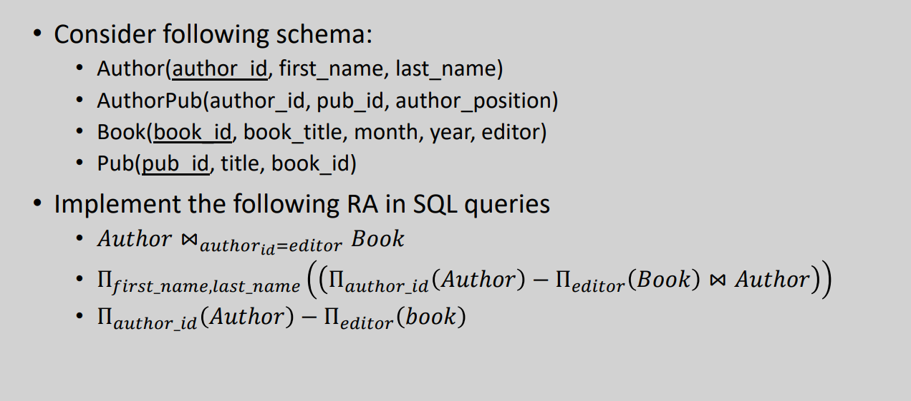

* SELECT *

FROM author, book

FULL OUTER JOIN author a

ON a.author_id = book.editor;

* SELECT author.last_name, author.first_name

FROM author, book

WHERE author.author_id != book.editor

* SELECT author.id

FROM author, book

WHERE author.author_id != book.editor

Task3:

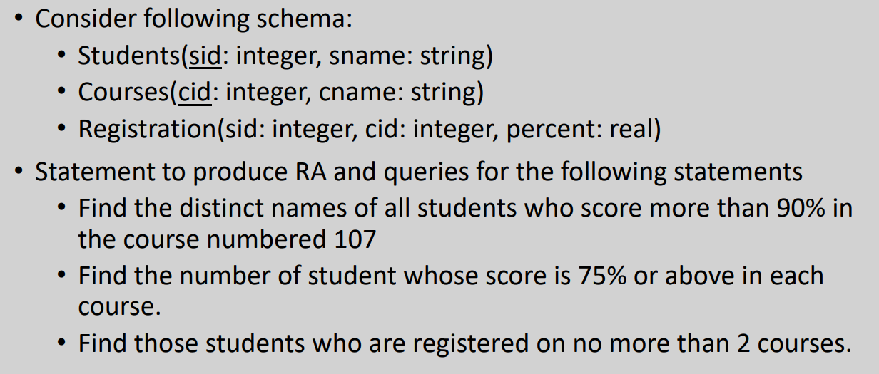

* SELECT DISTINCT Students.name

FROM Students, Registration

WHERE Registration.cid = 107 AND Registration.percent > 90 AND Student.sid = Registration.sid



* SELECT COUNT(DISTINCT Students)

FROM Students, Registration

WHERE Registration.percent > 75 AND Student.sid = Registration.sid

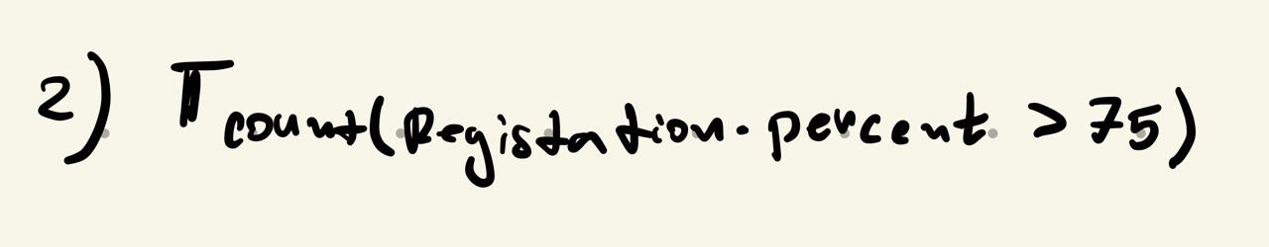

* SELECT *

FROM Students, Registration

WHERE COUNT(Registration.sid) <= 2 AND Studetns.sid = Registration.sid

