**Table of Content**

|  |  |
| --- | --- |
| **CHAPTER 1 INTRODUCTION** | **3-4** |
| 1.1 Project Overview | 3 |
| 1.2 Problem definition | 3 |
| 1.3 Proposed System | 4 |
| 1.4 Scope of work/project | 4 |
|  |  |
| **CHAPTER 2 LITERATURE SURVEY** | **5-6** |
| 2.1Presently available system | 5 |
| 2.2 Title/ Article | 5 |
| 2.3 Name of Author/ Name of web site/Book | 5-6 |
| 2.4 ISSN no. of Paper/Journal / Complete URL of website/ISBN No. of Book | 6 |
| 2.5 Conclusion: Include required facts, fig , Tables, Diagrams, and  Architecture etc. | 6 |
| **CHAPTER 3 ANALYSIS** | **7-9** |
| * 1. Requirement Analysis | 7 |
| 3.2 Use-Case Diagram | 7 |
| 3.3 Use-Case Description | 8 |
| 3.4 Sequence Diagram | 8 |
| 3.5 Activity Diagram | 9 |
| **CHAPTER 4 DESIGN** | **10-13** |
|  |  |
| 4.1 System Flow diagram | 10 |
| 4.2 Class Diagram | 11 |
| 4.3 Data Flow Diagram(DFD) | 12 |
| 4.4 Entity Relationship Diagram (ERD) | 13 |

|  |  |
| --- | --- |
| **CHAPTER 5 IMPLEMENTATION AND TESTING** | **14** |
| 5.1 Testing Strategies adapted | 14 |
| 5.2 System Testing | 14 |
|  |  |
| **CHAPTER 6 CONCLUSION AND FUTURE WORK** | **15-18** |
| References | 15 |
| Appendix A Software Requirement Specification (SRS) | 16 |
| Appendix B Screenshot | 17-18 |
|  |  |

**CHAPTER 1 INTRODUCTION**

**1.1 Project Overview**

In the real world the communication plays a very vital role. People have been communicating with each other through various applications or mediums. In the beginning people communicated with each other using letters or other sources, as these mediums could take much time to deliver the content.

Cell phones are another medium of communication but the drawback is for any limited or small message which need to be passed to another user then phone call is not an ideal way. The developers then looked to implement a text-based communication which would allow an in instant communication service. Instant messaging is an internet service that allows people to communicate with each other in real time through an instant messaging software. Unlike email, instant messaging allows messages from one person to appear right away on the other person’s mobile screen.

The main objective of Burble is to create a chat application which allow any types of users to chat and in any type of platform. Technologies used to make this application are Flutter, Dart and Firebase.

**1.2 Problem definition**

Communication through internet is becoming vital these days. An online communication allows the users to communicate with other people in a fast and convenient way. Today’s software are not that easy to understand for everyone specially for elderly people.

Burble is a messenger application that allows communication in a very simplified way. Simplicity of this app will let any type of user to use app without facing any difficulty.

**1.3 Proposed System**

This project is to create a chat application with a server and users to enable the users to chat with each other. To develop an instant messaging solution to enable users to seamlessly communicate with each other. The project should be very easy to use enabling even a novice person to use it.

**1.4 Scope of work/project**

Burble is an android based chat application which is very easy to use with simple user interface. A user can chat with any user by searching their email within the chat application.

**CHAPTER 2 LITERATURE SURVEY**

**2.1 Presently available system**

In the present available system, user can sign-in or login (if they have account) and they can chat with any user who has created account in the application.

All the user data will be stored in the firebase database which is configured with the project.

**2.2 Title/ Article**

Mobile Learning and Instant Messaging Development Over the years, mobile learning and instant messaging are one of the fastest growing technologies which are used by numerous individuals, companies and educational institutions.

Chatting is a feature or a program on the Internet to communicate directly with internet users who are online together. This communication can be in a form of text or voice.

Flutter is an opensource framework by Google for building beautiful, natively compiled, multi-platform applications from a single codebase.

Dart is a programming language designed for client development, such as for the web and mobile apps. It is developed by Google and can also be used to build server and desktop applications. It is an object-oriented, class-based, garbage-collected language with C-style syntax.

Firebase is BaaS (Backend as a Service) own by Google. Firebase offers solution to facilitate Mobile Apps Developer job. With Firebase, apps developer can focus to develop an application without worrying about backend issues.

**2.3 Name of Author/ Name of web site/Book**

1. Flutter
2. Pub.dev
3. Dart
4. Firebase

**2.4 ISSN no. of Paper/Journal / Complete URL of website/ISBN No. of Book**

<https://flutter.dev/>

<https://pub.dev/>

<https://dart.dev/>

<https://firebase.google.com/>

**2.5 Conclusion: Include required facts, fig , Tables, Diagrams, and Architecture etc.**

The above mentioned websites are very helpful in creating projects using flutter and firebase. It has proper documentation for everything so that anyone can go through it, learn and create projects from it.

**CHAPTER 3 ANALYSIS**

**3.1Requirement Analysis**

Hardware requirement for the project are Monitor, Keyboard and Mouse.

A system must have Flutter , Android toolchain - develop for Android devices (Android SDK version 32.1.0-rc1), Chrome - develop for the web,

Visual Studio - develop for Windows (Visual Studio Community 2022 17.3.2), Android Studio (version 2021.1), VS Code (version 1.73.1), Connected device and good internet connection.

**3.2 Use-Case Diagram**

**3.3 Use-Case Description**

A use case diagram captures the functional aspects of a system. A use case is a set of scenarios that describes an interaction between a user and a system. A use case diagram displays the relationship among actors and use cases. Use cases are used during the analysis phases of a project to identify and partition system functionality.

Actors represent roles that can are played by users of the system. Those users can be humans, other computers, pieces of hardware or even other software systems. The only criterion is that must be external to the part of the system being partitioned into use cases.

**3.4 Sequence Diagram**

A sequence diagram shows object interactions arranged in time sequence. It depicts the objects and classes involved in the scenario and the sequence of messages exchanged between the objects needed to carry out the functionality of the scenario.

Mobile Device

User

Database

Select Chat

Select friend

Type message and submit

Send user message

Add user Message in DB

Message is Sent Message is added

**3.5 Activity Diagram**

Activity diagram is basically a flow chart to represent the flow from one activity to another activity. The activity can be described as an operation of the system.

So the control flow is drawn from one operation to another. This flow can be sequential, branched or concurrent. Activity diagrams deals with all type of flow control by using different elements like fork, join etc.

**CHAPTER 4 DESIGN**

**4.1 System Flow diagram**

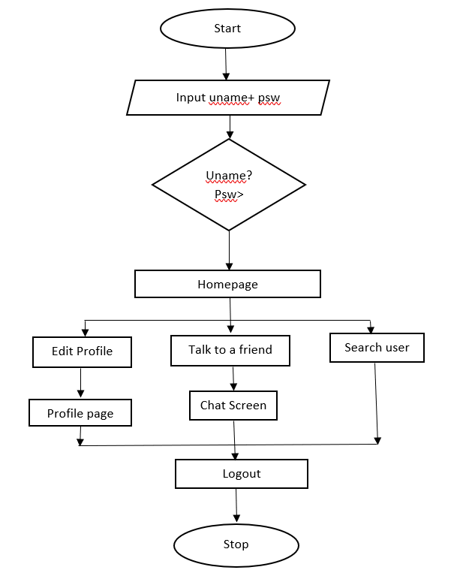

**4.2 Class Diagram**

Log In/ Sign In

User

Name,

Email,

Password,

Phone Number

Sign In(),

Log In()

Chat Screen

Send Text.

Send Image

Logout

**4.3 Data Flow Diagram (DFD)**

User

Services

Sign- Up

0 Level DFD

Home Page

1 Level DFD

**4.4 Entity Relationship Diagram (ERD)**

User

Successful login

Search

Homepage

Registration

Sign In

Login

**CHAPTER 5 IMPLEMENTATION AND TESTING**

**5.1 Testing Strategies adapted**

Structural testing is the strategy which is used in the project. It is one the techniques under unit testing.

* It is also called white-box testing because they are run by testers with thorough knowledge of the devices and systems it is functioning on.
* It is often run on individual components and interfaces to identify localized errors in data flows.

A good example would be using reusable, automated test harnesses for the tested system. With this harness in place, coders can create structural test cases for components right after they have written the code for each component. Then, they register the tests into the source code repository and the main component during integration.

**5.2 System Testing**

**System Testing** is a level of testing that validates the complete and fully integrated software product. The purpose of a system test is to evaluate the end-to-end system specifications. Usually, the software is only one element of a larger computer-based system. Ultimately, the software is interfaced with other software/hardware systems. System Testing is defined as a series of different tests whose sole purpose is to exercise the full computer-based system.

**CHAPTER 6 CONCLUSION AND FUTURE WORK**

The chat app provides a better and more flexible chat system. Developed with the latest technology in the way of providing a reliable system. The main advantage of the system is instant messaging, real-world communication, added security, simplicity etc.

References

1. [https://flutter.dev/](https://flutter.dev/%20)
2. [https://dart.dev/](https://dart.dev/%20)
3. <https://www.youtube.com/>

**Appendix A Software Requirement Specification (SRS)**

Flutter:- Flutter is an open-source UI software development kit created by Google. It is used to develop cross-platform applications for Android, iOS, Linux, macOS, Windows, Google Fuchsia, and the web from a single codebase. First described in 2015, Flutter was released in May 2017.

Chrome:- Google Chrome is a cross-platform web browser developed by Google. It was first released in 2008 for Microsoft Windows, built with free software components from Apple WebKit and Mozilla Firefox. Versions were later released for Linux, macOS, iOS, and also for Android, where it is the default browser.

Visual Studio:- Visual Studio is an integrated development environment from Microsoft. It is used to develop computer programs including websites, web apps, web services and mobile apps.

Visual Studio Code:- Visual Studio Code, also commonly referred to as VS Code, is a source-code editor made by Microsoft with the Electron Framework, for Windows, Linux and macOS. Features include support for debugging, syntax highlighting, intelligent code completion, snippets, code refactoring, and embedded Git.

Android Studio:- Android Studio is the official integrated development environment for Google's Android operating system, built on JetBrains' IntelliJ IDEA software and designed specifically for Android development. It is available for download on Windows, macOS and Linux based operating systems.

**Appendix B Screenshots**



