Day 1
Experimental works:
1. What happens to your RTL code between the moment you write it and the moment it becomes transistors on a chip?
Ans: From writing RTL code to make a physical silicon chip process is known as the RTL-to-GDSII flow.
(i)Logic Synthesis: From Code to Gates:
A compiler named “Synthesis” turns this code into Gate level netlist, it searches for the always block and if-else statement and turns them into boolean logic and turns them into AND OR NOT gates.
(ii)Design for Testability (DFT):
Before laying out the chip physically engineers try to understand if there’s any defect in the chip
(iii)Floorplanning and Power Planning:
This where the physical design begins ,
(iv) Placement:
With floorplanning an automated tools places all the millions of cells into designated rows. The goal here is to place cells that communicate frequently close to each other to minimize wire length, reducing delay and power consumption. At this stage, the cells are placed, but not yet wired together.
(v) Clock Tree Synthesis (CTS):
A synchronous chip relies on a clock signal arriving at every sequential element (like a flip-flop) at the exact same time
(vi) Routing:
Once the clock tree is built, the tool must connect all the remaining signal pins according to the gate-level netlist.

(vii) Physical and Timing Signoff
Before sending the design to the foundry, it must pass rigorous verification to ensure it will work in reality

Find one example of a simple module in SystemVerilog online or from your study materials. Annotate every line — what each keyword does, what each signal represents.

module shift_register (
input logic clk,
input logic rst_n,
input logic serial_in,
output logic [3:0] parallel_out
);

always_ff @(posedge clk or negedge rst_n) begin
if (!rst_n) begin
parallel_out <= 4'b0000;
end else begin
parallel_out <= {parallel_out[2:0], serial_in};
end
end

endmodule
module: The fundamental keyword that declares a new hardware block. It tells the synthesizer, "I am starting the blueprint for a physical circuit."
shift_register: The arbitrary name given to this specific module.
“(“: Opens the port declaration list (the physical pins of the chip).
input logic clk,
input: Defines this pin as receiving a signal from the outside world.
logic: The modern SystemVerilog data type representing a single bit (1 or 0).
clk: The name of the signal. This will act as the master heartbeat for the flip-flops.
input logic rst_n,
rst_n: The reset signal. The _n is a standard naming convention meaning "active-low" (it resets the circuit when the signal hits 0, not 1).
input logic serial_in,
serial_in: The single data bit entering the shift register on each clock cycle.
output logic [3:0] parallel_out
output: Defines this pin as sending data out to the rest of the system.
[3:0]: A vector declaration. It means this output is a 4-bit wide bus, numbered from bit 3 (Most Significant Bit) down to bit 0 (Least Significant Bit).
parallel_out: The name of the output bus
);
Closes the port list and ends the module header.
always_ff @(posedge clk or negedge rst_n) begin
always_ff: A procedural block keyword specifically telling the compiler to physically build D-Flip-Flops (sequential memory).
@(...): The sensitivity list. It defines the exact physical events that will cause the flip-flops to capture new data.
posedge clk: "Positive edge". The block triggers at the exact moment the clock transitions from 0 to 1.
or negedge rst_n: "Negative edge". The block also triggers immediately if the reset pin drops from 1 to 0 (creating an asynchronous reset).
begin: Opens the block of logic
if (!rst_n) begin
if: A standard conditional statement.
!: Logical NOT. If rst_n is 0, !rst_n evaluates to True (1). This ensures the reset logic executes when the pin is pulled low.
parallel_out <= 4'b0000;
parallel_out: The 4-bit output bus we are driving.
<=: The non-blocking assignment operator. It is strictly used in sequential (always_ff) blocks to ensure all flip-flops update at the exact same physical instant.
4'b0000: A literal number. 4 means it is four bits wide. 'b means the following numbers are binary. 0000 are the values. This clears the register.

end else begin
end: Closes the reset if block.
else begin: If the reset is not active, execute standard operating logic on the clock edge.
parallel_out <= {parallel_out[2:0], serial_in};
{ ... }: The concatenation operator. It physically wires signals together side-by-side.
parallel_out[2:0]: A part-select. It takes the bottom 3 bits of the current state of the register.
,: Appends the next signal.
serial_in: The new incoming bit.
Hardware translation: This single line shifts the existing data to the left by one position (dropping the old bit 3) and attaches the new serial_in bit at the very bottom (bit 0).
end
Closes the else block.
end
Closes the always_ff procedural block.
endmodule
endmodule: The keyword that closes the module boundary. No code belonging to this circuit can exist past this point.
Write a minimal SV module by hand (no simulator yet): a 2-input AND gate with a, b inputs and y output using assign. Annotate it fully.
module and_gate (
input logic a,
input logic b,
output logic y
);

assign y = a & b;

endmodule

Line-by-Line Annotation
module and_gate (
- module: The fundamental keyword that tells the synthesizer you are defining a self-contained hardware block.
- and_gate: The name of this specific hardware block.
- (: Opens the port declaration list, defining the physical pins that connect this gate to the outside world.
input logic a,
- input: Defines the direction of the pin. The signal is flowing into the module and cannot be driven from the inside.
- logic: The standard SystemVerilog data type representing a single wire or state (capable of holding 1, 0, X, or Z).
- a: The name of the first input pin.
input logic b,
- b: The name of the second input pin, matching the data type and direction of a.
output logic y
- output: Defines this pin as driving a signal out of the module.
- y: The name of the output pin. Notice there is no comma at the end of this line, as it is the final port in the list.
);
- Closes the port list and completes the module header.
assign y = a & b;
- assign: Creates a continuous assignment. It tells the synthesizer to hardwire the right side of the equation to the left side. It runs concurrently and permanently; the moment a or b changes, y updates instantly.
- y: The output wire we are driving.
- =: The blocking assignment operator, standard for continuous assign statements.
- a & b: The bitwise AND operator (&). It instructs the synthesis tool to physically build an AND gate connected to the a and b input nets.
- ;: Ends the structural statement.
endmodule
- endmodule: Closes the module definition. No logic for this specific hardware block can exist beyond this keyword.
Write out the difference between wire and logic in your own words. When would you use each?
A wire is basically a connecting which connects one rod to another , whereas a logic is a signal carrying 1 or 0
List five things that are valid in simulation but would not synthesise. Explain why for each.
Here are five common constructs that are perfectly valid in a simulation testbench but will fail to synthesize.

1. Hardcoded Time Delays (#)
Example: assign #10 y = a & b; or #5 clk = ~clk;

2. System Printing and File I/O Tasks
Example: $display("The value is %b", my_sig); or $readmemh("data.txt", mem);

3. Case Equality Operators (=== and !==)
Example: if (signal === 1'bX) begin ... end

4. Loops with Variable/Dynamic Bounds
Example: ```systemverilog for (int i = 0; i < dynamic_counter; i++) begin result[i] = a[i] & b[i]; end
All of the above are used for simulation to ensure and test if the block is operating correctly or not. So, it cant be turned into a physical layout of any sort.

DAY-2

Overlapping "1011" sequence detector
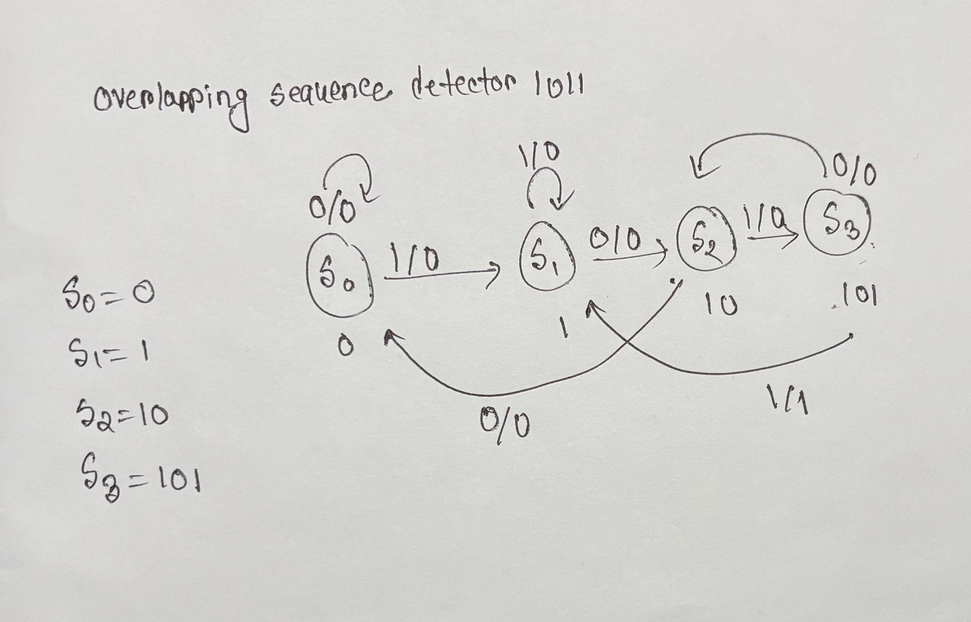
- S0: no bits of the pattern matched yet (reset)
- S1: matched 1
- S2: matched 10
- S3: matched 101States: S0 = matched nothing, S1 = matched 1, S2 = matched 10, S3 = matched 101. Output = 1 only on the S3 → S1 edge , which is the cycle the full pattern 1011 completes — and it lands back on S1, not S0, because the last digit of 1011 is also the first digit of the pattern, so that single 1 is still a valid partial match going forward which makes it overlapping.

Part 2 — Transition table
Current State | Input (din) | Next State | Output (detected)
S0 | 0 | S0 | 0
S0 | 1 | S1 | 0
S1 | 0 | S2 | 0
S1 | 1 | S1 | 0
S2 | 0 | S0 | 0
S2 | 1 | S3 | 0
S3 | 0 | S2 | 0
S3 | 1 | S1 | 1

Part 3 — Hand trace of 1 1 0 1 0 1 1
Start in S0:
Step | Input | Current State | Next State | Output
1 | 1 | S0 | S1 | 0
2 | 1 | S1 | S1 | 0
3 | 0 | S1 | S2 | 0
4 | 1 | S2 | S3 | 0
5 | 0 | S3 | S2 | 0
6 | 1 | S2 | S3 | 0
7 | 1 | S3 | S1 | 1
Only the last input produces output = 1. Sanity check: the last four bits of the stream are 1,0,1,1 — exactly the pattern — so a detection firing on step 7 is correct, and no earlier detection should fire since no other 4-bit window in 1101011 matches 1011.

Part 4 — Traffic light transition table (no timers)
Current State | Next State | Main Light | Side Light
MAIN_GREEN | MAIN_YELLOW | Green | Red
MAIN_YELLOW | SIDE_GREEN | Yellow | Red
SIDE_GREEN | SIDE_YELLOW | Red | Green
SIDE_YELLOW | MAIN_GREEN | Red | Yellow

Part 5 — Moore vs Mealy
A Moore Machine’s output depends only in the current state whereas for Meely Machines the output depends on both the current input and the current state. So for these behavior I would like to choose moore for Traffic Light control system where the current state matters most and for sequence detector I would choose meely.

DAY-3
Write a one-page explanation of why verification is a separate job from RTL design. What does a DV engineer do that a designer does not?

In the semiconductor industry, RTL Design and Design Verification (DV) are completely separate career tracks.
A designer’s job is to build. They are hyper-focused on how to map a specification into physical gates while minimizing power, maximizing speed, and saving silicon area (PPA). Because they built the logic, they naturally test it to see if it works.
A verification engineer’s job is to destroy. Their goal is to find the breaking points, the overlapping corner cases, and the impossible states.

What a DV Engineer Does
- Writes Software, Not Hardware: While designers write structural RTL, DV engineers write complex, Object-Oriented software using SystemVerilog classes and UVM .
- Builds Coverage Models: DV engineers define the mathematical goalposts (coverpoints and crosses) to prove that the state space has been adequately explored.
- Develops Golden Models: DV engineers often write C++ or high-level SystemVerilog algorithms (predictors) that mimic the hardware to serve as the absolute source of truth for the scoreboard.
- Wrangles Randomization: Instead of deciding exactly what 1s and 0s to drive, DV engineers write complex mathematical constraints and let solver algorithms generate millions of randomized tests.
Draw the anatomy of a testbench — a block diagram with DUT in the centre and all testbench components around it, with arrows showing data/signal flow.
Below is the standard architecture of a modern verification environment.
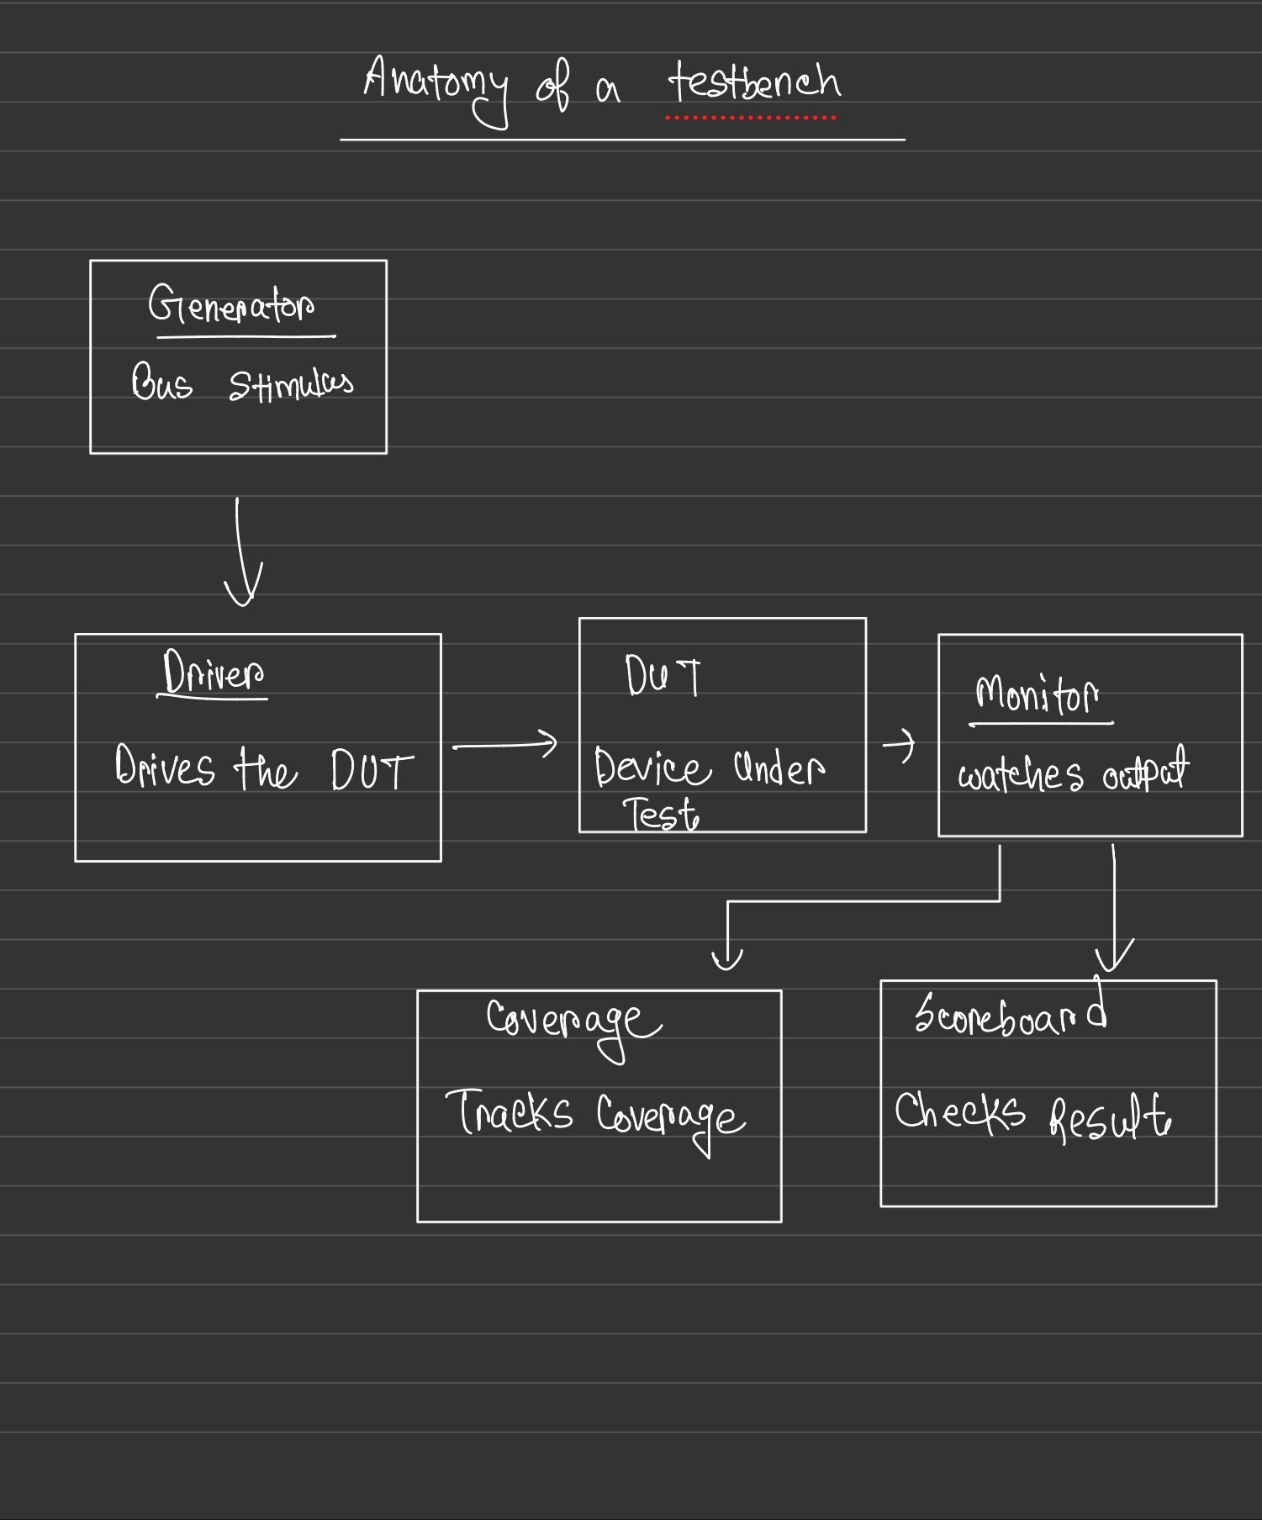

Look at the FIFO you will design next week. List 5 features of that FIFO that need to be verified. For each, write one sentence describing what a test for that feature would do.

- Full Flag Assertion
  - Test: Write data continuously into the FIFO without asserting a read command, and verify that the full flag goes HIGH on the exact cycle the final memory slot is filled.
- Empty Flag Assertion
  - Test: Fill the FIFO, then read data continuously without asserting a write command, and verify that the empty flag goes HIGH on the exact cycle the final word is extracted.
- Simultaneous Read and Write (Throughput)
  - Test: When the FIFO is partially full, assert both the read and write enable pins on the exact same clock cycle, and verify that both the read and write pointers increment correctly without corrupting the stored data.
- Over-Write Protection (Overflow)
  - Test: Force the FIFO into a full state, attempt to write another word of data into it, and verify that the new data is ignored and the existing data is not overwritten.
- Pointer Wraparound (Rollover)
  - Test: Perform a continuous, alternating sequence of reads and writes that vastly exceeds the physical depth of the FIFO to verify that the internal memory pointers correctly reset to address 0 without glitching.
Write 3 assertions in plain English (not code) for the sequence detector you studied in Day 2. Example: "detected must never be HIGH for two consecutive
cycles."
Assertions act as internal alarms. Here are three strict rules the 1011 overlapping sequence detector must obey at all times:
- "The detected output must never be HIGH for two consecutive clock cycles, because a valid overlapping sequence requires at least one '0' and three clock cycles to complete a new target."
- "If the active-low reset pin is pulled to 0, the detected output must immediately evaluate to 0 and the internal state must instantly revert to the IDLE condition."
- "If the FSM is currently in the initial IDLE state and a '0' is received on the input pin, the FSM must remain in the IDLE state on the following clock cycle."
Research: what is the difference between a scoreboard and a monitor? Write the answer in your own words with a concrete example.

While both components observe data in the testbench, they serve entirely different purposes.
The Monitor is a reporter. It sits passively on the interface wires and watches the electrical signals (the 1s and 0s) wiggling over time. Its only job is to translate those physical signals back into an abstract software packet (a "transaction") and broadcast it to the rest of the testbench. It does not know if the data is correct; it just reports exactly what it saw.
The Scoreboard is the judge. It receives the packets broadcasted by the monitor. It calculates what the output should be (using a golden reference model) and compares it against what the monitor actually saw coming out of the DUT. If they match, it logs a pass. If they differ, it crashes the simulation and flags a bug.
Concrete Example:
Imagine testing an Arithmetic Logic Unit (ALU).
- The Monitor watches the pins and sees Input_A = 5, Input_B = 3, Op = ADD. It packages this up. Later, it watches the output pins and sees Result = 9. It packages that up and sends both to the Scoreboard.
- The Scoreboard receives the inputs (5, 3, ADD), uses its own internal software math to calculate that the expected answer is 8. It then looks at the Monitor's output report (9), realizes they do not match, and throws a fatal error because the RTL failed to add properly.

DAY-4
Write the mini-spec first: ports (clk, rst_n, din, detected), states (IDLE, S1, S10, S101), and the full transition table for overlapping 1011.
- clk: System clock (Input)
- rst_n: Asynchronous active-low reset (Input)
- din: Serial data stream (Input)
- detected: High for one cycle when sequence is found (Output)
States
- IDLE: Initial state
- S1: Detected "1"
- S10: Detected "10"
- S101: Detected "101"
- S1011: Detected "1011" (Target State)
State Transition Table (Overlapping)
Current State | Input (din) | Next State | Output (detected)
IDLE | 0 | IDLE | 0
IDLE | 1 | S1 | 0
S1 | 0 | S10 | 0
S1 | 1 | S1 | 0
S10 | 0 | IDLE | 0
S10 | 1 | S101 | 0
S101 | 0 | S10 | 0
S101 | 1 | S1011 | 0
S1011 | 0 | S10 | 1
S1011 | 1 | S1 | 1

Implement rtl/seq_detect_1011.sv as a clean two-block Moore FSM.

Code snippet
module seq_detect_1011 (
input logic clk,
input logic rst_n,
input logic din,
output logic detected
);

typedef enum logic [2:0] {
IDLE = 3'b000,
S1 = 3'b001,
S10 = 3'b010,
S101 = 3'b011,
S1011 = 3'b100
} state_t;

state_t current_state, next_state;

// Block 1: State Register (Memory)
always_ff @(posedge clk or negedge rst_n) begin
if (!rst_n) begin
current_state <= IDLE;
end else begin
current_state <= next_state;
end
end

// Block 2: Next-State and Output Logic (Combinational)
always_comb begin
// Default assignments to prevent latches
next_state = current_state;
detected = 1'b0;

case (current_state)
IDLE: begin
if (din == 1'b1) next_state = S1;
end
S1: begin
if (din == 1'b0) next_state = S10;
else next_state = S1;
end
S10: begin
if (din == 1'b1) next_state = S101;
else next_state = IDLE;
end
S101: begin
if (din == 1'b1) next_state = S1011;
else next_state = S10;
end
S1011: begin
detected = 1'b1;
if (din == 1'b1) next_state = S1;
else next_state = S10;
end
default: begin
next_state = IDLE;
end
endcase
end
endmodule

Hand-trace the input 1 1 0 1 0 1 1 through your RTL logic before simulating. Predict exactly which cycle detected goes HIGH.
Input Sequence: 1 1 0 1 0 1 1

Clock Cycle | Input (din) applied | Current State | Next State Evaluated | Output (detected)
0 (Reset) | 0 | IDLE | IDLE | 0
1 | 1 | IDLE | S1 | 0
2 | 1 | S1 | S1 | 0
3 | 0 | S1 | S10 | 0
4 | 1 | S10 | S101 | 0
5 | 0 | S101 | S10 | 0
6 | 1 | S10 | S101 | 0
7 | 1 | S101 | S1011 | 0
8 | X | S1011 | (Depends on next input) | 1

Write a smoke testbench. Drive the stream 1 1 0 1 0 1 1, print din / state / detected each cycle.

module smoke_tb;

logic clk, rst_n, din, detected;

// Instantiate DUT
seq_detect_1011 dut (
.clk(clk),
.rst_n(rst_n),
.din(din),
.detected(detected)
);

// Clock generation (10 time units per cycle)
initial begin
clk = 0;
forever #5 clk = ~clk;
end

// Monitor testbench signals (Inputs and Output)
initial begin
$monitor("Time=%0t, rst_n=%b, din=%b, detected=%b", $time, rst_n, din, detected);
end

// Stimulus
initial begin
// Initialize and Reset
din = 0;
rst_n = 0;
#15; // Hold reset
rst_n = 1;

// Drive sequence: 1 1 0 1 0 1 1
// Driving inputs on the negative edge avoids setup/hold race conditions
@(negedge clk) din = 1; // Cycle 1
@(negedge clk) din = 1; // Cycle 2
@(negedge clk) din = 0; // Cycle 3
@(negedge clk) din = 1; // Cycle 4
@(negedge clk) din = 0; // Cycle 5
@(negedge clk) din = 1; // Cycle 6
@(negedge clk) din = 1; // Cycle 7

// Wait for Moore output to register
@(negedge clk); // Cycle 8 (Prediction: detected = 1)
@(negedge clk) din = 0;

#20 $finish;
end

endmodule

5. Execution & Issue Log
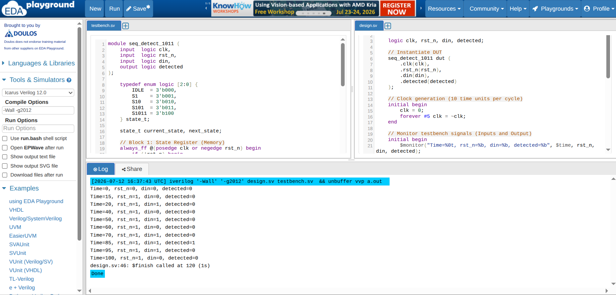
Issue Log:
ID | Issue Description | Root Cause | Resolution
01 | Testbench race conditions when applying stimulus. | Driving din simultaneously on posedge clk can cause the simulator to sample the old or new value unpredictably. | Shifted the stimulus injection to negedge clk in the testbench. This guarantees the input is stable and properly set up before the DUT's posedge clk evaluation.

Day -5
Define states: MAIN_GREEN, MAIN_YELLOW, SIDE_GREEN, SIDE_YELLOW. Define durations as parameters (use small values like 4, 2, 6, 2 for simulation).

// Defining the states
typedef enum logic [1:0] {
MAIN_GREEN = 2'b00,
MAIN_YELLOW = 2'b01,
SIDE_GREEN = 2'b10,
SIDE_YELLOW = 2'b11
} state_t;

// 2. Declare state variables using the new type
state_t current_state, next_state;

// 3. Define duration parameters (in clock cycles for simulation)
parameter int T_MAIN_GREEN = 4;
parameter int T_MAIN_YELLOW = 2;
parameter int T_SIDE_GREEN = 6;
parameter int T_SIDE_YELLOW = 2;

Build a state + duration table: State | Duration (cycles) | main_road lights | side_road lights.

State | Duration (cycles) | main_road lights | side_road lights
MAIN_GREEN | 4 | Green (3'b001) | Red (3'b100)
MAIN_YELLOW | 2 | Yellow (3'b010) | Red (3'b100)
SIDE_GREEN | 6 | Red (3'b100) | Green (3'b001)
SIDE_YELLOW | 2 | Red (3'b100) | Yellow (3'b010)

Implement rtl/traffic_light.sv: state register + down-counter in one always_ff; next-state logic in always_comb.

module traffic_light #(
parameter int T_MAIN_GREEN = 4,
parameter int T_MAIN_YELLOW = 2,
parameter int T_SIDE_GREEN = 6,
parameter int T_SIDE_YELLOW = 2
)(
input logic clk,
input logic rst_n,

// Six individual light outputs
output logic main_red,
output logic main_yellow,
output logic main_green,
output logic side_red,
output logic side_yellow,
output logic side_green
);

// FSM State Encoding
typedef enum logic [1:0] {
MAIN_GREEN = 2'b00,
MAIN_YELLOW = 2'b01,
SIDE_GREEN = 2'b10,
SIDE_YELLOW = 2'b11
} state_t;

state_t state, next_state;
logic [7:0] counter;

// ---------------------------------------------------------
// 1. Output Logic (Continuous Assignments)
// ---------------------------------------------------------
// A light is ON (1) only when the condition is true.
// Otherwise, it is forced to OFF (0).

assign main_green = (state == MAIN_GREEN);
assign main_yellow = (state == MAIN_YELLOW);
assign main_red = (state == SIDE_GREEN) || (state == SIDE_YELLOW);

assign side_green = (state == SIDE_GREEN);
assign side_yellow = (state == SIDE_YELLOW);
assign side_red = (state == MAIN_GREEN) || (state == MAIN_YELLOW);

// ---------------------------------------------------------
// 2. Next-State Logic (Combinational)
// ---------------------------------------------------------
always_comb begin
// Default assignment for next_state
next_state = state;

case (state)
MAIN_GREEN: next_state = MAIN_YELLOW;
MAIN_YELLOW: next_state = SIDE_GREEN;
SIDE_GREEN: next_state = SIDE_YELLOW;
SIDE_YELLOW: next_state = MAIN_GREEN;
endcase
end

// ---------------------------------------------------------
// 3. State Register and Down-Counter (Sequential)
// ---------------------------------------------------------
always_ff @(posedge clk or negedge rst_n) begin
if (!rst_n) begin
state <= MAIN_GREEN;
counter <= T_MAIN_GREEN - 1;
end else begin
if (counter == 0) begin
state <= next_state;

case (next_state)
MAIN_GREEN: counter <= T_MAIN_GREEN - 1;
MAIN_YELLOW: counter <= T_MAIN_YELLOW - 1;
SIDE_GREEN: counter <= T_SIDE_GREEN - 1;
SIDE_YELLOW: counter <= T_SIDE_YELLOW - 1;
endcase
end else begin
counter <= counter - 1;
end
end
end

endmodule
Smoke test with the small durations. Print state name and all 6 light outputs each cycle.

Testbench:
module tb_traffic_light;

// 1. Declare Testbench Signals
logic clk;
logic rst_n;
logic main_red, main_yellow, main_green;
logic side_red, side_yellow, side_green;

// 2. Instantiate the Device Under Test (DUT)
// Overriding parameters here with the small smoke-test values
traffic_light #(
.T_MAIN_GREEN(4),
.T_MAIN_YELLOW(2),
.T_SIDE_GREEN(6),
.T_SIDE_YELLOW(2)
) dut (
.clk(clk),
.rst_n(rst_n),
.main_red(main_red),
.main_yellow(main_yellow),
.main_green(main_green),
.side_red(side_red),
.side_yellow(side_yellow),
.side_green(side_green)
);

// 3. Clock Generation (10 time units period)
initial begin
clk = 0;
forever #5 clk = ~clk;
end

// 4. Stimulus and Simulation Control
initial begin
// Apply Reset
rst_n = 0;
#12; // Hold reset low for a little over one clock cycle
rst_n = 1; // Release reset

// Wait enough time to see one full loop of the FSM
// Total cycle time = 4 + 2 + 6 + 2 = 14 cycles.
// 14 cycles * 10 time units = 140 time units. Run for 160 to see it loop back.
#160;

$display("Smoke test complete.");
$finish;
end

// 5. Cycle-by-Cycle Monitor
// Trigger on negedge to read stable values after the posedge FSM updates
always @(negedge clk) begin
if (rst_n) begin
$display("Time: %3t | State: %11s | Main (R Y G): %b %b %b | Side (R Y G): %b %b %b",
$time,
dut.state.name(), // Grabs the enum string name from inside the DUT
main_red, main_yellow, main_green,
side_red, side_yellow, side_green);
end
end

endmodule

Result:

Time: 20 | State: MAIN_GREEN | Main (R Y G): 0 0 1 | Side (R Y G): 1 0 0
Time: 30 | State: MAIN_GREEN | Main (R Y G): 0 0 1 | Side (R Y G): 1 0 0
Time: 40 | State: MAIN_GREEN | Main (R Y G): 0 0 1 | Side (R Y G): 1 0 0
Time: 50 | State: MAIN_YELLOW | Main (R Y G): 0 1 0 | Side (R Y G): 1 0 0
Time: 60 | State: MAIN_YELLOW | Main (R Y G): 0 1 0 | Side (R Y G): 1 0 0
Time: 70 | State: SIDE_GREEN | Main (R Y G): 1 0 0 | Side (R Y G): 0 0 1
Time: 80 | State: SIDE_GREEN | Main (R Y G): 1 0 0 | Side (R Y G): 0 0 1
Time: 90 | State: SIDE_GREEN | Main (R Y G): 1 0 0 | Side (R Y G): 0 0 1
Time: 100 | State: SIDE_GREEN | Main (R Y G): 1 0 0 | Side (R Y G): 0 0 1
Time: 110 | State: SIDE_GREEN | Main (R Y G): 1 0 0 | Side (R Y G): 0 0 1
Time: 120 | State: SIDE_GREEN | Main (R Y G): 1 0 0 | Side (R Y G): 0 0 1
Time: 130 | State: SIDE_YELLOW | Main (R Y G): 1 0 0 | Side (R Y G): 0 1 0
Time: 140 | State: SIDE_YELLOW | Main (R Y G): 1 0 0 | Side (R Y G): 0 1 0
Time: 150 | State: MAIN_GREEN | Main (R Y G): 0 0 1 | Side (R Y G): 1 0 0
Time: 160 | State: MAIN_GREEN | Main (R Y G): 0 0 1 | Side (R Y G): 1 0 0
Time: 170 | State: MAIN_GREEN | Main (R Y G): 0 0 1 | Side (R Y G): 1 0 0
Smoke test complete.
design.sv:46: $finish called at 172 (1s)
Done

Verify the full cycle runs correctly: MAIN_GREEN → MAIN_YELLOW → SIDE_GREEN → SIDE_YELLOW → MAIN_GREEN.
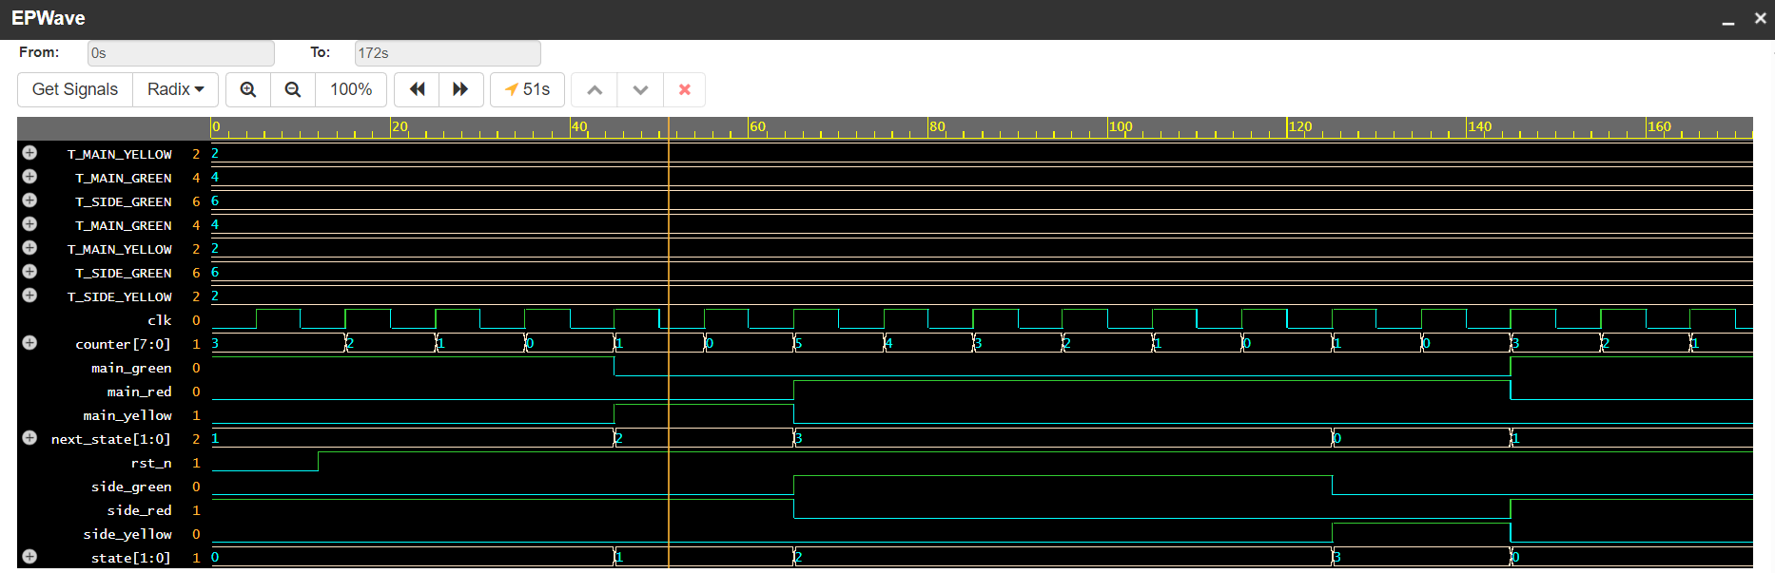
From the above waveform we can tell the cycle runs correctly

Day 6
Define ports: clk, rst_n, wr_en, rd_en, din [WIDTH-1:0], dout [WIDTH-1:0], full, empty. Parameters: WIDTH=8, DEPTH=8.

Port & Parameter Breakdown
Parameters:
- WIDTH = 8: Defines the size of each data word in the FIFO
- DEPTH = 8: Defines how many individual words the FIFO can store before it becomes completely full.
Control & Clocking:
- clk: The system clock. Both read and write operations are synchronized to the positive edge of this clock.
- rst_n: Active-low asynchronous reset to clear the FIFO pointers and status flags.

Write Interface:
- wr_en: Write Enable. When high during a clock edge, the FIFO captures the data on din if it’s not full.
- din: Data In. The bus carrying the information to be written into the memory array.
- full: Status flag indicating the FIFO has reached its maximum DEPTH. When high, further writes should be blocked to prevent overwriting unread data.
Read Interface:
- rd_en: Read Enable. When high during a clock edge, the FIFO outputs the next available data word on dout and advances its read pointer.
- dout: Data Out. The bus carrying the data read from the memory array.
- empty: Status flag indicating there is no unread data left in the FIFO. When high, further reads should be blocked to prevent reading invalid or old data.
Implement rtl/sync_fifo.sv: memory array, wr_ptr, rd_ptr, count all in one always_ff block. Derive full and empty combinationally from count.

module sync_fifo #(
parameter int WIDTH = 8,
parameter int DEPTH = 8
)(
input logic clk,
input logic rst_n,

// Write Interface
input logic wr_en,
input logic [WIDTH-1:0] din,
output logic full,

// Read Interface
input logic rd_en,
output logic [WIDTH-1:0] dout,
output logic empty
);

// For a DEPTH of 8, pointers need to count from 0 to 7 (needs 3 bits).
logic [2:0] wr_ptr;
logic [2:0] rd_ptr;

// The counter needs to hold the number 8, so it needs 4 bits.
logic [3:0] count;

// The actual memory array (8 boxes, each 8 bits wide)
logic [WIDTH-1:0] mem [0:DEPTH-1];

// ---------------------------------------------------------
// 1. Combinational Status Flags
// ---------------------------------------------------------
// These constantly check the counter without waiting for a clock
assign full = (count == DEPTH);
assign empty = (count == 0);

// ---------------------------------------------------------
// 2. Sequential Logic (Everything happens on the clock tick)
// ---------------------------------------------------------
always_ff @(posedge clk or negedge rst_n) begin
// --- Reset Logic ---
if (!rst_n) begin
wr_ptr <= 0;
rd_ptr <= 0;
count <= 0;
dout <= 0;
end else begin

// --- Write Logic ---
// If told to write, and we actually have room...
if (wr_en && !full) begin
mem[wr_ptr] <= din; // Put data into the memory box
wr_ptr <= wr_ptr + 1; // Move write pointer to the next box
end

// --- Read Logic ---
// If told to read, and there is actually data to read...
if (rd_en && !empty) begin
dout <= mem[rd_ptr]; // Take data out of the memory box
rd_ptr <= rd_ptr + 1; // Move read pointer to the next box
end

// --- Counter Logic ---
// Figure out how many items are in the FIFO right now
if ((wr_en && !full) && (rd_en && !empty)) begin
// We wrote 1 item and read 1 item at the exact same time.
// The total count stays exactly the same.
count <= count;
end
else if (wr_en && !full) begin
// We only added an item, so the count goes up.
count <= count + 1;
end
else if (rd_en && !empty) begin
// We only removed an item, so the count goes down.
count <= count - 1;
end

end
end

endmodule

Day -7

For each of your three RTLs, list the corner cases you can identify. Aim for at least 3 per design
- Overlapping Sequences: Can it detect all the sequences perfectly where there is a common 1.
- Reset Mid-Sequence: What if the rst_n is pulled during mid transaction like in S_10 or S_101.
- Invalid Data: what if an corrupt data arrives
RTL #2: Traffic Light Controller
- Reset during an Active State: If the system is reset while the light is YELLOW, it cannot reset to GREEN which could cause a crash. It must reset to a safe state (RED for all directions).
- Timer Overflow/Zero: What happens if the configurable timer for a state is accidentally set to 0 by the software team? Does the light flicker instantly to the next state, or does the hardware enforce a minimum safe duration?
- Simultaneous Triggers: If an emergency vehicle override sensor and a pedestrian crosswalk button trigger on the exact same clock cycle, which one gets priority?
RTL #3: Synchronous FIFO
- Simultaneous Read/Write when Full: Must accept the write and drop the full flag temporarily.
- Simultaneous Read/Write when Empty: Must block the read, accept the write, and drop the empty flag.
- Read request when Empty (Underflow): Must ignore the read enable and prevent the read pointer from incrementing to protect data integrity.

Draft the interface table for RTL #1 (Sequence Detector) by hand or in a text file. Every port, every column filled.

Interface Table (Sequence Detector)
Port Name | Direction | Width | Clock Domain | Active Level | Description
clk | Input | 1 | N/A | Rising Edge | Main system clock. All state transitions occur on the positive edge.
rst_n | Input | 1 | Asynchronous | Active-Low | Asynchronous reset. Forces the FSM back to the IDLE state immediately.
i_valid | Input | 1 | clk | Active-High | Data Valid flag. When HIGH, indicates i_bit contains valid data to be sampled.
i_bit | Input | 1 | clk | N/A | The serial data input stream. Sampled only when i_valid is HIGH.
o_match | Output | 1 | clk | Active-High | Match Detected flag. Pulses HIGH for one clock cycle immediately after the final bit of the target sequence is successfully sampled.

Write the ASCII state diagram for the Traffic Light Controller using text characters.

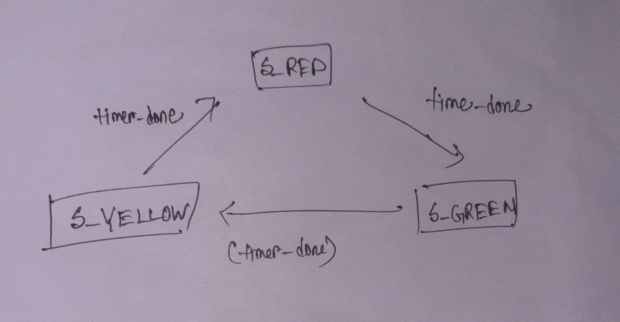
Write a one-paragraph overview for the FIFO as if explaining it to a DV engineer who has never seen the design.
This a synchronous FIFO which can read and write at the same time, when reset is pulled low it resets otherwise it reads and writes data. If its full or empty it indicated that through a flag. Any data cant be written when the FIFO is full or any data cant be read when FIFO is empty. Data can be read and write at the same time.

Day -9

Refining the FIFO Feature List, Categories, and Req-IDsAssign test categories to each FIFO feature. Write the category next to each feature and justify your choice.

Refined Feature Name | Category | Justification for Category | Req-ID
reset_initializes_pointers_and_empty_flag | Reset | Proves the DUT wakes up in a safe state with count = 0 and o_empty = 1 before any stimulus. | RST_001
sequential_write_read_data_integrity | Functional | Writing valid data and reading it back proves core FIFO functionality. | FUNC_001
simultaneous_read_write_maintains_count | Functional | Standard intended behavior for a dual-port FIFO. Count should not change if one item enters and one leaves simultaneously. | FUNC_002
full_flag_asserts_at_max_depth | Corner Case | Tests the absolute physical limit of the memory array (count == DEPTH). | CORNER_001
empty_flag_asserts_at_zero | Corner Case | Tests the bottom physical limit of the memory array (count == 0). | CORNER_002
write_ignored_when_full_overflow | Negative | Deliberately applying illegal inputs (writing when full) to prove the RTL protects itself. | NEG_001
read_ignored_when_empty_underflow | Negative | Deliberately applying illegal inputs (reading when empty) to ensure phantom data isn't popped. | NEG_002
sustained_max_throughput | Stress | Filling and emptying the FIFO back-to-back for 10,000+ cycles to ensure pointers don't drift over time. | STRESS_001
Write entry and exit criteria for verifying the Sequence Detector. Be specific — what does "done" actually mean?

Entry Criteria (Do not start testing until:)
- RTL Frozen: seq_detector.sv has passed basic compilation and the RTL designer has frozen the code.
- Spec Approved
- Environment Ready: The testbench clock generator, reset driver, and basic stimulus tasks are coded and compile without syntax errors.

Exit Criteria (Verification is done when:)
- Pass Rate: 100% of defined Req-IDs (including CORNER_001: Overlapping Sequence) pass with zero errors.
- Code Coverage:
  - 100% Toggle Coverage on all ports (especially o_match).
  - 100% FSM State Coverage (every state visited).
  - 100% FSM Transition Coverage (every arrow on the ASCII diagram was traversed).
- Bug Status: Zero open P0 (Critical) or P1 (High) bugs in the issue tracker.
Draw a simple traceability table for 3 FIFO features: Feature Name | Req-ID | Test Description (one line) | Coverage item (one line).
Feature Name | Req-ID | Test Description | Coverage Item
write_ignored_when_full_overflow | NEG_001 | Fill the FIFO, then assert i_wren while o_full is HIGH; verify wr_ptr and count do not increment. | Cross-coverage bin of (i_wren == 1) intersecting with (o_full == 1).
simultaneous_read_write_maintains_count | FUNC_002 | Fill FIFO halfway, assert both i_wren and i_rden on the same cycle; verify count is unchanged. | Cross-coverage bin of (i_wren == 1) intersecting with (i_rden == 1).
full_flag_asserts_at_max_depth | CORNER_001 | Write DEPTH consecutive times with i_rden LOW; verify o_full asserts on the final write. | Coverpoint bin for (count == DEPTH).

Day-10

For each of the 5 FIFO features you identified, assign: checker type (assertion / scoreboard / checker with expected) and stimulus type (directed / random). Write one sentence justifying each choice.
Feature Name | Stimulus Type | Checker Type | Justification
reset_initializes_pointers | Directed | Expected Value | We must explicitly assert the reset pin and check that the static outputs immediately drop to their hardcoded safe values (e.g., count = 0).
sequential_write_read | Constrained-Random | Scoreboard | To verify data integrity, we need to pump thousands of randomized data words through the FIFO, requiring a software reference model to track the payloads.
full_flag_asserts_at_depth | Directed | Expected Value | Hitting the exact boundary condition of a full memory array requires carefully scripted, step-by-step writes that a random generator might take too long to hit cleanly.
simultaneous_read_write | Constrained-Random | Scoreboard & Assertion | Randomizing concurrent read/write operations while checking against a scoreboard ensures no data is dropped during complex pointer overlaps.
write_ignored_when_full | Directed | Assertion | We must intentionally script an illegal scenario (writing to a full FIFO) and use an always-on assertion to prove internal pointers do not corrupt.

Write 3 assertions in plain English for the Traffic Light Controller. Example: "main_green and side_green must never be HIGH at the same time."

- The main road light and the side road light must never both be Green at the same time.
- The traffic light must never transition directly from Green to Red without passing through Yellow first.
- If the asynchronous reset is asserted, the state machine must immediately force all lights to Red, regardless of the timer.

Describe a scoreboard for the FIFO in plain English: what does it store, when does it compare, what does a mismatch mean?
A Scoreboard for the Synchronous FIFO acts as an independent accountant tracking the data.
What it stores: It contains a simple software queue like an array or list in SystemVerilog or C++. Whenever the testbench drives a valid write to the RTL FIFO, it simultaneously pushes that exact same data into the back of this software queue.
When it compares: Whenever the testbench reads from the RTL FIFO, the scoreboard immediately pops the oldest data word from its software queue and compares it against the o_rdata coming out of the RTL.
What a mismatch means: If the RTL data does not perfectly match the software data, it means the RTL is broken. It has either corrupted the data payload, dropped an item, allowed pointers to drift out of alignment, or suffered a latency issue causing data to arrive on the wrong clock cycle.

Assign P0 / P1 / P2 priority to each FIFO feature. Justify each.
Feature Name | Priority | Justification
reset_initializes_pointers | P0 (Must Pass) | If the reset fails, the FIFO powers up in an unknown, corrupted state. The silicon is dead on arrival.
sequential_write_read | P0 (Must Pass) | Data buffering is the entire purpose of a FIFO. If data goes in and doesn't come out correctly, the chip cannot be manufactured.
full_flag_asserts_at_depth | P0 (Must Pass) | If the full flag fails, upstream modules will blindly overwrite unread data, causing catastrophic system-wide data loss.
simultaneous_read_write | P1 (High Importance) | Highly important for max performance, but if broken, a software or architectural workaround could theoretically force idle cycles between reads and writes to save the chip.
sustained_max_throughput | P2 (Nice to Have) | This stress test builds immense confidence in the design's stability, but if you run out of time before the tape-out deadline, the core P0/P1 functionality is enough to sign off.
Write one paragraph explaining: why would you use both directed and random stimulus on the same design?

I would use both at the same design for different purpose. For example, if I want to test any specific scenario where output is already known to me I would do a direct test to see if thats matching, if its acting right on the corner cases otherwise for stress testing and if the overall module is working or not properly to check that i would do random stimulus

Day 11

For the Sequence Detector: list the FSM states and transitions. Write a coverage model in plain English — what coverpoints and bins would you define to say "the FSM has been fully exercised"?

States to Track:

- S_IDLE, S_1, S_10, S_101, S_1011
Transitions to Track:

- S_IDLE → S_1 (If 1) | S_IDLE → S_IDLE (If 0)
- S_1 → S_10 (If 0) | S_1 → S_1 (If 1)
- S_10 → S_101 (If 1) | S_10 → S_IDLE (If 0 - failure, back to start)
- S_101 → S_1011 (If 1) | S_101 → S_10 (If 0 - partial overlap)
- S_1011 → S_1 (If 1 - overlap) | S_1011 → S_10 (If 0 - overlap)

For the FIFO: write a coverage plan in plain English for count. What bins would you define? Why?

- State Coverpoint: Contains 5 bins, one for each state. This proves the machine physically entered every phase.
- Transition Coverpoint: Contains bins for all valid state-to-state jumps. Specifically, I want dedicated bins for the "overlap" transitions exiting S_1011. Proving that S_1011 successfully jumps back to S_10 (if a 0 arrives) instead of crashing to S_IDLE proves our overlapping logic works.

For a FIFO with DEPTH = 16, testing every single number from 0 to 16 equally is inefficient. Instead, we use bins to target boundaries.

Coverpoint: FIFO Fill Level (count)

- bin empty_bin = {0}; → Proves the absolute bottom boundary. The FIFO was fully drained.
- bin almost_empty = {1}; → Proves the edge case right before empty.
- bin normal_op = {[2:14]}; → A catch-all bin to prove the FIFO operated in a steady, partially-filled state.
- bin almost_full = {15}; → Proves the edge case right before maximum capacity.
- bin full_bin = {16}; → Proves the absolute top physical boundary. The FIFO maxed out.

Write a cross coverage item in plain English for wr_en and rd_en in the FIFO. List all four bins and why each matters.

Because a dual-port FIFO has independent Read and Write enables, we must prove the hardware handles all possible combinations on the exact same clock edge.

Cross Coverpoint: i_wren crossed with i_rden

- Bin 1 (00 - Idle): Neither signal is asserted. Matters because it proves the FIFO pointers stay frozen and no data is corrupted when the bus is quiet.
- Bin 2 (10 - Write Only): Matters because it proves standard data entry functionality.
- Bin 3 (01 - Read Only): Matters because it proves standard data extraction functionality.
- Bin 4 (11 - Simultaneous Read/Write): The most critical bin. Matters because it proves the memory array and internal pointers can safely handle data entering and exiting at the exact same physical moment without dropping a word.

Look at your FIFO feature table from Day 10. Add a "Coverage Item" column. Write one coverage item per feature in plain English.

Feature Name | Stimulus | Checker | Coverage Item (Plain English)
reset_initializes_pointers | Directed | Expected Value | A bin that tracks count == 0 on the exact clock cycle after rst_n goes HIGH.
sequential_write_read | Random | Scoreboard | Bins that track standard single-write (10) and single-read (01) operations occurring.
full_flag_asserts_at_depth | Directed | Expected Value | A coverpoint bin that tracks count == DEPTH occurring simultaneously with o_full == 1.
simultaneous_read_write | Random | Scoreboard & Assertion | The cross-coverage bin 11 tracking i_wren == 1 AND i_rden == 1 on the same clock cycle.
write_ignored_when_full | Directed | Assertion | A cross-coverage bin tracking i_wren == 1 intersecting with o_full == 1.

Write one paragraph: what is the difference between 100% branch coverage and 100% functional coverage? Can you have one without the other?
The difference between 100% branch coverage and 100% functional coverage is the difference between what the code says and what the architecture is supposed to do. Branch coverage is automatically tracked by the simulator and just ensures that every if/else statement in the RTL was evaluated as both true and false. Functional coverage is written manually by the DV engineer to ensure that specific architectural scenarios like filling a FIFO or overlapping a sequence actually happened.

We can achieve 100% branch coverage by simply toggling inputs randomly for a few seconds , but completely fail to hit 100% functional coverage because random stimulus never managed to fill the FIFO all the way up to exactly 16.

