DAY - 8
For each RTL write all sections: Overview, Key Features, Interface Table, Microarchitecture, FSM Specification, Timing, Corner Cases, RTL Code.

MODULE 1: Sequence Detector (1011 Overlapping)

1.1 Overview
This module is a synchronous finite state machine designed to detect the serial binary pattern "1011" from a continuous input stream. It is designed to handle overlapping sequences without dropping detections.

1.2 Key Features
- Detects the target sequence "1011" in a continuous serial stream.
- Supports overlapping pattern detection.
- Data input is gated by a valid signal to pause detection without losing state.
- Synchronous active-low reset for safe initialization.

1.3 Interface Table
Port Name | Direction | Width | Clock Domain | Active Level | Description
clk | Input | 1 | N/A | Rising Edge | Main system clock. All state transitions occur on the positive edge.
rst_n | Input | 1 | Asynchronous | Active-Low | Asynchronous reset. Forces the FSM to the IDLE state immediately.
i_valid | Input | 1 | clk | Active-High | Data Valid flag. When HIGH, indicates i_bit contains valid data to sample.
i_bit | Input | 1 | clk | N/A | The serial data input stream. Sampled only when i_valid is HIGH.
o_match | Output | 1 | clk | Active-High | Match flag. Pulses HIGH for one clock cycle when the sequence is detected.

1.4 Microarchitecture & FSM Specification

State Encoding Table:
State Name | Encoding ([2:0]) | Description
S_IDLE | 3'b000 | Reset state. Waiting for the first '1'.
S_1 | 3'b001 | Detected "1".
S_10 | 3'b010 | Detected "10".
S_101 | 3'b011 | Detected "101".
S_1011 | 3'b100 | Detected "1011",Drives o_match = 1.
Transition Table:
Current State | Condition (i_bit) | Next State | Output (o_match)
S_IDLE | 0 | S_IDLE | 0
S_IDLE | 1 | S_1 | 0
S_1 | 0 | S_10 | 0
S_1 | 1 | S_1 | 0
S_10 | 0 | S_IDLE | 0
S_10 | 1 | S_101 | 0
S_101 | 0 | S_10 | 0
S_101 | 1 | S_1011 | 0
S_1011 | 0 | S_10 | 1
S_1011 | 1 | S_1 | 1

ASCII State Diagram:
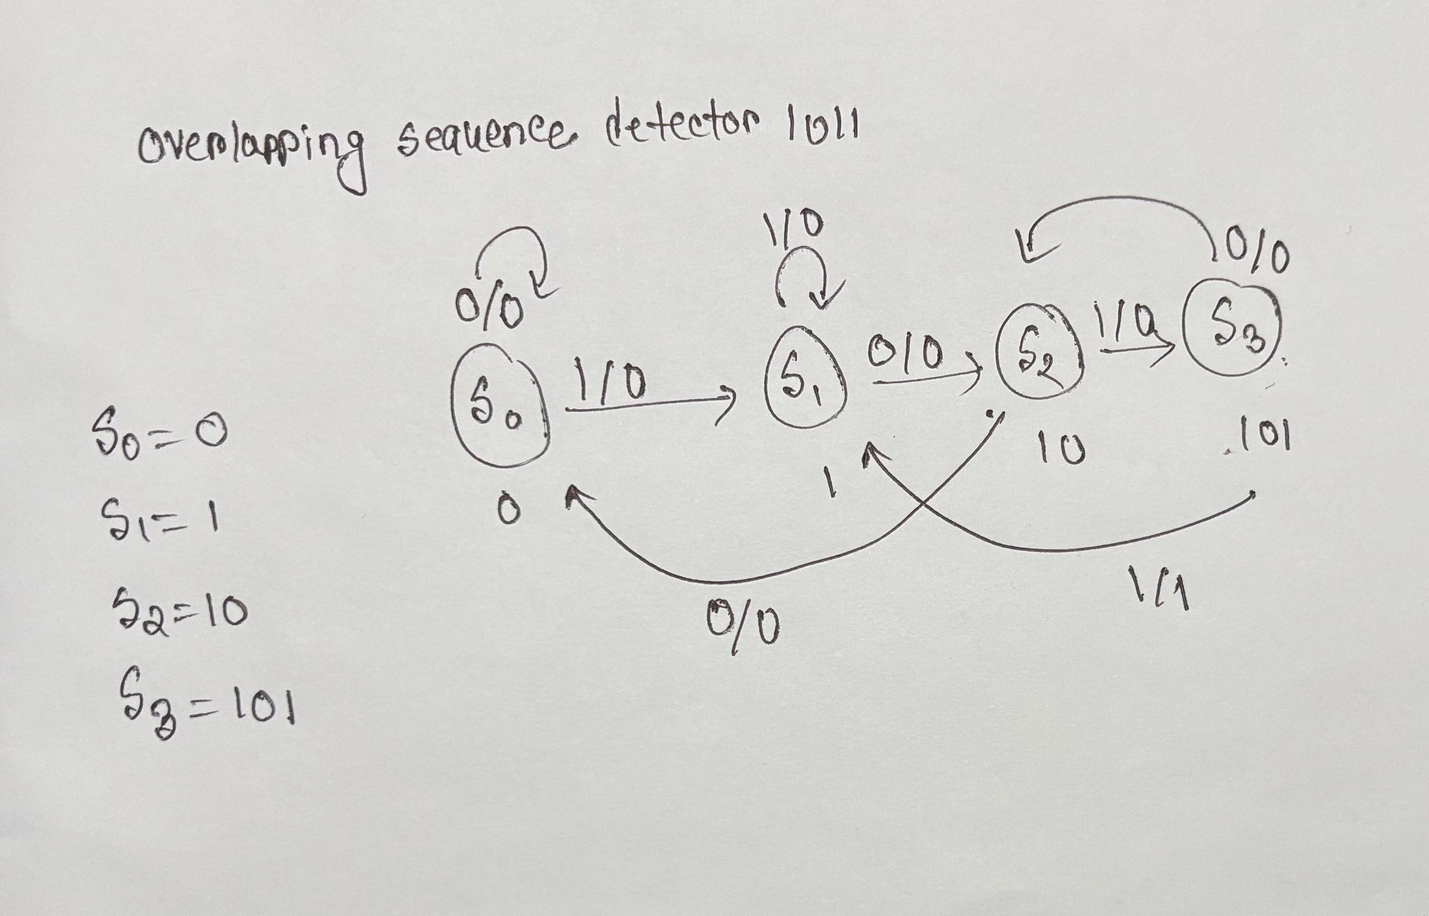

1.5 Timing Diagrams
- i_bit must be stable before the rising edge of clk when i_valid is HIGH.
- o_match asserts synchronously on the clock edge immediately following the transition into the S_1011 state.

1.6 Corner Cases
Scenario | Expected Behaviour | How it is Handled in RTL
Overlapping Sequence (1011011) | Must assert o_match twice. It must not reset to IDLE after the first match. | Transition from S_1011 with i_bit=0 routes back to S_10, retaining the start of the next sequence.
Reset Mid-Sequence | If rst_n asserts while in S_101, state must wipe instantly without pulsing o_match. | State register uses an asynchronous active-low reset prioritizing IDLE.
Invalid Data Toggle | If i_bit toggles while i_valid is LOW, the state machine must not advance. | FSM state transitions are strictly gated inside an if(i_valid) block.

1.7 RTL Code (Revised)
module seq_detector (
input logic clk,
input logic rst_n,
input logic i_valid,
input logic i_bit,
output logic o_match
);

// State Encoding
typedef enum logic [2:0] {
S_IDLE = 3'b000,
S_1 = 3'b001,
S_10 = 3'b010,
S_101 = 3'b011,
S_1011 = 3'b100
} state_t;

state_t current_state, next_state;

// Sequential Block: State transitions with active-low async reset
always_ff @(posedge clk or negedge rst_n) begin
if (!rst_n) begin
current_state <= S_IDLE;
end else if (i_valid) begin
current_state <= next_state;
end
end

// Combinational Block: Next State logic handling overlaps
always_comb begin
next_state = current_state; // Default hold

case (current_state)
S_IDLE: next_state = i_bit ? S_1 : S_IDLE;
S_1: next_state = i_bit ? S_1 : S_10;
S_10: next_state = i_bit ? S_101 : S_IDLE;
S_101: next_state = i_bit ? S_1011 : S_10;
S_1011: next_state = i_bit ? S_1 : S_10;
default: next_state = S_IDLE;
endcase
end

// Combinational Block: Output logic
// Match asserts only when in S_1011 state
assign o_match = (current_state == S_1011);

endmodule

MODULE 2: Traffic Light Controller

2.1 Overview
This FSM module consists of a main road and side road. We need to properly design this so no accident could happen. Each state has a timer until that timer ends it remains in that state and then moves to the next state. The side state also changes with respect to the main state.

2.2 Key Features
- Deterministic state rotation (Green → Yellow → Red).
- Interfaces with an external timer module for configurable state durations.
- Enforces a safe all-red state upon reset.

2.3 Interface Table
Port Name | Direction | Width | Clock Domain | Active Level | Description
clk | Input | 1 | N/A | Rising Edge | Main system clock.
rst_n | Input | 1 | Asynchronous | Active-Low | Asynchronous reset. Forces lights to RED in all directions.
i_timer_done | Input | 1 | clk | Active-High | Asserted by the timer when the current state duration has expired.
o_start_timer | Output | 1 | clk | Active-High | Pulses HIGH for one cycle to restart the timer upon entering a new state.
o_main_light | Output | [1:0] | clk | N/A | Main road light status. (00: Red, 01: Green, 10: Yellow).
o_side_light | Output | [1:0] | clk | N/A | Side road light status. (00: Red, 01: Green, 10: Yellow).

2.4 Microarchitecture & FSM Specification
State Encoding Table:
State Name | Encoding ([1:0]) | Description
S_MAIN_GREEN | 2'b00 | Main road is Green, Side road is Red.
S_MAIN_YELLOW | 2'b01 | Main road is Yellow, Side road is Red.
S_SIDE_GREEN | 2'b10 | Main road is Red, Side road is Green.
S_SIDE_YELLOW | 2'b11 | Main road is Red, Side road is Yellow.
(Note: Safe Red/Red is handled dynamically during reset before entering S_MAIN_GREEN).
ASCII State Diagram:Plaintext
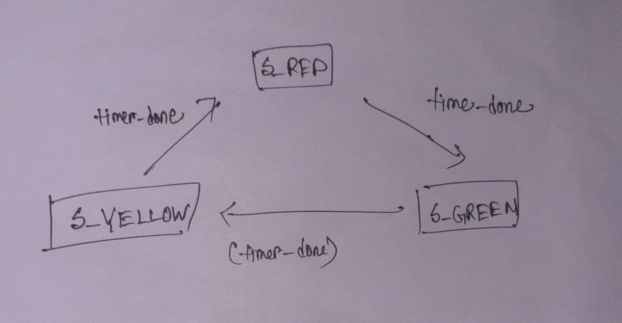2.5 Timing Diagrams
- When i_timer_done is sampled HIGH, the state changes on the next rising clock edge.
- o_start_timer pulses HIGH combinationally alongside the state transition to restart the external countdown.

2.6 Corner Cases
Scenario | Expected Behaviour | How it is Handled in RTL
Reset during Yellow | Must not jump straight to Green. Must initialize in a safe Red state before starting the Main Green timer. | rst_n forces default outputs directly to 2'b00 (Red) before the FSM begins normal operation.
Timer set to 0 | If the timer expires instantly, the FSM might flicker. A minimum state time must be enforced. | External timer (or FSM logic) prevents i_timer_done from asserting if elapsed time is 0.

2.7 RTL Code (Revised)

module traffic_light (

input logic clk,

input logic rst_n,

input logic i_timer_done,

output logic o_start_timer,

output logic [1:0] o_main_light,

output logic [1:0] o_side_light

);

// Light Color Encodings

localparam logic [1:0] RED = 2'b00;

localparam logic [1:0] GREEN = 2'b01;

localparam logic [1:0] YELLOW = 2'b10;

// State Encoding

typedef enum logic [1:0] {

S_MAIN_GREEN = 2'b00,

S_MAIN_YELLOW = 2'b01,

S_SIDE_GREEN = 2'b10,

S_SIDE_YELLOW = 2'b11

} state_t;

state_t current_state, next_state;

// Sequential Block: State Register

always_ff @(posedge clk or negedge rst_n) begin

if (!rst_n) begin

current_state <= S_MAIN_GREEN; // Default FSM start

end else if (i_timer_done) begin

current_state <= next_state;

end

end

// Combinational Block: Next State and Timer Trigger

always_comb begin

next_state = current_state;

o_start_timer = 1'b0;

if (i_timer_done) begin

o_start_timer = 1'b1; // Pulse timer reset

case (current_state)

S_MAIN_GREEN: next_state = S_MAIN_YELLOW;

S_MAIN_YELLOW: next_state = S_SIDE_GREEN;

S_SIDE_GREEN: next_state = S_SIDE_YELLOW;

S_SIDE_YELLOW: next_state = S_MAIN_GREEN;

default: next_state = S_MAIN_GREEN;

endcase

end

end

// Combinational Block: Output Logic (Safe-Red on Reset Override)

always_comb begin

if (!rst_n) begin

o_main_light = RED;

o_side_light = RED;

end else begin

// Default to RED unless explicitly overwritten

o_main_light = RED;

o_side_light = RED;

case (current_state)

S_MAIN_GREEN: o_main_light = GREEN;

S_MAIN_YELLOW: o_main_light = YELLOW;

S_SIDE_GREEN: o_side_light = GREEN;

S_SIDE_YELLOW: o_side_light = YELLOW;

endcase

end

end

endmodule

MODULE 3: Synchronous FIFO

3.1 Overview
A FIFO is module where whichever data comes first also leaves first. It is commonly used to maintain a synchronisation across various devices of different clock so data doesnt get corrupted. As it is a synchronous FIFO data can be written and read at the same time.

3.2 Key Features
- Parameterized DATA_WIDTH and DEPTH.
- Simultaneous Read and Write capabilities on a single clock edge.
- Combinationally evaluated full and empty status flags to prevent data loss.

3.3 Interface Table
Port Name | Direction | Width | Clock Domain | Active Level | Description
clk | Input | 1 | N/A | Rising Edge | Main system clock.
rst_n | Input | 1 | Asynchronous | Active-Low | Asynchronous reset. Clears pointers and count register.
i_wren | Input | 1 | clk | Active-High | Write Enable. Pushes i_wdata into memory if !o_full.
i_wdata | Input | [31:0] | clk | N/A | Write Data. Payload to be buffered.
i_rden | Input | 1 | clk | Active-High | Read Enable. Pops oldest data to o_rdata if !o_empty.
o_rdata | Output | [31:0] | clk | N/A | Read Data. Driven on the clock cycle following a valid read.
o_full | Output | 1 | clk | Active-High | Full Flag. High when count == DEPTH.
o_empty | Output | 1 | clk | Active-High | Empty Flag. High when count == 0.

3.4 Microarchitecture Specification
The datapath consists of a 2D memory array (reg [31:0] mem [0:15]). Two internal registers, wr_ptr and rd_ptr, track the current indices. A count register tracks the total number of valid elements. Pointers automatically wrap back to 0 upon reaching DEPTH-1.

3.5 Timing Diagrams
- Write Latency: Data presented on i_wdata with i_wren = 1 is written to memory on the next rising clock edge.
- Read Latency: When i_rden = 1, the data at the current rd_ptr is available on o_rdata on the immediate next clock cycle (latency of 1).

3.6 Corner Cases
Scenario | Expected Behaviour | How it is Handled in RTL
Write when Full (Overflow) | Write must be ignored. Count and wr_ptr must not increment. | Gated by assign write_valid = i_wren && !o_full.
Read when Empty (Underflow) | Read must be ignored. Count and rd_ptr must not decrement. | Gated by assign read_valid = i_rden && !o_empty.
Simultaneous R+W when Full | Write accepted. Count remains at DEPTH. Both pointers advance. | Combinational o_full allows i_rden to ungate the write. Count holds steady.
Simultaneous R+W when Empty | Read blocked. Write accepted. Count increments to 1. | o_empty blocks read. Treated as Write-Only.

module sync_fifo #(
parameter DATA_WIDTH = 32,
parameter DEPTH = 16
) (
input logic clk,
input logic rst_n,
input logic i_wren,
input logic [DATA_WIDTH-1:0] i_wdata,
input logic i_rden,
output logic [DATA_WIDTH-1:0] o_rdata,
output logic o_full,
output logic o_empty
);

// Internal parameter for pointer widths based on DEPTH
localparam ADDR_WIDTH = $clog2(DEPTH);

// Memory array and pointers
logic [DATA_WIDTH-1:0] mem [0:DEPTH-1];
logic [ADDR_WIDTH-1:0] wr_ptr;
logic [ADDR_WIDTH-1:0] rd_ptr;

// Count needs to go up to DEPTH (e.g., 0 to 16 requires 5 bits)
logic [$clog2(DEPTH+1)-1:0] count;

logic write_valid;
logic read_valid;

// Combinational flags
assign o_full = (count == DEPTH);
assign o_empty = (count == 0);

// Read/Write Validation Logic
// Corner Case: If full, write is only valid if a read is simultaneously freeing a spot
assign read_valid = i_rden && !o_empty;
assign write_valid = i_wren && (!o_full || i_rden);

// Sequential Block: Counters and Pointers
always_ff @(posedge clk or negedge rst_n) begin
if (!rst_n) begin
wr_ptr <= '0;
rd_ptr <= '0;
count <= '0;
end else begin
// Count Update Logic
case ({write_valid, read_valid})
2'b10: count <= count + 1; // Write only
2'b01: count <= count - 1; // Read only
2'b11: count <= count; // Simultaneous R/W: Count holds steady
2'b00: count <= count; // No operation
endcase

// Write Pointer Update (with wrap-around)
if (write_valid) begin
wr_ptr <= (wr_ptr == DEPTH - 1) ? '0 : wr_ptr + 1;
end

// Read Pointer Update (with wrap-around)
if (read_valid) begin
rd_ptr <= (rd_ptr == DEPTH - 1) ? '0 : rd_ptr + 1;
end
end
end

// Sequential Block: Memory Write
always_ff @(posedge clk) begin
if (write_valid) begin
mem[wr_ptr] <= i_wdata;
end
end

// Sequential Block: Memory Read (1 cycle latency)
always_ff @(posedge clk or negedge rst_n) begin
if (!rst_n) begin
o_rdata <= '0;
end else if (read_valid) begin
o_rdata <= mem[rd_ptr];
end
end

endmodule

